NAME:- Kaif Shaikh
0827CY221028

ASSIGNMENT-1
Introduction of DBMS
A Database Management System (DBMS) is a software system that is designed to manage and organize data in a structured manner. It allows users to create, modify, and query a database, as well as manage the security and access controls for that database.
DBMS provides an environment to store and retrieve the data in coinvent and efficient manner.

Applications of DBMS:
There are different fields where a database management system is utilized. Following are a few applications that utilize the information base administration framework.
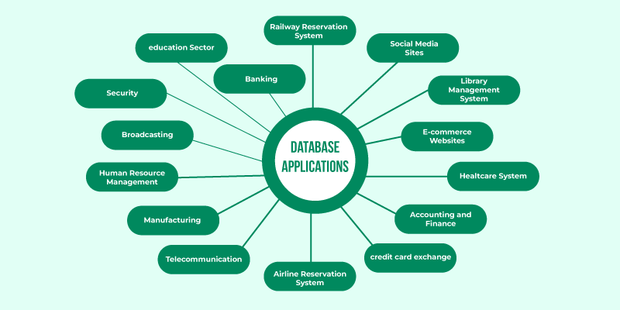

Advantages of DBMS
- Data organization: A DBMS allows for the organization and storage of data in a structured manner, making it easy to retrieve and query the data as needed.
- Data integrity: A DBMS provides mechanisms for enforcing data integrity constraints, such as constraints on the values of data and access controls that restrict who can access the data.
- Concurrent access: A DBMS provides mechanisms for controlling concurrent access to the database, to ensure that multiple users can access the data without conflicting with each other.
- Data security: A DBMS provides tools for managing the security of the data, such as controlling access to the data and encrypting sensitive data.
- Backup and recovery: A DBMS provides mechanisms for backing up and recovering the data in the event of a system failure.
- Data sharing: A DBMS allows multiple users to access and share the same data, which can be useful in a collaborative work environment.

Disadvantages of DBMS
- Complexity: DBMS can be complex to set up and maintain, requiring specialized knowledge and skills.
- Performance overhead: The use of a DBMS can add overhead to the performance of an application, especially in cases where high levels of concurrency are required.
- Scalability: The use of a DBMS can limit the scalability of an application, since it requires the use of locking and other synchronization mechanisms to ensure data consistency.
- Cost: The cost of purchasing, maintaining and upgrading a DBMS can be high, especially for large or complex systems.
- Limited Use Cases: Not all use cases are suitable for a DBMS, some solutions don’t need high reliability, consistency or security and may be better served by other types of data storage.
These are the main reasons which made a shift from file system to DBMS. Also, see
A Database Management System (DBMS) is a software system that allows users to create, maintain, and manage databases. It is a collection of programs that enables users to access and manipulate data in a database. A DBMS is used to store, retrieve, and manipulate data in a way that provides security, privacy, and reliability.

Several Types of DBMS
- Relational DBMS (RDBMS): An RDBMS stores data in tables with rows and columns, and uses SQL (Structured Query Language) to manipulate the data.
- Object-Oriented DBMS (OODBMS): An OODBMS stores data as objects, which can be manipulated using object-oriented programming languages.
- NoSQL DBMS: A NoSQL DBMS stores data in non-relational data structures, such as key-value pairs, document-based models, or graph models.
- Examples of DBMS's include MySQL, MariaDB, PostgreSQL, Microsoft SQL Server, Oracle Database, and Microsoft Access.

INTRODUCTION OF RDBMS
RDBMS stands for Relational Database Management Systems. It is basically a program that allows us to create, delete, and update a relational database. A Relational Database is a database system that stores and retrieves data in a tabular format organized in the form of rows and columns

ADVANTAGE OF RDBMS
Easy to manage
Security
Flexible
Easy Data Handling:
DISADVANTAGE OF RDBMS
High Cost and Extensive Hardware and Software Support
Scalability
Complexity
Structured Limits
EXAMPLE OF RDBMS
he following table STUDENT consists of three columns Roll Number, Name, Section and four records of students 1, 2, 3 and 4 respectively. The records can’t be completely same, the Roll Number acts as a candidate key which separates records.

Roll number | Name | Section
1 | Ishita | A
2 | Yash | B
3 | Ishita | A
4 | Mallika | C

Application of RDBMS

Difference Between DBMS and RDBMS
DBMS | RDBMS
DBMS stores data as file. | RDBMS stores data in tabular form.
Data elements need to access individually. | Multiple data elements can be accessed at the same time.
No relationship between data. | Data is stored in the form of tables which are related to each other.
Normalization is not present. | Normalization is present.
DBMS does not support distributed database. | RDBMS supports distributed database.
It stores data in either a navigational or hierarchical form. | It uses a tabular structure where the headers are the column names, and the rows contain corresponding values.
It deals with small quantity of data. | It deals with large amount of data.
Data redundancy is common in this model. | Keys and indexes do not allow Data redundancy.
It is used for small organization and deal with small data. | It is used to handle large amount of data.
Not all Codd rules are satisfied. | All 12 Codd rules are satisfied.
Security is less | More security measures provided.
It supports single user. | It supports multiple users.
Data fetching is slower for the large amount of data. | Data fetching is fast because of relational approach.
The data in a DBMS is subject to low security levels with regards to data manipulation. | There exists multiple levels of data security in a RDBMS.
Low software and hardware necessities. | Higher software and hardware necessities.
Examples: XML, Window Registry, Forxpro, dbaseIIIplus etc. | Examples: MySQL, PostgreSQL, SQL Server, Oracle, Microsoft Access etc.

.

