Hello and thank you for download my Asset!

Vehicles for Logistics Center - a controllable sample of vehicle in a lowpoly style.

In this package you can drive a Truck, van, forklift, raise and drop objects on the shelves. With the help of the van or truck you can transport objects. In Asset tuned physics, colliders and the vehicle controller. <br>

- with controller ( acceleration \ turning \ braking, move cargo up\down)<br>

- animation of opening and closing the doors of the van and truck <br>

- controllable a truck with a trailer<br>

- .fbx models with easy textures<br>

<br>

This demo project will continue a major upgrade to the logistics center pack.<br>

Please don't forget to rate and leave a comment!

Drag prefabs forklift truck, a van or truck with a trailer to the scene

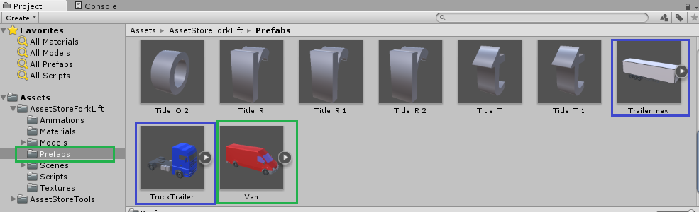

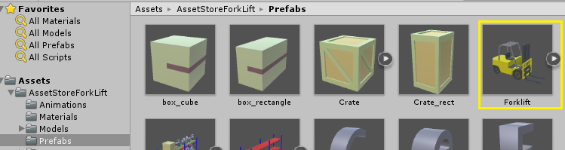

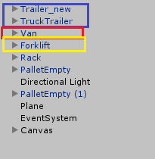

And configure the controller or use standard parameters

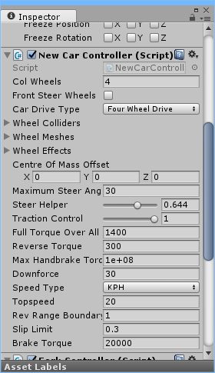

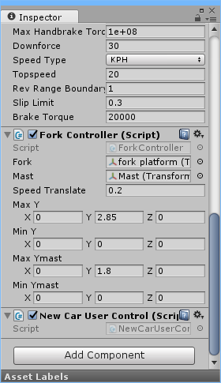

For forklift truck using the optional script:

ForkController.cs - The script for the management platform forklift.

In this script, you can customize the speed settings, the minimum and maximum height of the mast and fork platform.

For van used script for opening and closing doors:

VehicleBackDoors.cs - Script opening and closing the doors of the van.

For trailer used script for opening and closing doors:

VehicleBackDoors.cs - Script opening and closing the doors of the van.

In order to attach the trailer to the truck must be in a trailer Add HingeJoint component and set all the parameters.

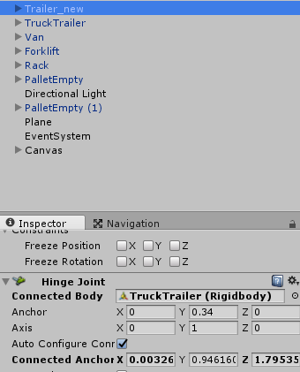

In the settings NewCarController add the required amount of the trailer wheels.

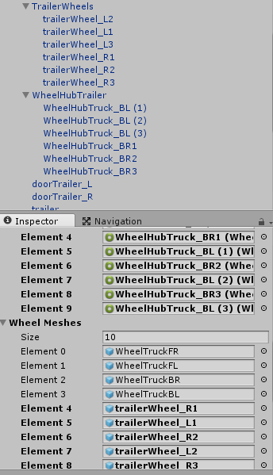

To select the control forklift truck, van or truck using a script:

SelectVehicle.cs - Script for selecting driving car. Move it on any empty object or a camera.

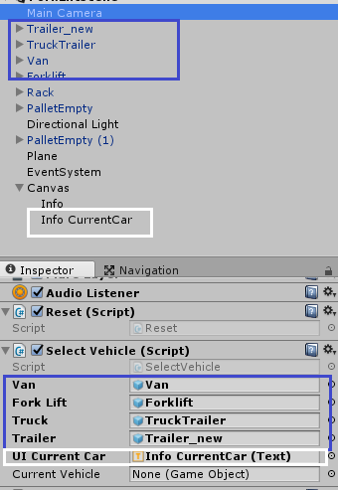

Move into an empty field Van, a forklift, truck and trailer

To the screen displays the name of the selected vehicle to move in the UI Current Car component text