作業(五) 商研一 A09741303 鄭守開

Answer these questions by R.

1. Make 1000 random variables from Bin(15, 0.4)

sample <- rbinom(1000,15,0.4)

sample

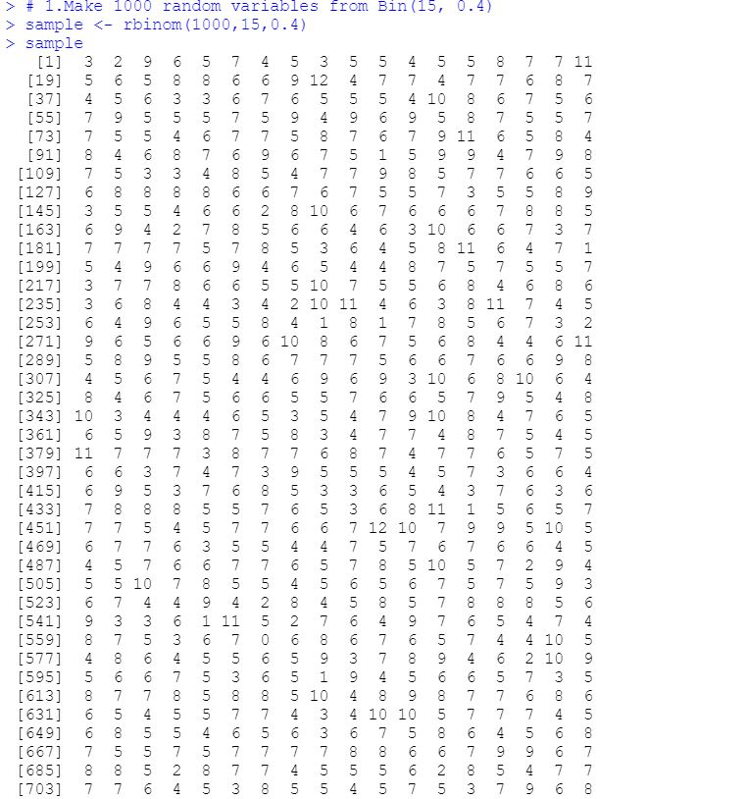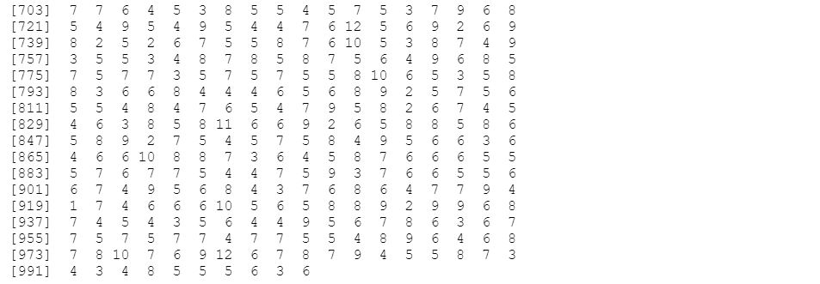

1. Draw a bar plot of your samples.

table<-table(sample)

barplot(table)

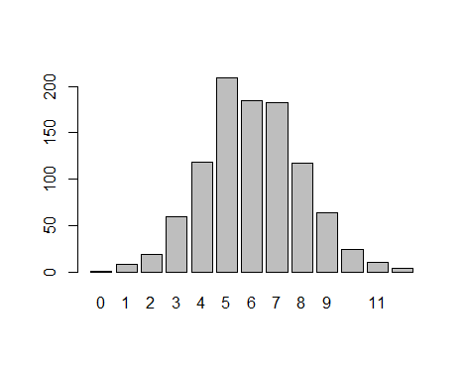

1. Calculate P(X=7)=0.1770837

dbinom(7,15,0.4)

4. What is the proportion of number 7 in your sample?table(sample)

182/1000= 0.182

