**Introduction**

Intro paragraph 1: large wood importance, context and grand question

Intro paragraph 2: large wood and conceptual models of storage and transport

Intro paragraph 3: large wood in great rivers and the UMR

Large wood likely plays an important ecological and geomorphic role in the UMRS, yet very limited information exists on its spatial and temporal distribution. We addressed this gap by leveraging a unique, long-term monitoring dataset to 1) describe the occurrence frequency of LW across various levels of river organization, 2) evaluate changes through time, and 3) assess associations between LW distributions and potential drivers across the large spatial scale of the UMRS. In doing so, our overall aim is to provide fundamental information about the spatio-temporal patterns of LW and their broad-scale environmental drivers in a complex large river-floodplain ecosystem to guide potential passive and active restoration programs on the UMRS.

**Methods**

*The Upper Mississippi River System*

The Upper Mississippi River System (UMRS) comprises approximately 1853 river kilometers and adjacent floodplain lands of commercially navigable waters of the Upper Mississippi and Illinois Rivers (Water Resources Development Act of 1986, 33 U.S.C §§ 652). Water levels between river kilometer X and 327 of the Mississippi River, as well as the Illinois River, are regulated with a series of low-head dams to maintain sufficient water depths for navigation during low-flow conditions. Below river kilometer 327 the Mississippi River is free flowing (i.e., lacks locks and dams) and is influenced by the Missouri River. {aquatic habitat diversity/relevant trends in forest cover vs other land types here}

*The Long Term Resource Monitoring Program and Dataset*

Environmental monitoring data are collected in the UMRS as part of the Long Term Resource Monitoring Program (LTRM), a component of the federally funded Upper Mississippi River Restoration Program (UMRR) that was established by Congress in 1986 and reauthorized in 1999 under the Water Resources Development Act. The LTRM uses standardized protocols to collect environmental and ecological monitoring data in six Trend Analysis Areas (TAAs) throughout the UMRS (Figure 1; Gutreuter et al. 1995). Pools 4, 8, 13, and 26 are located in the impounded reach of the Upper Mississippi River, the La Grange pool is located in the Illinois River, and the Open River is located on an unimpounded stretch of the Upper Mississippi River south of St. Louis, near Jackson, MO.

We used wood presence/absence data generated from the LTRM fish monitoring program collection effort. The goal of this program is to monitor fish communities and their relevant habitat characteristics through time and space. Since 1993, the program has employed a spatially stratified random sampling design across strata that roughly represent aquatic habitat types (Cochran 1977; Gutreuter et al. 1995). The sampling strata are based on enduring geomorphic features described by Wilcox (1993) and include the main channel, side channels, impounded areas, and backwaters (Table 1). Teams employ a variety of gear types across these strata (nets, electrofishing), but we used data from only daytime electrofishing because sampling occurs in a standardized transect adjacent to shorelines (200m x 30m) across relevant strata (i.e., main channel border, side channel borders, impounded area shorelines, and backwater shorelines).

While electrofishing, field teams record a suite of relevant environmental characteristics that includes water depth, velocity, substrate type, presence of shoreline revetment, water depth, and wood presence/absence (protocol citation, Table X). Field teams make a visual assessment of the presence of wood within the 6000 m2 sampling area, which could include wood exposed or visible immediately below the water surface or partially submerged wood along shorelines.

These data are served online after a rigorous quality assurance and control process.

(Table S1 – number of sampling observations across all years by study area and aquatic habitat type.)

Table 1. Codes, names, descriptions, and number of sampling locations analyzed for each aquatic habitat type. Descriptions are modified from Gurtreuter et al. (1995).

|  |  |  |  |
| --- | --- | --- | --- |
| Stratum Code | Stratum Name | Description | # Observations |
| BWC | Backwater, Contiguous Shoreline | Backwaters are aquatic areas that have some aquatic link to the main navigation channel but are separated from the main channel by a terrestrial area. Sampling occurs in this aquatic area type within 50m of the nearest shoreline. | 3189 |
| IMP | Impounded Shoreline | Impounded areas are usually large, mostly open-water areas located immediately upstream from locks and dams. Sampling occurs in impounded areas within 50m of the nearest shoreline. | 908 |
| MCB | Main Channel Border | Aquatic area between the margins of the main navigation channel and the nearest natural shoreline areas, including islands and mainland. Revetted shorelines are sampled. | 2736 |
| SCB | Side Channel Border | The border of a secondary or tertiary channel (Wilcox 1993) that have terrestrial margins and have measurable velocities at normal water elevations. | 3118 |

*Geospatial Datasets*

*Statistical Methods*

To understand spatial distributions of LW, we calculated the proportion of sampling locations with LW detections and summarized these values across multiple levels of river organization, including across all TAAs and aquatic habitat types. We tested for significant differences among TAAs and aquatic habitat types using Chi-squared tests with post-hoc pairwise comparisons using Bonferroni corrections, assuming a significance value of *p* = 0.05.

To assess temporal patterns of LW, we developed an annual time series of the proportion of sampling locations with LW for each TAA and we evaluated it for monotonic trends and break points in mean values. We applied the non-parametric Mann-Whitney Trend Test to assess whether a monotonic trend was present in the data. In cases where a trend was detected, we fit a linear regression model to characterize the nature of the trend. We used the non-parametric Pettitt Test for single change points (Pettitt 1979) to detect an abrupt shift in the central tendency of the distribution of sampling points with large wood. In cases where a significant change point was detected, we divided the dataset into two segments at the change-point year and fit two separate linear regression models to each segment; we did not test for monotonic trends within segments due to limited sample size. We repeated these analyses for aquatic habitat types in each TAA to understand whether wood occurrence varied differently through time across aquatic habitat types within a given TAA. Trend analysis and change-point tests were completed using the package *trend* in R (Pohlert 2018).

We evaluated the relationship between LW detection at sampling locations and environmental covariates using boosted regression trees (BRTs; Elith et al. 2008). BRTs are _{summary of approach}__. We used the presence or absence of large wood at each point as the response variable and assumed a Bernoulli error distribution within the modeling framework. We developed predictive BRT models of large wood presence/absence using the follow variables derived from ancillary geospatial datasets and the LTRM fish sampling datasets as described above and shown in Table X: var 1, var 2, var 3, blah blah blah.

We performed all computations in R statistical software (R Core Team 2018).

**Results**

*Spatial Patterns*

Large wood (LW) was detected in 56.5% of all sampling locations throughout the entire study region (Table 2) and varied in occurrence frequency across aquatic habitat types (Χ2 = 42.452, df = 3, p < 0.001; Table S2). LW was detected most frequently along channel borders (65%; p=?, Table 2, Table S2). LW was least likely to be detected in impounded areas and contiguous backwater areas, which were statistically indistinct from each other (Table S2).

Large Wood occurrence varied significantly across TAAs (Χ2 = 340.6, df = 5, p < 0.001; Table S3). The greatest LW occurrence was detected in Pools 4 and 13 where LW was found in over 67% of sampling locations (Table 2). Pools 8 and 26 had the next highest levels of LW occurrence (51.7 and 56.4% of sampling locations) but were not statistically different from each other (Table S3). LW was least likely to be detected in the Open River (43.1% of sampling locations) compared to all other pools (Table 2; Table S3).

In all six TAAs, LW was consistently most likely to be found in side channel borders than any other aquatic habitat type (Table 2). In pools from the Upper Impounded Reach, LW was also frequently observed in main channel borders (64.0 – 81.7% of sampling locations; Table 2). In Pool 26 and the La Grange reach of the Illinois River, LW was more likely to be found in contiguous backwaters than in main channel borders, however. The Open River has only 2 of the 4 aquatic habitat types but patterns of LW occurrence mirrored patterns in other pools: LW was more common in side channel than unstructured main channel borders (46.3% vs 37.7% of sampling locations).

Table 2. Proportion of sampling locations with large wood detections by Trend Analysis Area (TAA) and aquatic habitat type. Aquatic habitat types include contiguous backwater areas (BWC), impounded areas (IMP), main channel borders (MCB), and side channel borders (SCB). Boldface values indicate that large wood was detected in more than 60% of the sampling locations.

|  |  |  |  |  |  |  |
| --- | --- | --- | --- | --- | --- | --- |
|  | *n obs* | Overall | Aquatic Habitat Type | | | |
|  | BWC | IMP | MCB | SCB |
| All locations | *9951* | 0.565 | 0.512 | 0.481 | 0.558 | **0.650** |
| Pool 4 | *1663* | **0.675** | 0.502 | *n.a.* | **0.767** | **0.789** |
| Pool 8 | *1702* | 0.517 | 0.378 | 0.416 | **0.640** | **0.653** |
| Pool 13 | *1450* | **0.708** | **0.669** | **0.631** | **0.817** | **0.847** |
| Pool 26 | *1721* | 0.564 | **0.625** | 0.375 | 0.502 | **0.709** |
| La Grange | *2403* | 0.496 | 0.425 | *n.a.* | 0.405 | **0.641** |
| Open River | *1012* | 0.431 | *n.a.* | *n.a.* | 0.377 | 0.463 |

*Temporal Patterns*

The occurrence of large wood varied through time for some – but not all – of the TAAs (Figure 2). In addition, the direction of these trends (i.e., positive, negative, neutral) varied among TAAs and aquatic habitat types. Change points indicating abrupt shifts in mean occurrence frequency were detected in four of the six TAAs, including all the TAAs from the upper impounded reach and the Illinois River (Table 3), but the timing and magnitude of these shifts were not synchronized among TAAs. Mean frequency values decreased by nearly 10% in Pool 13 and 41% in La Grange between the two periods, wheras mean values increased by ~1.5 times from 1999-2017 compared to 1993 – 1998 in Pool 4 (0.487 vs 0.730; Figure 2). In two of the TAAs with change points, Pool 8 and La Grange, significant Mann-Whitney Trend Tests also indicated the proportion of LW monotonically decreased from 1993 – 2017 (Table 3). Temporal trends in Pool 8 were unique in that the proportion of sampling locations with LW declined significantly during the first period (1993 – 1999; slope=-0.029, p=0.020) but remained steady at a mean value of 0.430 from 2000 – 2017 (Figure 2). No change points or trends were detected in Pool 26 or the Open River, possibly due to greater interannual variability (Table 3; Figure 2).

Table 3. Results of change-point detection (Pettit) and monotonic (Mann-Kendall) trend analysis of wood detection occurrence for six Trend Analysis Areas (TAAs) and aquatic habitat types they comprise (BWC = contiguous backwater areas, MCB = main channel border, SCB = side channel border, IMP = impounded areas). Bolded values indicate statistically significant test results (p < 0.05). U* = Pettit test statistic, t = year of change point, z = test statistic for Mann-Kendall test.

|  |  |  |  |  |  |  |
| --- | --- | --- | --- | --- | --- | --- |
|  |  | Pettitt Test | | | Mann-Kendall Trend Test | |
|  |  | U* | p | *t* | z | p |
| Pool 4 | TAA | 114 | **0.016** | 1999 | 1.472 | 0.141 |
| BWC | 67 | **0.038** | 1999 | -0.280 | 0.779 |
| MCB | 112 | **0.019** | 1999 | 2.197 | **0.028** |
| SCB | 114 | **0.001** | 2001 | 3.272 | **0.001** |
| Pool 8 | TAA | 134 | **0.003** | 2003 | -3.971 | **<0.001** |
| BWC | 140 | **0.001** | 2002 | -4.799 | **<0.001** |
| MCB | 46 | 0.916 | *n.a.* | -0.897 | 0.370 |
| SCB | 115 | **0.015** | 2003 | -2.925 | **0.003** |
| IMP | 119 | **0.011** | 2001 | -3.604 | **<0.001** |
| Pool 13 | TAA | 110 | **0.023** | 2005 | -1.635 | 0.102 |
| BWC | 61 | 0.506 | *n.a.* | -0.935 | 0.350 |
| MCB | 94 | 0.077 | *n.a.* | -2.119 | **0.034** |
| SCB | 91 | 0.094 | *n.a.* | -1.234 | 0.217 |
| IMP | 91 | 0.094 | *n.a.* | -1.452 | 0.147 |
| Pool 26 | TAA | 55 | 0.655 | *n.a.* | -0.514 | 0.607 |
| BWC | 65 | 0.420 | *n.a.* | -1.239 | 0.216 |
| MCB | 46 | 0.916 | *n.a.* | 0.866 | 0.386 |
| SCB | 86 | 0.130 | *n.a.* | -1.707 | 0.088 |
| IMP | 47 | 0.885 | *n.a.* | -0.235 | 0.814 |
| La Grange | TAA | 118 | **0.012** | 2011 | -3.667 | **<0.001** |
| BWC | 118 | **0.012** | 2004 | -3.598 | **<0.001** |
| MCB | 118 | **0.012** | 2011 | -2.523 | **0.012** |
| SCB | 122 | **0.008** | 2007 | -3.248 | **0.001** |
| Open River | TAA | 74 | **0.265** | *n.a.* | -0.818 | 0.413 |
| MCB | 94 | 0.077 | *n.a.* | -1.521 | 0.128 |
| SCB | 62 | 0.484 | *n.a.* | -0.047 | 0.963 |

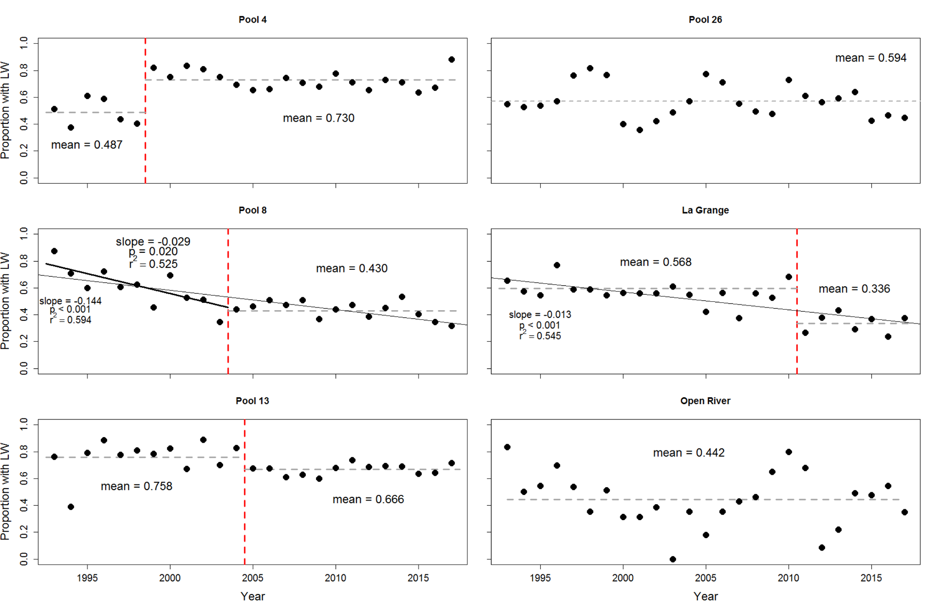

Figure 2. Breakpoints and trends in temporal variation in the proportion of sampling locations with large wood by TAA. Vertical dashed red lines indicate a statistically significant break point in the central tendency. Solid black lines indicate statistically significant linear regression model fit to either a portion of the time series (thick line, Pool 8) or entire time series (thin lines, Pool 8 and La Grange). Dashed grey lines indicate segment or whole-series mean proportion of sampling locations with large wood.

Temporal patterns in the proportion of sampling locations with large wood varied by aquatic habitat type in ways generally consistent with overall TAA patterns (Table 3, Figure 3). Pools 4, 8 and La Grange had significant trends in at least one aquatic habitat type, whereas Pools 8, 26 showed no trends or breakpoints in wood occurrence. In Pool 4, patterns of large wood occurrence across all aquatic habitats were consistent with overall TAA-level patterns. Statistically significant break points were observed within a similar time frame as the overall TAA break point (Table 3) such that mean values of large wood prevalence increased after each break point in all three habitats (Table S4). Trends in wood occurrence varied among aquatic habitat types, however: Large wood frequency decreased over time in contiguous backwater areas in Pool 4 after 2000, but occurrence rates remained steady in other habitats during the same period (Table 3). Positive monotonic trends in the main and side channel border habitats were detected (Table S5) but appear to be driven by low proportions of large wood at sampling sites prior to 1999 (Table S4). In Pool 8, overall patterns of large wood prevalence through time appear to be driven mainly by patterns in side channel border, backwater, and impounded area habitats. Statistically significant monotonic declines in large wood occurrence and break points in these three habitats were consistent with overall TAA patterns (Table 3, Table S4, Table S5). The proportion of sampling locations with large wood declined sharply prior to the break points in impounded and backwater habitats, leveling out to only slight or non-significant declines later in time (Table 3, Figure 3). No statistically significant break points or trends were detected for the main channel border habitat, suggesting that factors driving patterns of large wood occurrence in this habitat are different from those in other habitats. In Pool 13, the only statistically significant pattern observed across aquatic habitat types was a monotonic decline in the main channel border habitat. However, a linear regression model was not statistically significant (F=1.541, R2adj = 0.022, p=0.227), possibly due to the influence of low values during the first 3 years of sampling to which the Mann-Kendall test would be more robust. All other habitat types in Pool 13 exhibited no trends or break points. Patterns of large wood prevalence through time in the aquatic habitats of the La Grange reach were also consistent with overall TAA patterns: large wood occurrence declined strongly through time in all three habitats. Break points were detected in all three habitat types, but only the break point in the main channel border habitat aligned temporally with the overall TAA break point of 2011. occurrence

Figure 3. Temporal trends and breakpoints in the proportion of sampling locations with large wood (LW) in aquatic habitat types (MCB=main channel border, SCB=side channel border, BWC=contiguous backwater, IMP=impounded). Vertical lines indicate a statistically significant break point in the central tendency. Other lines indicate statistically significant linear regression models fit to either a portion of the time series or entire time series.

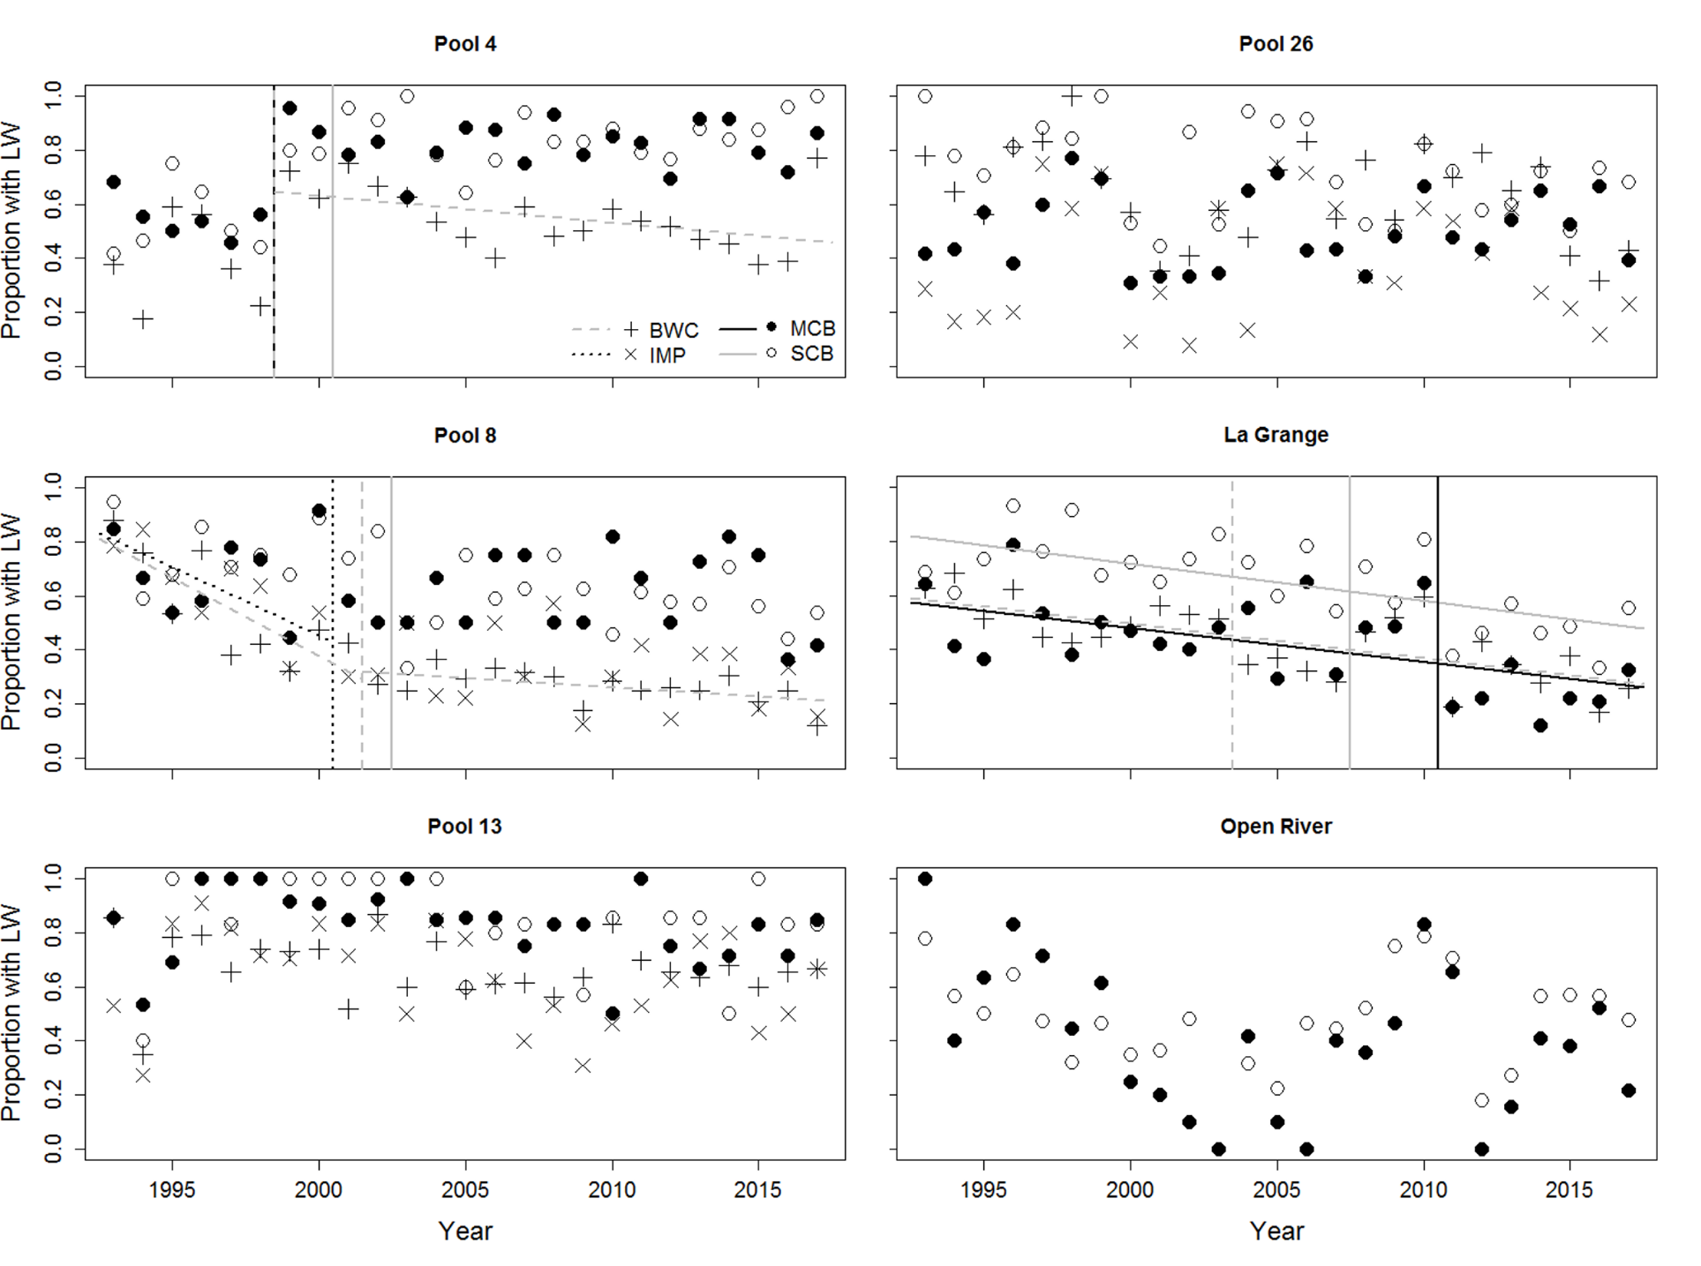

*Associations with Environmental Attributes*

{TBD}

**Discussion**

1. Large wood is relatively abundant in UMR overall, likely providing important benefits to the river-floodplain ecosystem.
   1. benefits to the river-floodplain ecosystem.
   2. relate to Angradi and others – similar patterns of distribution?
   3. Relate to historical values – and mention potential for future change due to fpf structure and composition?
2. Despite its overall abundance, the distribution of LW exhibits spatial and temporal patterns in abundance that may have important ecological implications.
   1. Distributions across pools
      1. provide important structure to aquatic areas in La grange and Open River reaches which lack other structures (aq veg, eg) compared to other navigation pools. Therefore, although we observed long term declines in LW occurrence in Pool 8 and La Grange, the loss of wood from the La Grange pool may be more ecologically impactful in that stretch of river compared to Pool 8. Continued LW monitoring would be important in all areas, but especially in reaches like the La Grange pool.
      2. low occurrence in open river may be due to lack of complexity, limited forested borders, and different flow characteristics that contribute to greater likelihood of wood being transported through the system rather than remaining anchored in place (speculation!). Open River ecology is different than other reaches. Wood could be important refuge in open river because “matrix” is harsh compared to more hydrogeomorphically diverse stretches of river
   2. Distributions across habitat types
      1. side channel borders and their hydraulic and ecological function
3. The spatially and temporally varying distributions of LW we document here suggest that the occurrence of LW in the UMRS is related to complex eco-hydrological processes.
   1. {describe processes}
   2. Additional studies on the transport of woody debris in the UMRS would greatly improve our understanding of LW in a great river of national and international importance.
4. We detected spatial and temporal patterns using a relatively coarse dataset that was design for the purposes of fish population monitoring rather than understanding long-term woody debris dynamics.
   1. Long-term datasets are powerful assets to not only for monitoring resource availability or ecological management planning, but also for addressing research questions that are both anticipated and unanticipated during the planning and initiation stages of the data collection effort. It is important, therefore, for long-term monitoring programs to place a high value on maintaining standardized measurements through time (or if not possible, provide cross-walks to bridge revised methods), detailed metadata including the archiving of protocol and field notes, and accessible data archive.
   2. Limitations of our dataset:
      1. Fish monitoring protocol rigorously standardized across field stations. However, no quantitative measures of LW are made in the field that would serve as size occurrence limits, although personnel all agree LW must be sized large enough to serve as permanent or semi-permanent habitat for fish (i.e., not floating and of substantial size). Occurrence of woody debris occurs both above the water line and below, the latter which can vary depending on total suspended solids concentration. High flow conditions might also impact occurrence, as high water levels would obscure partially submerged pieces. In addition field station at pool 13 also includes presence of LW when encountered while wading in shallow water even if the piece is not visible from above water – this could inflate occurrence values at this site compared to other sites.
      2. Low turn-over in field staff through time makes it unlikely that occurrence rate changes through time would be an artifact of personnel changes.
   3. Improvements
      1. Quantitative measures of wood
      2. Even coarse classifications (like field season 2018) to understand at a coarse level the quantity of wood.
      3. Ancillary data such as remotely sensed aerial imagery, side-scanning sonar data, etc. could be used to gain a fuller understanding of the quantity and distribution of LW in the UMRS, which in turn would form the basis for future analyses of transport dynamics and eco-geomorphic roles.

**Acknowledgements**

The authors thank Benjamin Schlifer for assistance with the LTRM fish monitoring database and Brian Ickes for interpreting LTRM fish sampling methodology. KG, SB, BB, DDB, and RH were supported by the National Science Foundation Research Experience for Undergraduates in Mathematical Biology, award #1559663. RE was supported through ___. KJJ and MVA were supported through the U.S. Army Corps of Engineers’ Upper Mississippi River Restoration Program. Any use of trade, firm, or product names is for descriptive purposes only and does not imply endorsement by the U.S. Government.

**References**

Elith, J., J. R. Leathwick, and T. Hastie. 2008. A working guide to boosted regression trees. Journal of Animal Ecology 77:802–813.

Pettitt, A.N. 1979. A non-parametric approach to the change-point problem. Applied Statistics 28: 126 – 135.

Pohlert, T. 2018. Non-parametric trend tests and change-point occurrence, version 1.1.1. CRAN R package “*trend*”.

R Core Team. 2018. R: a language and environment for statistical computing. R Foundation for Statistical Computing, Vienna, Austria. URL: [https://www.R-project.org/](https://www.r-project.org/).

|  |  |  |  |
| --- | --- | --- | --- |
| Variable | **Unit** | **Collection Method** | **Spatial scale** |
| Wood | Presence/absence | Visual | Site |
| Water depth | Meters | Sonar, manual measurement (?) | Site |
| Water velocity | m/s | Velocity meter | Site |
| Substrate type |  | Visual | Site |
| % Veg coverage | Percent | Visual | Site |
| Wing dam | Presence/absence | Visual | Site |
| Revetment | Presence/absence | Visual | Site |
| Stratum | MC, SC, IMP, BW | Design-based |  |
| Nearest land cover | Forest, grasses, marsh, sand/mud | GIS |  |
| Distance to forest | Meters | GIS |  |
| Aquatic area metrics – SDI, perimeter, volume, etc (?) |  | GIS | “Polygon” |
|  |  |  |  |