Software Requirements Specification

for

Scheduling Manager

Version <0.1>

Prepared by

Group Name: Group 4

|  |
| --- |
| Daniel Kelly |
| Mason Hardy |
| Nickolas Haugen |
| Benjamin McSwain |
| Mark Walters |

|  |  |
| --- | --- |
| Instructor: | Amanda Schwartz |
| Course: | CSCI540 |

# Specific Requirements

## External Interface Requirements

### User Interfaces

**Figure 1**

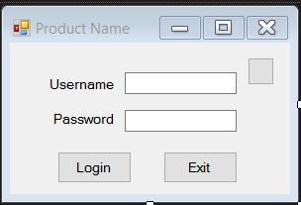

The first window a user will see is the login screen(Figure 1). Here the user will input their username and password and click the "Login" button to log into their account. If the user is the employer, the login button links to the Employer Schedule Form(Figure 4). If the user is an employee, the login button links to the Employee Availability Form(Figure 2). Clicking the "Exit" button will close the window and exit the program.

**Figure 2**

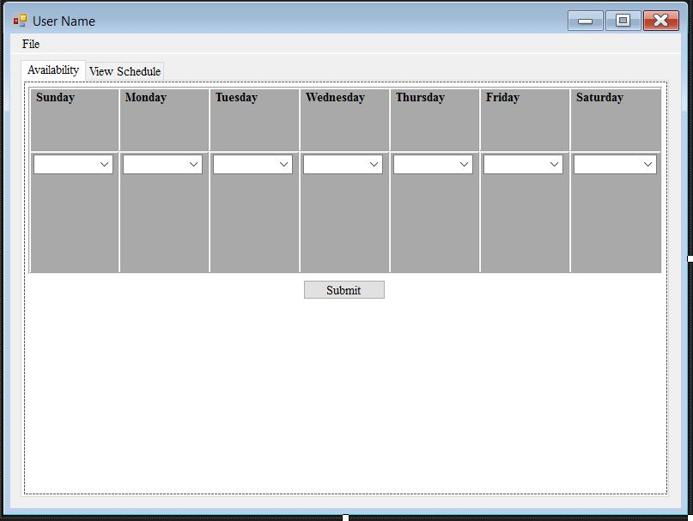

After an employee logs in, they will be taken to the Employee Availability Form(Figure 2). Here the employee will be able to click a drop down box under each day of the week and select the shift that they are able to work for that day. Once shifts have been selected, the employee may click the "Submit" button to submit their availability to the employer. Clicking the "View Schedule" tab will allow the employee to see the schedule that the employer has generated for the week. Clicking “File” will give the employee the option of requesting a certain date off.

**Figure 3**

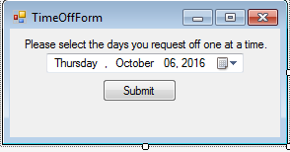

An employee is taken to the Time Off Form(Figure 3) after clicking “File”->”Request Time Off”. Here the employee may select a specific date from the drop down box to ask off from work. Upon clicking the “Submit” button, the request will be sent to the employer.

**Figure 4**

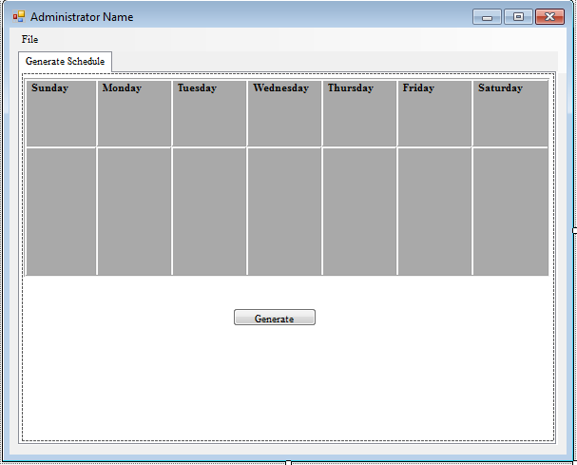

After an employer logs in, they will be taken to the Employer Schedule Form(Figure 4). The employer can hit the "Generate" button to create a schedule for the week based off employees' availabilities. Clicking "File" will give the employer the option to add employees or edit employees.

**Figure 5**

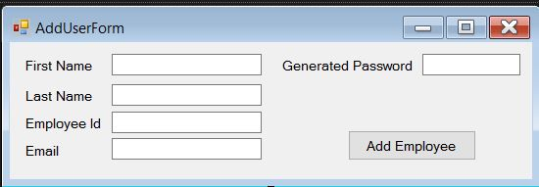

An employer is taken to the Add Employee Form(Figure 5) after clicking "File"->"Add Employee". Here the employer can enter the first name, last name, employee id, and email for a new employee. The "Generated Password" field is populated with a randomly generated password that the employer can give to the new employee to log into the program. Once the "Add Employee" button is clicked, the employee is added to the database and the employer is taken back to the Employer Schedule Form(Figure 4).

**Figure 6**

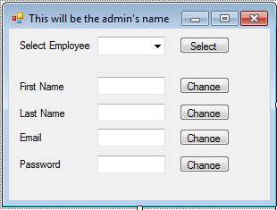

An employer is taken to the Edit Employee Form(Figure 6) after clicking "File"->"Edit Employee". Here the employer will select an employee from the "Select Employee" drop down box and click the "Select" button. The following boxes will fill with the selected employee's information (first name, last name, email, etc.). The employer can then click the "Change" button next to a particular information box in order to edit that information.

### Software Interfaces

### The program will work on a computer that has Windows XP or higher. The computer should have the latest Java Runtime Environment installed to run the program. Employee and administrative data will be stored in a SQL server database.

## Functional Requirements

The software will be capable of allowing users to create a profile which has a certain level of clearance. The two levels will be referred to as an employee profile and an employer profile. The employer will be given an administrative username and password. Employees will log in with their email address and a password provided by the employer. Through the "Add Employee Form"(Figure 5), the employer will have the ability to add employees to the database. To do this, the employer will fill in the text boxes for first name, last name, employee id, and email and click the "Add New Employee" button.

Once an employee is added to the database, they may sign in using their login information provided by the employer. Employee profiles have the ability to edit their work availability, request time off, and view the schedule. Through the Employee Availability Form(Figure 2), the employee will be able to click a drop down box under each day of the week to choose what shift they will be able to work. The drop down box will contain shifts ranging from 4-8 hours within the operating business hours. To finalize their availability, the employee will click the "Submit" button. The employee can click "File"->"Request Time Off". This will take them to the Time Off Form(Figure 3) where they can select a specific date in the future in which they need to have off from work. Once they click the “Submit” button to submit the request, it will be sent to the employer to approve/deny, and the employee will be sent back to the Employee Availability Form(Figure 2). Finally, the "View Schedule" tab will display the employee's final generated schedule in a weekly table.

When the employer logs in to the Scheduling program, they are taken to the Employer Schedule Form(Figure 4). Here they will click the "Generate" button to be presented with a generated schedule for the week based on the employees’ availability. Clicking "File" will provide the employer with options to add employees or edit employees.

If the employer clicks "Add Employee" under "File", they are taken to the Add Employee Form(Figure 5). Here the employer can enter in first name, last name, employee id, email, and a password for a new employee. These fields will be checked to make sure information is entered in the proper format. Once the employer clicks the "Add Employee" button, the employee will be added to the database and the employer will be taken back to the Employer Schedule Form(Figure 4).

If the employer clicks "Edit Employee" under "File", they are taken to the Edit Employee Form(Figure 6). Here they will use the "Select Employee" drop down box to select an employee from the database. After selecting, they may click the "Select" button to populate the following text fields with that selected employee's information. They may click in a text field to edit the information contained and click the "Change" button next to the text field to submit the changes. Closing this page will take the employer back to the Employer Schedule Form(Figure 4).

## Behaviour Requirements

### Use Case View