bac-2330-005930
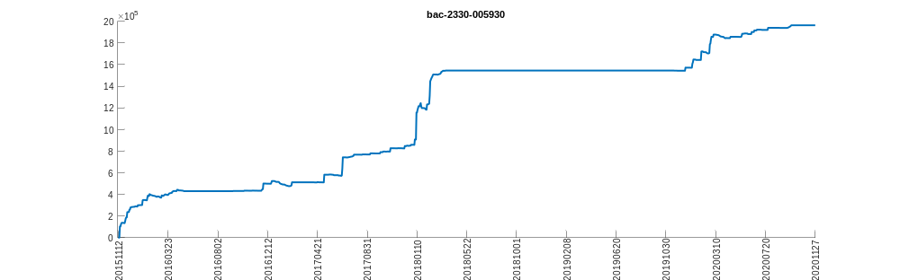
bac-HSI-HSCEI
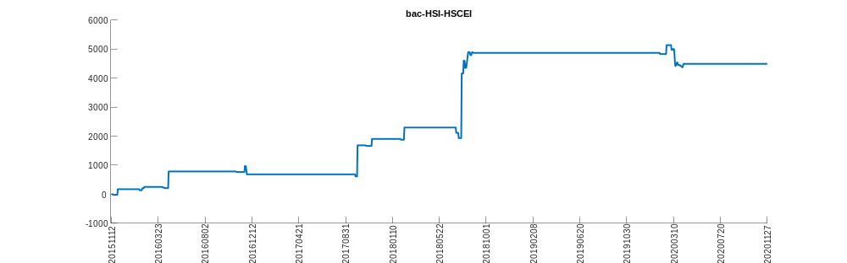
bac-NKY-TPX
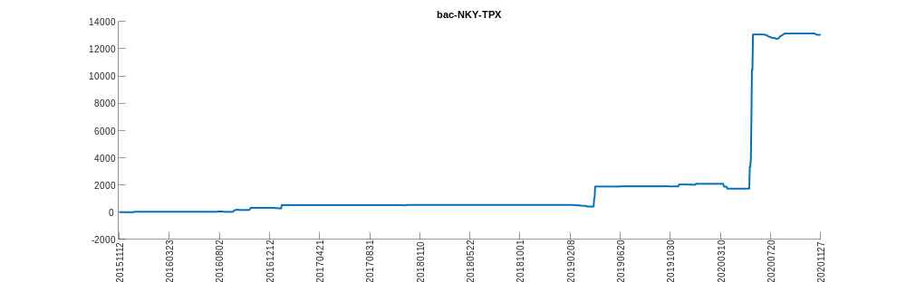
bac-NTN_1M-KWN_1M
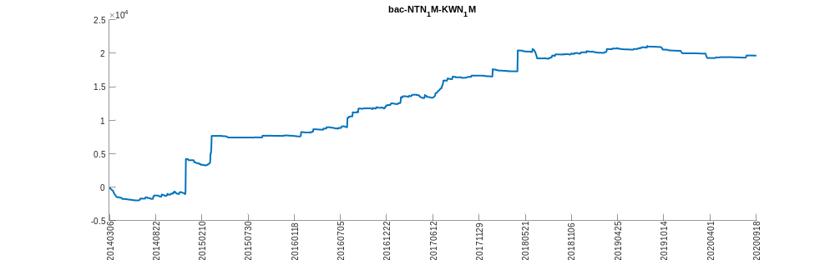
bac-NTN_1M-NTN_12M
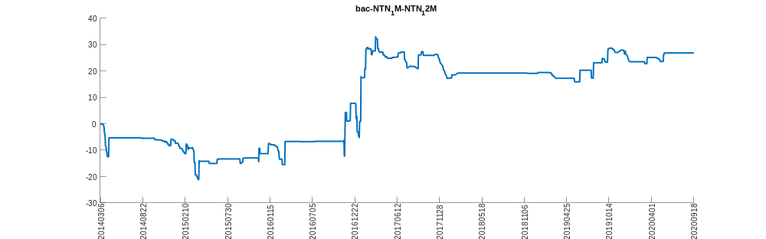
bac-NTN_1M-NTN_6M
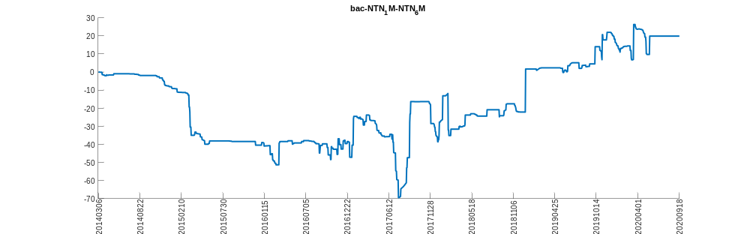
bac-TAMSCI-TWSE
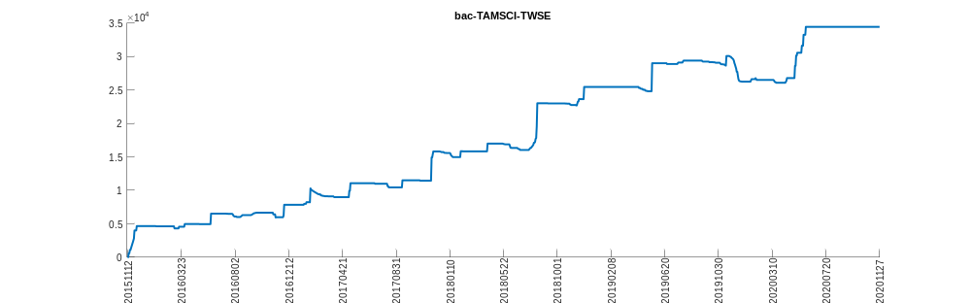
bac-XIN9I-HSCEI
