S34增强效果-上证综指
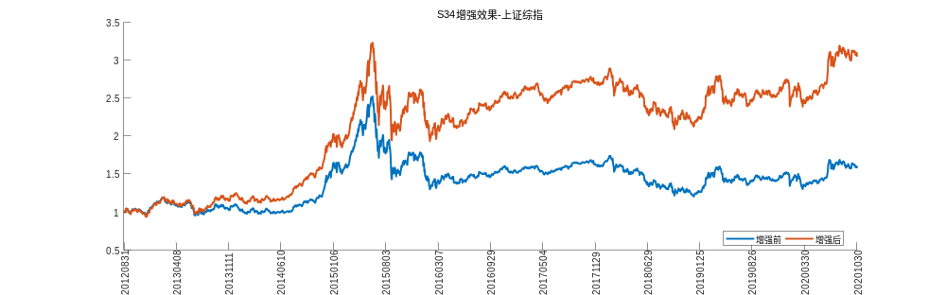

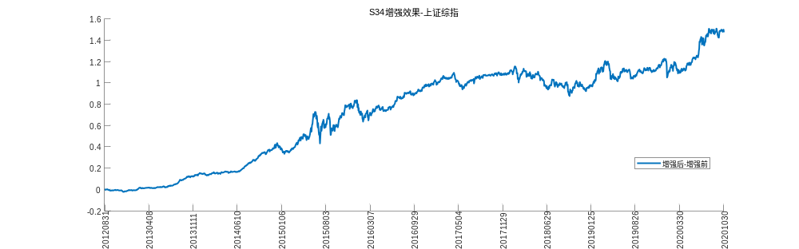
S34增强效果-上证50
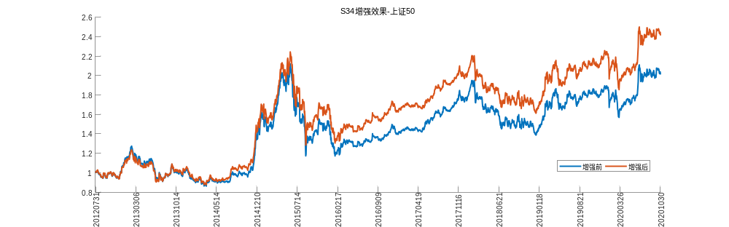

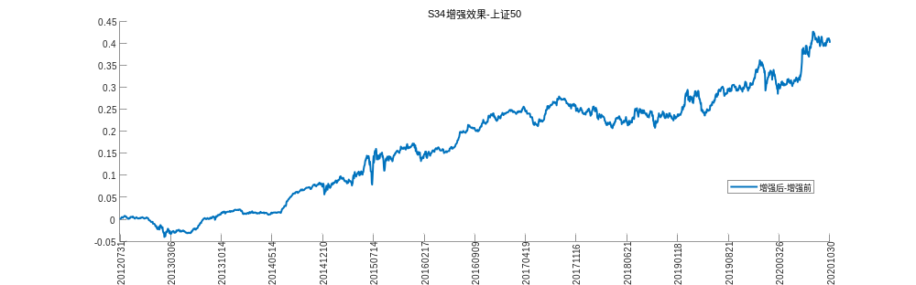
S34增强效果-中证500
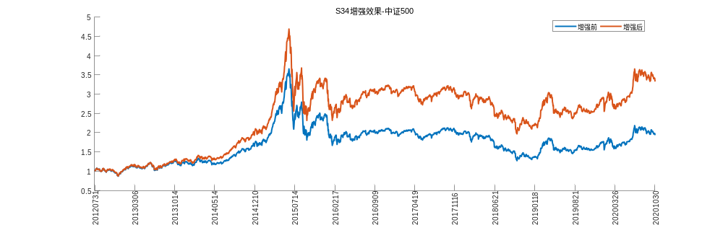

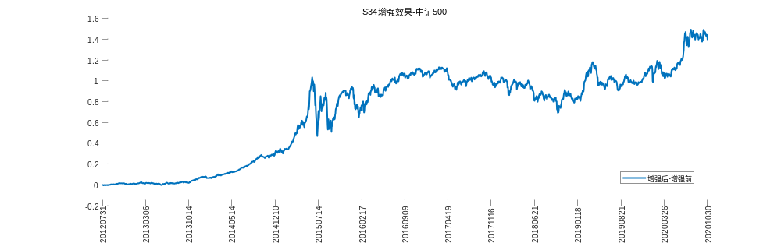
S34增强效果-沪深300
