When Adaptivity Erases the Signal:
Kalman Filters, Hedge Ratios and the Limits of a Visa–Mastercard Pairs Trade
Kaiki Ikeda
Research report · 2026 · code and data pipeline: github.com/kaikiikeda/kalman-filter-pairs-trading

Abstract
I test whether a Kalman-filter estimate of a time-varying hedge ratio improves an out-of-sample pairs-trading strategy over static and rolling ordinary least squares (OLS). The pair is Visa and Mastercard, the only one of four candidates that is cointegrated over 2016–2021. All models are fitted on 2016–2021 and traded on 2022–2025 with transaction costs.
In the first version of this study the Kalman strategy made no trades at all. I show that this was caused by a mis-specified observation-noise variance that was about 200 times too large, not by the filter adapting too quickly. Correcting it uncovers a deeper problem: a drifting hedge ratio and a slowly mean-reverting spread are nearly indistinguishable in one-day-ahead forecasts. When I model the spread as its own hidden state and estimate everything by maximum likelihood, the likelihood assigns all persistent deviations to the hedge ratio and gives the spread a half-life of half a day. In other words, the best-fitting model has nothing left to trade.
Restricting how fast the hedge ratio may move, with the restriction chosen on training data only, yields a model with a 21.6-day spread half-life. Out of sample it had the highest Sharpe ratio (0.73) and the smallest drawdown (−1.7%) of six strategies, but it made only three trades. Bootstrap intervals show that four years of data cannot rank the strategies. Rolling OLS, the original winner, remains the most robust to entry thresholds and costs.

1. Introduction
Pairs trading bets that a temporary gap between two related assets will close. It needs two things: a hedge ratio that defines the spread, and a rule that says when the spread is unusually wide. If the hedge ratio is estimated once and held fixed, the spread can drift away from zero simply because the relationship changed, and the strategy will keep betting on a reversion that never comes. A Kalman filter offers an appealing fix: it updates the hedge ratio every day as new prices arrive.
That adaptivity has a cost which is easy to overlook. Every day the filter must decide how much of a surprise to treat as a change in the relationship and how much as a deviation from it. Anything it attributes to the relationship is no longer in the spread, and so is no longer tradable. This report is about that trade-off. It began as a comparison of three estimators. The Kalman strategy failed to trade, and the effort to understand why became the main contribution.

2. Research question and hypotheses
Question. Does a Kalman-filter-based, time-varying hedge ratio improve the out-of-sample risk-adjusted performance of a pairs-trading strategy relative to static and rolling OLS?
H₀: the Kalman filter provides no improvement in out-of-sample Sharpe ratio. H₁: it improves risk-adjusted performance through higher returns, lower risk, or both.
I fixed the evaluation design before running any test-period backtest: the same train/test split, entry and exit rule, position sizing, execution timing and cost assumption for every model. Parameters that had to be chosen, such as the latent model's hedge-ratio drift, were chosen using training data only.

3. Data and pair selection
I use daily split- and dividend-adjusted closing prices from Yahoo Finance for eight large U.S. stocks forming four economically related pairs: Coca-Cola and PepsiCo, Visa and Mastercard, ExxonMobil and Chevron, and Home Depot and Lowe's. The sample runs from 4 January 2016 to 31 December 2025 (2,514 trading days). The first six years (1,511 days) are the training period; the last four (1,003 days) are the test period and were not used for any modeling decision.
Visually, Home Depot and Lowe's look like the closest pair. Statistics disagree. Correlation measures whether two stocks move together day to day; cointegration measures whether a combination of their prices returns to a stable level, which is what a mean-reversion trade needs. I applied the Engle–Granger test to training-period log prices (H₀: no cointegration).
Table 1. Candidate pairs, training period (2016–2021), with the same test re-run on the test period for reference.
Pair | Daily return correlation | Engle–Granger p (train) | Engle–Granger p (test) | Passes 5%
Visa / Mastercard | 0.907 | 0.003 | 0.007 | Yes
Coca-Cola / PepsiCo | 0.738 | 0.062 | 0.166 | No
Home Depot / Lowe's | 0.798 | 0.232 | 0.255 | No
ExxonMobil / Chevron | 0.828 | 0.804 | 0.616 | No
Testing four pairs raises the chance of a false positive; Visa/Mastercard also passes the Bonferroni-adjusted threshold of 0.05/4 = 0.0125.
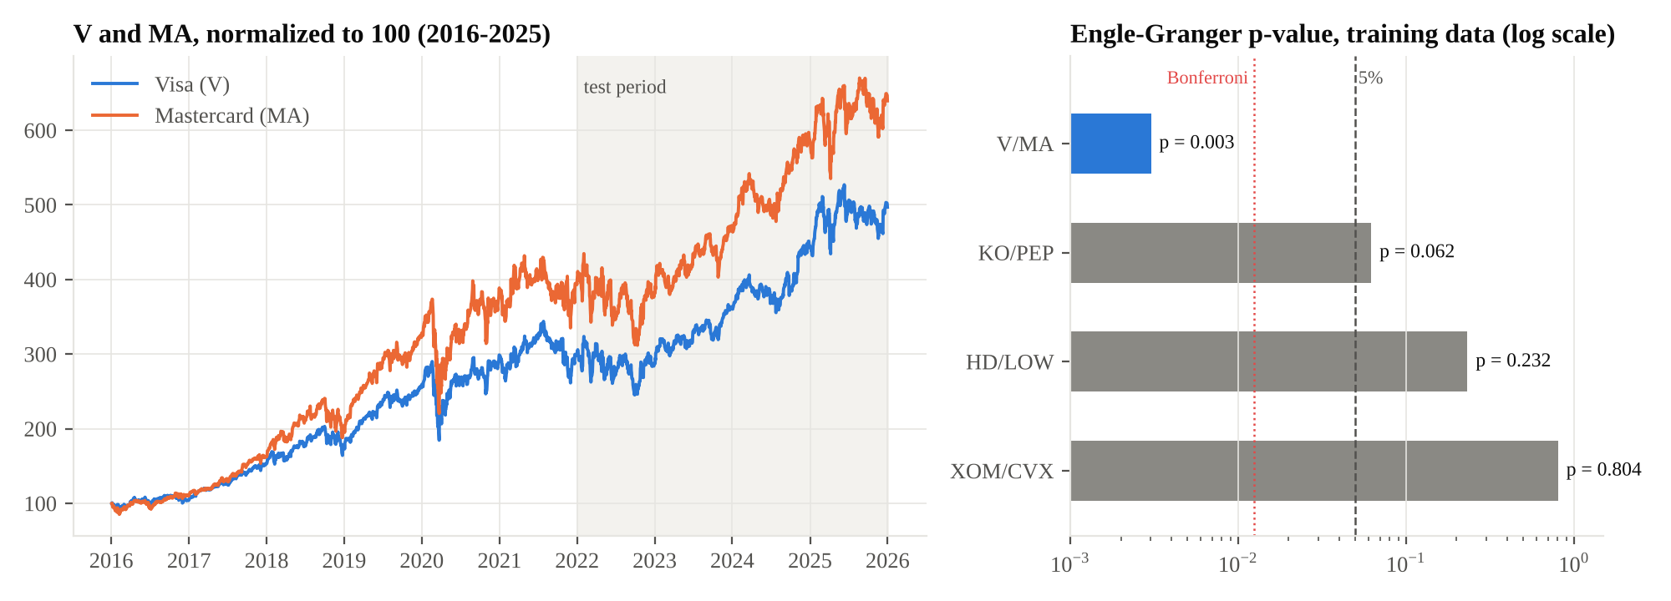
Figure 1. Left: Visa and Mastercard normalized to 100; the shaded region is the test period. Right: Engle–Granger p-values on training data (log scale). Only Visa/Mastercard is below 5%.

4. The static spread and why it broke
Regressing log Mastercard on log Visa over the training period gives
ln MAₜ = −0.8693 + 1.2559 · ln Vₜ + εₜ (1)
and the residual εₜ is the spread. In training it is clearly stationary (augmented Dickey–Fuller p = 0.0006). I standardize it with its training mean and standard deviation to get a z-score, and trade when |z| exceeds 2.
Out of sample, the static relationship did not hold. Mastercard outgrew Visa by more than the training hedge ratio implied, and the static z-score drifted steadily downward, reaching −5.9 in 2025 (Figure 2). The ADF p-value of the static spread over the test period is 0.33: the training spread is no longer stationary. Yet the pair itself remains cointegrated when the hedge ratio is re-estimated on test data (p = 0.007). The relationship survived, but its parameters moved. This is precisely the situation adaptive estimators are meant for.

5. Kalman filter models

5.1 The original specification
The original model treats the intercept and hedge ratio as a hidden state that follows a random walk:
yₜ = αₜ + βₜ xₜ + vₜ, vₜ ~ N(0, R) (2)
θₜ = θₜ₋₁ + wₜ, θₜ = [αₜ, βₜ]ᵀ, wₜ ~ N(0, Q) (3)
with y = ln MA and x = ln V. Each day the filter predicts yₜ from the previous estimate, computes the forecast error eₜ and its variance Sₜ = HₜPₜ|ₜ₋₁Hₜᵀ + R, and updates the state with the Kalman gain. The trading signal was the standardized forecast error zₜ = eₜ/√Sₜ. I set Q = 10⁻⁵·I and set R equal to the variance of the training OLS residual, 0.00102.

5.2 Why it never traded
Over the four test years the original Kalman z never left the range ±1.08; its median absolute value was 0.11. The reason is R. The OLS residual variance measures how far the spread wanders from zero, and that wandering is highly persistent (lag-1 autocorrelation 0.96, standard deviation 0.032). The filter, however, interprets R as independent day-to-day noise. The actual day-to-day forecast errors had a standard deviation of 0.0081, while the filter assumed about 0.042. When R is estimated by maximum likelihood on the same training data it is 5.1 × 10⁻⁶, roughly 200 times smaller than the value used. With R inflated, every forecast error looks small relative to what the filter expects, so nothing ever crosses ±2.
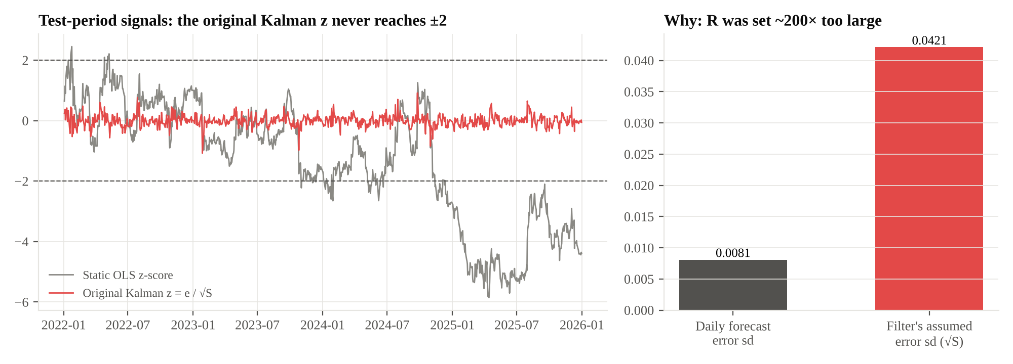
Figure 2. Left: test-period signals. The static OLS z-score (grey) crosses ±2 and later drifts far below it; the original Kalman z (red) never reaches ±2. Right: the standard deviation of the daily forecast errors compared with the error size the filter assumed (√S).
My first report attributed the silence to the filter adapting too aggressively. That intuition points in the right direction, as Section 5.4 shows, but it was not the mechanism behind zero trades. The mechanism was a single mis-set parameter.

5.3 Fix one: estimate the noise by maximum likelihood
Estimating Q = diag(q_α, q_β) and R by maximum likelihood gives q_α = 3.4 × 10⁻⁶, q_β = 1.9 × 10⁻⁶ and R = 5.1 × 10⁻⁶. Two strategies use these estimates. The first trades the standardized innovation exactly as before; it now trades 26 times, but the positions last 1.7 days on average, because innovations of a well-specified filter are close to white noise. The second is the common practitioner approach: use the filter only for the hedge ratio, form the spread yₜ − βₜxₜ, and z-score it against its own trailing 63 days.

5.4 Fix two: the spread as a hidden mean-reverting state
The original model has no place for a tradable spread: anything persistent must go either into the random-walk intercept or into noise. I therefore built a state-space model in which the spread is its own state with its own dynamics:
yₜ = μ + βₜ xₜ + sₜ + εₜ, εₜ ~ N(0, R) (4)
βₜ = βₜ₋₁ + ηₜ, ηₜ ~ N(0, q_β) (5)
sₜ = φ sₜ₋₁ + ζₜ, ζₜ ~ N(0, σ²ₛ) (6)
The filter now separates three things the original model mixed together: slow structural change in the hedge ratio (βₜ), a mean-reverting dislocation that should be traded (sₜ), and daily noise (εₜ). A dislocation's half-life is ln 2 / (−ln φ) days. The signal is the filtered spread sₜ|ₜ divided by its training-period standard deviation. I implemented the model as a custom statsmodels state-space model.
The identification problem. When all five parameters are estimated freely, maximum likelihood chooses φ = 0.26, a half-life of 0.5 days, with q_β = 1.8 × 10⁻⁶. The likelihood scores one-day-ahead forecasts, and over one day a slowly drifting βₜ and a slowly mean-reverting sₜ explain the data almost equally well. Given the choice, the likelihood prefers to let βₜ absorb every persistent deviation. The best-fitting model is the one with nothing left to trade.
I therefore treat q_β, the speed at which the hedge ratio may drift, as a modeling choice. I profile the likelihood over a grid of q_β values, estimating the other parameters at each, and select the value whose strategy has the best Sharpe ratio on the training period. That value is q_β = 10⁻⁶, which gives φ = 0.968 and a half-life of 21.6 days. Figure 3 shows the full trade-off: as q_β rises the likelihood improves monotonically while the spread's half-life collapses from about 340 days to under one.
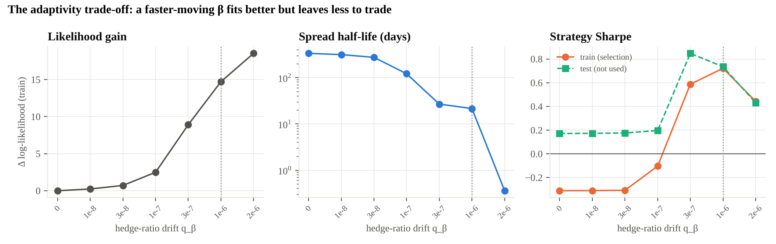
Figure 3. The adaptivity trade-off for the latent-spread model, as a function of the hedge-ratio drift q_β. Left: gain in training log-likelihood. Centre: implied spread half-life (log scale). Right: strategy Sharpe ratio on training data, used for selection, and on test data, shown for reference only. The dotted line marks the selected value.

6. Backtest design
- Entry and exit. Short the spread when z > 2, long when z < −2, and close when z crosses back through zero.
- Sizing. Mastercard weight ±1/(1 + |β|) and Visa weight ∓β/(1 + |β|), so gross exposure is one unit.
- Timing. A position chosen at the close of day t earns the return of day t + 1.
- Costs. 5 basis points per unit of turnover, with a sensitivity analysis from 0 to 20 basis points.
- Uncertainty. 95% confidence intervals for the Sharpe ratio from a stationary block bootstrap (mean block length 21 days, 5,000 resamples).
- Causality checks. An automated test corrupts every price after a cutoff date and confirms that each strategy's signal and hedge ratio before the cutoff are unchanged to within 10⁻¹⁰. A second test confirms the code reproduces the original notebook results exactly.

7. Results
Table 2. Out-of-sample performance, Visa/Mastercard, January 2022 to December 2025, 5 bp costs.
Strategy | Annual return | Sharpe | 95% CI | Max drawdown | Trades | Hit rate
Static OLS | 1.45% | 0.37 | [−0.47, 1.13] | −5.5% | 4 | 75%
Rolling OLS (126-day) | 3.12% | 0.67 | [−0.08, 1.49] | −5.3% | 13 | 85%
Kalman, original specification | 0.00% | — | — | 0.0% | 0 | —
Kalman, MLE noise (innovations) | 0.92% | 0.60 | [−0.22, 1.22] | −1.2% | 26 | 81%
Kalman β + rolling 63-day z | 2.14% | 0.60 | [−0.35, 1.56] | −4.1% | 33 | 70%
Latent-spread state space | 1.59% | 0.73 | [0.15, 1.28] | −1.7% | 3 | 3 of 3
The first three rows reproduce the original study. With only three trades the latent model's effective sample size is three, so a bootstrap over days understates its uncertainty; three wins in three trades would occur 12.5% of the time by chance.
Rolling OLS earned the highest return; the latent-spread model had the highest Sharpe ratio and by far the smallest drawdown, because it was in the market only 10% of the time. The two practical Kalman strategies sit between static and rolling OLS. None of these differences is statistically meaningful: the confidence intervals overlap almost completely (Figure 7).
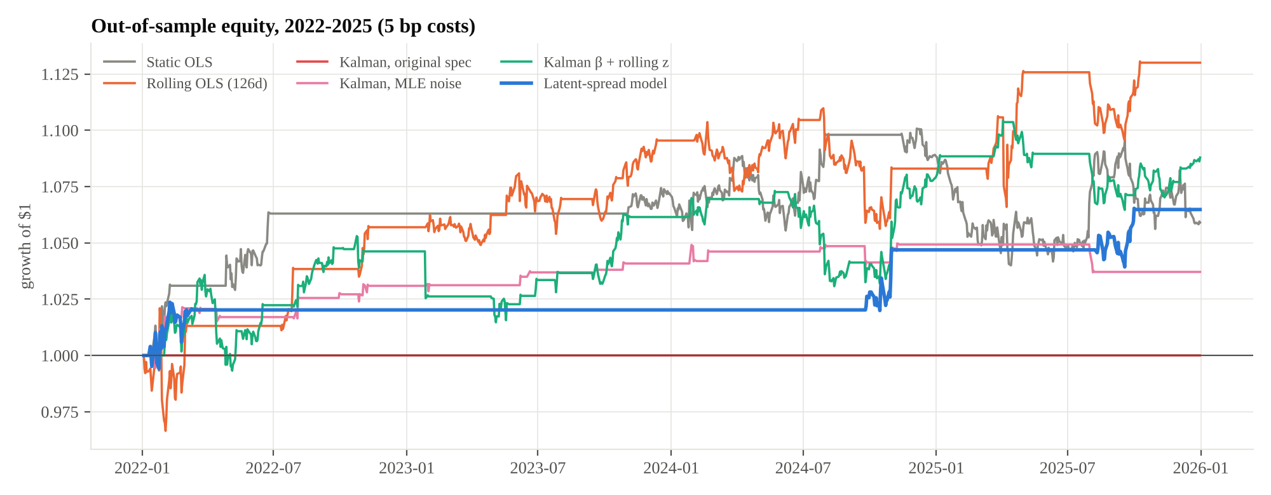
Figure 4. Growth of $1 for each strategy over the test period, net of 5 bp costs.
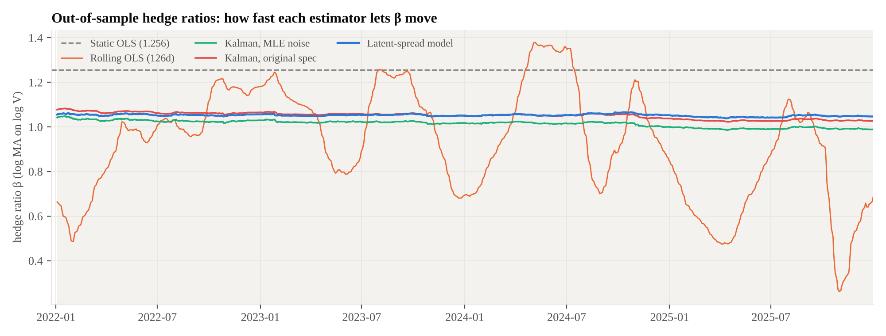
Figure 5. Out-of-sample hedge ratios. Rolling OLS swings between 0.26 and 1.38; the Kalman-based estimates stay between about 0.99 and 1.08. The static estimate (1.256) sits above all of them, which is why the static spread drifted.
Figure 5 explains much of the ranking. The 126-day rolling regression reacts violently, and its hedge ratio swings by a factor of five. The filters move far more slowly. A fast hedge ratio keeps the spread centred but injects noise into the position sizes; a slow one keeps the positions stable but lets the spread drift. Rolling OLS happened to profit from its swings over this period, but the same mechanism produced losses on the other pairs (Section 7.2).
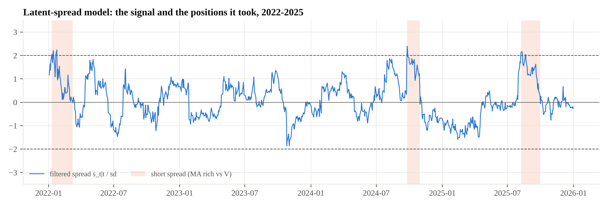
Figure 6. Latent-spread model: the standardized filtered spread and its three trades. All three were short-spread trades, entered when Mastercard looked expensive relative to Visa.
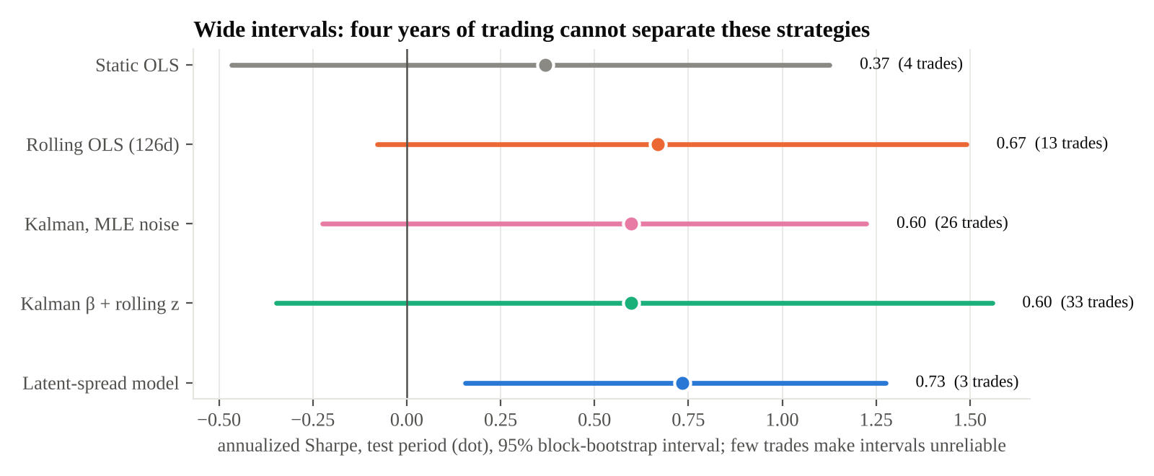
Figure 7. Test-period Sharpe ratios with 95% block-bootstrap intervals. The intervals overlap almost completely; the latent model's interval is narrow only because it rests on three trades.

7.1 Sensitivity to the entry threshold and costs
Table 3. Test-period Sharpe ratio by entry threshold and transaction cost (basis points per unit of turnover).
Strategy | z = 1.5, 5 bp | z = 2.0, 0 bp | z = 2.0, 5 bp | z = 2.0, 20 bp | z = 2.5, 5 bp
Static OLS | 0.55 | 0.39 | 0.37 | 0.31 | 0.07
Rolling OLS | 0.66 | 0.75 | 0.67 | 0.44 | 0.80
Kalman, MLE noise (innovations) | −0.05 | 1.02 | 0.60 | −0.62 | 0.05
Kalman β + rolling z | 0.34 | 0.82 | 0.60 | −0.07 | 0.46
Latent-spread state space | 0.53 | 0.77 | 0.73 | 0.63 | no trades

Trading raw Kalman innovations is the most fragile choice: its Sharpe ratio falls from 1.02 with no costs to −0.62 at 20 basis points, because it trades often and holds briefly. The latent model is nearly insensitive to costs but stops trading entirely at a 2.5 threshold. Rolling OLS is positive in every configuration I tried.

7.2 Generalization to the other pairs
As a check on whether any method works beyond a single pair, I ran all six strategies on the three pairs that failed the cointegration screen. On Coca-Cola/PepsiCo every strategy that traded lost money, and on Home Depot/Lowe's the results were small and mixed. Rolling OLS earned 5.7% a year on ExxonMobil/Chevron but lost 3.6–3.8% a year on the other two. The original Kalman specification made no trades on any pair, consistent with the diagnosis in Section 5.2. The main lesson is that the cointegration screen did its job: without a stable long-run relationship, no hedge-ratio method rescued the trade.
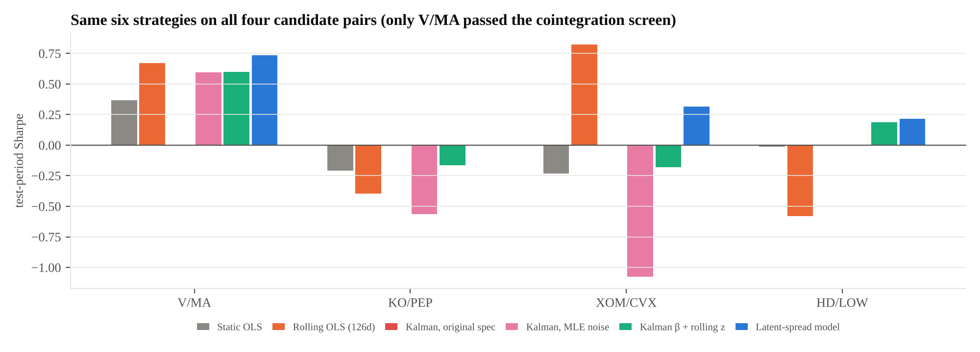
Figure 8. Test-period Sharpe ratio of the six strategies on all four candidate pairs. Missing bars are strategies that made no trades.

8. Discussion
The original hypothesis, that a Kalman filter would improve risk-adjusted performance, is not supported. The original specification never traded. The corrected specifications performed comparably to rolling OLS, without being distinguishable from it statistically. The more useful finding is the mechanism.
Adaptivity is a dial, not a free improvement. Every adaptive estimator splits each day's surprise between the relationship and the spread. The more it gives to the relationship, the better it forecasts tomorrow's price and the less there is to trade. Maximum likelihood turns the dial all the way toward forecasting, because one-day forecast accuracy is what it measures. A trader cares about something else: whether a deviation will close over the next few weeks. That objective has to be imposed through the model's structure or chosen deliberately, as I did with q_β. It will not emerge from the likelihood on its own.
Parameter choices are not details. A single number, R, decided whether the original strategy traded at all, and a sensible-looking default was wrong by a factor of 200. Checking that a model's assumed error size matches its realized error size is cheap, and it would have caught the problem immediately.
A static hedge ratio is a bet that nothing changes. The static spread drifted to almost six standard deviations below its training mean because the relationship's parameters moved, even though the pair stayed cointegrated. Some form of updating is necessary; the question is how fast.

9. Limitations
- Sample size. Four test years and between 3 and 33 round trips per strategy are too few to separate Sharpe ratios of this size.
- One pair. Only Visa/Mastercard passed the screen, so the main comparison rests on a single relationship.
- Selection of q_β. The hedge-ratio drift was chosen by training-period Sharpe using in-sample filtered states. The test period was not used, but this is still a form of optimization.
- Execution. Trades occur at closing prices with a flat cost; borrow fees, market impact and intraday execution are ignored.
- No regime check. None of the strategies stops trading if cointegration breaks down out of sample.

10. Conclusion
A Kalman filter did not improve this pairs trade, but the reasons are instructive. The original strategy was silenced by a noise variance 200 times too large. Once that was corrected, the likelihood itself preferred a model that adapts away the signal, because a drifting hedge ratio and a mean-reverting spread are nearly indistinguishable one day ahead. Constraining the hedge ratio's drift, chosen on training data, produced a model that trades rarely and well, with the best Sharpe ratio and smallest drawdown of the strategies tested. Three trades are not evidence, though, and four years of data cannot rank these approaches.
The natural next steps are a longer history or a universe of many pairs, to obtain enough trades for statistical power; an explicit test for cointegration breakdown that halts trading; and choosing the hedge-ratio drift through a multi-day forecasting objective instead of a backtested Sharpe ratio.

Appendix: estimated parameters
Table 4. Parameter estimates on the training period.
Model | Parameter | Estimate
Static OLS | α, β | −0.8693, 1.2559
Kalman, original | Q, R | 10⁻⁵·I (set), 1.02 × 10⁻³ (set)
Kalman, MLE | q_α, q_β, R | 3.42 × 10⁻⁶, 1.86 × 10⁻⁶, 5.05 × 10⁻⁶
Latent spread, free MLE | φ, half-life, q_β | 0.265, 0.5 days, 1.83 × 10⁻⁶
Latent spread, selected | q_β (chosen), φ, half-life | 10⁻⁶, 0.968, 21.6 days
Latent spread, selected | σ²ₛ, R, μ | 2.15 × 10⁻⁵, 6.07 × 10⁻⁶, 0.215

All results in this report are produced by scripts/run_all.py in the repository; the numbers in every table are written to results/tables/ and results/summary.json.

