Introduction
Pairs trading is a statistical trading strategy that seeks to profit from temporary deviations between two financial assets with a historically stable relationship. Because market conditions and asset relationships change over time, a fixed hedge ratio estimated through static OLS may fail to reflect the pair’s current equilibrium. A Kalman filter offers an adaptive alternative by continuously updating the estimated hedge ratio as new market observations become available.

Research Question & Hypothesis
This study investigates whether a Kalman-filter-based, time-varying hedge ratio can improve the out-of-sample risk-adjusted performance of a pairs-trading strategy relative to static and rolling OLS approaches. The hypothesis is that dynamically adapting to changes in the relationship between the assets may produce more informative spread estimates and trading signals. The null hypothesis is that the Kalman filter provides no meaningful performance improvement, while the alternative hypothesis is that it improves risk-adjusted performance through higher returns, lower risk, or both.

Data and Asset Selection
The initial analysis uses four pairs of financially related companies: KO and PEP, V and MA, XOM and CVX, and HD and LOW, using daily adjusted closing prices from 2016 through 2025. The prices are normalized to 100 so that their relative movements can be compared even though the stocks trade at different price levels. From the graphs, HD and LOW appear to move together most closely, especially from 2019 through 2022, although they begin to separate more noticeably again in 2024 and 2025.
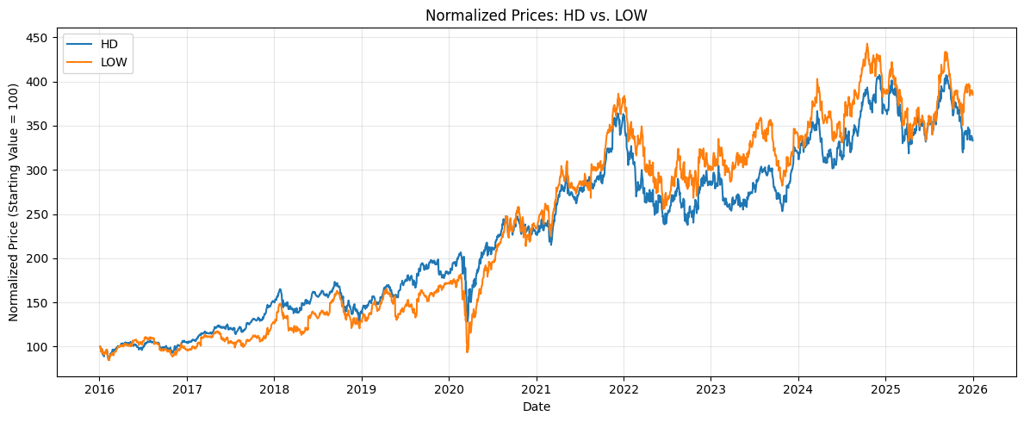
KO and PEP also show similar movement for much of the sample, but PEP pulls well ahead from roughly 2021 through 2024 before the gap narrows.
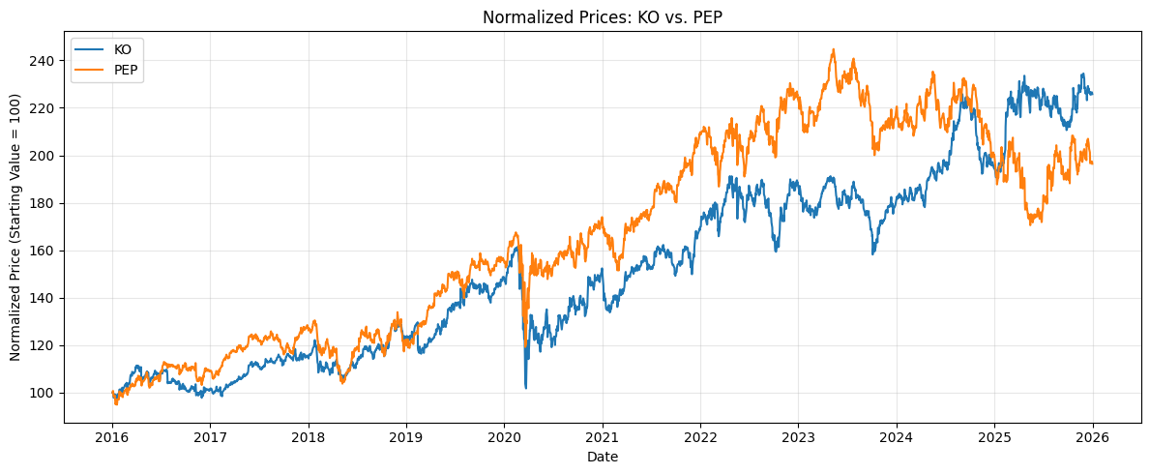
XOM and CVX both react sharply around 2020 and rise strongly after 2021, but CVX remains above XOM for long stretches, while V and MA show the clearest long term divergence as MA increasingly outpaces V after about 2018.
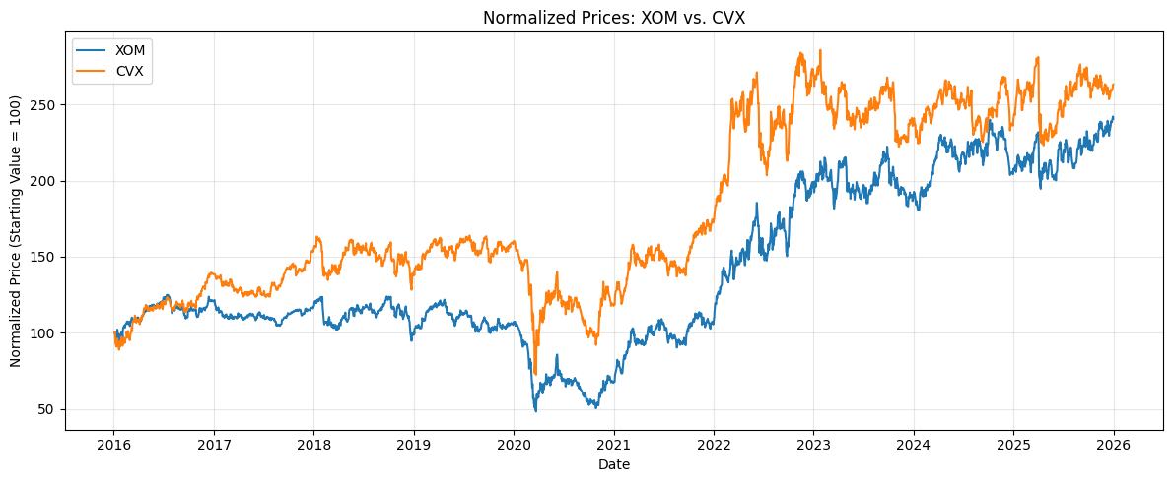
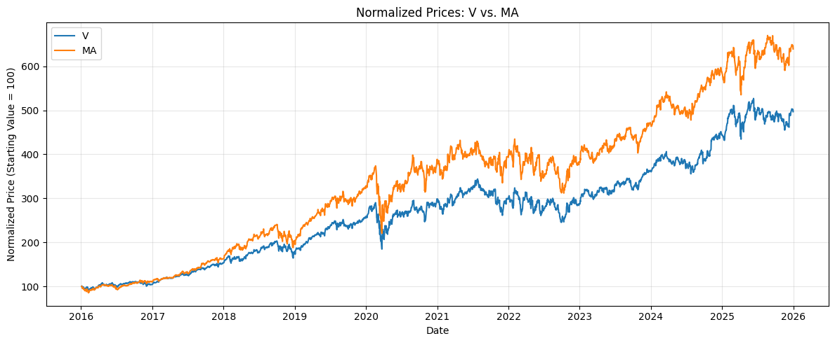
Based on visual inspection alone, HD and LOW appear to be the strongest candidates, but correlation and cointegration tests are needed before selecting a pair for the strategy.

Correlation and Cointegration Analysis
To compare how closely each pair moved on a day to day basis, I calculated daily log returns using
$$r_{t }= ln\left(\frac{P_{t}}{P_{t-1}}\right)$$
where Pt is the current adjusted closing price and Pt−1 is the previous trading day’s price. Correlation was then used to measure how similarly the two assets’ daily returns moved, with values closer to 1 indicating stronger positive co movement. However, correlation only tells us whether two assets tend to move together in the short run; it does not tell us whether their price relationship stays tied to a stable long run equilibrium. Cointegration addresses that second question by testing whether a linear combination of the two price series remains stationary, meaning the relationship tends to return toward a stable level rather than drift apart indefinitely.
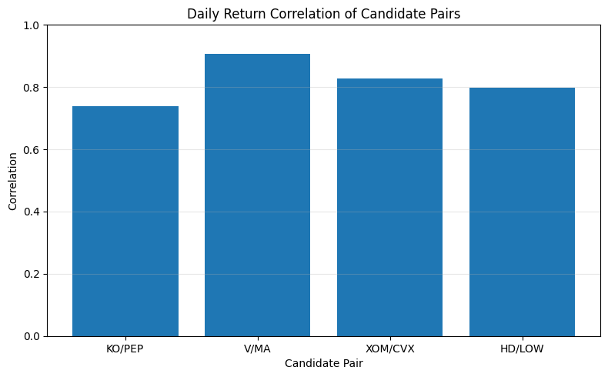
During the 2016 to 2021 training period, V and MA had the highest daily return correlation at approximately ρ ≈ 0.91, followed by XOM and CVX at about 0.83, HD and LOW at 0.80, and KO and PEP at 0.74. I then applied the Engle Granger cointegration test, where
H0: The two price series are not cointegrated.
Using a significance level of
$$α = 0.05$$
V and MA were the only pair with p < 0.05, so the null hypothesis was rejected for that pair and the results provided evidence of cointegration. The other three pairs failed to reject H0. This distinction is important because HD and LOW looked especially similar in the normalized price graph, but V and MA were the only pair that combined strong daily return correlation with statistical evidence of a stable long run relationship. For that reason, V and MA were selected for the remainder of the analysis.
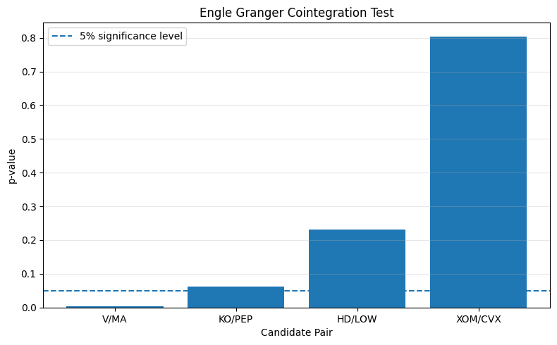

OLS and Spread Construction
A static OLS regression was used to estimate the long run relationship between Visa and Mastercard during the 2016 to 2021 training period. Using log prices, the model is
ln(MAₜ) = α + β ln(Vₜ) + εₜ
where α is the intercept, β measures the estimated relationship between the two log price series, and εₜ represents the portion of Mastercard's price that is not explained by the fitted relationship with Visa. The estimated coefficients were α = −0.8693 and β = 1.2559, giving
ln(MAₜ) = −0.8693 + 1.2559 ln(Vₜ) + εₜ
The scatterplot shows that the observations remain closely concentrated around the fitted OLS line, supporting a strong linear relationship between the two assets during the training period.
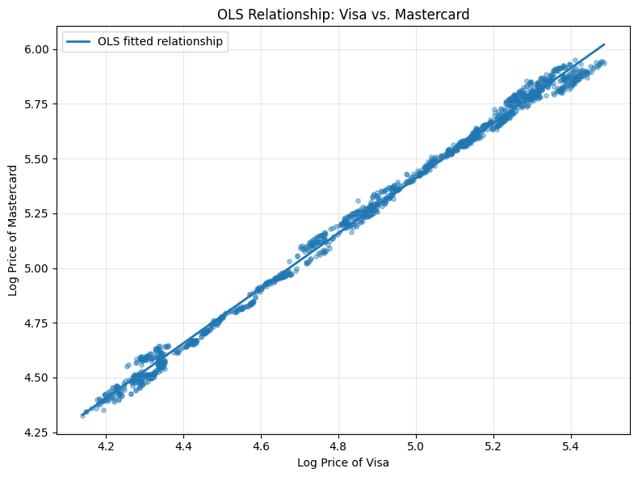
The residual from the regression was then treated as the spread:
Spreadₜ = ln(MAₜ) − [−0.8693 + 1.2559 ln(Vₜ)]
A positive spread means Mastercard is trading above the level implied by its historical relationship with Visa, while a negative spread means it is below that estimated equilibrium. The spread repeatedly moves above and below its mean near zero rather than consistently drifting in one direction. For example, it rose sharply above 0.075 around late 2016 and early 2017, while a prolonged negative deviation occurred during 2021 before the spread rapidly returned toward zero near the end of the year.
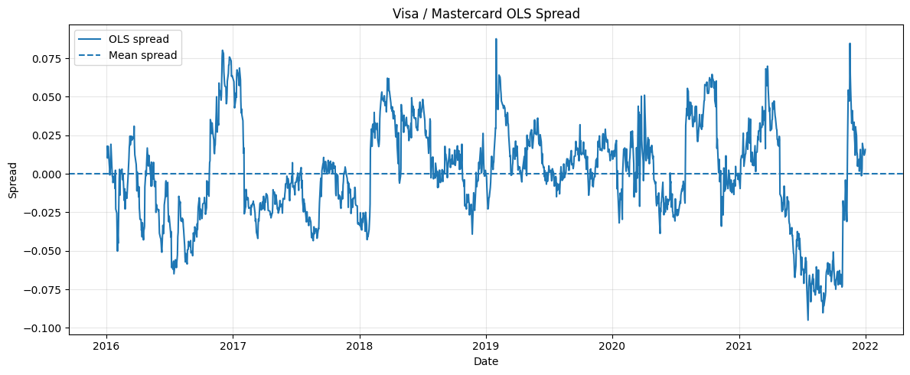
To test whether this apparent mean reversion was statistically supported, an Augmented Dickey Fuller test was applied to the spread. The test evaluates
H₀: The spread is nonstationary and contains a unit root.
H₁: The spread is stationary.
The resulting ADF statistic was −4.2349 with p = 0.0006. Since p < 0.05, the null hypothesis is rejected, providing strong evidence that the estimated spread was stationary during the training period. This supports the use of mean reversion as the basis for the pairs trading strategy.
Finally, the spread was standardized into a z score:
zₜ = (Spreadₜ − μₛ) / σₛ
where μₛ and σₛ are the training period mean and standard deviation of the spread. This allows deviations to be interpreted relative to their historical size. Values above z = +2 or below z = −2 represent unusually large deviations from equilibrium. The graph shows several such events, including positive deviations around early 2017 and 2019 and a prolonged negative deviation below −2 during 2021. These extreme observations will later form the basis for potential trading signals.
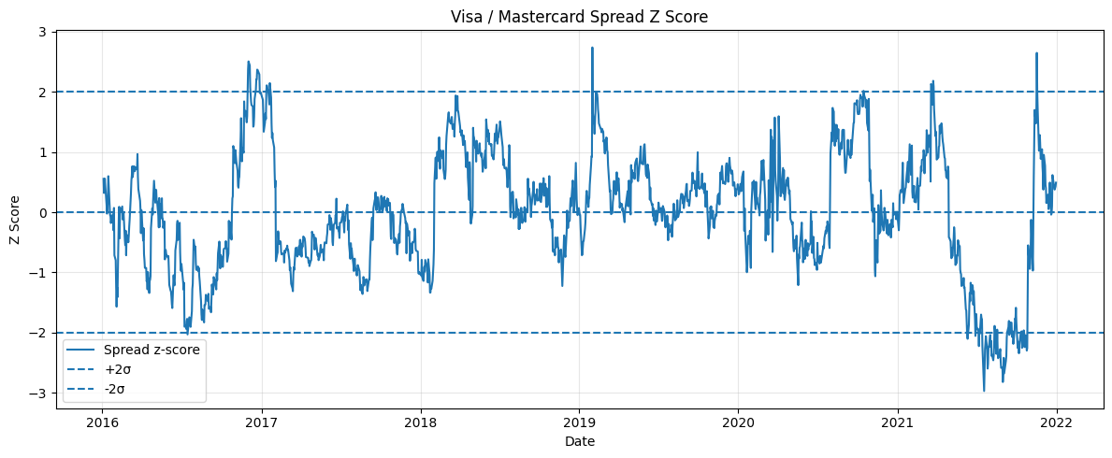

Kalman Filter Model
The Kalman filter extends the static OLS model by allowing the relationship between Visa and Mastercard to change over time. Instead of using one fixed hedge coefficient, the hidden state is:
θₜ = [ αₜ, βₜ ]ᵀ
where αₜ is the time varying intercept and βₜ is the time varying relationship coefficient.
The observation equation is:
yₜ = αₜ + βₜxₜ + vₜ
and the relationship is allowed to evolve through time according to:
θₜ = θₜ₋₁ + wₜ
Each day, the filter first predicts the current relationship using the previous estimate:
θ̂ₜ|ₜ₋₁ = θ̂ₜ₋₁|ₜ₋₁
It then calculates the prediction error:
eₜ = yₜ − ŷₜ|ₜ₋₁
The Kalman gain determines how strongly the new observation should change the previous estimate:
Kₜ = Pₜ|ₜ₋₁Hₜᵀ(HₜPₜ|ₜ₋₁Hₜᵀ + R)⁻¹
The filter then updates its estimate of αₜ and βₜ:
θ̂ₜ|ₜ = θ̂ₜ|ₜ₋₁ + Kₜeₜ
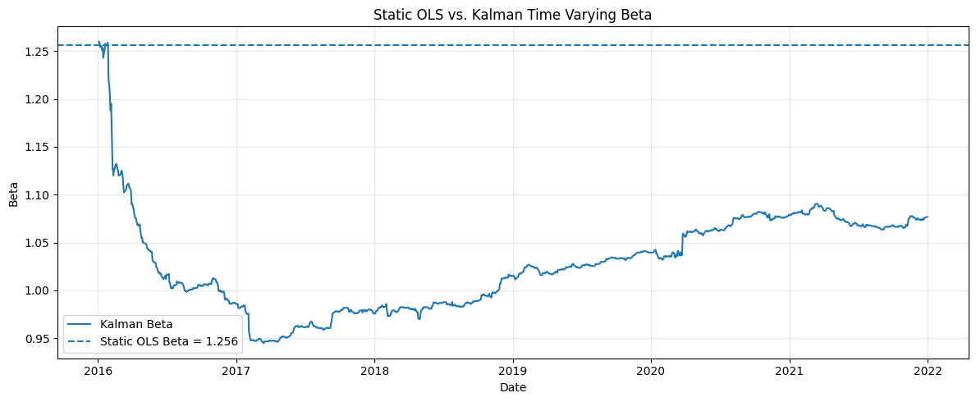
While static OLS holds β = 1.2559 constant, the Kalman estimate ranged from 0.9448 to 1.2599 and finished at 1.0767. This shows that the estimated relationship between Visa and Mastercard changed substantially during the training period rather than remaining fixed.
The prediction error is standardized using:
zₜ = eₜ / √Sₜ
where Sₜ represents the Kalman filter’s estimated variance of the prediction error.
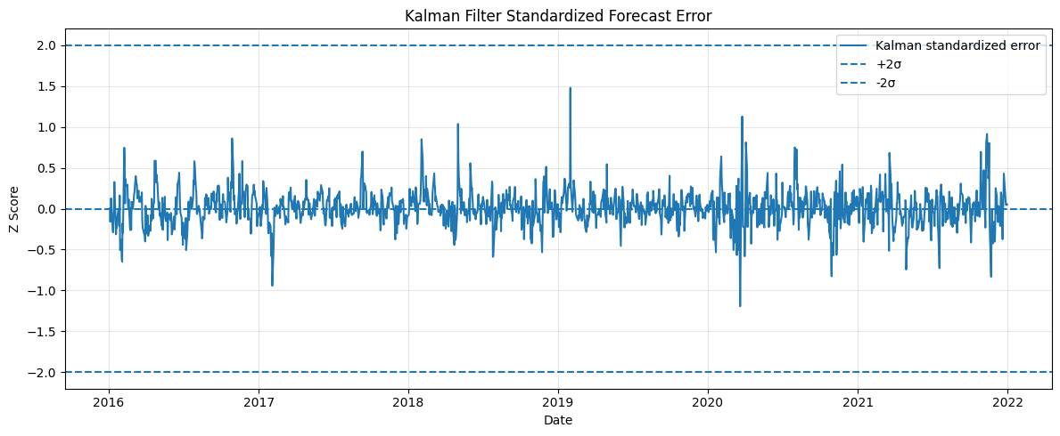
Most standardized errors remained close to zero and did not cross the ±2 thresholds. This suggests that the Kalman filter adapted to changes in the relationship quickly enough that many deviations considered large under static OLS were no longer considered extreme. The next step is to test whether this adaptability actually improves out of sample trading performance.

Backtest and Results
The three strategies were evaluated on the untouched 2022 to 2025 test period. A trading position was opened when the standardized spread crossed the entry threshold,
zₜ > 2 → short the spread
zₜ < −2 → long the spread
and was closed once the spread returned toward zₜ = 0. Signals were shifted forward by one trading day to avoid look ahead bias, and a transaction cost of 5 basis points per unit of turnover was included.
The rolling OLS strategy produced the strongest out of sample results, with an annualized return of 3.12%, a Sharpe ratio of 0.67, and a maximum drawdown of −5.33%. Static OLS produced a lower annualized return of 1.45% and Sharpe ratio of 0.37, with a similar maximum drawdown of −5.52%. Rolling OLS traded more frequently, generating 13 trades and turnover of 28.16 compared with only 4 trades and turnover of 7.00 for static OLS.
The Kalman filter generated no trades because its standardized forecast error never crossed the ±2 entry thresholds. As a result, its return and drawdown were 0, while its Sharpe ratio was undefined. This does not necessarily mean the Kalman filter failed; rather, under the current model parameters and trading rule, the filter adapted quickly enough that deviations were not considered sufficiently extreme to trigger a position.
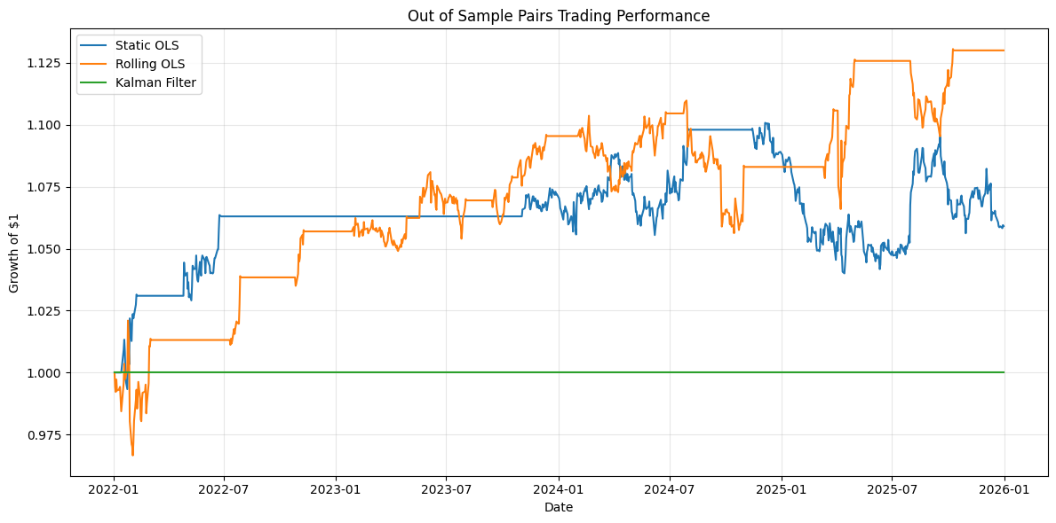
Overall, rolling OLS performed best in this experiment. The result does not support the original hypothesis that the Kalman filter would improve risk adjusted performance under the chosen specification. Instead, it highlights an important tradeoff: a model can adapt so aggressively to changing relationships that it removes the very deviations a mean reversion strategy is designed to trade.
Key Results

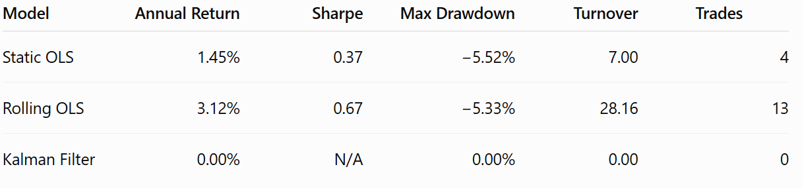

Conclusion
This study compared static OLS, rolling OLS, and a Kalman filter for estimating the relationship between Visa and Mastercard in a pairs trading framework. The results showed that rolling OLS produced the strongest out of sample performance, while the Kalman filter generated no trades under the chosen parameters because its adaptive estimates kept standardized deviations within the ±2 entry thresholds. Therefore, the original hypothesis was not supported in this experiment. The findings suggest that greater model adaptability does not automatically improve trading performance and that the responsiveness of the Kalman filter, along with its trading thresholds and parameter choices, plays a critical role in whether useful mean reversion signals are preserved.

