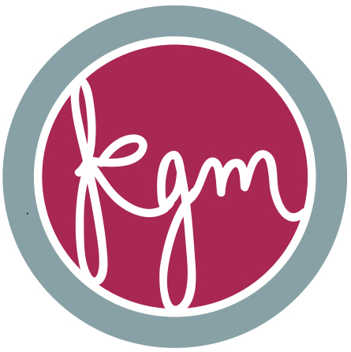EDUCATION

**University of Connecticut,** Storrs CT

Bachelor of Science, Individualized Major: Human-Computer Interaction June 2015

GPA: 3.7

*Relevant Coursework: Graduate Seminars in Biology/Neuroscience; Research Methods, Computer Engineering/Programming; Digital Logic Design, Web Design & Advanced Web Design, Human-Factors Design, Statistics; Internships involving research in Cognitive Science and Media Development*

CAREER INTEREST: Seeking job opportunity in web development and user-interface design

RESEARCH AND WORK EXPERIENCE

**Tyler Technologies,** Portland ME

* Worked on MUNIS Financial’s development team and individually redesigned six major programs for client efficiency
* In team of two, designed and developed a responsive new software for use in the public sector
* Presented weekly on new designs and development strategies for company-wide implementation

**Human Factors Design Presentation,** Storrs CT

*Web Interface Redesign for UCONN’S Academic Student Center, College of Liberal Arts and Sciences* May 2014

* Led a group project for redesigning marketing strategy
* Singlehandedly researched student users using standard UX practices, & analyzed and implemented results in a sitemap and web interface redesign for one of UCONN’s major academic centers.

**UConn Outdoors,** Storrs CT 2012 - Current

*Senior Trip Leader & Peer Coordinator*

* Lead Outdoor trips for peers in Whitewater Kayaking, Mountain Biking, Ice Climbing, Backpacking, Cross-Country Skiing, Rock Climbing, etc.
* Responsible for maintaining the program and the planning and completion of UCONN Outdoors events. (I organize and schedule all trips and events as event coordinator, as well as train and manage my peer workers)
* Media Design Specialist- Develop all logos and promotional materials for this division of UCONN Recreation. Edit, expand, and maintain the recreation department website.

**Oschner Lab: Columbia University,** New York City, NY Summer 2013

* Singlehandedly developed and maintained website for Oschner lab
* Expanded social media for the school research institute by designing permanent logo for the laboratory, and the logos and advertisements for individual experiments
* Scored and analyzed multiple year’s worth of participant data
* Ran participants for fMRI emotion study

**Graduate Seminar in Neuroscience Presentations,** Storrs CTMarch 2013 & May 2013

* Presented on higher level coursework at intervals during the semester as the only undergraduate

**“First Impressions” Group Research Team Presentation** May 2013

* Designed and implemented experiment on human behavior for research methods course, which cumulated in a thesis and final presentation

**Myers Lab Research Presentation,** Storrs CTApril 2012 & September 2012

* Presented analysis of relevant research study to lab work and personal results/research

**Myers Lab,** Storrs CT 2012 - 2013

*Undergraduate Research Assistant, Digital MRI Data Analyzer*

* Mapped brain lesions in individuals with aphasia using Mricron software
* Ran participants in learning consolidation study
* Expanded field knowledge with weekly research study presentations
* Participated in studies investigating phonological mapping, memory and recollection, EEG/ERP

**Honors Holster Project Presentation,** Storrs CT 2012

* Spoke regarding the bases, results, and implications of my summer research

**Holster Scholarship Research Project,** Storrs CT 2012

*Conducted Individual Research Project*

* Investigated language therapy benefits for individuals with aphasia
* Measured conversational analysis as a tool for gauging change
* Tested effectiveness of constraint-induced language therapy

**Darlene’s,** Old Greenwich, CT 2011 - 2012

* Worked in Customer Service, Cashiering, Inventory Managing,

Party Organizing, Design Coordinating

**International Baccalaureate Honors Thesis,** Palo Alto CA 2010 - 2011

* Individual research project investigating psychology of artist Auguste Rodin at Stanford University

HONORS & AWARDS

Named UCONN Outdoors’ Most Valuable Employee 2014

Named UCONN Outdoors’ Senior Manager and Trip Coordinator 2013

Most Valuable UCONN Outdoors Adventure Center Employee 2013

Dean’s List, University of Connecticut 2011- Current

Recipient of UCONN Honors Holster Scholarship 2011

Recipient of University of Connecticut Leadership Award 2011- 2014

Sequoia HS Salutatorian 2011

SERVICE & COMMITTEES

University of Connecticut Global Leadership Initiative 2012 - Current

University of Connecticut Honors Council 2010 - Current

Honors Student Speaker Selection Committee 2013

UConn Holster Scholarship Mentor 2012 - 2013

University of Connecticut Honors Initiatives for Prospective Students 2011 - 2013

ATHLETICS & ACTIVITES

Digital Media Design Club *Member* 2013 - Current

Cycling Team, Mountain and Road *Member*  2012 - Current

USA Cycling *Member* 2012 – Current

Water Polo Club *Treasurer and Co-Founder*  2012 - 2014

Swim Club *Member*  2010 – 2012

Computer Skills*: iWork; Microsoft Office; SPSS; Minitab; Java; MRIcron; MATLAB; HTML5; CSS3; JavaScript, JQuery, Balsamiq Mockups; Mockflow; Visio; Omnigraffle; SublimeText2; Visual Studio; Adobe Products: Dreamweaver, Illustrator, InDesign, Photoshop, Fireworks; Familiar with Windows and Mac OSX; Familiar with Bootstrap, Angular, and Genero.*