Introduction

To visualizing the trends in COVID-19 cases and deaths over time, identifying hotspots, and assessing the effectiveness of public health measures.

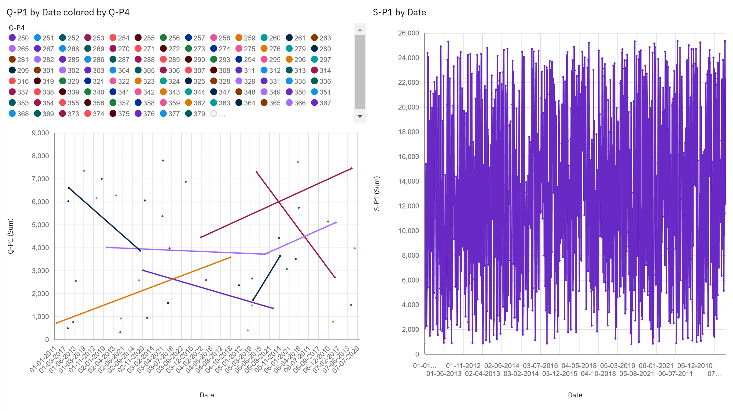



Procedure:

* Obtain a reliable and up-to date COVID-19 cases and deaths.
* Load the raw data into your preferred data analysis tool, such as IBM cognos.
* Ensure data consistency and uniformty by standardizing data types and formats.
* If the data set contains geographic information, you might need to aggregate or disaggregate the data to the desire level.
* Time series data should be organized into a chronological order to facilitate temporal analysis.
* Analysis how public health measure,vaccination campaigns, and other factors have influenced the trajectory of COVID-19 cases and deaths.

Visualization:

* A line chart showing the daily or weekly COVID-19 cases and death over time.
* A heat map displaying the intensity of cases in different geographic regions.
* A bar chart comparing cases and death across age groups or genders.
* A choropleth map illustrating COVID-19 incidence by state or country.
* A dashboard that combines varies visualizations to provide a comprehensive view of the data.