,

|  |  |  |
| --- | --- | --- |
| Project: COVID-19 Data Analysis using  IBM Cognos Team member  962221106064 - M Kailas Phase1 document submission  Problem Statement  The project aims to analyze COVID-19 cases and deaths data within the European Union and European Economic Area (EU/EEA). Specifically, the goal is to compare and contrast the mean values and standard deviations of daily COVID-19 cases and associated deaths across different countries in the EU/EEA. This analysis will provide insights into the variation of COVID-19 spread and its impact on mortality within this region.  Understanding the Problem  To successfully accomplish this project, we need to: | | |
|  | 1. Define Analysis Objectives: | |
|  | | * Calculate and compare mean values of daily COVID-19 cases and deaths. * Determine the standard deviations to understand the data variability. * Visualize the data for easy interpretation and communication of insights. |
|  | 2. Collect COVID-19 Data: | |
|  | | * Identify reliable sources for daily COVID-19 cases and deaths data for EU/EEA countries. * Ensure data integrity and consistency by verifying sources. |
|  | 3. Design Relevant Visualizations in IBM Cognos: | |
|  | | * Create appropriate charts and graphs to represent the data. * Choose visualization types that best convey the key insights. * Ensure that visualizations are user-friendly and insightful. |
|  | 4. Derive Insights from the Data: | |
|  | | * Analyze the visualized data to identify trends and patterns. * Highlight variations in COVID-19 cases and deaths. * Identify potential factors contributing to these variations. |

|  |  |  |
| --- | --- | --- |
| Proposed Approach  Data Collection and Preparation: | | |
|  | * Identify reputable sources such as official health organizations, government reports, or APIs for daily COVID-19 data. * Gather data for all EU/EEA countries, ensuring consistency and completeness. * Clean and preprocess the data, handling missing values and outliers. | |
| Analysis in IBM Cognos: | | |
|  | * Import the cleaned data into IBM Cognos for analysis. * Create datasets and data modules to facilitate analysis. * Design relevant visualizations, including line charts, bar charts, and heatmaps. * Use calculated fields or measures to compute mean values and standard deviations. | |
| Comparative Analysis: | | |
|  | * Compare and contrast mean daily COVID-19 cases and deaths across EU/EEA countries. * Use visualizations to highlight variations and trends. * Consider additional factors such as vaccination rates, population density, and healthcare   infrastructure for context. | |
| Deriving Insights: | | |
|  | * Interpret the visualized data to derive meaningful insights. * Identify countries with high and low variations in COVID-19 cases and deaths. * Investigate potential reasons for these variations, considering regional differences and   public health measures. | |
| Documentation and Reporting: | | |
|  | * Prepare a comprehensive report summarizing the analysis. * Include visualizations, insights, and recommendations. * Ensure the report is clear and accessible to stakeholders. | |
|  | | Graph: |

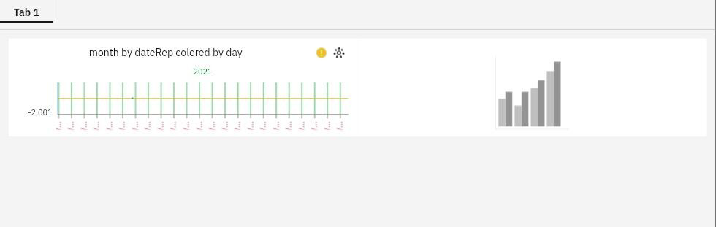

Conclusion

Thisdocumentoutlinestheproblemstatement,understanding,andproposedapproachfor the project involving COVID-19 data analysis using IBM Cognos within the EU/EEA.ThesuccessfulexecutionofthisprojectwillprovidevaluableinsightsintotheCOVID-19situationintheregion,aidingindecision-makingandpublichealthefforts.

Feel free to expand or modify this document based on your specific projectrequirementsandavailableresources.Ifyouhaveanyadditionaldetailsorquestions,pleaselet meknow, andI'llbehappytoassist further.

This document outlines the problem statement, understanding, and proposed approach for the

project involving COVID-19 data analysis using IBM Cognos within the EU/EEA. The successful execution of this project will provide valuable insights into the COVID-19 situation in the region, aiding in decision-making and public health efforts.