F5 AUTOMATION WITH ANSIBLE
Implementation & Demo Guide
Automated creation of F5 LTM Health Monitor, Pool, Pool Members and HTTPS Virtual Server
Prepared by | Kailas Pathade
Mobile | 7777050805
Email | kailasdreams@gmail.com
Demo Scope | Ansible Automation Platform / AWX + F5 BIG-IP LTM

Professional Demo Document

1. Demo Objective
This demo shows how Ansible can automate common F5 BIG-IP LTM configuration tasks through the F5 Networks Ansible collection. The workflow creates an HTTPS health monitor, an application pool, two pool members, and an HTTPS virtual server.

2. Automation Flow
Step | Component | Purpose
1 | Ansible / AWX Project | Project contains the F5 automation playbook and supporting files.
2 | Inventory | Defines the F5 BIG-IP target used by the automation job.
3 | Credential | Stores the F5 connection credentials used by the job template.
4 | Job Template | Connects the project, inventory and credential into a repeatable job.
5 | Playbook Execution | Creates the monitor, pool, members and virtual server.
6 | Validation | Successful job output confirms the configuration tasks completed.

1. F5 Inventory
Description: This screen shows the Ansible inventory used for the F5 automation project. The inventory provides the target F5 device that the automation job will manage.
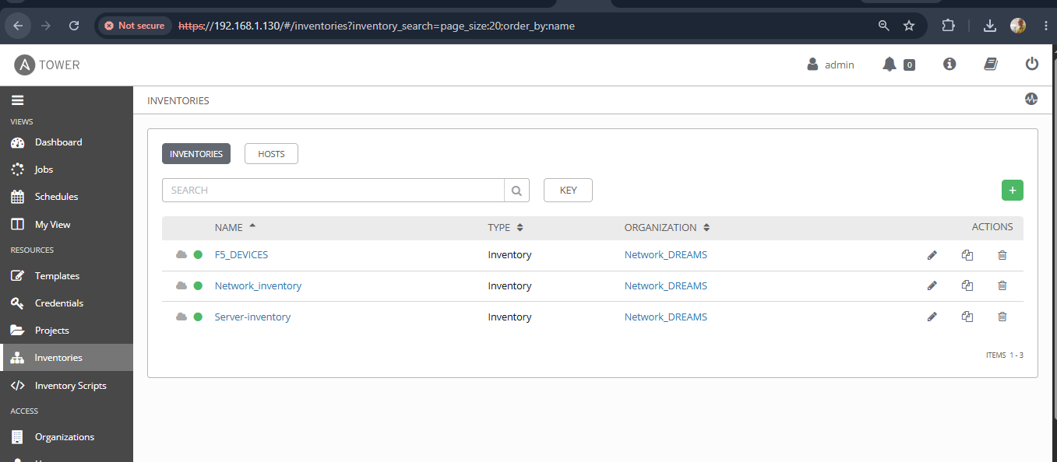

2. F5 Host Variables
Description: This screen shows the F5 host entry and its connection variables. The host is associated with the F5 management address used by the playbook.
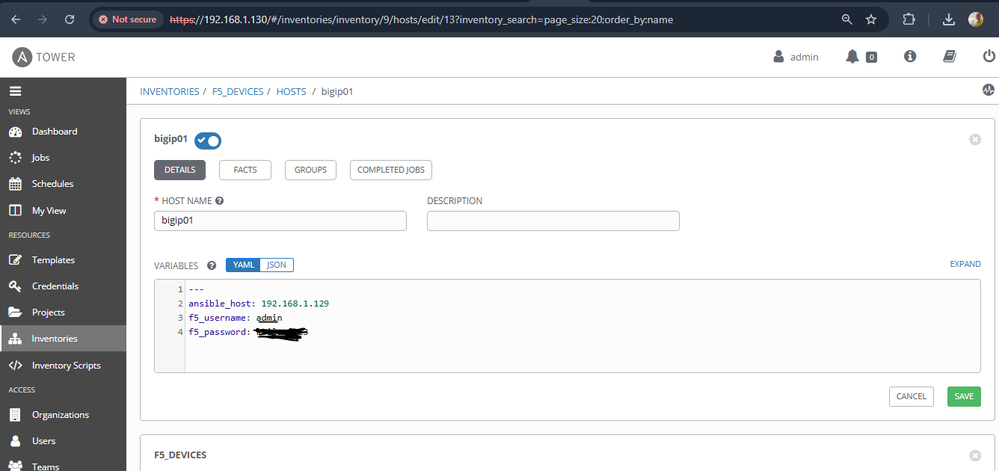

3. Ansible Project Configuration
Description: This screen shows the Ansible project configuration. The project points to the automation content and establishes the project directory used by the job.
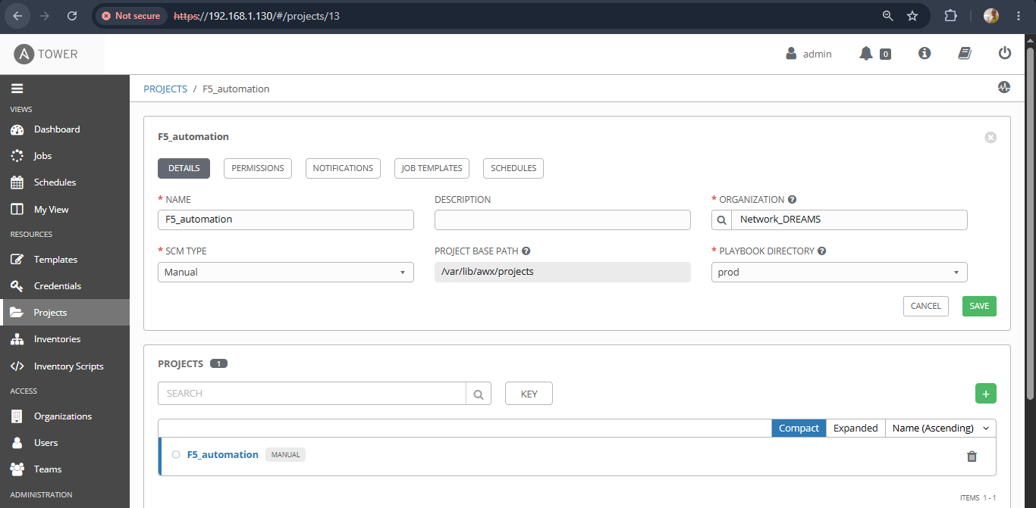

4. F5 Credential
Description: This screen shows the credential configured for the F5 automation. The credential is supplied to the job template so connection details do not need to be hard-coded into the playbook.
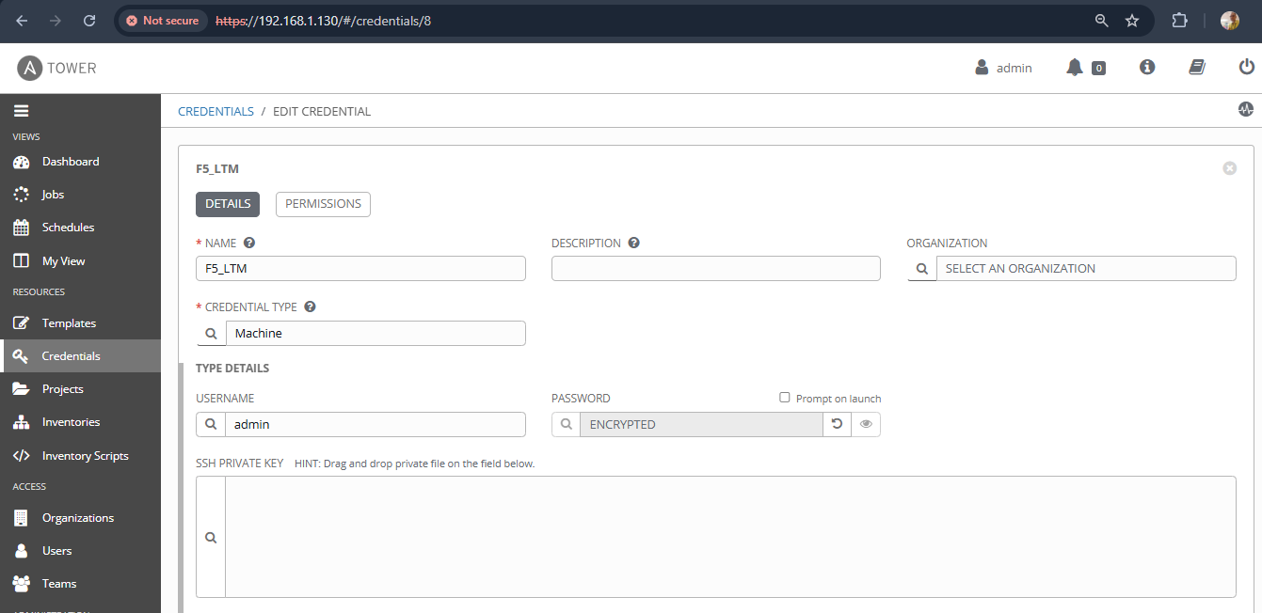

5. Job Template
Description: This screen shows the job template that combines the F5 project, inventory and credential. The template provides a repeatable way to launch the F5 automation.
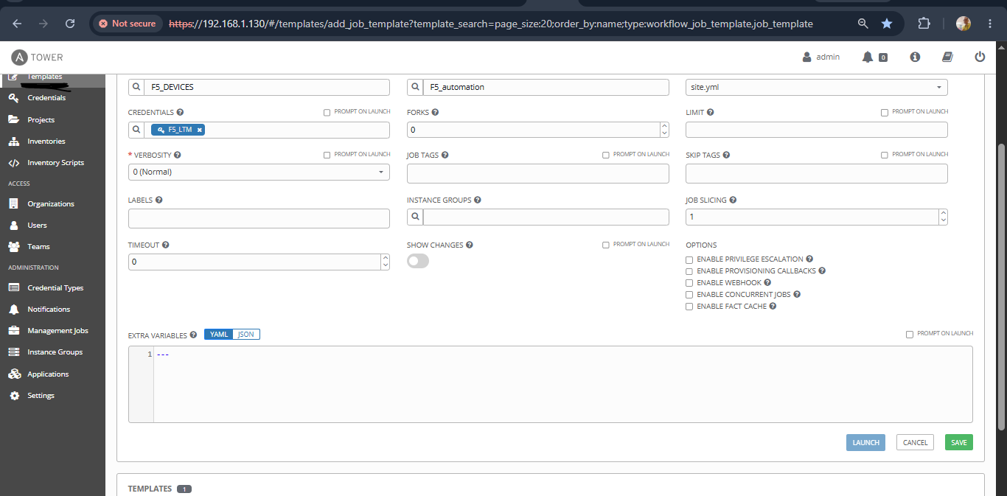

6. Successful Automation Run
Description: This screen shows the completed automation job. The task output confirms execution of the HTTPS monitor, pool, pool-member and virtual-server tasks.
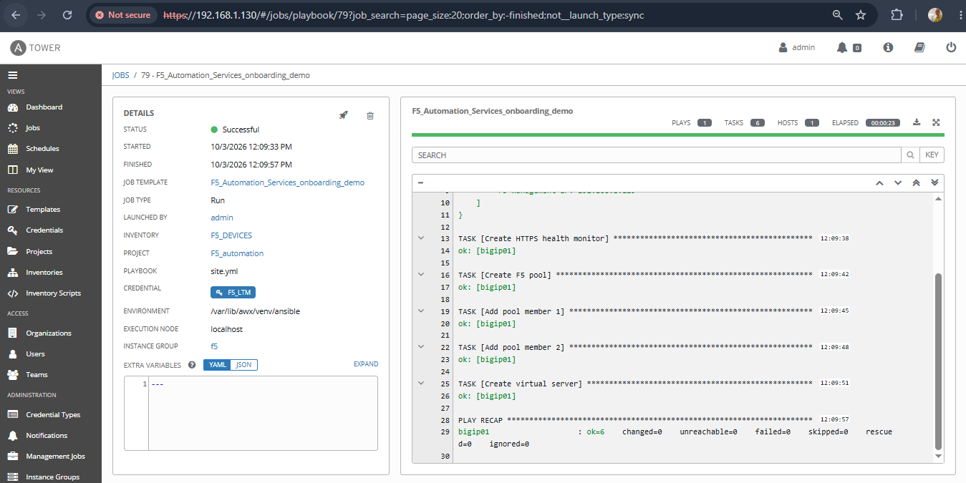

F5 Evidences:
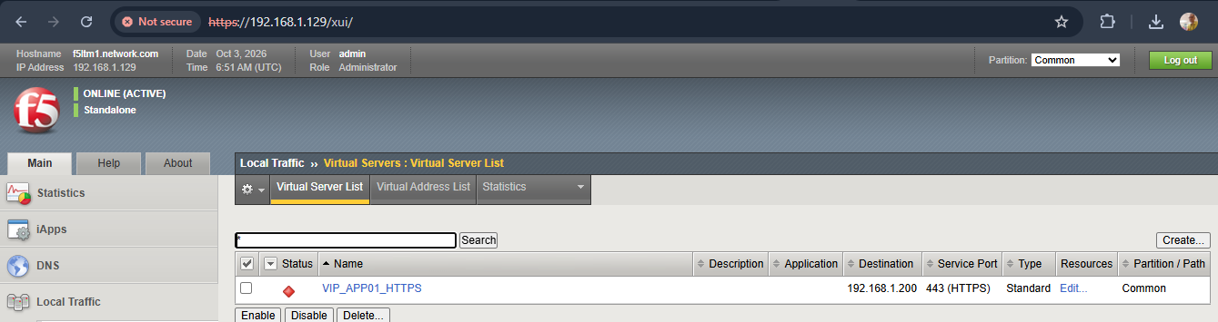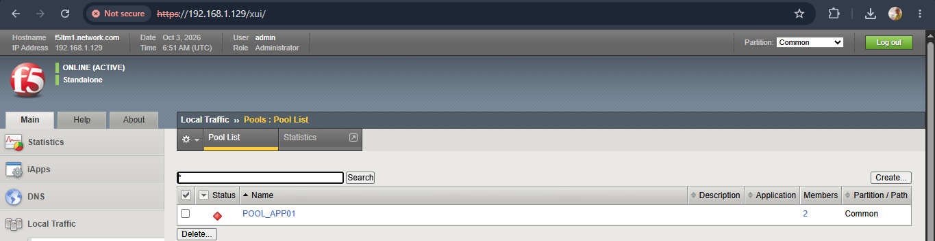
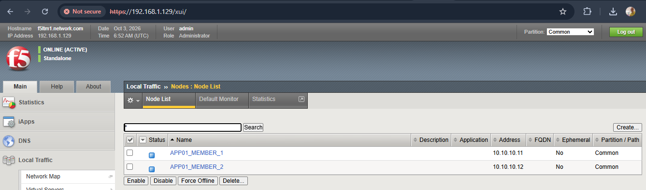
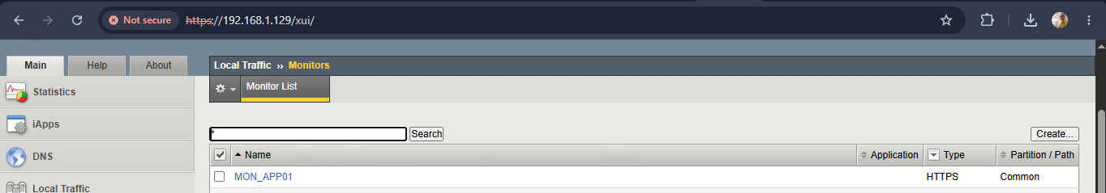
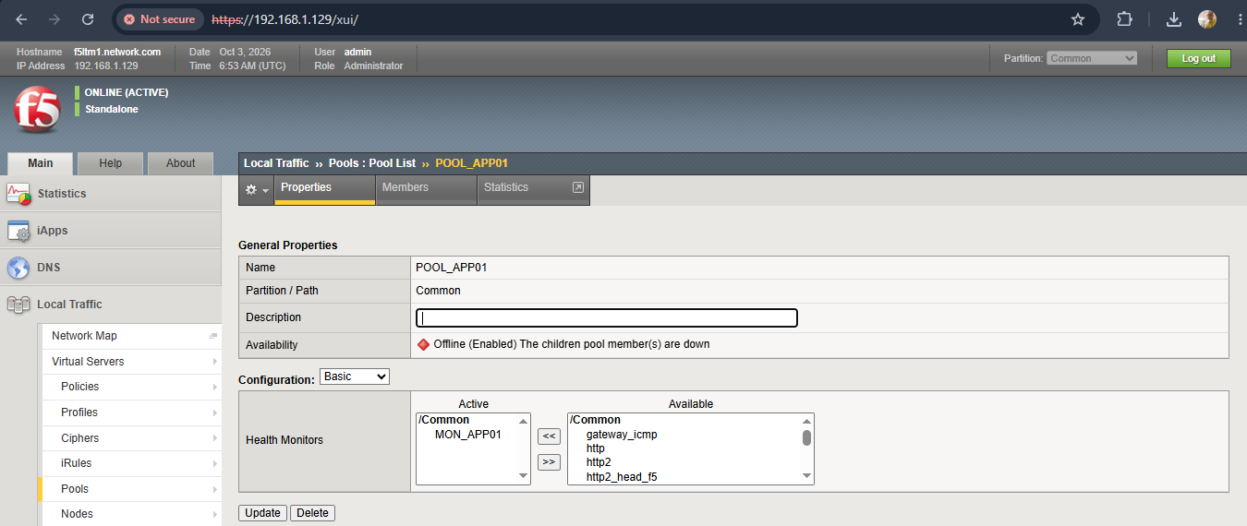

3. F5 LTM Automation Playbook
The following playbook content is retained from the supplied demo document. It uses the f5networks.f5_modules collection and defines the F5 provider from inventory and supplied credentials.
---
- name: Create F5 LTM VIP and Pool
hosts: all
connection: local
gather_facts: false
collections:
- f5networks.f5_modules
vars:
f5_provider:
server: "{{ ansible_host }}"
user: "{{ f5_username }}"
password: "{{ f5_password }}"
validate_certs: false
tasks:
- name: Show F5 connection information
ansible.builtin.debug:
msg:
- "Inventory host: {{ inventory_hostname }}"
- "F5 management IP: {{ ansible_host }}"
- name: Create HTTPS health monitor
f5networks.f5_modules.bigip_monitor_https:
name: MON_APP01
provider: "{{ f5_provider }}"
send: "GET /"
receive: "HTTP"
interval: 5
timeout: 16
state: present
- name: Create F5 pool
f5networks.f5_modules.bigip_pool:
name: POOL_APP01
lb_method: round-robin
monitors:
- MON_APP01
provider: "{{ f5_provider }}"
state: present
- name: Add pool member 1
f5networks.f5_modules.bigip_pool_member:
pool: POOL_APP01
name: APP01_MEMBER_1
host: 10.10.10.11
port: "443"
provider: "{{ f5_provider }}"
state: present
- name: Add pool member 2
f5networks.f5_modules.bigip_pool_member:
pool: POOL_APP01
name: APP01_MEMBER_2
host: 10.10.10.12
port: "443"
provider: "{{ f5_provider }}"
state: present
- name: Create virtual server
f5networks.f5_modules.bigip_virtual_server:
name: VIP_APP01_HTTPS
destination: 192.168.1.200
port: "443"
pool: POOL_APP01
ip_protocol: tcp
profiles:
- http
provider: "{{ f5_provider }}"
state: present

4. Configuration Created by the Demo
Object | Name / Address | Key Setting | Purpose
HTTPS Health Monitor | MON_APP01 | GET / ; expects HTTP | Checks application availability.
Pool | POOL_APP01 | Round-robin | Groups application servers behind the VIP.
Pool Member 1 | APP01_MEMBER_1 | 10.10.10.11:443 | Backend application endpoint.
Pool Member 2 | APP01_MEMBER_2 | 10.10.10.12:443 | Backend application endpoint.
Virtual Server | VIP_APP01_HTTPS | 192.168.1.200:443 | Client-facing HTTPS VIP.

5. Demo Talking Points
- Ansible provides a repeatable and structured method to automate F5 configuration.
- The F5 provider is built from inventory and runtime credential variables.
- The playbook uses F5-specific Ansible modules instead of manually entering tmsh commands.
- The automation sequence creates the health monitor first, then the pool, pool members and virtual server.
- The successful job output provides an auditable execution trail for the change.

6. Key Takeaway
Outcome: The demo demonstrates a complete F5 LTM application onboarding flow through Ansible, from inventory and credentials through job execution and successful creation of the required LTM objects.

Kailas Pathade | 7777050805 | [EMAIL ID – Kailasdreams@gmail.com]

