Plagiarism Detection Using

Brute-Force String Matching
Design and Analysis of Algorithms
Name: Kailash

1. Aim
To implement brute-force (naive) string matching in Python to simulate a plagiarism-detection scan of a large document for a short pattern, and to analyze the algorithm's time complexity and its practical efficiency.

2. Problem Statement
A plagiarism detection system scans large documents to match a given pattern using brute-force string matching. The document size is very large and pattern occurrences are rare. This report explains how the algorithm operates in this scenario, analyzes its time complexity, and discusses why the approach becomes inefficient for large text inputs.

a) How Brute-Force String Matching Operates in This Scenario
Brute-force string matching (also called naive matching) checks every possible alignment of the pattern against the text, one character shift at a time, without any preprocessing of the pattern or reuse of earlier comparison results. Applied to plagiarism detection, the “text” is the (very large) document being scanned and the “pattern” is the suspected plagiarised phrase.
The algorithm proceeds as follows:
- Let the document have length n and the pattern have length m.
- For each starting position i from 0 to n − m (every possible alignment of the pattern inside the text):
- – Compare the pattern to the text character by character, starting at text[i].
- – Stop the comparison as soon as a mismatch is found (this is what keeps the algorithm fast on typical, non-repetitive text).
- – If all m characters match, record i as an occurrence (a plagiarised match).
- Slide the pattern one position to the right (i → i + 1) and repeat, regardless of whether the previous alignment matched or not.
Because pattern occurrences are rare in this scenario, the vast majority of alignments fail almost immediately — typically after just one or two character comparisons — since a mismatch is very likely near the very start of the pattern on random or unrelated text. Only at the few positions where the document actually contains the plagiarised phrase does the algorithm perform the full m comparisons.

b) Time Complexity Analysis

Basic operation
The basic operation is a single character comparison, text[i + j] vs. pattern[j]. The total running time is proportional to the total number of such comparisons performed across all alignments.

Worst case — O(n × m)
In the worst case, every alignment requires comparing almost the entire pattern before a mismatch is found (or a match is confirmed). This happens on highly repetitive text — for example, a document consisting mostly of the letter 'a' being searched for a pattern of many 'a's followed by a single different character. There are (n − m + 1) alignments, and each can take up to m comparisons, giving:
T(n, m) = O((n − m + 1) × m) = O(n × m)

Best / average case on typical text — O(n)
For a plagiarism scanner, the pattern is usually short relative to the document, occurrences are rare, and the surrounding text is not adversarially repetitive. On such text, most alignments are rejected after only one or two character comparisons (the first character already differs). Since the number of alignments is still (n − m + 1) ≈ n, but the average work per alignment is close to a small constant, the practical running time is approximately:
T(n, m) ≈ O(n), for m ≪ n and non-repetitive text

Space complexity
Brute-force matching uses no auxiliary data structures beyond a few counters and the match-position list, so its space complexity is O(1) (excluding the input text and pattern themselves, and O(k) to store k reported matches).

c) Why the Approach Becomes Inefficient for Large Text Inputs
- No preprocessing / no reuse of information: every alignment is checked from scratch. When a mismatch occurs after matching a partial prefix of the pattern, the algorithm discards that information entirely and only shifts by one position — unlike KMP or Boyer–Moore, which use the partial match to skip ahead.
- Worst-case O(n × m) blow-up: real documents can contain repetitive structure (repeated words, boilerplate, whitespace runs), which pushes brute force toward its O(n × m) worst case, making scans far slower than the near-O(n) typical case.
- Poor scalability with document size and pattern length: as document collections grow (plagiarism systems often compare against millions of documents) and as patterns/phrases get longer, both n and m increase, and cost grows multiplicatively in the worst case.
- Single-pattern, single-pass design: a real plagiarism checker must test many candidate phrases against many documents. Repeating an O(n) – O(n×m) brute-force scan for every pattern/document pair does not scale to corpus-wide comparison.
- No amortization across queries: brute force builds no reusable index (e.g. suffix array, hash table of k-grams) that could answer many future pattern queries in sub-linear time — every new phrase requires rescanning the whole document again.
For these reasons, production plagiarism-detection systems use smarter algorithms and data structures — KMP, Boyer–Moore, Rabin–Karp (rolling hashes), suffix arrays/trees, or k-gram/shingling with inverted indexes — to avoid re-scanning the entire document for every pattern and to guarantee better worst-case bounds.

3. Source Code (Screenshots)
The complete Python implementation is provided separately as Source_Code.docx. Screenshots of the source code are included below.
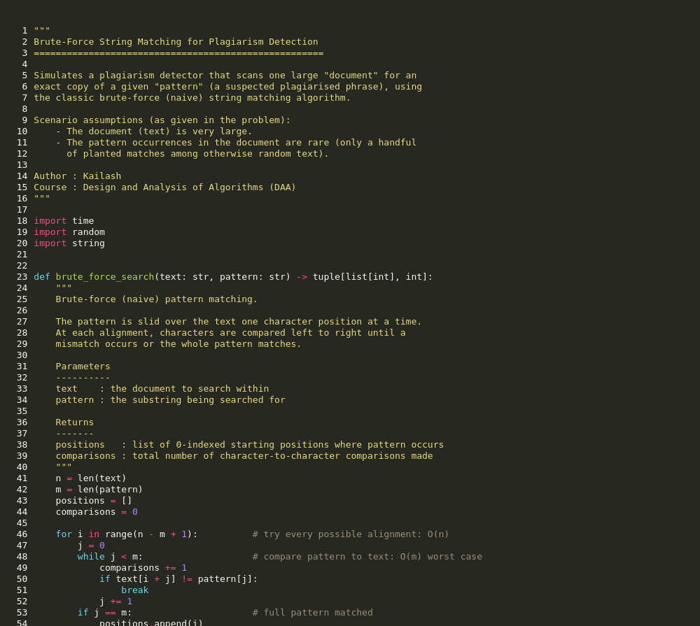
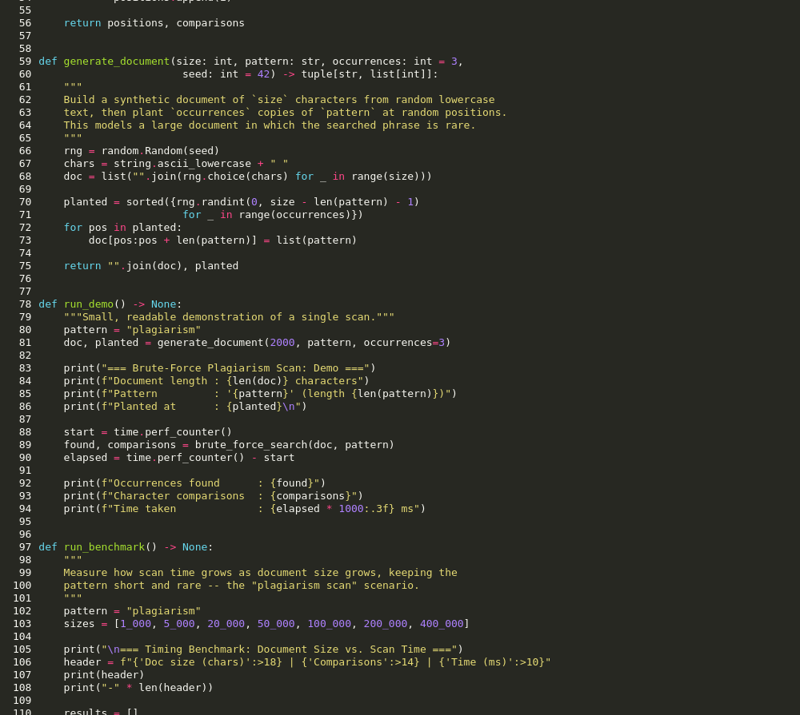
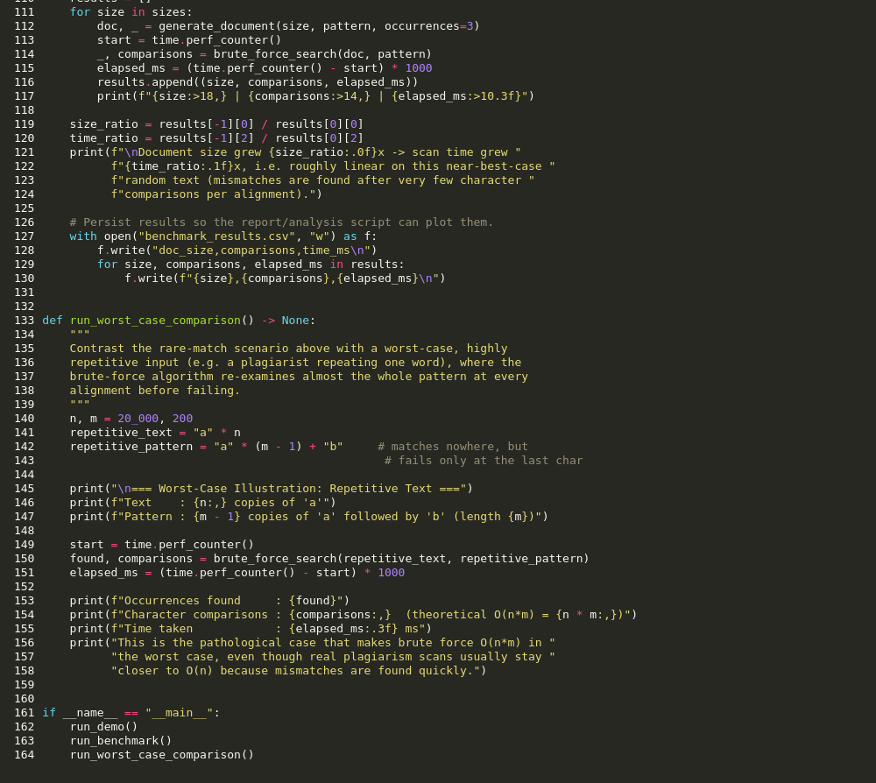

4. Output
Running the program produces a small demo scan, a timing benchmark across increasing document sizes, and a worst-case illustration on repetitive text:

5. Conclusion
Brute-force string matching is simple to implement and works correctly for plagiarism detection on small inputs, achieving roughly O(n) time on typical, non-repetitive documents where the pattern is rare. However, its worst-case O(n × m) time complexity, its inability to reuse partial-match information, and the need to rescan the entire document for every pattern make it unsuitable for large-scale, real-world plagiarism detection. Algorithms such as KMP, Boyer–Moore, and Rabin–Karp, or indexing-based approaches (suffix arrays, k-gram hashing), are preferred in production systems for their better worst-case guarantees and ability to amortize work across many queries.

