Big Data Sorting Framework

Merge Sort vs. Quick Sort
CSA0613Design and Analysis of Algorithms — Case Study Report
Name: Kailash

1. Problem Statement
A big data platform must process and sort terabytes of information efficiently. This case study analyzes Merge Sort and Quick Sort -- both divide-and-conquer sorting algorithms -- for this environment, identifies issues such as memory usage, scalability and speed, compares them under different input conditions, and recommends the most suitable design.

2. Divide-and-Conquer Overview

2.1 Merge Sort
Merge Sort splits the array into two halves (divide), recursively sorts each half, and then merges the two sorted halves back together (combine). The merge step always looks at every element once, so the algorithm's behaviour does not depend on the initial ordering of the input.

2.2 Quick Sort
Quick Sort picks a pivot element, partitions the array into elements smaller and larger than the pivot (divide), and recursively sorts each partition; no explicit combine step is needed because partitioning already places the pivot in its final position. Performance depends heavily on how balanced the partitions are, which in turn depends on the pivot choice and the input order.

3. Complexity Analysis
Algorithm | Best case | Average case | Worst case | Space | Stable?
Merge Sort | O(n log n) | O(n log n) | O(n log n) | O(n) | Yes
Quick Sort (naive pivot) | O(n log n) | O(n log n) | O(n²) | O(log n)–O(n) | No
Quick Sort (randomized pivot) | O(n log n) | O(n log n) | O(n²), expected O(n log n) | O(log n)–O(n) | No

Merge Sort's O(n log n) bound holds unconditionally because the split is always exactly in half. Quick Sort's worst case O(n²) occurs when partitioning is maximally unbalanced (e.g. always picking the smallest or largest element as pivot) -- which happens deterministically on already-sorted or reverse-sorted data if the pivot is always the first element. Recursion depth also grows to O(n) in that case, since each partition only shrinks by one element.

4. Issues in a Big-Data Environment

4.1 Memory usage
- Merge Sort needs O(n) auxiliary space for the temporary arrays created during merging -- for terabyte-scale data this auxiliary buffer itself can be a large, but predictable and bounded, overhead.
- Naive-pivot Quick Sort on sorted/nearly-sorted big-data batches (a common case -- e.g. log files, timestamped records) causes O(n) recursion depth and repeated list copies in a Python-style implementation, which the benchmark below shows inflating peak memory by two to three orders of magnitude.

4.2 Scalability
- Merge Sort's behaviour is independent of input order, so it scales predictably as data volume grows -- a property that is valuable when the exact distribution of terabyte-scale data is unknown in advance.
- Quick Sort's scalability is conditional: with a good (e.g. randomized or median-of-three) pivot it matches Merge Sort's O(n log n), but a poor pivot strategy makes it scale far worse (O(n²)) on adversarial or partially-sorted big-data batches.
- Merge Sort decomposes naturally into independent sub-problems that merge in a predictable pattern, which maps cleanly onto distributed/external sorting frameworks (e.g. MapReduce-style external merge sort) used for data that doesn't fit in memory.

4.3 Speed
- In-memory, well-implemented Quick Sort is usually faster in practice than Merge Sort because of better cache locality (in-place partitioning) and a smaller constant factor -- confirmed by the random-data benchmark below.
- Merge Sort's extra allocation and copying for the auxiliary arrays adds constant-factor overhead, but this cost buys guaranteed worst-case performance.

5. Source Code (Screenshots)
Python implementation used for the benchmark: Merge Sort, a naive-pivot Quick Sort, and a randomized-pivot Quick Sort, benchmarked across input sizes and distributions with time and peak-memory measurement (tracemalloc).
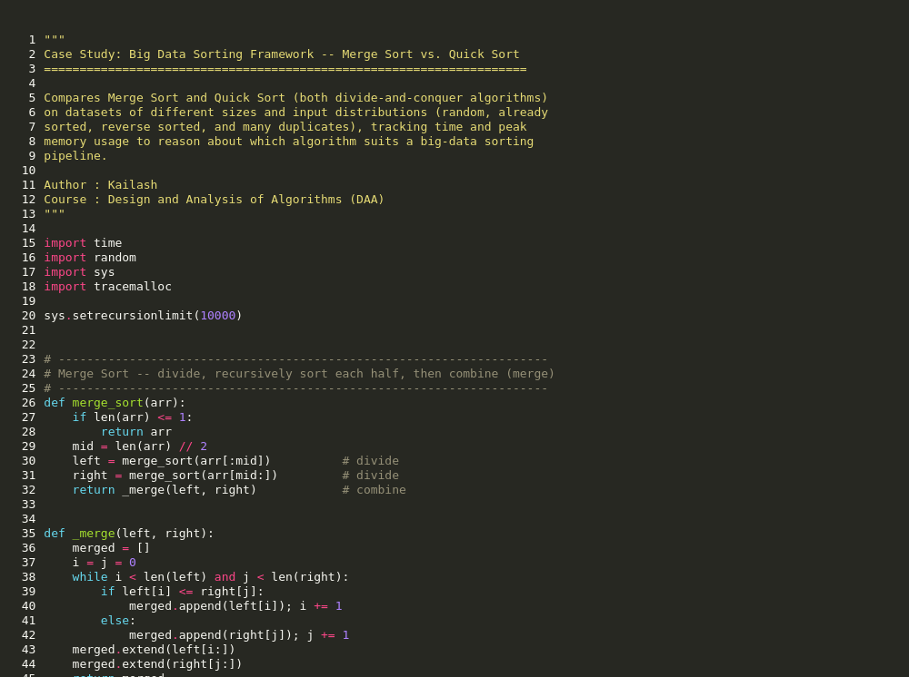
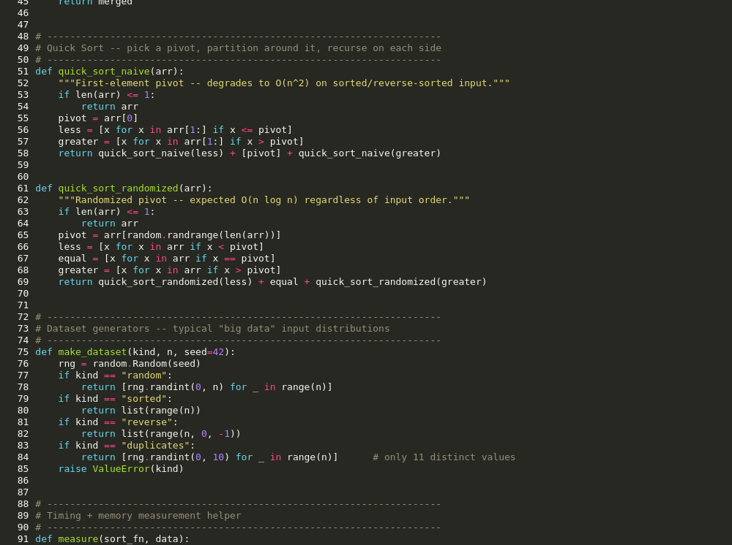
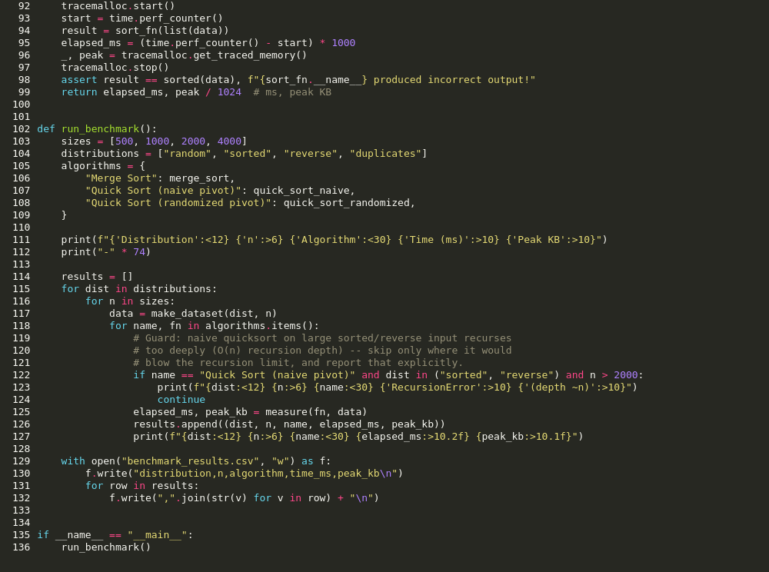
Figure 1. Source code — sorting_case_study.py

6. Output
Benchmark output across four input distributions (random, sorted, reverse-sorted, many duplicates) and increasing sizes n. Naive-pivot Quick Sort on sorted/reverse input at n = 4000 exceeds Python's recursion limit (O(n) recursion depth), reported explicitly rather than crashing the run:
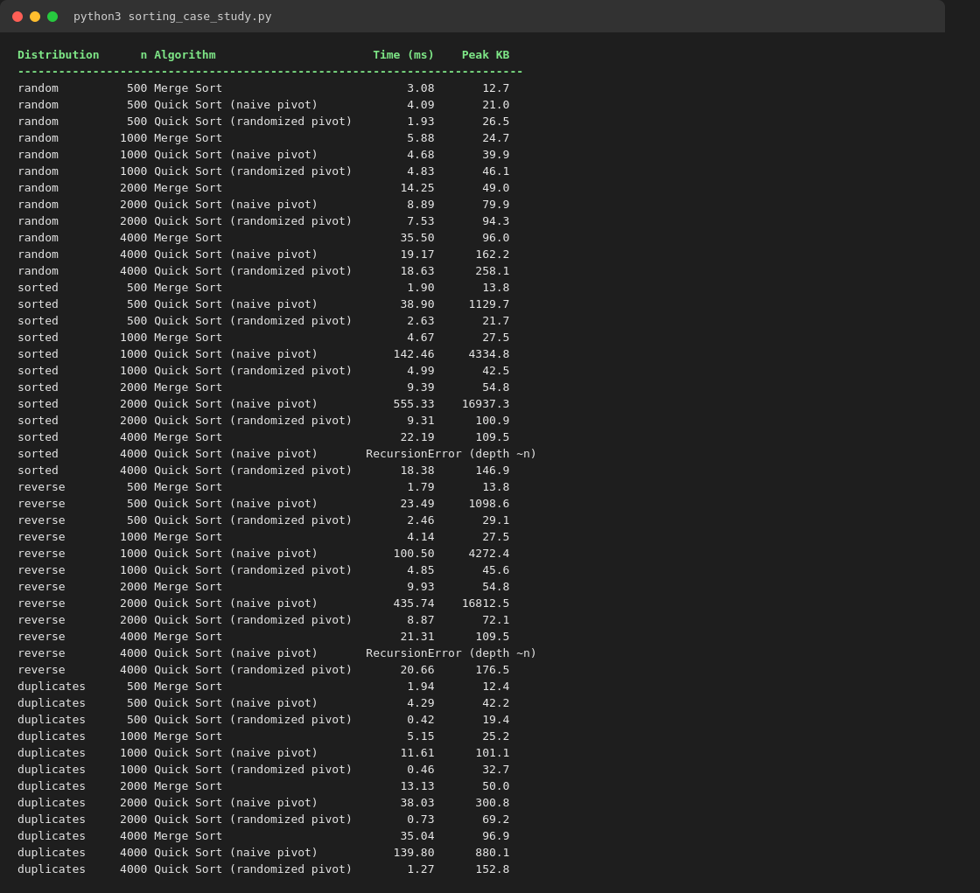
Figure 2. Program output — full benchmark results

7. Conclusion
Merge Sort and Quick Sort both apply divide-and-conquer, but they make different trade-offs: Merge Sort guarantees O(n log n) time and predictable O(n) space regardless of input order, at the cost of extra memory traffic; Quick Sort is typically faster and more memory-light in the average case, but a poor pivot choice degrades it to O(n²) time and drastically higher memory usage on the very input patterns (sorted or nearly-sorted batches) that are common in real big-data pipelines. A production big-data sorting framework should combine external Merge Sort for scalability across disk/distributed chunks with randomized-pivot Quick Sort for speed within each in-memory chunk.

