ITA 0605 – MACHINE LEARNING
CO1 ASSESSMENT – SET 2 :
Q1. A machine learning model shows the following loss values during training:
(a) Epoch 1: Training Loss = 3.0, Validation Loss = 2.7
(b) Epoch 2: Training Loss = 2.6, Validation Loss = 2.3
(c) Epoch 3: Training Loss = 2.3, Validation Loss = 2.1
(d) Epoch 4: Training Loss = 2.1, Validation Loss = 2.0
(e) Epoch 5: Training Loss = 1.9, Validation Loss = 2.2
(f) Epoch 6: Training Loss = 1.7, Validation Loss = 2.5
(g) Epoch 7: Training Loss = 1.6, Validation Loss = 2.8
(h) Epoch 8: Training Loss = 1.4, Validation Loss = 3.1
i) At which epoch does the model achieve optimal generalization?
ii) Identify signs of overfitting from the data.
iii) Recommend two regularization techniques and explain their impact.

CODE :
import matplotlib.pyplot as plt
# Data
epochs = [1, 2, 3, 4, 5, 6, 7, 8]
training_loss = [3.0, 2.6, 2.3, 2.1, 1.9, 1.7, 1.6, 1.4]
validation_loss = [2.7, 2.3, 2.1, 2.0, 2.2, 2.5, 2.8, 3.1]
# Find the epoch with minimum validation loss
best_loss = min(validation_loss)
best_epoch = epochs[validation_loss.index(best_loss)]
print("Best Generalization Epoch:", best_epoch)
print("Minimum Validation Loss:", best_loss)
# Check for overfitting
print("\nOverfitting Analysis:")
for i in range(1, len(epochs)):
if training_loss[i] < training_loss[i-1] and validation_loss[i] > validation_loss[i-1]:
print(f"Overfitting starts after Epoch {epochs[i-1]} (at Epoch {epochs[i]}).")
break
# Plot the losses
plt.plot(epochs, training_loss, marker='o', label="Training Loss")
plt.plot(epochs, validation_loss, marker='s', label="Validation Loss")
plt.title("Training vs Validation Loss")
plt.xlabel("Epoch")
plt.ylabel("Loss")
plt.xticks(epochs)
plt.grid(True)
plt.legend()
plt.show()
# Recommendations
print("\nRegularization Techniques:")
print("1. Dropout - Randomly disables neurons during training to reduce overfitting.")
print("2. L2 Regularization (Weight Decay) - Penalizes large weights and improves generalization.")
OUTPUT :
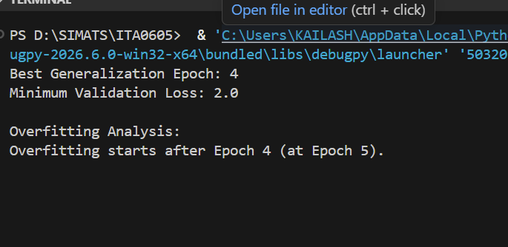
ANS :
i) Optimal Generalization Epoch:
- Epoch 4
- Validation loss is minimum (2.0), indicating the model performs best on unseen data.
ii) Signs of Overfitting:
- From Epoch 5 onwards, training loss continues to decrease:
  - 2.1 → 1.9 → 1.7 → 1.6 → 1.4
- But validation loss increases:
  - 2.0 → 2.2 → 2.5 → 2.8 → 3.1
- This indicates the model is memorizing the training data and not generalizing well.
iii) Two Regularization Techniques:
- Dropout
  - Randomly deactivates neurons during training.
  - Prevents the network from relying too much on specific neurons, reducing overfitting.
- L2 Regularization (Weight Decay)
  - Adds a penalty for large weight values.
  - Encourages simpler models and improves generalization to new data.
Q2.
In an industrial process, an AI robot is assigned to segregate the front and back
tires automatically. Let the number of tires are 250 (125 front and 125 back tires).
(5 Marks)

a. Front identified as Front: 119
a. Front identifies as Back: 06
a. Back identified as Back: 120
a. Back identified as Front: 05
Compute: Accuracy, Precision, Sensitivity, Specificity and F1-Score.
CODE :
import matplotlib.pyplot as plt
# Loss values
train_loss = [3.0, 2.6, 2.3, 2.1, 1.9, 1.7, 1.6, 1.4]
val_loss = [2.7, 2.3, 2.1, 2.0, 2.2, 2.5, 2.8, 3.1]
epochs = list(range(1, 9))
# i) Optimal Generalization Epoch
best_epoch = val_loss.index(min(val_loss)) + 1
print("i) Optimal Generalization Epoch:", best_epoch)
# ii) Check Overfitting
print("\nii) Overfitting Analysis:")
for i in range(1, len(val_loss)):
if train_loss[i] < train_loss[i-1] and val_loss[i] > val_loss[i-1]:
print("Overfitting starts from Epoch", i + 1)
break
# iii) Regularization Techniques
print("\niii) Regularization Techniques:")
print("1. Dropout - Randomly disables neurons during training to reduce overfitting.")
print("2. L2 Regularization (Weight Decay) - Penalizes large weights and improves generalization.")
# Plot graph
plt.plot(epochs, train_loss, marker='o', label='Training Loss')
plt.plot(epochs, val_loss, marker='s', label='Validation Loss')
plt.title("Training vs Validation Loss")
plt.xlabel("Epoch")
plt.ylabel("Loss")
plt.xticks(epochs)
plt.legend()
plt.grid(True)
plt.show()

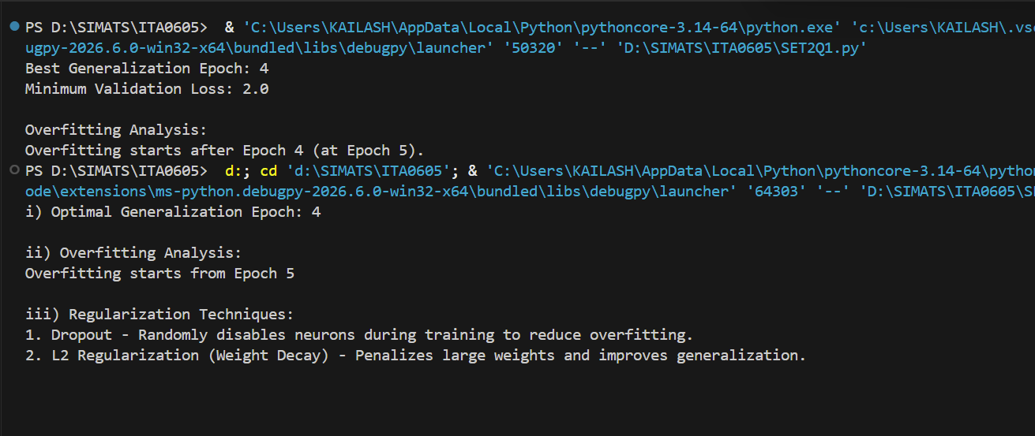
Q3:
In a medical diagnosis system, an AI model detects whether a patient has a
disease or not. Out of 300 cases (150 diseased and 150 healthy): (5 Marks)
a. Diseased identified as Diseased: 138
a. Diseased identified as Healthy: 12
a. Healthy identified as Healthy: 135
a. Healthy identified as Diseased: 15
Compute: Accuracy, Precision, Sensitivity (Recall), Specificity, and F1-Score.
Code :
# Confusion Matrix
TP = 138
FN = 12
TN = 135
FP = 15

# Metrics
accuracy = (TP + TN) / (TP + TN + FP + FN)
precision = TP / (TP + FP)
recall = TP / (TP + FN)
specificity = TN / (TN + FP)
f1 = 2 * precision * recall / (precision + recall)

# Display Results
print("Accuracy =", round(accuracy, 4), "(", round(accuracy*100, 2), "%)")
print("Precision =", round(precision, 4), "(", round(precision*100, 2), "%)")
print("Recall =", round(recall, 4), "(", round(recall*100, 2), "%)")
print("Specificity =", round(specificity, 4), "(", round(specificity*100, 2), "%)")
print("F1-Score =", round(f1, 4), "(", round(f1*100, 2), "%)")
output :
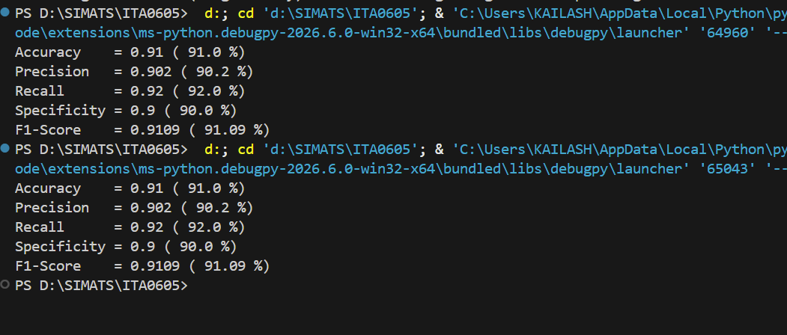
Q4:
In a spam email filtering system, an AI model classifies emails as Spam or Not
Spam. Out of 400 emails (200 spam and 200 non-spam): (5 Marks)
• Spam identified as Spam: 180
• Spam identified as Not Spam: 20
• Not Spam identified as Not Spam: 170
• Not Spam identified as Spam: 30
Compute: Accuracy, Precision, Sensitivity, Specificity, and F1-Score.
Code :
# Confusion Matrix
TP = 180 # Spam predicted as Spam
FN = 20 # Spam predicted as Not Spam
TN = 170 # Not Spam predicted as Not Spam
FP = 30 # Not Spam predicted as Spam

# Calculate Metrics
accuracy = (TP + TN) / (TP + TN + FP + FN)
precision = TP / (TP + FP)
recall = TP / (TP + FN) # Sensitivity
specificity = TN / (TN + FP)
f1_score = 2 * precision * recall / (precision + recall)

# Display Results
print("Accuracy =", round(accuracy, 4), "(", round(accuracy*100, 2), "%)")
print("Precision =", round(precision, 4), "(", round(precision*100, 2), "%)")
print("Sensitivity =", round(recall, 4), "(", round(recall*100, 2), "%)")
print("Specificity =", round(specificity, 4), "(", round(specificity*100, 2), "%)")
print("F1-Score =", round(f1_score, 4), "(", round(f1_score*100, 2), "%)")
output :
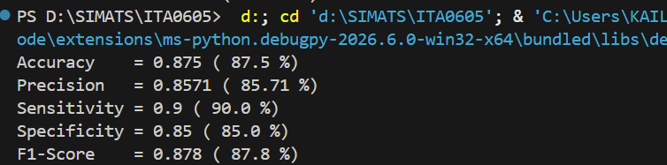
Q5 :
In a quality inspection system in manufacturing, an AI model identifies defective
and non-defective products. Out of 500 products (250 defective and 250 non-
defective): (5 Marks)
• Defective identified as Defective: 2 30
• Defective identified as Non-Defective: 20
• Non-Defective identified as Non-Defective: 225
• Non-Defective identified as Defective: 25
Compute: Accuracy, Precision, Sensitivity, Specificity, and F1-Score.

Code :
# Confusion Matrix Values
TP = 230 # Defective predicted as Defective
FN = 20 # Defective predicted as Non-Defective
TN = 225 # Non-Defective predicted as Non-Defective
FP = 25 # Non-Defective predicted as Defective

# Calculate Metrics
accuracy = (TP + TN) / (TP + TN + FP + FN)
precision = TP / (TP + FP)
sensitivity = TP / (TP + FN) # Recall
specificity = TN / (TN + FP)
f1_score = 2 * precision * sensitivity / (precision + sensitivity)

# Print Results
print("Accuracy :", round(accuracy * 100, 2), "%")
print("Precision :", round(precision * 100, 2), "%")
print("Sensitivity :", round(sensitivity * 100, 2), "%")
print("Specificity :", round(specificity * 100, 2), "%")
print("F1-Score :", round(f1_score * 100, 2), "%")
Output :
