1. **Write a program to print numbers from 1 to 100.**

**IPO:**

Input: None

Process: Loop from 1 to 100

Output: Numbers from 1 to 100

**CODE:**

#include <stdio.h>

void main()

{

for(int i = 1; i <= 100; i++)

{

printf("%d ", i);

}

}

**OUTPUT:**



1. **Write a program to print even numbers from 1 to 50.**

**IPO:**

Input: None

Process: Loop from 1 to 50 and check even

Output: Even numbers from 1 to 50

**CODE:**

#include <stdio.h>

void main()

{

for(int i = 1; i <= 50; i++)

{

if(i % 2 == 0)

printf("%d ", i);

}

}

**OUTPUT:**

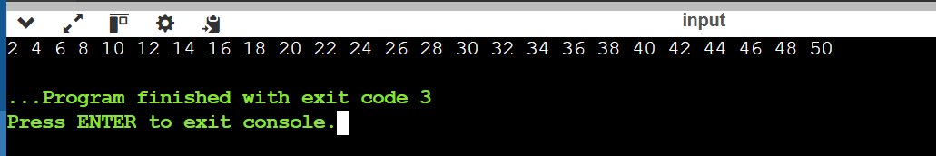

1. **Write a program to find the factorial of a number.**

**IPO:**

Input: Number n

Process: Multiply numbers from 1 to n

Output: Factorial of n

**CODE:**

#include <stdio.h>

void main()

{

int n, fact = 1;

scanf("%d", &n);

for(int i = 1; i <= n; i++)

{

fact *= i;

}

printf("Factorial = %d", fact);

}

**OUTPUT:**

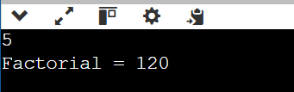

1. **Write a program to calculate the sum of digits of a number.**

**IPO:**

Input: Number

Process: Extract digits and sum

Output: Sum of digits

**CODE:**

#include <stdio.h>

void main()

{

int num, sum = 0;

scanf("%d", &num);

while(num != 0)

{

sum += num % 10;

num /= 10;

}

printf("Sum = %d", sum);

}

**OUTPUT:**

1. **Write a program to reverse a number.**

**IPO:**

Input: Number

Process: Extract digits and reverse

Output: Reversed number

**CODE:**

#include <stdio.h>

void main()

{

int num, rev = 0;

scanf("%d", &num);

while(num != 0)

{

rev = rev * 10 + num % 10;

num /= 10;

}

printf("Reversed = %d", rev);

}

**OUTPUT:**

1. **Write a program to check whether a number is a palindrome**

**IPO:**

Input: Number

Process: Reverse and compare with original

Output: Palindrome or not

**CODE:**

#include <stdio.h>

void main()

{

int num, temp, rev = 0;

scanf("%d", &num);

temp = num;

while(num != 0)

{

rev = rev * 10 + num % 10;

num /= 10;

}

if(temp == rev)

printf("Palindrome");

else

printf("Not Palindrome");

}

**OUTPUT:**

1. **Write a program to print multiplication table of a number.**

**IPO:**

Input: Number

Process: Multiply by 1 to 10

Output: Multiplication table

**CODE:**

#include <stdio.h>

void main()

{

int n;

scanf("%d", &n);

for(int i = 1; i <= 10; i++)

{

printf("%d x %d = %d\n", n, i, n * i);

}

}

**OUTPUT:**

1. **Write a program to count the number of digits in a number.**

**IPO:**

Input: Number

Process: Divide number by 10 and count

Output: Total digits

**CODE:**

#include <stdio.h>

void main()

{

int num, count = 0;

scanf("%d", &num);

while(num != 0)

{

num /= 10;

count++;

}

printf("Digits = %d", count);

}

**OUTPUT:**

1. **Write a program to print the Fibonacci series up to n terms.**

**IPO:**

Input: Number of terms n

Process: Generate Fibonacci series

Output: Fibonacci series up to n

**CODE:**

#include <stdio.h>

void main()

{

int n, a = 0, b = 1, c;

scanf("%d", &n);

printf("%d %d ", a, b);

for(int i = 3; i <= n; i++)

{

c = a + b;

printf("%d ", c);

a = b;

b = c;

}

}

**OUTPUT:**

**10. Write a program to calculate the sum of the first n natural numbers**

**IPO:**

Input: Number n

Process: Sum 1 to n using formula

Output: Sum of natural numbers

**CODE:**

#include <stdio.h>

void main()

{

int n, sum;

scanf("%d", &n);

sum = n * (n + 1) / 2;

printf("Sum = %d", sum);

}

**OUTPUT:**

