MedShield

22/09/2026:
Creating a web based on the medical field which is used to track the live info about the hospital(Details).
1.Created a web which includes the info about the patient details and the emergency block and all.
2.we had added the functionality in the web like take the inputs and tracking live condition about the patients.
3.In the patient surveillance section we added the add patient button which takes the criterias like name and all.
4.We had fixed the variation which is displaying in the random way by taking the real data and make it for displaying on the screen.
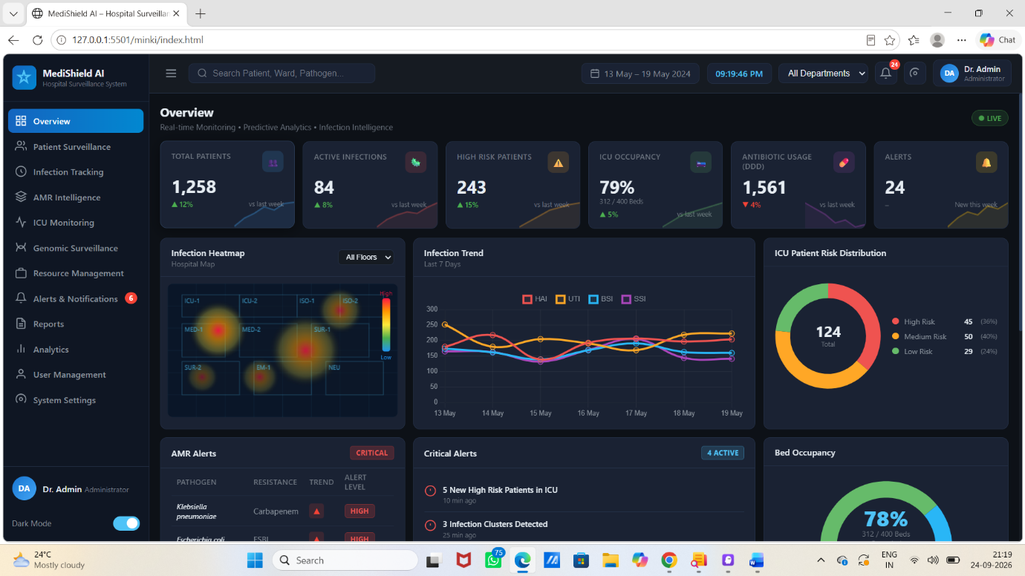

Missing:
To push the updated data into the git..

24/09/2026:

Changes made in the web page:
1.Enabled the generate report button based on the patient details and the current condition .
2.The user management button was enabled and we have added the add user button in that which takes the user and their role and documents etc….
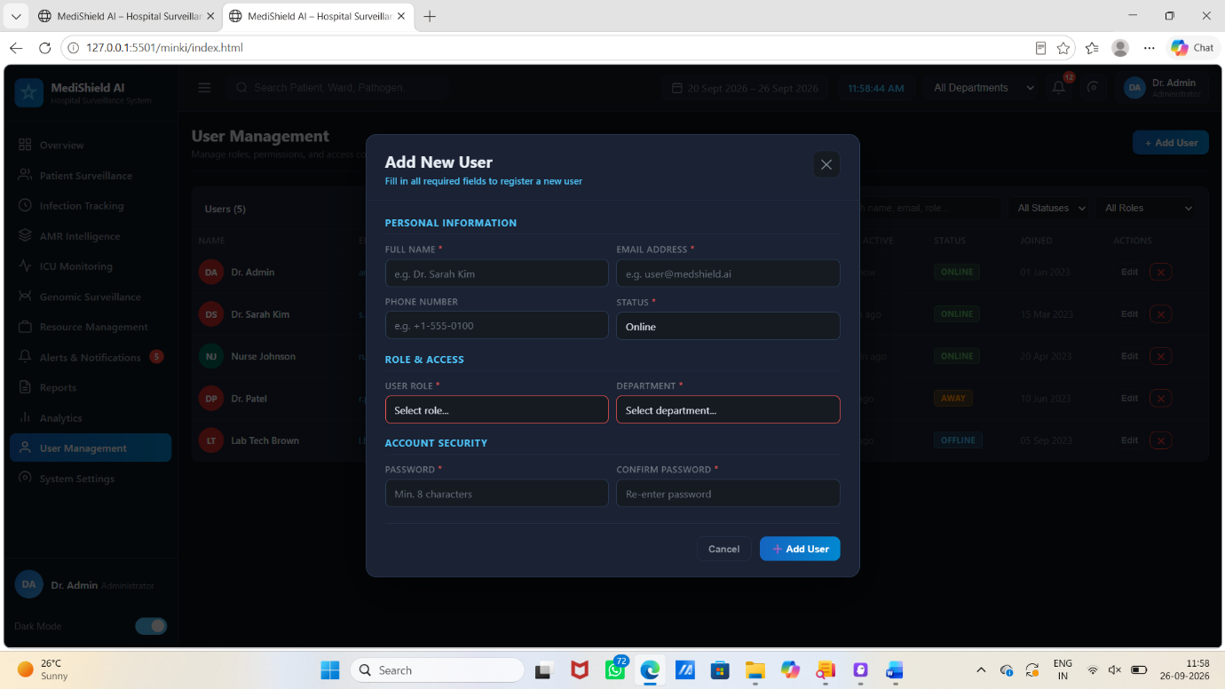

Missing:
Search button to be enabled and display the result of that.

26/09/2026:

Changes made:
1.The search is enabled and when we search any patient who registered their details is showing in the overview.
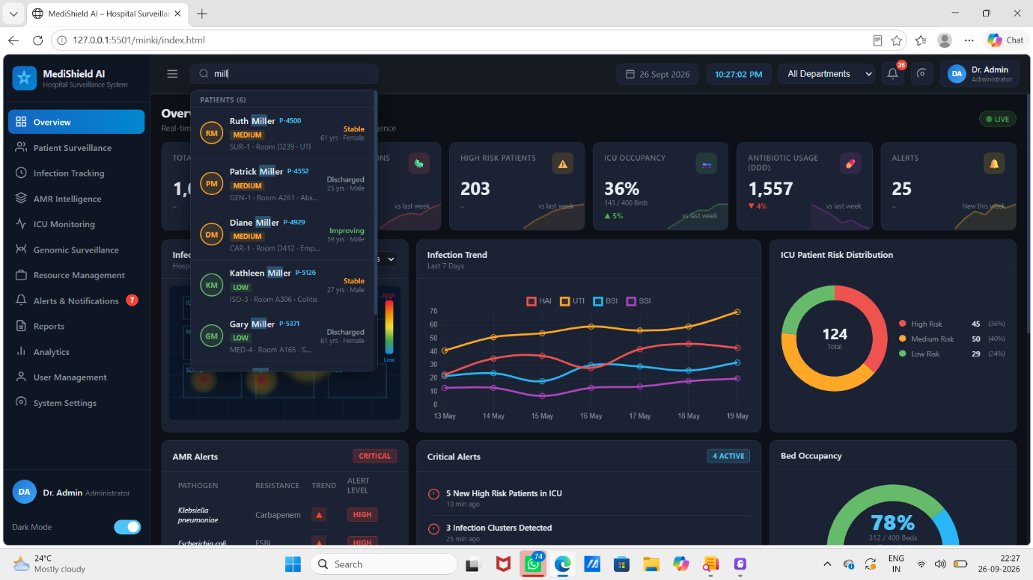

Pending:
1.The web don’t have any memory to store the patient list and it is constant it is not increasing when we enter the patient details.
2.Kiro points are over 50/50.
3.pushing to git.

