Resnet18 model on Cifar10 dataset

The flask api generates a html file whose layout goes like this-

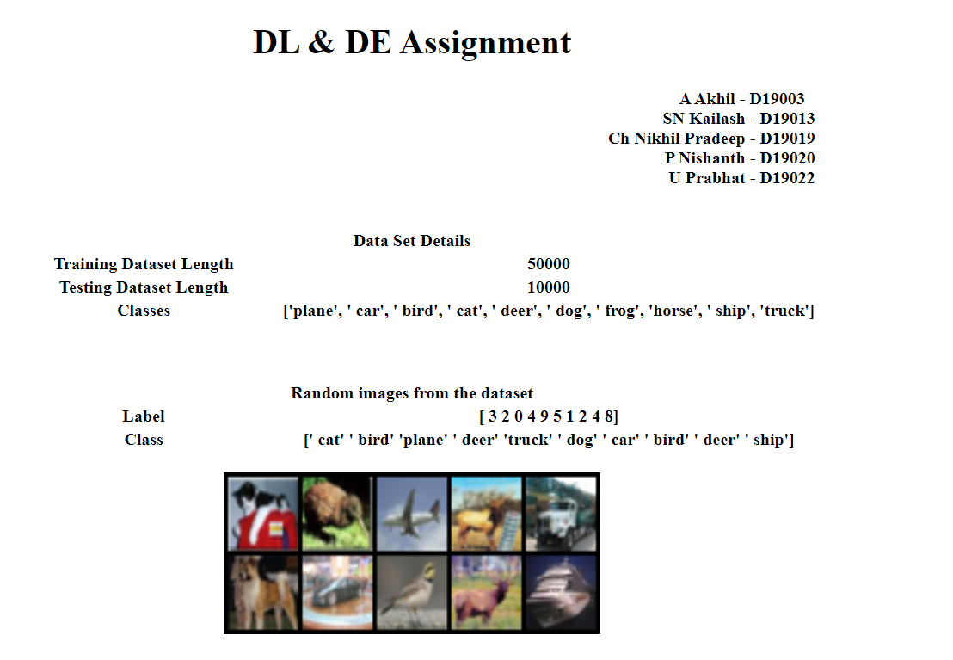

We have presented the user with 3 options-

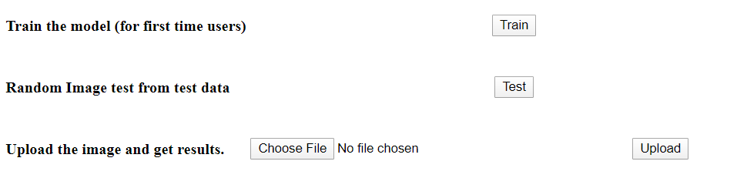

The random test process takes an image from the testloader and displays both the image and it’s predicted class-

