|  |  |
| --- | --- |
| NAME | KAILASH S |
| ASS NO | DATABRICKS 5 |
| DATE | 03-01-24 |
| TOPIC | Delta lake storage, storage account |

DATABRICKS ASSIGNMENT 5

Storage account:

Azure account contains all of our azure data objects like blobs, files, queues and tables. The storage account provides a unique namespace for our Azure Storage data that is accessible from anywhere in the world over HTTP or HTTPS. It supports worldwide hosting. Storage account is must need for performing function executions and task execution.

Azure data lake:

A data lake is a repository of data that is stored in its natural format, usually as blobs or files. Azure Data Lake Storage is a comprehensive, massively scalable, secure, and cost-effective data lake solution for high performance analytics built into Azure. Data Lake Storage builds on Azure Blob storage capabilities to optimize it specifically for analytics workloads.

CREATING STORAGE ACCOUNT:

During the creation of storage account, we must enable the hierarchical namespace to get azure data lake storage gen2.

The created storage account will look like this.

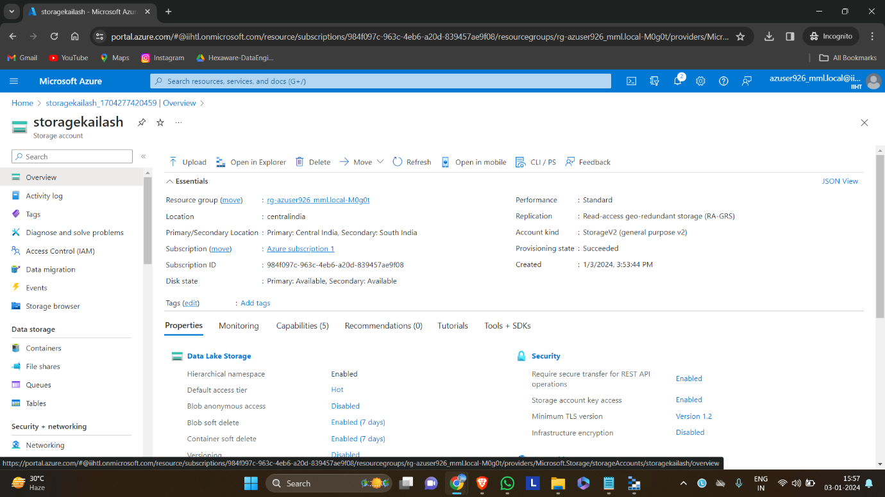

After deploying the storage account, we must create a container to store files which acts as adirectory.

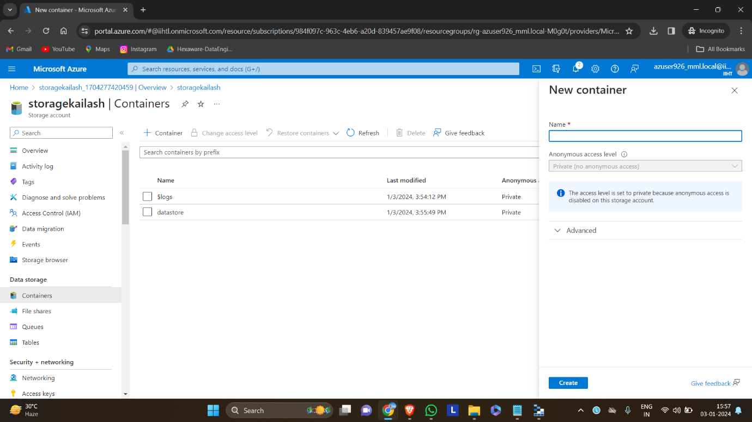

The container helps us store and retrieve data in the storage account.

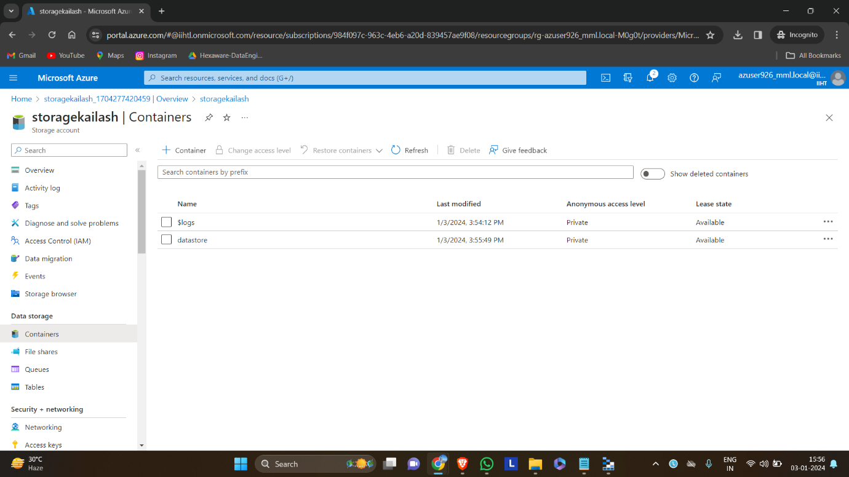

To use azure storage account in the local system we should install azure storage explorer. It helps to connect with the azure subscription account.

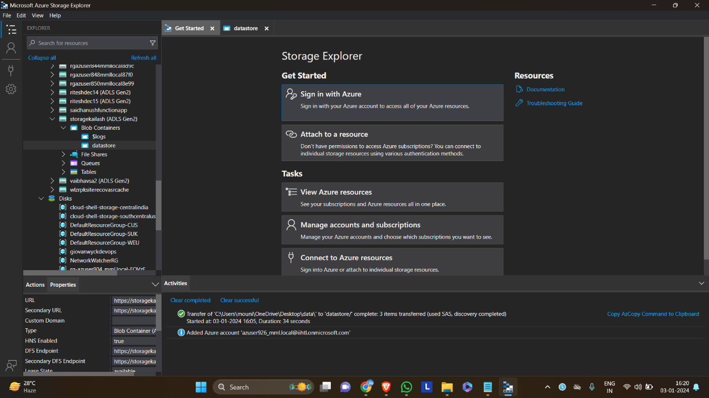

After installing the azure storage account, we should signin into our azure account by selecting the azure option.

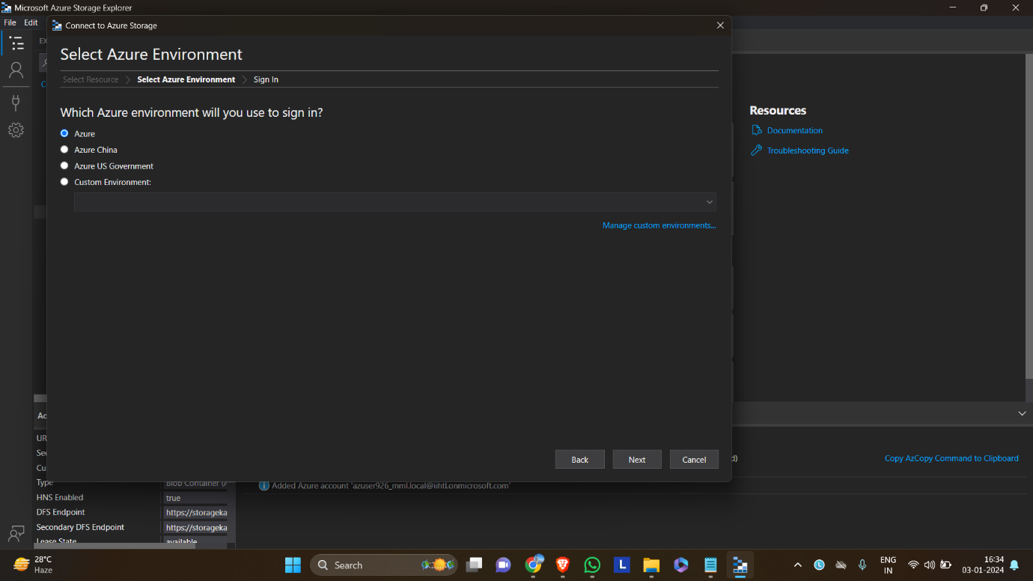

Signing in using the given credentials.

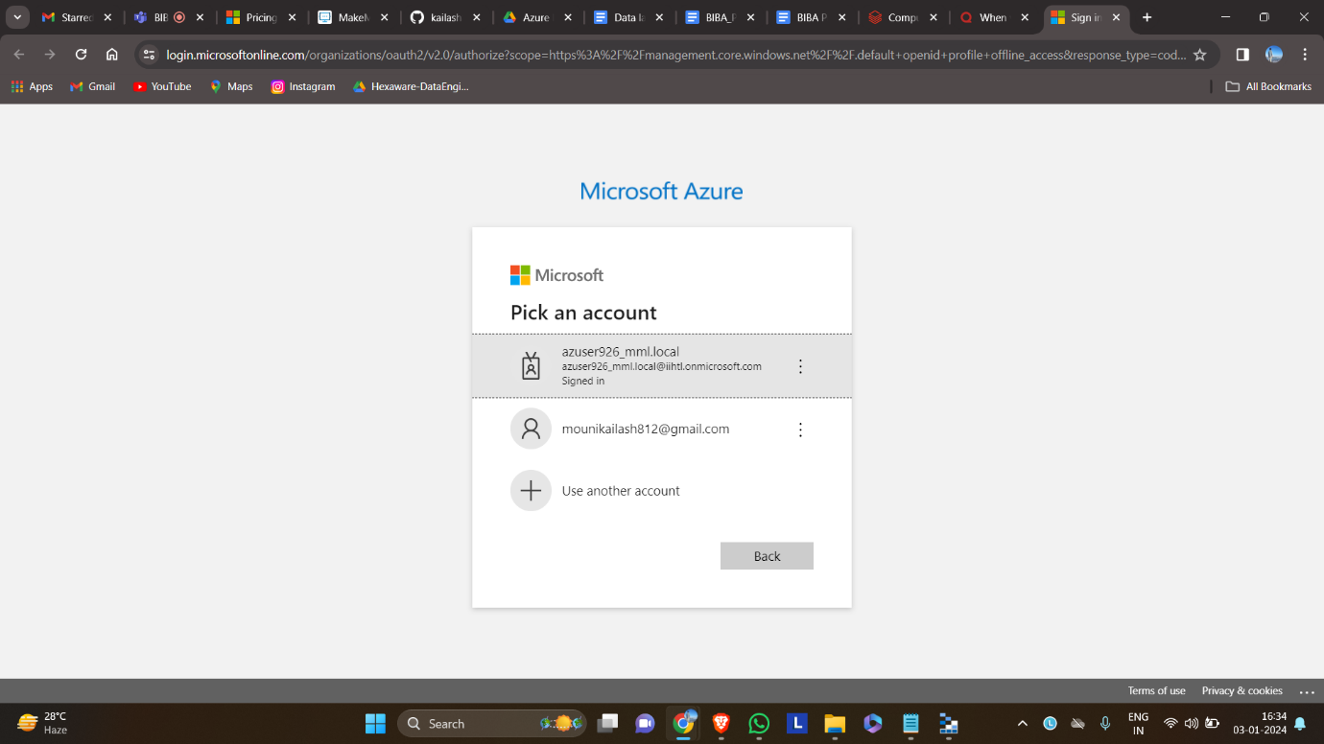

After signing in wecan share the local files into azure account easily.

