|  |  |
| --- | --- |
| NAME | KAILASH S |
| ASS NO | 1 |
| DATE | 08-01-24 |
| TOPIC | AZURE DEVOPS |

**AZURE DEVOPS:**

Azure DevOps is a set of development tools and services provided by Microsoft to facilitate the entire DevOps lifecycle. It offers a variety of services for building, testing, deploying, and managing applications.

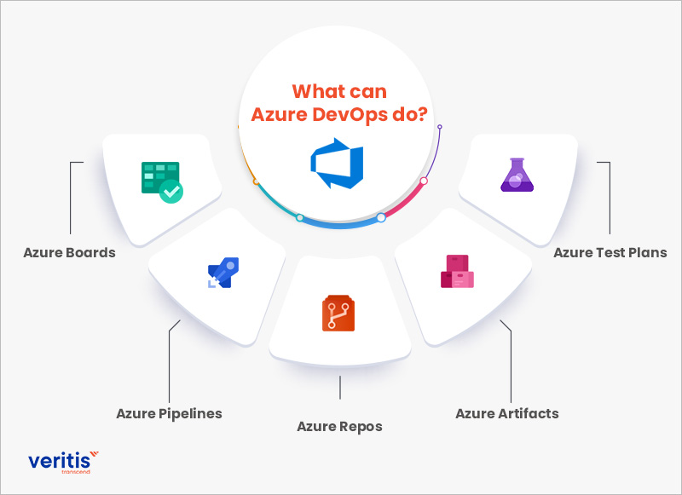

The key components of Azure DevOps include:

1. **Azure Boards:** Agile project management tool that allows teams to plan, track, and discuss work across the entire development process.

2. **Azure Repos:** Version control service that supports Git repositories for source control.

3. **Azure Pipelines:** Continuous Integration (CI) and Continuous Deployment (CD) service that enables automated build, test, and deployment of applications.

4. **Azure Test Plans:** Test management tool that helps teams to plan, track, and manage their testing efforts.

5. **Azure Artifacts:** Package management service that allows teams to create, host, and share packages.

Azure DevOps provides integration with various tools and languages, making it suitable for a wide range of development environments. It supports both cloud and on-premises scenarios, providing flexibility for different types of projects. Developers can use Azure DevOps to set up pipelines for building and deploying applications, manage work items and issues, collaborate with team members, and ensure the quality of their code through testing. Azure DevOps is designed to work seamlessly with Microsoft Azure services, but it also supports integration with third-party tools and services, making it a versatile solution for DevOps practices.

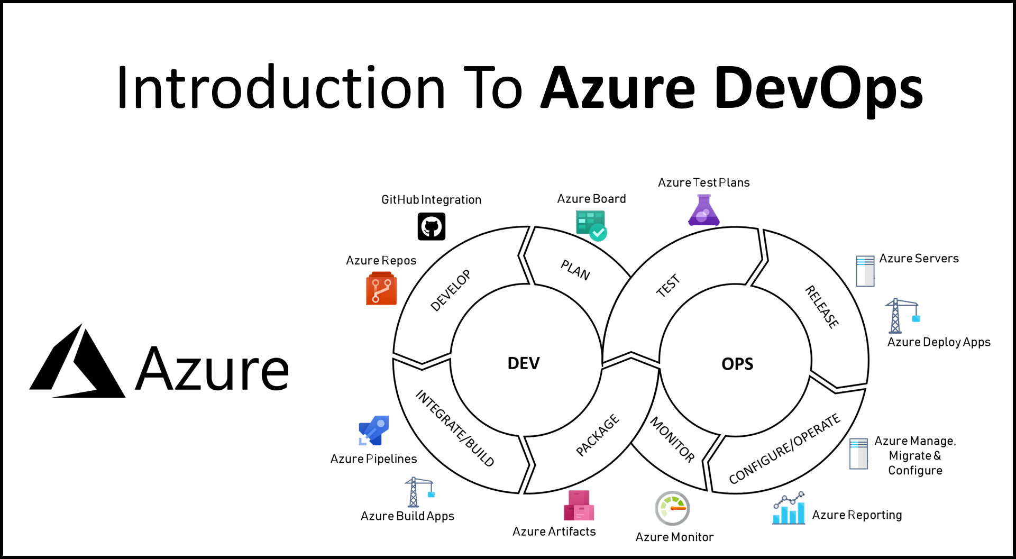

**Azure DevOps main focus:**

* Continuous Integration (CI)
* Continuous Deployment (CD)
* Continuous Learning & Monitoring (CL)

**CI/CD/CL** are three key concepts in the context of software development and DevOps practices. They stand for Continuous Integration (CI), Continuous Deployment (CD), and Continuous Learning (CL).

**1. Continuous Integration (CI):**

CI is a software development practice where developers regularly integrate their code changes into a central repository. Each integration triggers an automated build and a series of tests to detect and address integration issues early in the development process.

**2. Continuous Deployment (CD):**

CD is an extension of Continuous Integration. It involves automatically deploying code changes to a production environment after passing through the CI process. The goal is to release software changes to production quickly and with minimal manual intervention.

**3. Continuous Learning (CL) / Continuous Monitoring:**

Continuous Learning emphasizes the importance of learning from each phase of the development and deployment lifecycle. It involves collecting and analysing feedback from users, monitoring system performance, and using this information to make informed decisions for future development cycles.

Together, these practices contribute to the principles of DevOps, promoting collaboration, automation, and a feedback-driven development cycle.