Date: 15-12-23

Python assignment-5

Topics: Sets, Set methods, functions types of arguments, prime number, odd even function.

SETS:

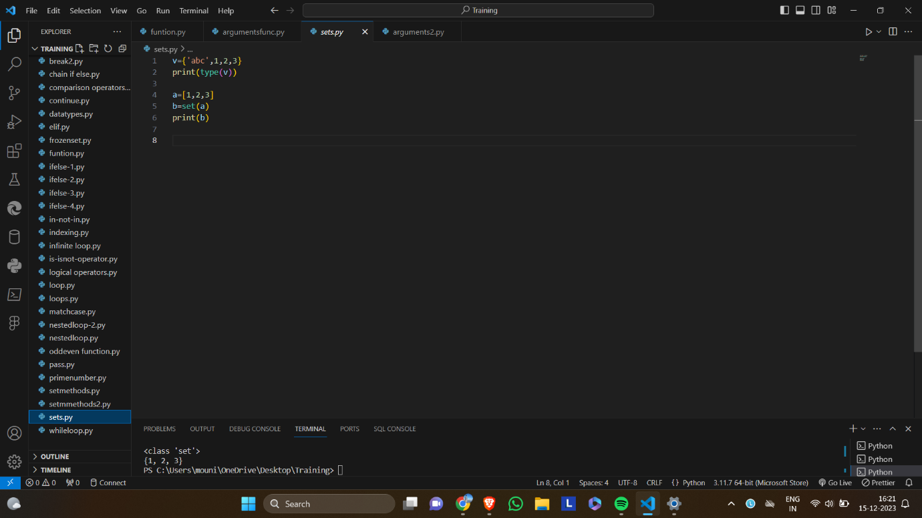

SET METHODS:

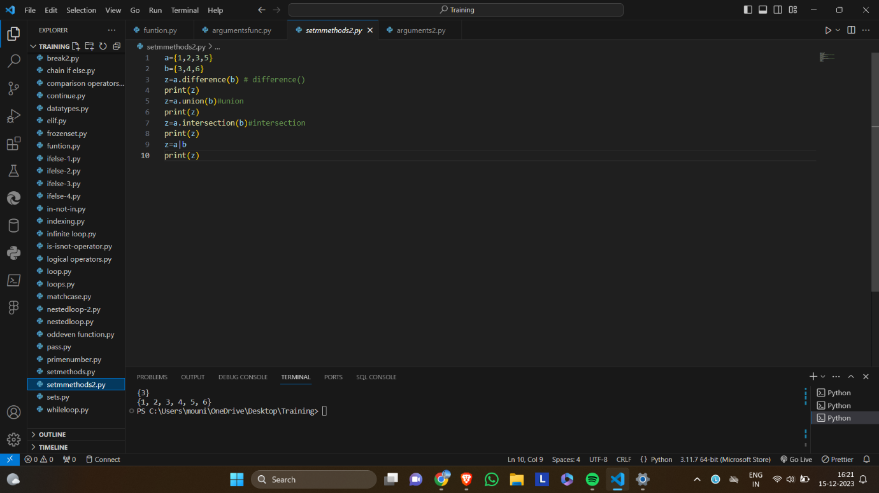

FUNCTIONS:

ARGUMENTS:

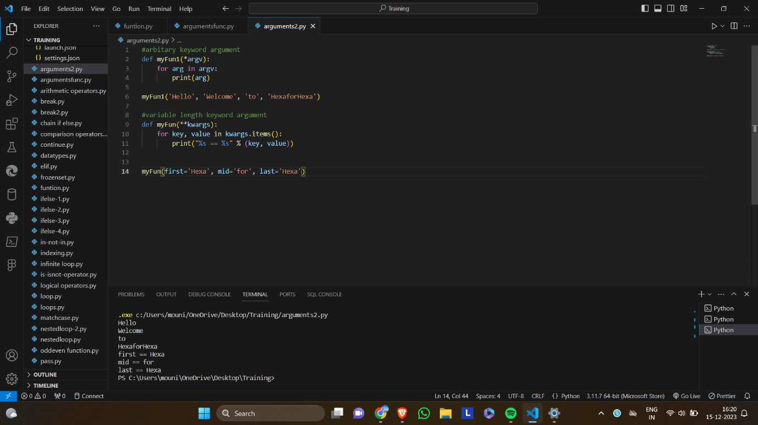

PRIME NUMBER:

ODD OR EVEN:

