**Assessment-2**

**SQL Commands:**

**Data Definition Language commands:**

CREATE:

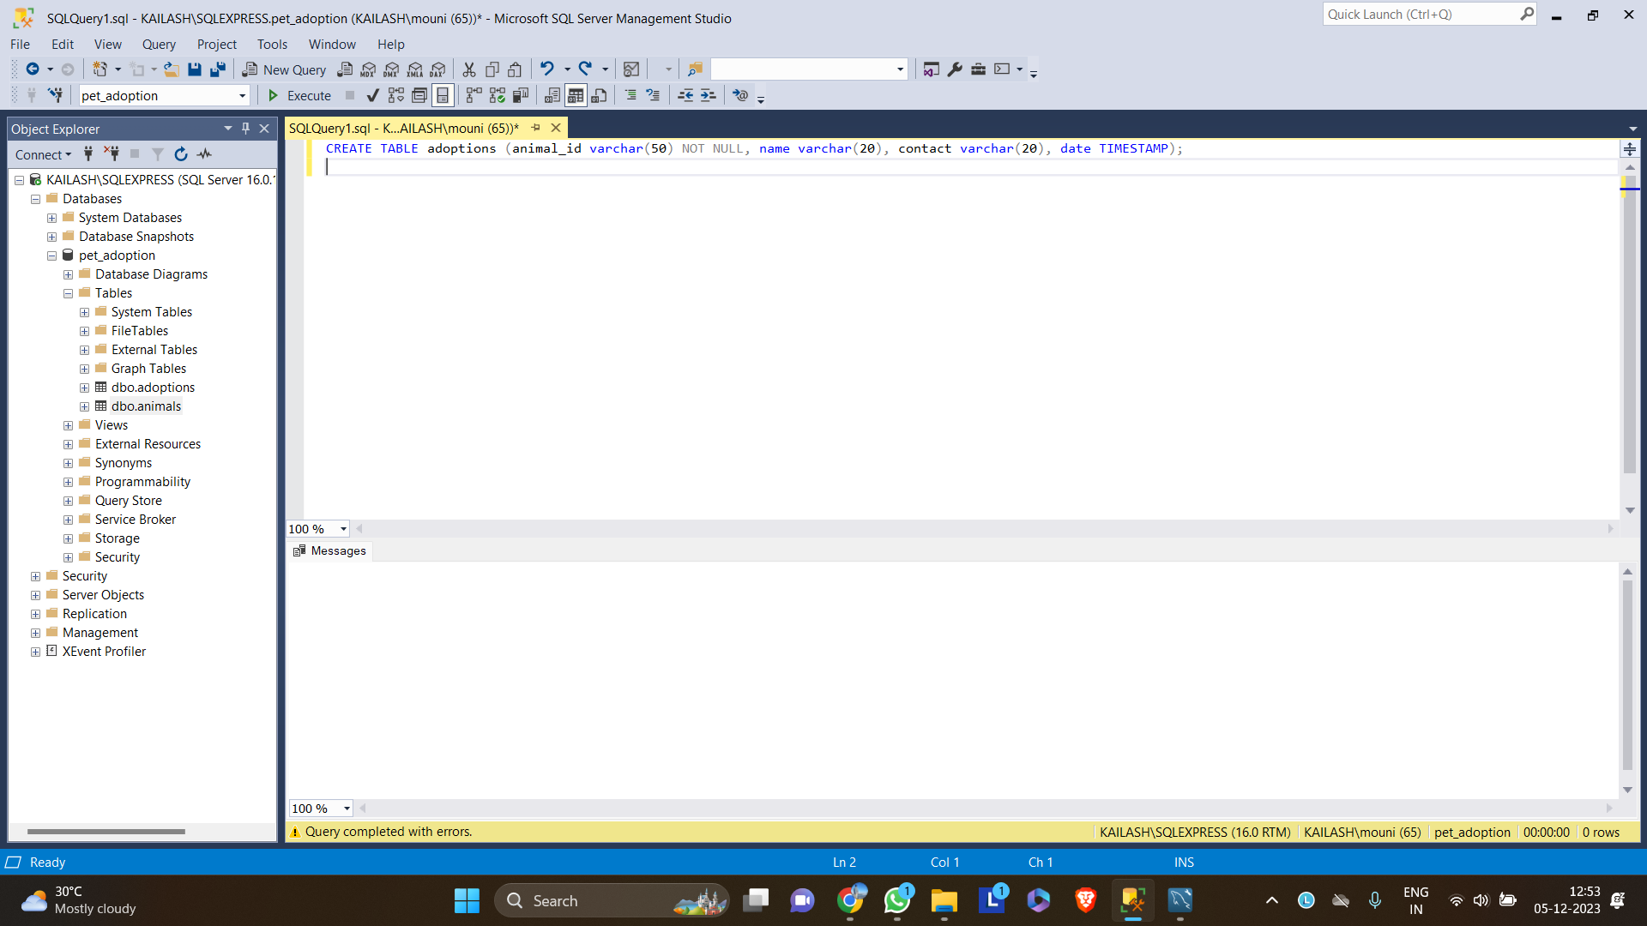

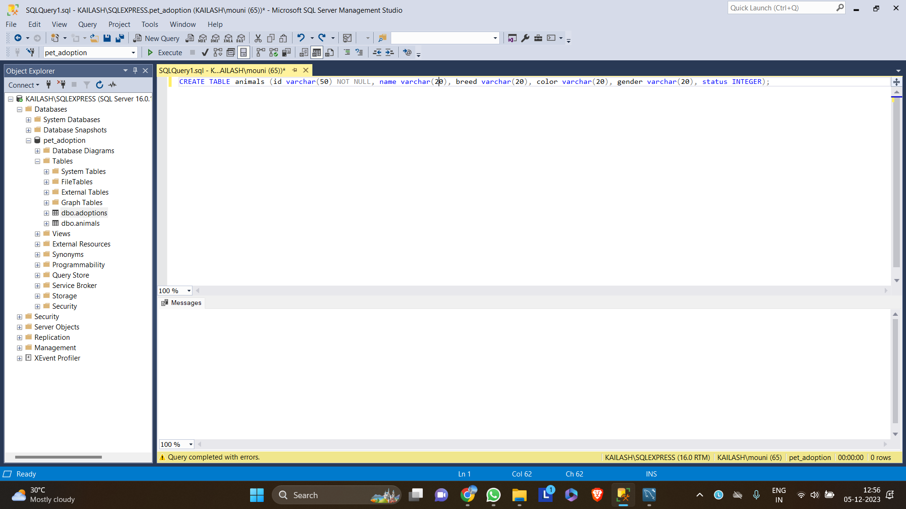

ALTER:

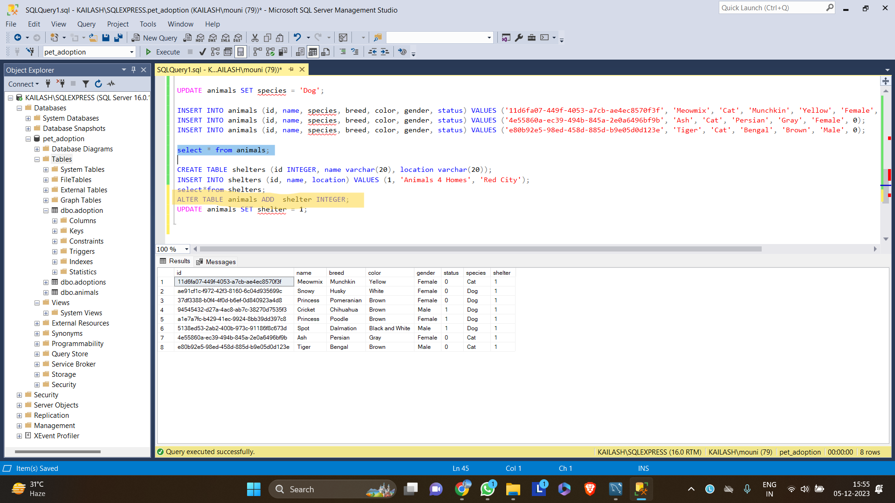

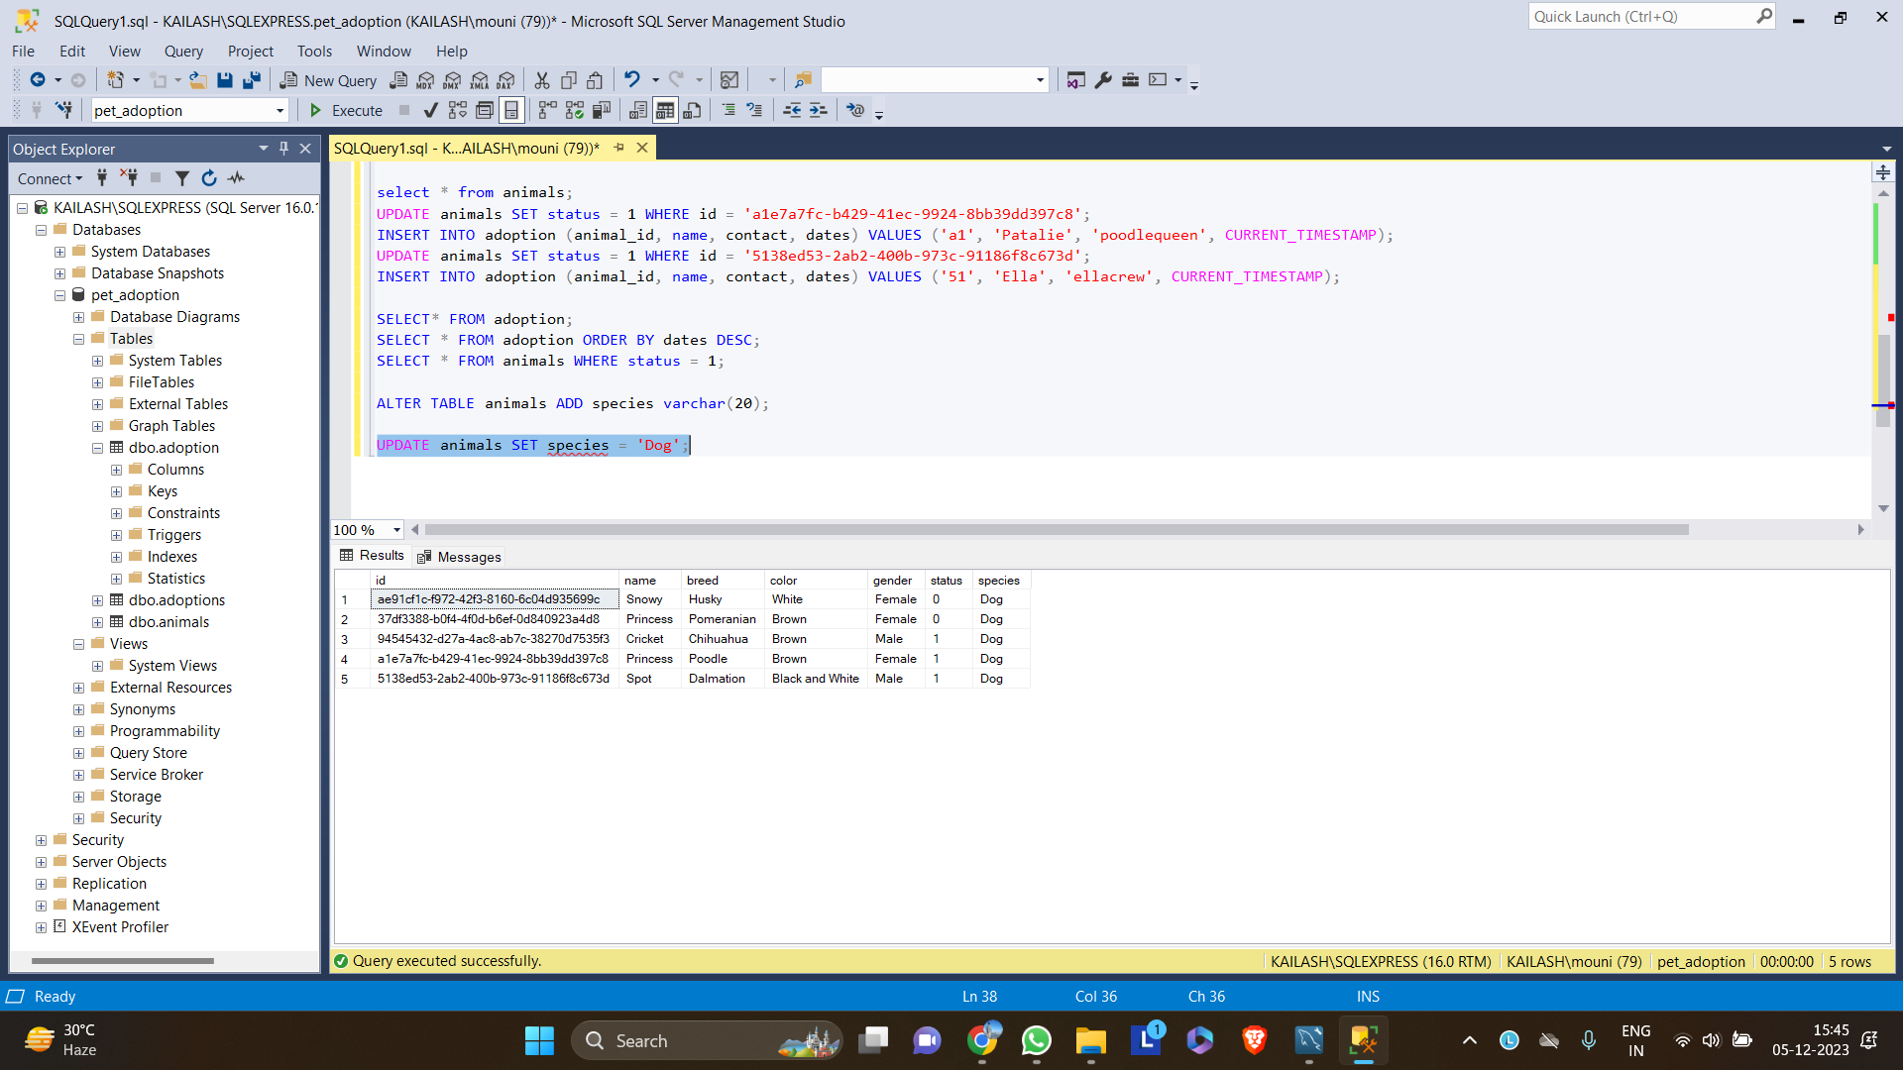

DROP:

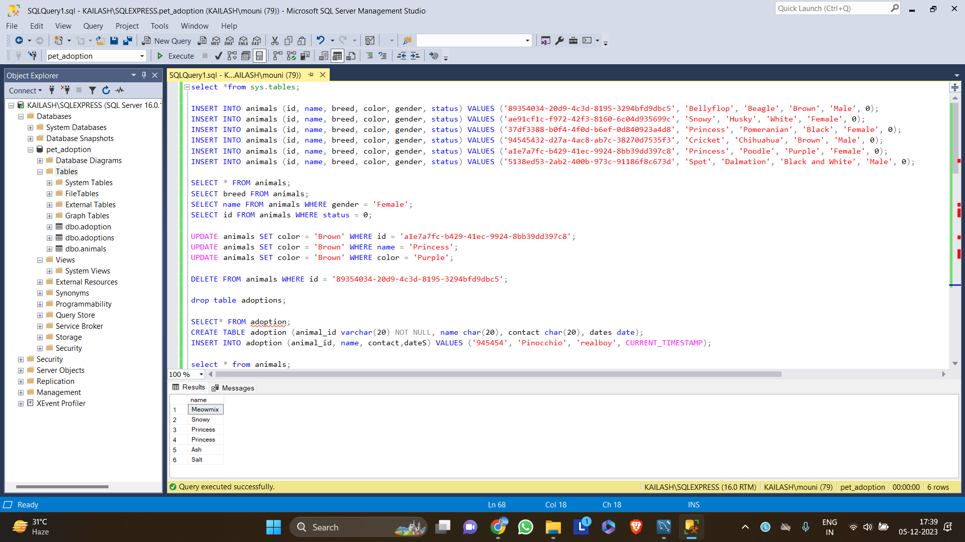

**Data Manipulation Language:**

SELECT:

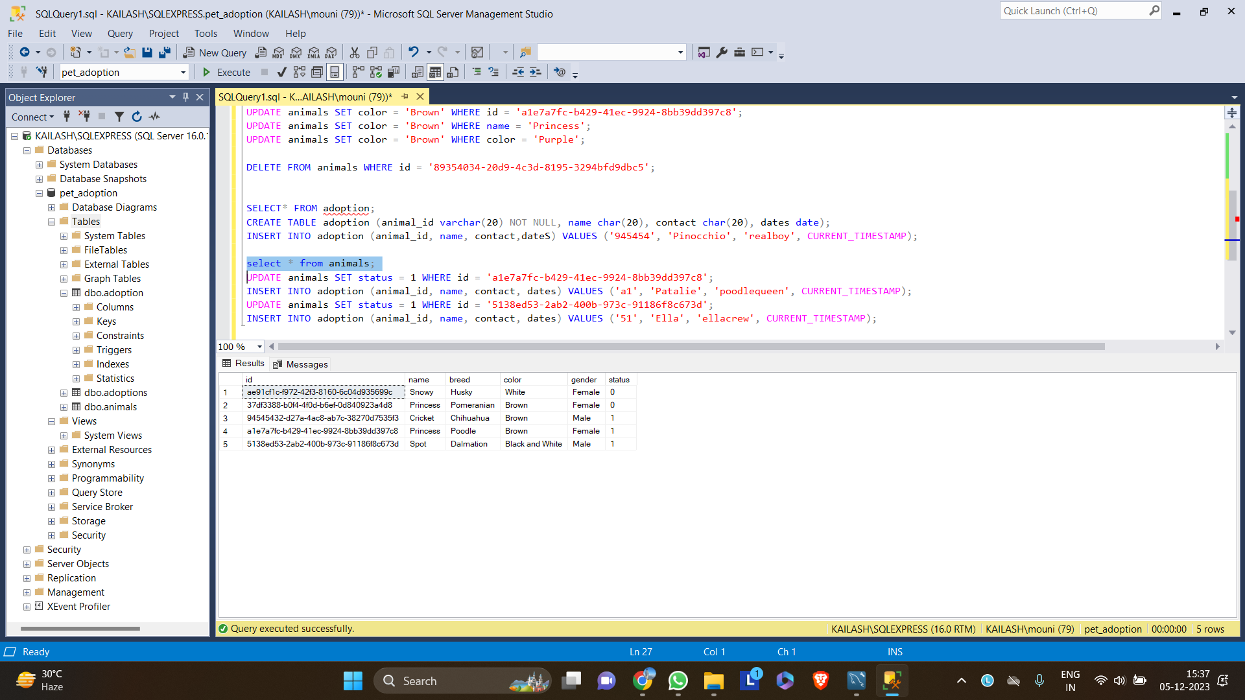

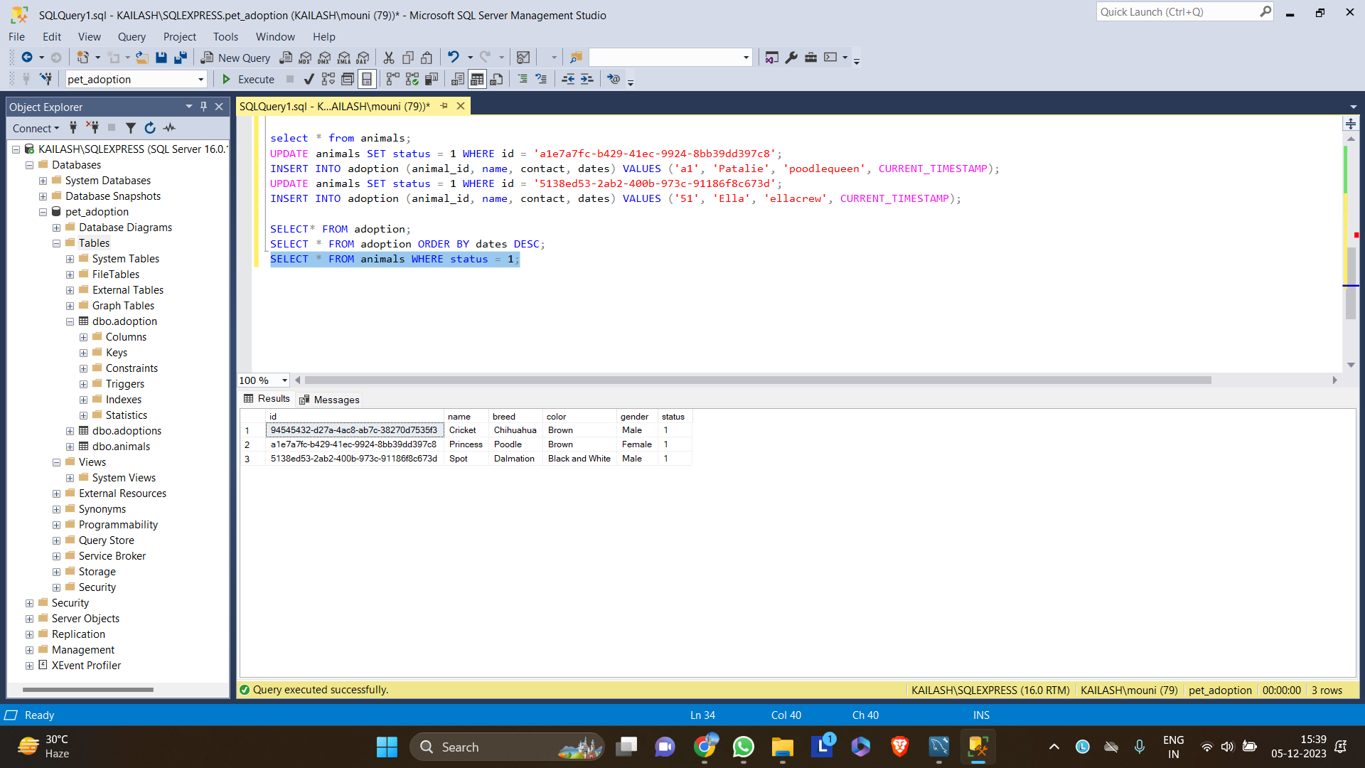

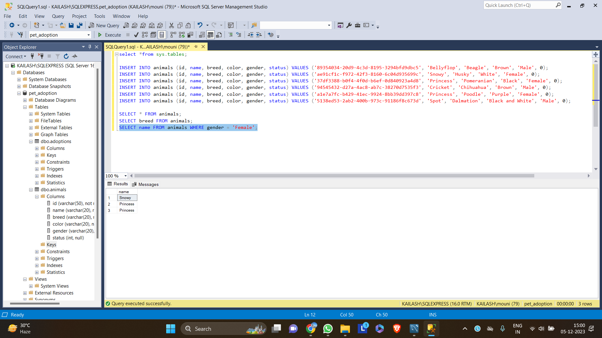

INSERT:

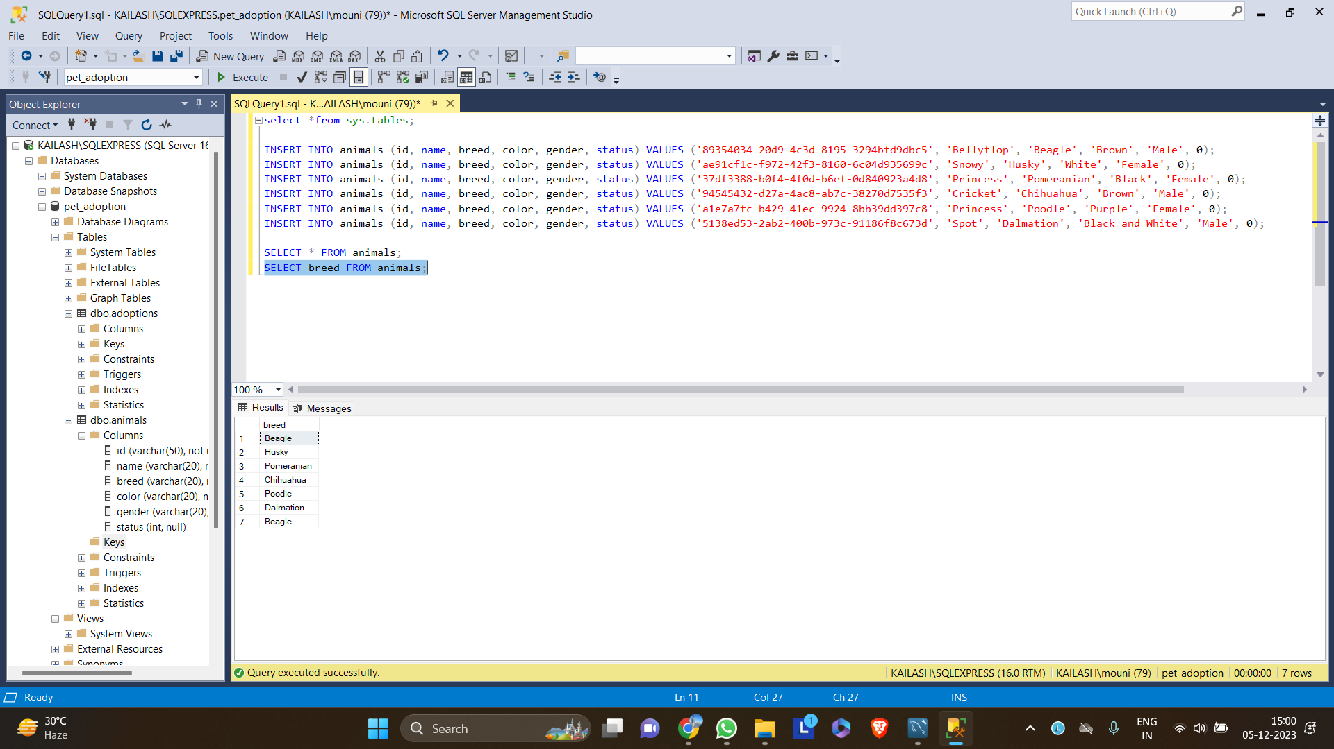

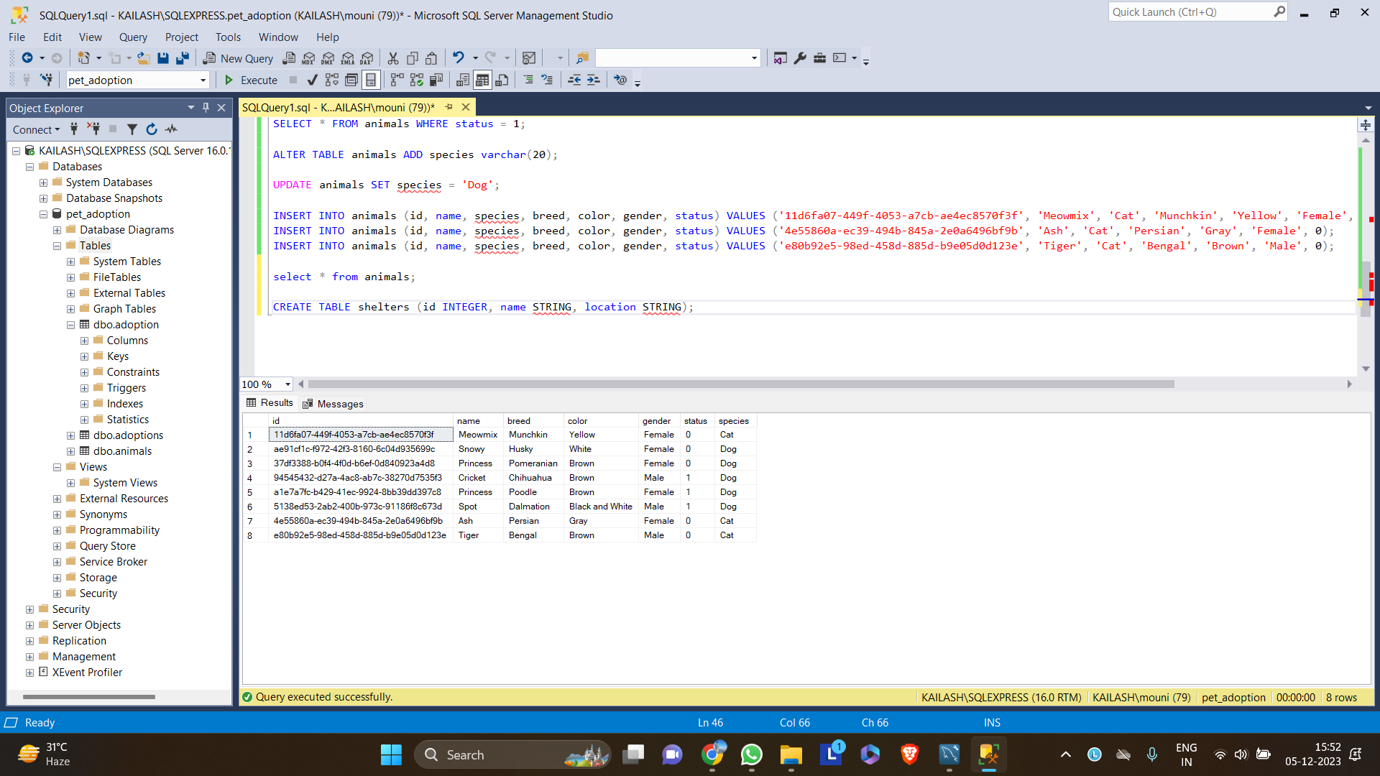

UPDATE:



DELETE:

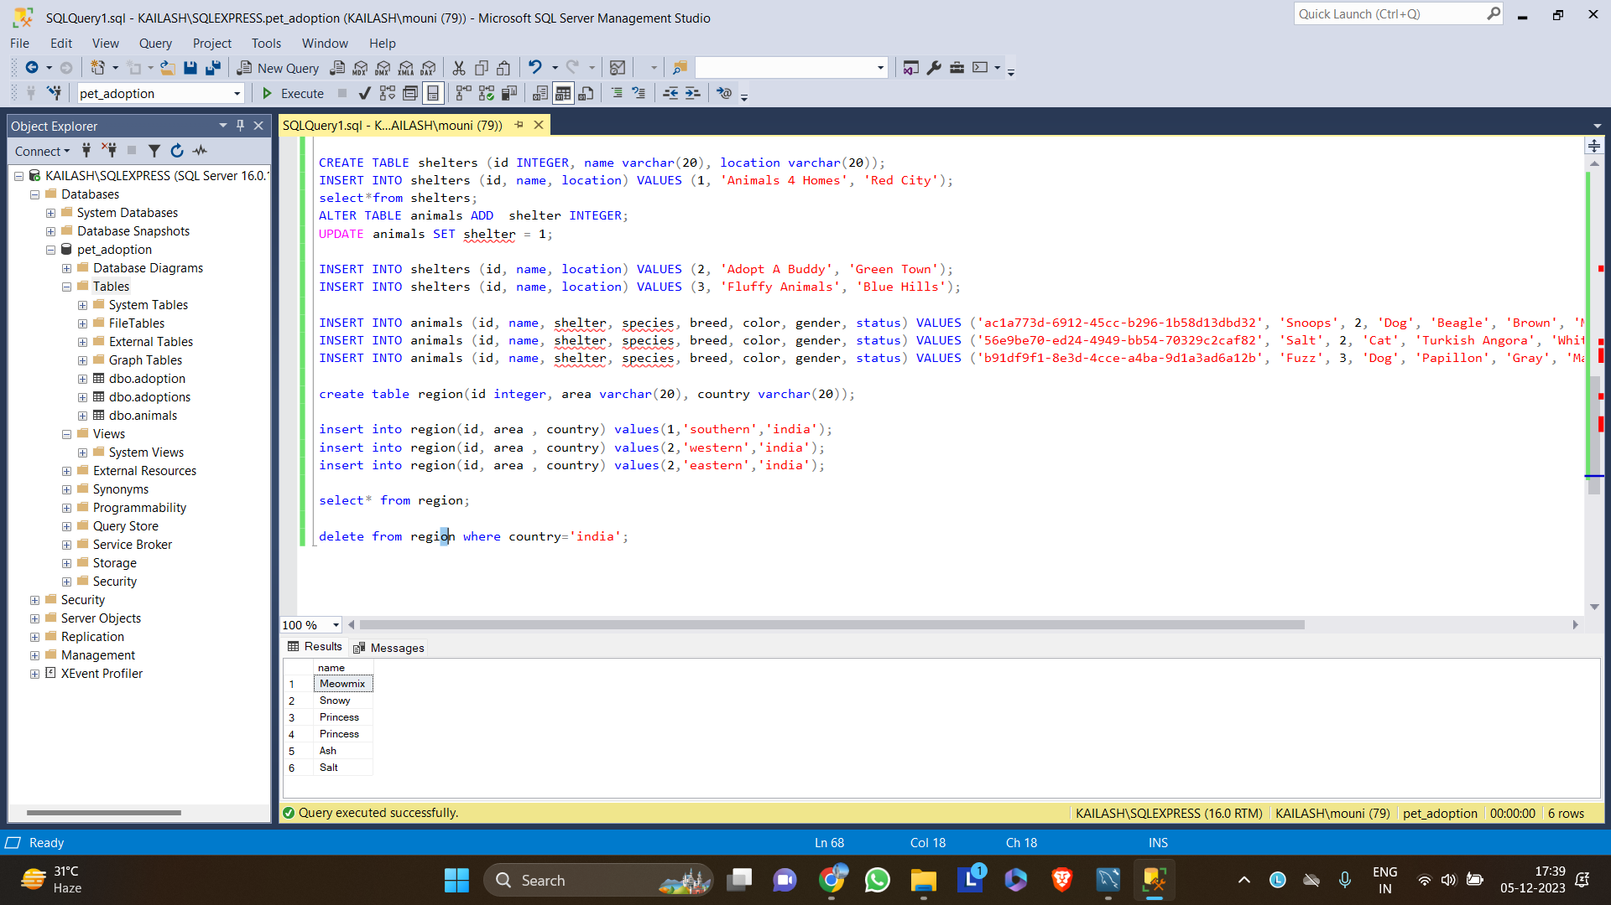

This is database of **pet adoptions** where three tables were created. **animals** table for detail of animals, **adoption** table for detail of adoption of pets and **shelter** table for detail of growing pet stores. The commands used here are **CREATE, ALTER, DROP, TRUNCATE, SELECT, UPDATE, DELETE** ETC.