45-DAYS INDUSTRIAL TRAINING REPORT
ON
SALES FORCASTING SYSTEM
COMPLETED AT
WHITEHAT CODERS

By
KAILASH CHAUDHARY
Roll No.23303142



DEPARTMENT OF COMPUTER SCIENCE AND ENGINEERING SARDAR BEANT SINGH STATE UNIVERSITY, GURDASPUR
July, 2026

CERTIFICATE

About the Company



ABOUT US
WHITE HAT CODERS is India based leading strategic IT Company offering integrated IT solutions with the vision to provide Excellence in software solution. We at WHITE HAT CODERS bring innovative ideas and cutting edge technologies into business of customers.WHITE HAT CODERS is having rich experience in providing high technology end to end solutions in MOBILE APP AND WEB DEVELOPMENT.

4

PHILOSOPHY

- To impart hard-core practical quality training among students/developers about latest technologies trending today.
- To share knowledge of information security and create awareness in the market. The solution to clients' as per the International standard practices and governance.

- To support good business practices through continual employee training and education

- To equip a local team with a strong knowledge of international best practices and international expert support so as to provide practical advisories in the best interests of our clients

OUR MISSION


To Protect Client's information system by
Detecting Threats, Deterring Attacks, and provide best solution in the ever changing
Info - Security Challenges. We accomplish this by integrating our People, Process, and Technology in the most efficient way to increase value for all stakeholders

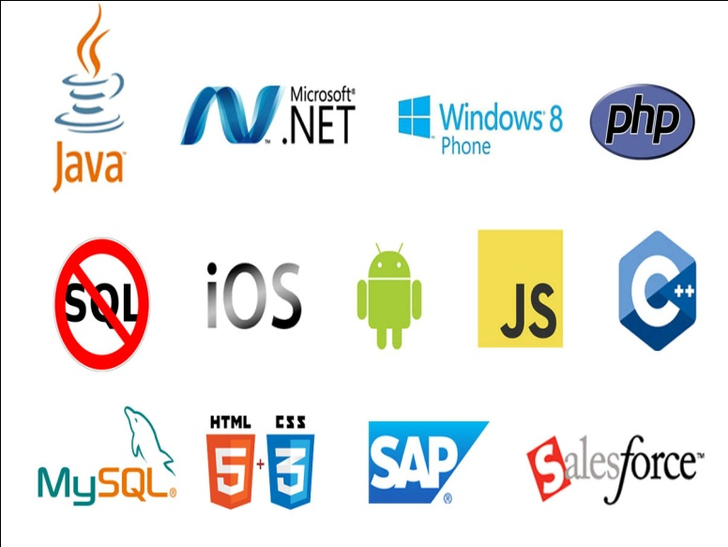
OUR SERVICES

- RISK Management Services

- Quality Control

- Business Process Re-Engineering
- Network Risk Analysis
- Software Testing

- Mobile Application Testing
- Wireless Penetration Testing
- Network Penetration Testing
- Application Security Testing

OUR SERVICES IN SOFTWARE DEVELOPMENT

We are proficient in all platforms of software Development practices — Agile, SCRUM, Lean, Waterfall, Prototype, Incremental, Iterative, and V-Mo
OUR CLIENTS


Abstract
Agriculture plays a vital role in the economy of many countries, and improving crop productivity is essential for ensuring food security and sustainable farming. Farmers often face challenges in selecting suitable crops, estimating crop yield, and choosing the appropriate fertilizer due to changing weather conditions, soil characteristics, and agricultural practices. The Agri Advisor – Crop Yield Prediction & Fertilizer Recommendation System is a machine learning-based application developed to assist farmers in making informed agricultural decisions.
The system utilizes historical agricultural datasets containing information such as rainfall, temperature, humidity, soil nutrients, and crop details. By applying the Random Forest Machine Learning Algorithm, the application predicts the expected crop yield and recommends the most suitable fertilizer based on the given input parameters. Data preprocessing techniques such as cleaning, handling missing values, feature selection, and model training are performed to improve prediction accuracy and reliability.
The project is developed using Python and Streamlit, providing a simple, interactive, and user-friendly web interface. The application enables users to enter agricultural parameters, generate crop yield predictions, and receive fertilizer recommendations instantly. Visualization libraries such as Matplotlib are used to present meaningful insights and improve the understanding of prediction results.
The Agri Advisor system demonstrates the practical application of machine learning in modern agriculture by integrating data analysis, predictive modeling, and interactive visualization into a single platform. It helps farmers reduce uncertainty, optimize fertilizer usage, improve crop productivity, and support sustainable farming practices. This project represents a complete end-to-end data science solution, transforming raw agricultural data into actionable insights for smarter and more efficient farming.

Acknowledgment
I would like to express my sincere gratitude to Ms. Kamal Saini, our respected instructor, for her constant guidance, encouragement, and valuable suggestions throughout the development of the Agri Advisor – Crop Yield Prediction & Fertilizer Recommendation System. Her continuous support and technical expertise motivated me to successfully complete this project.
I am also thankful to the Department of Computer Science and Engineering, Sardar Beant Singh State University, Gurdaspur, for providing me with the opportunity to work on this project and enhance my practical knowledge in the fields of Data Science and Machine Learning.
I would like to extend my heartfelt thanks to all the faculty members, friends, and classmates who directly or indirectly contributed through their suggestions, discussions, and encouragement during the project development process.
Finally, I express my gratitude to the developers and contributors of Python, Streamlit, Scikit-learn, Pandas, NumPy, Matplotlib, and the open-source community for providing excellent tools, libraries, and learning resources that made the successful implementation of this project possible.
I sincerely acknowledge everyone who supported me during this project and helped me gain valuable practical experience in applying Machine Learning techniques to solve real-world agricultural problems.

TABLE OF CONTENTS

Sr. No. Topics / Headings Page No.

I. Title Page 1

II. Certificate 2

III. About the Company 3–5

IV. Abstract 6

V. Acknowledgment 7

VI. Table of Contents 8–10

Chapter 1: Introduction 11–14
1.1 Introduction to Project
1.2 Problem Definition
1.3 Objectives
1.3.1 Functional Objectives
1.3.2 Technical Objectives

Chapter 2: Implementation 15–19
2.1 Introduction to Technologies
2.2 Development Environment (VS Code & Streamlit)
2.3 System Architecture
2.3.1 Data Collection
2.3.2 Data Preprocessing
2.3.3 Feature Selection
2.3.4 Random Forest Model
2.3.5 Crop Yield Prediction
2.3.6 Fertilizer Recommendation
2.3.7 Streamlit User Interface
2.4 Project Implementation Phases

Chapter 3: Software and Model Testing 20–22
3.1 Introduction to Testing
3.2 Unit Testing
3.3 Machine Learning Model Testing
3.4 Integration Testing
3.5 System & User Interface Testing
3.6 Error Handling

Chapter 4: System Maintenance 23–24
4.1 Introduction to Maintenance
4.2 Model Retraining
4.3 Data Management
4.4 Future Updates

Chapter 5: Requirement Analysis & System Specification 25–27
5.1 Introduction to Requirement Analysis
5.2 Feasibility Study
5.2.1 Technical Feasibility
5.2.2 Economic Feasibility
5.2.3 Operational Feasibility
5.2.4 Schedule Feasibility
5.3 Data Requirements
5.4 Software Development Life Cycle (SDLC)

Chapter 6: Hardware & Software Requirements 28–30
6.1 Hardware Requirements
6.2 Software Requirements
6.3 Development Tools
6.4 Data Flow Diagram (DFD)
6.4.1 Level 0 DFD
6.4.2 Level 1 DFD

Chapter 7: Project Screenshots 31–33

Chapter 8: Conclusion & Future Scope 34–35
8.1 Summary
8.2 Conclusion
8.3 Future Scope

Chapter 9: Bibliography 36
9.1 Books & Research Papers
9.2 Official Documentation
9.3 Online Resources

CHAPTER 1
INTRODUCTION
1.1 Introduction to Project
Agriculture is one of the most important sectors of every country's economy, providing food, employment, and raw materials for various industries. Farmers face many challenges such as unpredictable weather conditions, soil nutrient imbalance, improper fertilizer usage, and lack of scientific decision-making. These challenges often result in low crop productivity and financial losses. With the advancement of Artificial Intelligence (AI) and Machine Learning (ML), it has become possible to analyze agricultural data and provide accurate recommendations that help farmers make better decisions.
The Agri Advisor – Crop Yield Prediction & Fertilizer Recommendation System is a Machine Learning-based web application developed to assist farmers in improving agricultural productivity. The system predicts crop yield and recommends suitable fertilizers based on important agricultural parameters such as rainfall, temperature, humidity, soil pH, Nitrogen (N), Phosphorus (P), Potassium (K), and crop type.
The project is developed using Python and Streamlit, while the Random Forest Algorithm is used as the Machine Learning model because of its high accuracy and reliability. The application provides a simple and interactive interface where users can enter agricultural data and receive instant predictions.
The main objective of this project is to support smart farming practices by reducing manual effort, improving crop planning, and promoting efficient fertilizer management. The system can also be extended in the future by integrating weather forecasting APIs, IoT sensors, mobile applications, and cloud-based technologies.

1.2 Problem Definition
Traditional farming practices mainly depend on farmers' experience and assumptions while selecting fertilizers and estimating crop production. Incorrect decisions regarding fertilizer application, irrigation, and crop planning often reduce productivity and increase cultivation costs. Moreover, changing climatic conditions make agricultural decision-making more difficult.
Although large amounts of agricultural data are available, many farmers do not have access to intelligent systems that can analyze this information effectively. As a result, valuable data remains underutilized.
The Agri Advisor system addresses these challenges by using Machine Learning to analyze agricultural parameters and generate accurate crop yield predictions along with fertilizer recommendations. The system helps farmers make informed decisions, reduce unnecessary fertilizer usage, and improve overall agricultural productivity.

1.3 Objectives
The primary objective of the Agri Advisor project is to develop an intelligent decision support system for agriculture using Machine Learning techniques. The application aims to provide reliable crop yield predictions and fertilizer recommendations through an easy-to-use web interface.
The project also focuses on improving farming efficiency, reducing cultivation costs, promoting balanced fertilizer usage, and supporting sustainable agricultural practices. Another important objective is to demonstrate the practical application of Data Science and Machine Learning in solving real-world agricultural problems.

1.3.1 Functional Objectives
- Predict crop yield using the Random Forest Machine Learning algorithm.
- Recommend suitable fertilizers based on soil nutrient values.
- Accept agricultural parameters through a Streamlit web interface.
- Display prediction results instantly.
- Provide graphical visualization of agricultural data.
- Improve farming decisions using data-driven analysis.
- Reduce unnecessary fertilizer usage.
- Support sustainable and smart farming practices.

1.3.2 Technical Objectives
- Develop the application using Python.
- Build the user interface using Streamlit.
- Perform data preprocessing using Pandas and NumPy.
- Train the Machine Learning model using Scikit-learn.
- Use the Random Forest algorithm for prediction.
- Generate graphs using Matplotlib.
- Create a scalable and maintainable project structure.
- Allow future integration with weather APIs, IoT devices, and cloud platforms.

CHAPTER 2
IMPLEMENTATION
2.1 Introduction to Technologies
The Agri Advisor – Crop Yield Prediction & Fertilizer Recommendation System is developed using modern technologies including Python, Streamlit, Pandas, NumPy, Matplotlib, and Scikit-learn. These technologies provide an efficient environment for data processing, machine learning model development, and web application deployment.
Python is used as the programming language because of its simplicity and strong support for Machine Learning. Streamlit is used to develop an interactive web interface, while Pandas and NumPy are used for data preprocessing and numerical operations. Matplotlib is used for graphical visualization, and the Random Forest algorithm from Scikit-learn performs crop yield prediction and fertilizer recommendation.

2.2 Development Environment (VS Code & Streamlit)
The project was developed using Visual Studio Code (VS Code) as the coding environment. VS Code provides syntax highlighting, debugging tools, integrated terminal, and Git support, making development easier.
The web application is built using Streamlit, which allows users to enter agricultural details through an interactive interface. The application is executed using:
streamlit run app.py
The interface displays prediction results instantly after processing the user inputs.
📌 Insert Fig. 2.1 – VS Code Development Environment

2.3 System Architecture
The Agri Advisor system follows a modular architecture. Users enter agricultural parameters such as rainfall, temperature, humidity, soil pH, Nitrogen, Phosphorus, Potassium, and crop type through the Streamlit interface. The input data is preprocessed and passed to the trained Random Forest model. The model predicts crop yield and recommends suitable fertilizers. Finally, the results are displayed through the web application along with graphical visualization.
📌 Insert Fig. 2.2 – Agri Advisor System Architecture

2.3.1 Data Collection
Agricultural datasets were collected from publicly available sources. The dataset contains rainfall, temperature, humidity, soil pH, Nitrogen, Phosphorus, Potassium, crop names, fertilizer information, and crop yield values.
The collected data was checked for duplicate records, missing values, and inconsistent entries before being used for model training.

2.3.2 Data Preprocessing
Data preprocessing improves dataset quality before training the Machine Learning model. Missing values and duplicate records were removed, while categorical values were converted into numerical format. The cleaned dataset was then prepared for model training.

2.3.3 Feature Selection
Feature selection identifies the most important variables influencing crop yield prediction. Parameters such as rainfall, temperature, humidity, soil pH, Nitrogen, Phosphorus, Potassium, and crop type were selected because they significantly affect agricultural productivity.

2.3.4 Random Forest Model
The Random Forest algorithm was selected because it provides high prediction accuracy and reduces overfitting. Multiple decision trees are trained using agricultural data, and the final prediction is generated by combining their outputs. This approach improves reliability and overall prediction performance.

2.3.5 Crop Yield Prediction
The trained Random Forest model predicts crop yield based on the agricultural parameters entered by the user. The generated prediction helps farmers estimate crop production and make better farming decisions.
📌 Insert Fig. 2.3 – Crop Yield Prediction Output

2.3.6 Fertilizer Recommendation
The fertilizer recommendation module analyzes soil nutrient values and crop type to suggest the most suitable fertilizer. This helps farmers improve soil fertility, reduce fertilizer wastage, and increase agricultural productivity.
📌 Insert Fig. 2.4 – Fertilizer Recommendation Output

2.3.7 Streamlit User Interface
The Streamlit interface provides a simple and interactive platform for users. Farmers can enter agricultural parameters through input fields and receive crop yield predictions and fertilizer recommendations within a few seconds. The interface also displays graphs and prediction summaries, making the application easy to understand and use.
📌 Insert Fig. 2.5 – Streamlit Home Page

2.4 Project Implementation Phases
The implementation of the Agri Advisor project was completed in the following phases:
- Requirement Analysis
- Data Collection
- Data Preprocessing
- Feature Selection
- Model Training using Random Forest
- Streamlit Application Development
- Testing and Validation
- Deployment and Documentation
These phases ensured the successful development of an efficient and reliable agricultural advisory system

CHAPTER 3 : SOFTWARE AND MODEL TESTING
3.1 Introduction to Testing
Testing is one of the most important phases in the Software Development Life Cycle (SDLC). It ensures that the developed application functions correctly, produces accurate results, and satisfies all user requirements. In Machine Learning applications, testing is even more critical because both the software functionality and the prediction model must be validated before deployment.
The Agri Advisor – Crop Yield Prediction & Fertilizer Recommendation System was thoroughly tested to verify its reliability, prediction accuracy, usability, and overall system performance. The testing process included verification of user inputs, machine learning predictions, system integration, graphical user interface, and error handling mechanisms. Various testing techniques were performed to ensure that every component of the application works efficiently under different operating conditions.
The primary objective of testing was to identify software defects, eliminate logical errors, improve prediction reliability, and ensure that the application provides accurate crop yield predictions and fertilizer recommendations. Multiple test cases were executed using different agricultural input values to validate the correctness of prediction results. The testing process also evaluated system response time, interface usability, and compatibility with different user inputs.
Proper software testing increases user confidence, improves system stability, minimizes operational failures, and ensures smooth execution of the application in real-world agricultural environments.

3.2 Unit Testing
Unit Testing is the process of testing individual components or modules of a software application independently to ensure that each unit performs its intended function correctly. Every module of the Agri Advisor system was tested separately before integrating it into the complete application.
The Data Loading Module was tested to verify that agricultural datasets were loaded successfully without data corruption or missing records. The Data Preprocessing Module was tested to ensure that missing values, duplicate records, and invalid inputs were correctly handled.
The Machine Learning Module was tested independently to verify that the Random Forest algorithm generated prediction results successfully after training. Various agricultural input combinations were supplied to evaluate the consistency and reliability of prediction outputs.
The Streamlit Interface Module was tested to ensure that all input fields accepted valid user inputs and displayed prediction results correctly. Buttons, forms, dropdown menus, and graphical outputs were verified to ensure smooth functionality.
Each unit successfully passed testing without major defects. Any minor issues identified during testing were corrected before moving to the integration phase.

3.3 Machine Learning Model Testing
Machine Learning Model Testing evaluates the accuracy and reliability of the trained prediction model using unseen testing data. Since the Agri Advisor system depends on Machine Learning for crop yield prediction and fertilizer recommendation, validating the model was an essential step.
The agricultural dataset was divided into training and testing datasets. The Random Forest algorithm was trained using the training dataset, while prediction performance was evaluated using the testing dataset.
Several prediction samples were analyzed to compare predicted values with actual values available in the dataset. Different evaluation methods were used to measure the overall performance of the model and determine whether the algorithm generalized well for unseen data.
The Random Forest model demonstrated high prediction accuracy because it combines multiple decision trees and minimizes overfitting. The algorithm successfully handled multiple agricultural parameters such as rainfall, temperature, humidity, soil pH, Nitrogen, Phosphorus, Potassium, and crop information.
The prediction model generated reliable crop yield estimates and fertilizer recommendations for different agricultural conditions. The testing process confirmed that the trained model was suitable for deployment in the Streamlit application.

3.4 Integration Testing
Integration Testing verifies that all software modules communicate correctly after being combined into a single application. In the Agri Advisor project, several independent modules such as data preprocessing, machine learning prediction, fertilizer recommendation, visualization, and Streamlit interface were integrated together.
Testing was performed to verify the complete data flow from user input to prediction output. Users entered agricultural parameters through the Streamlit interface, which were then processed by the preprocessing module before being passed to the Random Forest model.
The prediction results generated by the Machine Learning model were successfully transferred to the output module and displayed through the user interface without any interruption. Graphical visualizations were also generated correctly using Matplotlib.
Integration testing confirmed that all modules exchanged data properly without communication errors or data loss. The application maintained consistent performance throughout the prediction process.

3.5 System & User Interface Testing
System Testing evaluates the complete software application under real operating conditions to verify that all functional and non-functional requirements have been satisfied. The Agri Advisor application was tested using different agricultural scenarios to ensure proper execution of all system functionalities.
The Streamlit interface was examined for usability, navigation, responsiveness, and accessibility. All input fields accepted user data correctly, while prediction buttons executed the Machine Learning model successfully.
Various combinations of agricultural parameters were entered to verify that crop yield prediction and fertilizer recommendation results were displayed accurately. Invalid inputs were also tested to ensure that the application handled unexpected situations appropriately.
The application demonstrated fast response time and smooth navigation throughout the testing process. Graphical charts and prediction summaries were displayed correctly, providing users with meaningful information in a simple and understandable format.
Overall, the system met all functional requirements and provided a reliable, user-friendly, and efficient environment for agricultural prediction and decision support.

3.6 Error Handling
Error handling is an important aspect of software development because it prevents application failure and improves user experience. The Agri Advisor system includes appropriate validation and exception handling mechanisms to manage invalid inputs and unexpected situations effectively.
Input validation was implemented to ensure that users provide valid numerical values for agricultural parameters such as rainfall, temperature, humidity, soil pH, Nitrogen, Phosphorus, and Potassium. Invalid or incomplete inputs generate meaningful warning messages instead of causing application failure.
The application also handles missing datasets, incorrect file paths, model loading failures, and unexpected runtime exceptions using Python's exception handling techniques. Error messages are displayed in a user-friendly manner so that users can easily understand the problem and correct it.
During Machine Learning prediction, the system verifies that all required input parameters are available before executing the Random Forest model. This prevents incorrect predictions caused by incomplete information.
Proper error handling significantly improves application stability, reduces software crashes, enhances prediction reliability, and provides a smooth user experience. It also makes the system easier to maintain and upgrade in future versions.

CHAPTER 4 : SYSTEM MAINTENANCE
4.1 Introduction to Maintenance
System maintenance is one of the most important phases in the Software Development Life Cycle (SDLC). After the successful development and deployment of a software application, continuous maintenance is required to ensure that the system performs efficiently, remains reliable, and adapts to changing user requirements. Maintenance helps in correcting software errors, improving performance, updating machine learning models, and adding new functionalities whenever necessary.
The Agri Advisor – Crop Yield Prediction & Fertilizer Recommendation System has been designed with a modular architecture, making it easier to maintain and upgrade. Since agricultural conditions continuously change due to climate variations, soil conditions, and farming practices, the application requires periodic updates to maintain prediction accuracy and system reliability.
Regular maintenance ensures that the machine learning model remains accurate with newly collected agricultural data. Software libraries, security updates, and application components are also maintained to improve compatibility with newer technologies. The Streamlit interface is periodically reviewed to enhance usability and provide a better user experience.
The maintenance process includes correcting software bugs, improving prediction performance, updating datasets, optimizing system resources, and introducing additional features based on user feedback. Proper maintenance increases the lifespan of the application and ensures that it continues to provide reliable agricultural recommendations for farmers and researchers.
4.2 Model Retraining
Machine Learning models require periodic retraining because agricultural conditions change over time. Factors such as climate change, rainfall variation, soil nutrient levels, crop varieties, and farming techniques continuously influence crop production. If the model is trained only once and never updated, its prediction accuracy may gradually decrease.
The Agri Advisor system supports model retraining using newly collected agricultural datasets. New data is first cleaned and preprocessed before being added to the existing dataset. The Random Forest algorithm is then retrained using the updated dataset so that it can learn new agricultural patterns and improve its prediction capability.
Model retraining helps the system adapt to changing farming conditions and increases the reliability of crop yield prediction and fertilizer recommendation. After retraining, the updated model is evaluated using testing datasets before deployment to ensure that prediction accuracy has improved.
Periodic retraining ensures that the application remains accurate, efficient, and useful for real-world agricultural decision-making.

4.3 Data Management
Effective data management is essential for maintaining the quality and reliability of any Machine Learning application. Since the Agri Advisor system depends on agricultural datasets for prediction, proper storage, organization, and maintenance of data are extremely important.
The collected agricultural data is stored in a structured format that allows easy access during preprocessing, model training, and prediction. Duplicate records, missing values, and incorrect entries are regularly identified and removed to maintain data quality.
Backup procedures are also implemented to prevent data loss due to hardware failure or accidental deletion. Version control techniques help maintain different versions of datasets and trained Machine Learning models for future reference.
Data security is another important aspect of data management. Access to sensitive files and trained models is controlled to prevent unauthorized modifications. Proper documentation is maintained for datasets, preprocessing steps, and model versions to simplify future maintenance and upgrades.
Efficient data management improves model performance, reduces processing time, and ensures consistent prediction accuracy throughout the application's lifecycle.

4.4 Future Updates
The Agri Advisor system has been developed with flexibility and scalability so that additional features can be incorporated in future versions. Continuous technological advancements provide opportunities to improve the application and make it more beneficial for farmers.
One of the major future enhancements is the integration of real-time weather forecasting APIs, allowing the system to consider current weather conditions while generating crop yield predictions. This will further improve prediction accuracy.
The application can also be integrated with IoT-based soil sensors to automatically collect soil moisture, temperature, humidity, and nutrient values directly from agricultural fields. This will eliminate manual data entry and provide real-time recommendations.
A mobile application can be developed so that farmers can access the system from smartphones without requiring a desktop computer. Multilingual support can also be added to make the application more accessible to farmers from different regions.
Future versions may include satellite image analysis, disease detection using Deep Learning, crop recommendation, market price prediction, irrigation management, and government scheme recommendations. These features will transform the application into a complete Smart Agriculture Decision Support System.
Cloud deployment can also be implemented to allow users to access the application from anywhere with an internet connection. Additional Machine Learning and Deep Learning algorithms can be incorporated to further improve prediction accuracy and system performance.
Overall, future updates will enhance the intelligence, scalability, usability, and reliability of the Agri Advisor system, making it a comprehensive digital solution for modern agriculture.

CHAPTER 5 : REQUIREMENT ANALYSIS & SYSTEM SPECIFICATION
5.1 Introduction to Requirement Analysis
Requirement Analysis is one of the most important phases in the Software Development Life Cycle (SDLC). It involves identifying, analyzing, and documenting the functional and non-functional requirements of a software system before development begins. A well-defined requirement analysis helps developers understand user expectations, system objectives, technical constraints, and project scope, resulting in the successful implementation of the application.
For the Agri Advisor – Crop Yield Prediction & Fertilizer Recommendation System, requirement analysis was performed to understand the needs of farmers, agricultural researchers, and other users. The primary objective of the system is to predict crop yield and recommend suitable fertilizers using Machine Learning techniques. During this phase, all necessary functional requirements, technical requirements, hardware requirements, software requirements, and data requirements were carefully analyzed.
The system requires users to provide agricultural parameters such as rainfall, temperature, humidity, soil pH, Nitrogen (N), Phosphorus (P), Potassium (K), and crop type. Based on these inputs, the application generates crop yield predictions and fertilizer recommendations using the trained Random Forest Machine Learning model.
The requirement analysis also includes identifying system limitations, resource availability, software compatibility, security requirements, and future scalability. Proper requirement analysis minimizes development risks, reduces implementation errors, and improves overall software quality.
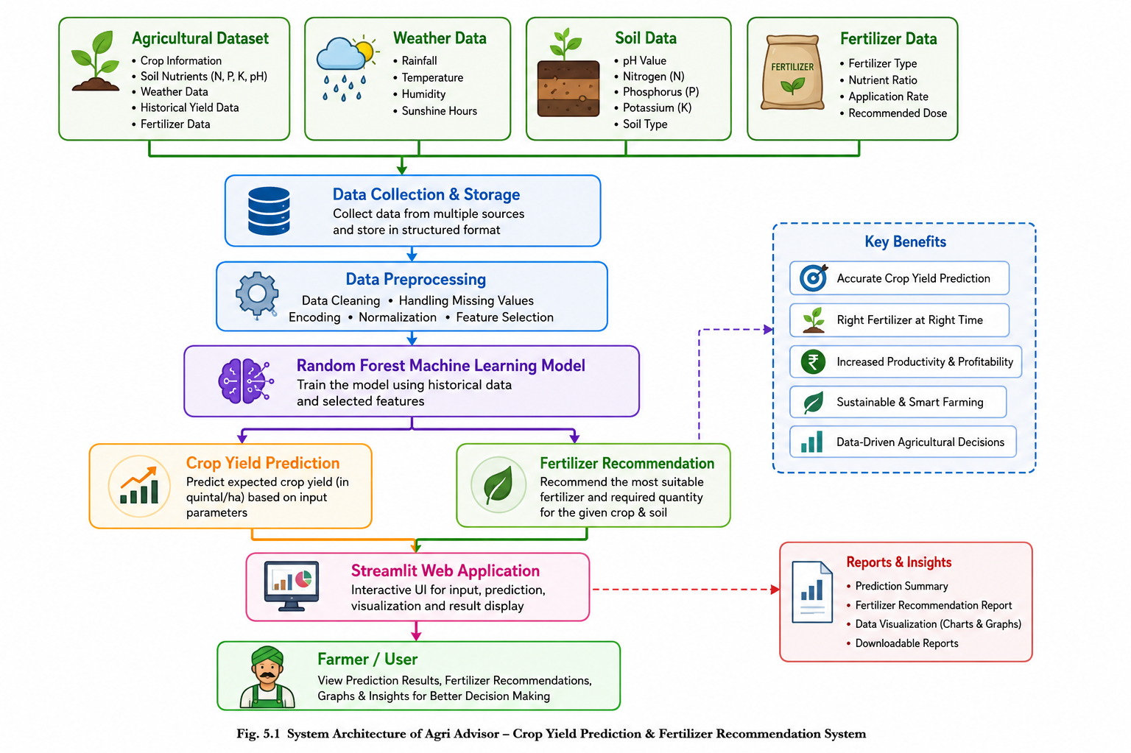

5.2 Feasibility Study
A feasibility study determines whether the proposed software project is technically, economically, operationally, and practically feasible before implementation. It evaluates the project's viability, available resources, development cost, expected benefits, and overall success probability.
The Agri Advisor project was analyzed from different feasibility perspectives to ensure that the system could be developed successfully using available technologies and resources.

5.2.1 Technical Feasibility
Technical feasibility evaluates whether the required hardware, software, programming languages, and development tools are available for implementing the project.
The Agri Advisor system is technically feasible because it uses open-source technologies such as Python, Streamlit, Pandas, NumPy, Matplotlib, and Scikit-learn. These technologies are widely used in Data Science and Machine Learning applications and require only a standard computer system for development and execution.
The Random Forest Machine Learning algorithm is highly suitable for agricultural prediction because it provides excellent accuracy, handles large datasets efficiently, and minimizes overfitting. The required development tools are freely available, making technical implementation simple and reliable.

5.2.2 Economic Feasibility
Economic feasibility determines whether the project can be developed within a reasonable budget while providing valuable benefits.
The Agri Advisor project is economically feasible because almost all software tools used during development are open-source and freely available. Python, Streamlit, VS Code, Pandas, NumPy, Matplotlib, and Scikit-learn do not require expensive software licenses.
Only a standard computer with internet access is required for development. Therefore, the total development cost is minimal while the expected benefits, including improved crop productivity and better fertilizer management, are significant.
The project provides a cost-effective solution for farmers and agricultural organizations by reducing unnecessary fertilizer usage and improving crop planning.

5.2.3 Operational Feasibility
Operational feasibility determines whether the proposed system can be successfully used by its intended users.
The Agri Advisor system is designed with a simple and interactive Streamlit interface that can be operated easily by users with basic computer knowledge. Farmers only need to enter agricultural parameters into the application, after which the system automatically generates crop yield predictions and fertilizer recommendations.
The application requires minimal training, responds quickly, and provides results in an understandable format. Therefore, the system is operationally feasible and suitable for practical agricultural use.

5.2.4 Schedule Feasibility
Schedule feasibility determines whether the project can be completed within the available time frame.
The Agri Advisor project follows a structured Software Development Life Cycle consisting of requirement analysis, data collection, preprocessing, model training, application development, testing, deployment, and documentation.
Each development phase was planned systematically, enabling the project to be completed within the allocated academic timeline. Proper project planning and modular implementation helped ensure timely completion without affecting software quality.

5.3 Data Requirements
Data is the foundation of every Machine Learning application. The prediction accuracy of the Agri Advisor system depends directly on the quality and quantity of agricultural data used for training the Machine Learning model.
The project requires agricultural datasets containing important features such as rainfall, temperature, humidity, soil pH, Nitrogen (N), Phosphorus (P), Potassium (K), crop type, fertilizer information, and crop yield values.
The collected datasets undergo preprocessing to remove duplicate records, missing values, inconsistent data, and irrelevant attributes. Feature selection techniques are applied to identify the most influential variables affecting crop yield prediction.
High-quality agricultural datasets improve model accuracy, reduce prediction errors, and increase the reliability of fertilizer recommendations.

5.4 Software Development Life Cycle (SDLC)
The Agri Advisor project follows the Software Development Life Cycle (SDLC) to ensure systematic software development and proper project management.
The major phases of SDLC followed in this project are:
Requirement Analysis: User requirements, system objectives, and project scope were identified.
System Design: The architecture of the Machine Learning application and Streamlit interface was designed.
Data Collection: Agricultural datasets were collected from reliable sources.
Data Preprocessing: Missing values, duplicate records, and inconsistent data were removed.
Model Development: The Random Forest Machine Learning model was trained using historical agricultural data.
Application Development: The Streamlit web application was developed using Python.
Testing: Unit Testing, Integration Testing, Model Testing, and User Interface Testing were performed.
Deployment: The trained Machine Learning model was integrated into the Streamlit application for real-time prediction.
Maintenance: Future updates, model retraining, and dataset improvements are planned to maintain system accuracy and performance.
Following the SDLC ensures that the Agri Advisor system is reliable, maintainable, scalable, and capable of meeting user requirements efficiently.

CHAPTER 6:
HARDWARE AND SOFTWARE REQUIREMENTS
6.1 Introduction
The successful development and execution of the Agri Advisor – Crop Yield Prediction & Fertilizer Recommendation System require appropriate hardware and software resources. Selecting suitable hardware ensures smooth execution of Machine Learning algorithms, while appropriate software tools simplify application development, testing, and deployment. Since the project involves data preprocessing, model training, visualization, and web application development, all system components must work together efficiently.
The Agri Advisor project has been developed using modern open-source technologies. The software environment supports Machine Learning libraries, data visualization tools, and an interactive web interface developed using Streamlit. The hardware requirements are moderate and can easily be fulfilled by a standard personal computer or laptop. Proper hardware and software configuration improves system performance, reduces execution time, and provides a better user experience.

6.2 Hardware Requirements
The hardware configuration used for developing and executing the Agri Advisor project is sufficient to perform data preprocessing, Machine Learning model training, and real-time prediction. The minimum hardware requirements are listed below.
Component | Specification
Processor | Intel Core i3 / AMD Ryzen 3 or Higher
RAM | Minimum 8 GB (Recommended 16 GB)
Storage | 256 GB SSD or Higher
Hard Disk Space | At least 5 GB Free Space
Operating System | Windows 10/11, Linux or macOS
Display Resolution | 1366 × 768 or Higher
Internet Connection | Required for downloading libraries and datasets
The project does not require dedicated GPU hardware because the Random Forest algorithm performs efficiently on a standard CPU. However, better hardware configuration improves model training speed and overall application performance.

6.3 Software Requirements
Several software tools and libraries were used during the development of the Agri Advisor system. All software components are open-source, reliable, and widely used in Data Science and Machine Learning projects.
Software | Purpose
Python 3.x | Programming Language
Visual Studio Code | Code Development Environment
Streamlit | Web Application Development
Pandas | Data Manipulation and Analysis
NumPy | Numerical Computation
Matplotlib | Data Visualization
Scikit-learn | Machine Learning Model Development
Git & GitHub | Version Control
Web Browser | Running Streamlit Application
These software tools work together to develop an efficient and user-friendly Machine Learning application.
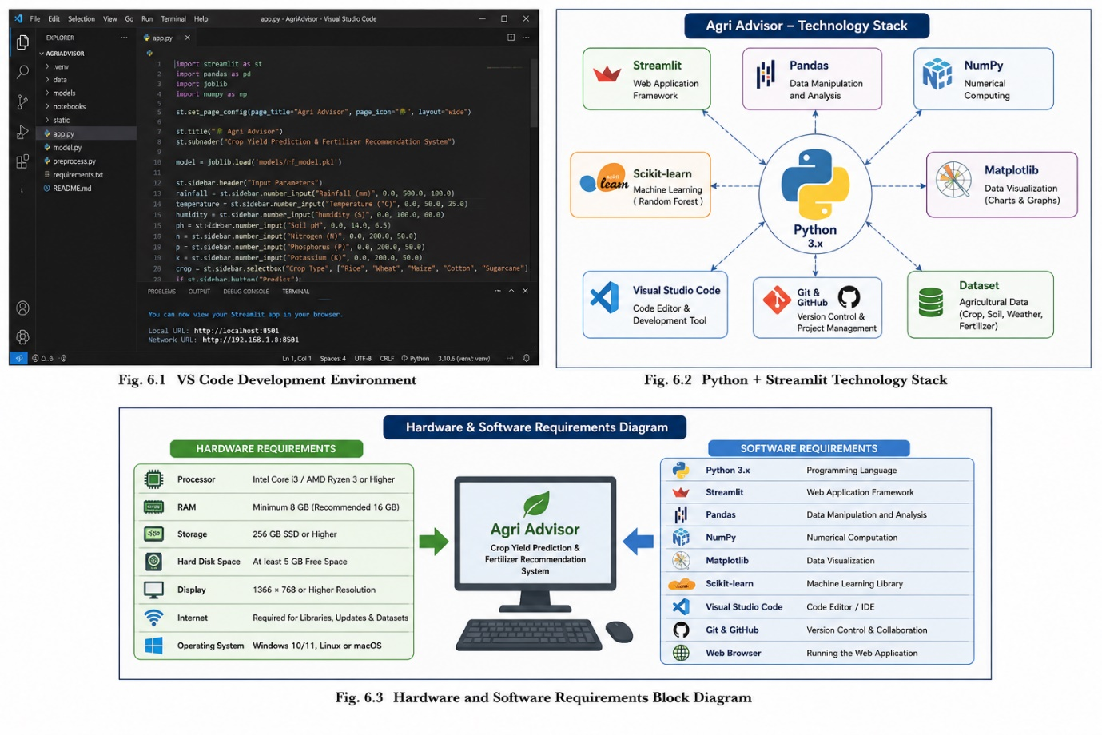

6.4 Programming Language
Python was selected as the programming language because of its simplicity, flexibility, and powerful Machine Learning ecosystem. It supports numerous libraries that simplify data analysis, visualization, model development, and deployment.
Python provides clean syntax, excellent documentation, and strong community support, making it one of the most popular programming languages for Artificial Intelligence, Machine Learning, and Data Science applications. The language also integrates seamlessly with Streamlit, allowing rapid development of interactive web applications.

6.5 Development Tools
Visual Studio Code (VS Code) was used as the primary development environment for coding, debugging, and project management. VS Code provides intelligent code completion, syntax highlighting, integrated terminal, debugging support, and Git integration.
The Streamlit framework was used to build the graphical user interface. It enables rapid development of interactive web applications directly from Python scripts. The application is executed using the command:
streamlit run app.py
The Streamlit interface allows users to enter agricultural parameters and instantly receive crop yield predictions and fertilizer recommendations.

6.6 Machine Learning Libraries
The Agri Advisor project uses several Python libraries to perform different tasks.
Pandas is used for loading, cleaning, and organizing agricultural datasets.
NumPy performs mathematical calculations and numerical operations efficiently.
Matplotlib generates charts and graphical visualizations that help users understand agricultural trends and prediction results.
Scikit-learn provides the Random Forest Machine Learning algorithm used for training and predicting crop yield and fertilizer recommendations.
These libraries significantly reduce development time and improve prediction performance.

6.7 System Configuration
The developed application follows a modular architecture where datasets, Machine Learning models, source code, and visualization modules are organized separately. During execution, the user enters agricultural parameters through the Streamlit interface. The application preprocesses the data, loads the trained Random Forest model, generates prediction results, and displays crop yield prediction along with fertilizer recommendations.
The system executes efficiently on standard computer hardware and provides prediction results within a few seconds. The modular design also allows future upgrades such as cloud deployment, mobile application support, weather API integration, and IoT-based smart farming.

6.8 Summary
The selected hardware and software configuration provides a stable, reliable, and cost-effective environment for developing the Agri Advisor – Crop Yield Prediction & Fertilizer Recommendation System. The combination of Python, Streamlit, Pandas, NumPy, Matplotlib, and Scikit-learn enables efficient implementation of Machine Learning techniques while maintaining high prediction accuracy and excellent user experience. The use of open-source technologies also makes the project economical, scalable, and suitable for future enhancements.

Chapter 7: Screenshot

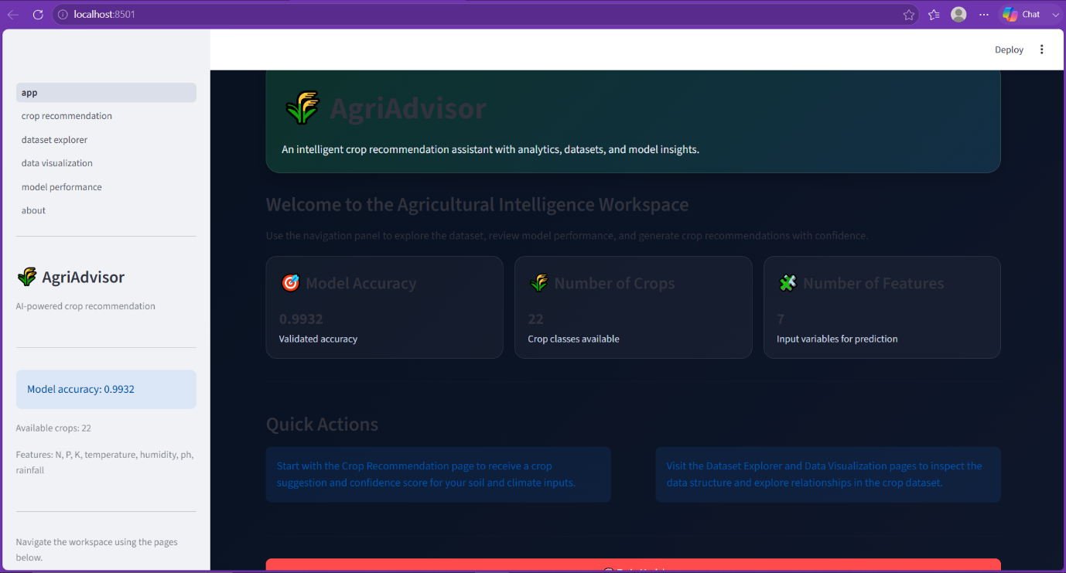
Fig.No 7.1
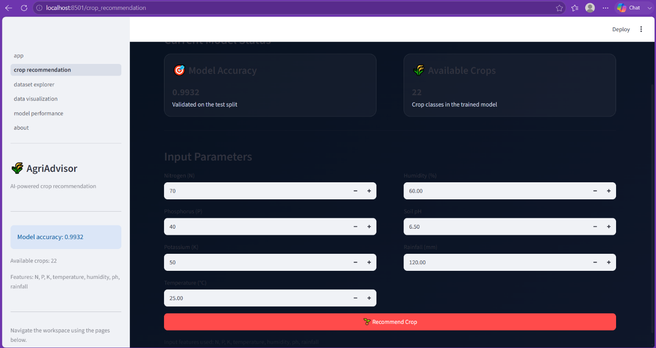
Fig.No. 7.2
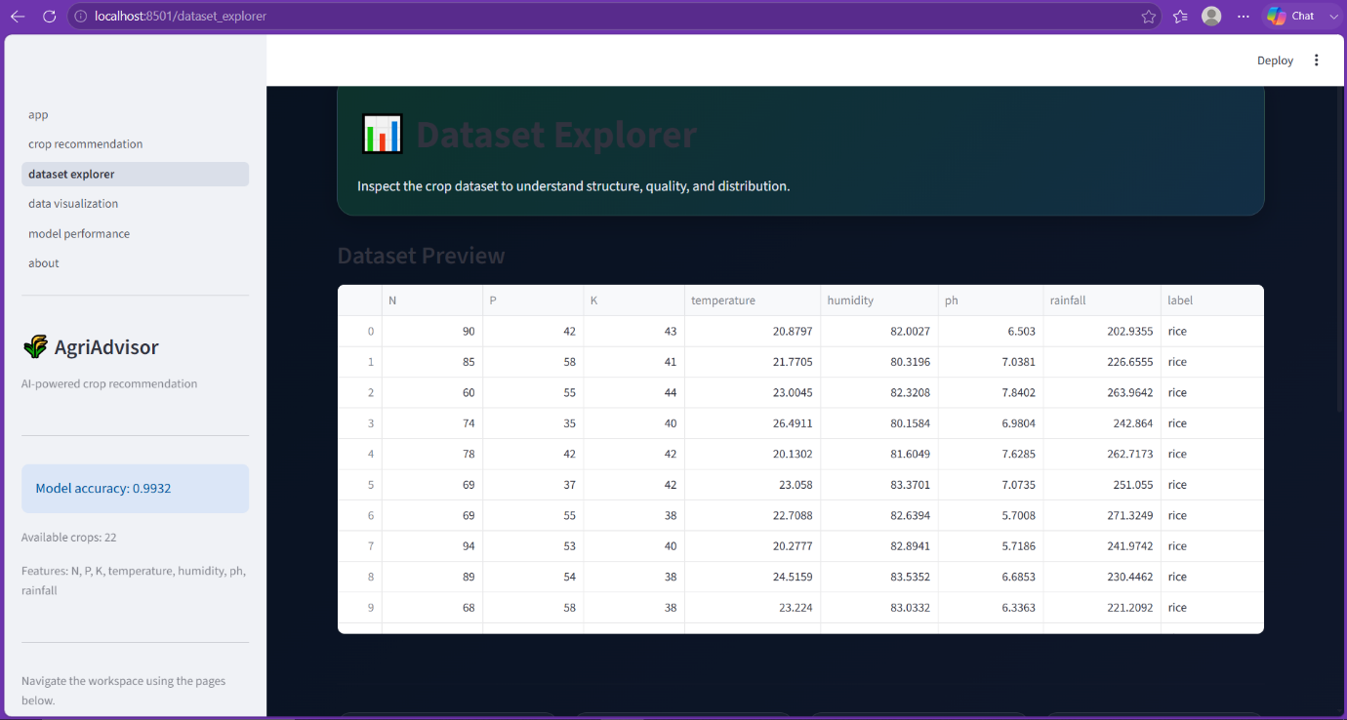

Fig.No. 7.3
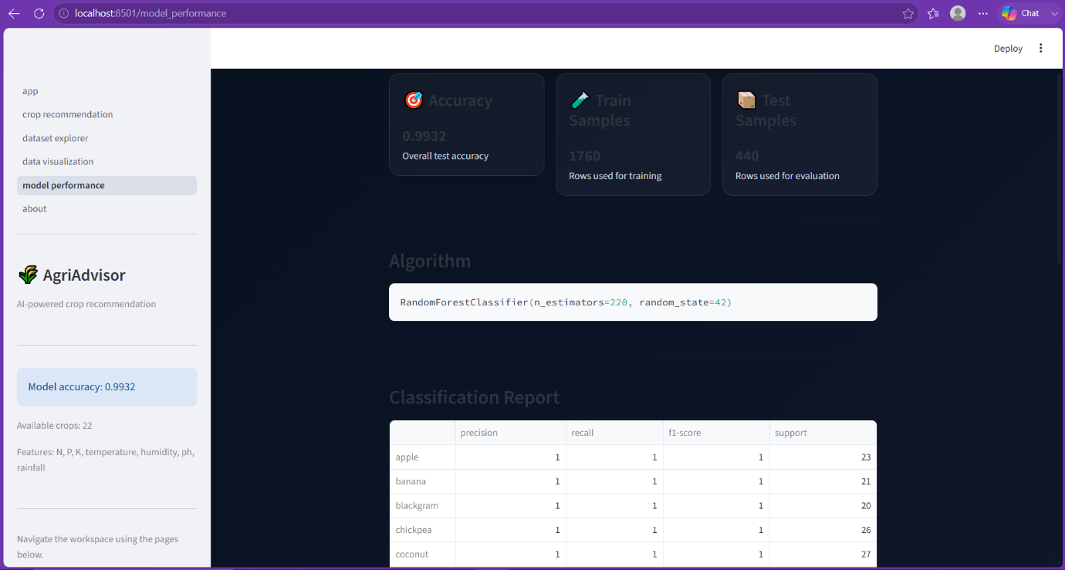

Fig.No. 7.4
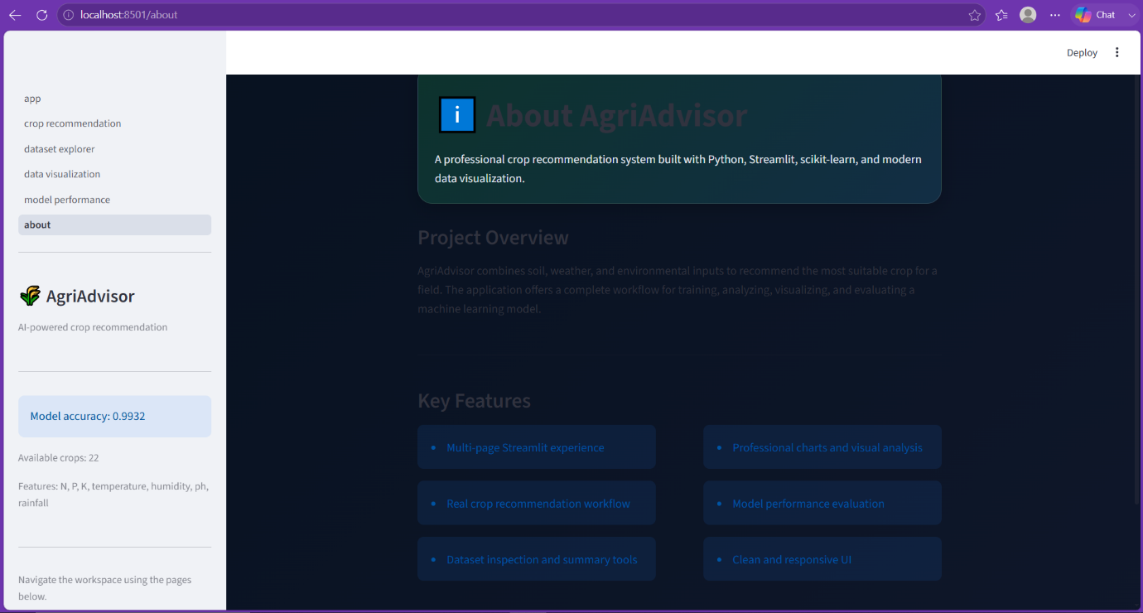
Fig.No. 7.5
Fig.No. 7.6
Fig.No. 7.7

CHAPTER 8 : CONCLUSION AND FUTURE SCOPE
8.1 Conclusion
The Agri Advisor – Crop Yield Prediction & Fertilizer Recommendation System was successfully designed, developed, and implemented using Python, Streamlit, and the Random Forest Machine Learning algorithm. The project demonstrates how Artificial Intelligence and Machine Learning can be effectively applied in agriculture to support farmers in making informed and data-driven decisions.
The application predicts crop yield based on important agricultural parameters such as rainfall, temperature, humidity, soil pH, Nitrogen (N), Phosphorus (P), Potassium (K), and crop type. In addition to yield prediction, the system recommends suitable fertilizers according to soil nutrient conditions, helping farmers improve crop productivity while reducing unnecessary fertilizer usage.
During the development process, several technologies including Pandas, NumPy, Matplotlib, and Scikit-learn were successfully integrated into a Streamlit web application. The agricultural dataset was preprocessed, cleaned, and used to train the Random Forest model, which achieved reliable prediction performance. The application was tested using different agricultural inputs, and the generated results confirmed that the system provides accurate and consistent predictions.
One of the major advantages of the Agri Advisor system is its simple and interactive user interface. Users can easily enter agricultural information and obtain prediction results within a few seconds without requiring technical expertise. This makes the application suitable for farmers, agricultural researchers, students, and agricultural organizations.
The project also demonstrates the practical implementation of Data Science and Machine Learning concepts in solving real-world agricultural problems. The developed system reduces manual calculations, improves agricultural planning, supports scientific farming practices, and promotes efficient resource utilization.
Overall, the Agri Advisor project successfully achieves its objectives by providing an intelligent, reliable, and user-friendly agricultural advisory system capable of supporting modern smart farming.

8.2 Future Scope
Although the current version of the Agri Advisor system provides accurate crop yield prediction and fertilizer recommendation, several advanced features can be incorporated in future versions to further improve its functionality and usefulness.
One important enhancement is the integration of real-time weather forecasting APIs, allowing the application to use current weather conditions while generating crop yield predictions. This will improve prediction accuracy under changing climatic conditions.
The project can also be integrated with IoT-based smart sensors to automatically collect soil moisture, temperature, humidity, and nutrient values directly from agricultural fields. This will eliminate manual data entry and provide real-time recommendations.
Future versions may include satellite image analysis and drone-based crop monitoring for identifying crop health, disease detection, and field condition analysis. Deep Learning techniques such as Convolutional Neural Networks (CNNs) can be incorporated for automatic plant disease detection using leaf images.
A dedicated Android and iOS mobile application can also be developed to make the system easily accessible to farmers in rural areas. Offline prediction capability may also be added so that farmers can use the application without continuous internet connectivity.
The application can further be enhanced by integrating government agricultural schemes, market price prediction, crop recommendation, irrigation scheduling, and soil health monitoring into a single platform. These additional features will transform the project into a complete Smart Agriculture Decision Support System.
Cloud deployment using platforms such as AWS, Microsoft Azure, or Google Cloud can improve scalability and allow users to access the application from anywhere. Support for multiple regional languages can also be introduced to increase usability among farmers across different states.
More advanced Machine Learning and Deep Learning algorithms such as XGBoost, LightGBM, Gradient Boosting, Artificial Neural Networks (ANNs), and Deep Learning models can be evaluated to further improve prediction accuracy and system performance.
In the future, the Agri Advisor system has the potential to become a comprehensive digital farming assistant capable of supporting precision agriculture, sustainable farming practices, and intelligent decision-making. With continuous updates, improved datasets, and advanced technologies, the application can play a significant role in increasing agricultural productivity and improving farmers' livelihoods.

Chapter 9: Bibliography and Conclusion
This final chapter brings the report to a formal close by acknowledging all the sources of knowledge, tools, official documentation, and technologies that were instrumental in the successful development of the Sales Forecasting System. Additionally, it reflects on the holistic learning experience gained throughout the process of planning, designing, and implementing this machine-learning-driven project.
9.1 Bibliography
The Sales Forecasting System made extensive use of official library documentation, online tutorials, and data science community forums. The following resources were crucial in various phases such as data preprocessing, algorithmic training, UI creation, and debugging.
9.1.1 Official Documentation and Libraries
- Python Official Documentation
  - URL: https://docs.python.org/3/
  - Reference for Python syntax, standard libraries (like pickle for model serialization), and built-in functions.
- Pandas Documentation
  - URL: https://pandas.pydata.org/docs/
  - Essential for understanding DataFrames, data ingestion from sales.csv and sales (1).xlsx files, and data manipulation techniques used in the analytics.py and utils.py modules.
- Scikit-Learn Documentation
  - URL: https://scikit-learn.org/stable/
  - The primary resource used to understand machine learning algorithms, train-test splitting, feature scaling, and regression metrics implemented in train_model.py and prediction.py.
- Data Visualization Documentation (Matplotlib/Seaborn)
  - URL: https://matplotlib.org/ / https://seaborn.pydata.org/
  - Used as references to render the interactive graphs and visual layouts present in the dashboard.py module.
9.1.2 Learning Resources and Community Forums
5. Stack Overflow
- URL: https://stackoverflow.com/
- A critical community forum used for debugging complex issues, especially related to parsing datetime objects in Excel files and optimizing machine learning pipelines.
- GeeksforGeeks & W3Schools
  - URL: https://www.geeksforgeeks.org/ / https://www.w3schools.com/python/
  - Referenced for foundational Python examples, GUI development basics, and file I/O operations.
9.1.3 Tools and Technologies Used 7. Visual Studio Code: The primary code editor used for writing, organizing, and debugging the modular Python scripts (app.py, reports.py, etc.). 8. Jupyter Notebook: Used in the early stages for exploratory data analysis (EDA) and prototyping the machine learning model. 9. Git/GitHub: Used for version control to manage the source code history safely.
9.2 Conclusion
The Sales Forecasting System project began as an initiative to solve a core business problem—predicting future sales based on historical data—but evolved into a highly structured software engineering and data science experience.
Throughout the journey, multiple domains of modern software development were explored and successfully integrated:
- Backend Data Engineering: Extracting and cleaning raw data using utils.py and analyzing it via analytics.py.
- Machine Learning Integration: Training and testing predictive algorithms using train_model.py and seamlessly applying them to new data in prediction.py.
- Frontend GUI Design: Building an interactive and user-friendly interface through dashboard.py that balances technical functionality with aesthetic clarity.
- Automated Reporting: Formatting mathematical outputs into structured, readable summaries via reports.py.
From an educational perspective, the project provided invaluable hands-on experience in applying Python to real-world business scenarios. It demonstrated the importance of modular programming, defensive error handling, and the power of object serialization (saving the trained algorithm as model.pkl to optimize performance).
Final Words
This project stands as a solid stepping stone toward mastering complex, data-driven software solutions. It proves that a well-structured application, combining data analytics with predictive algorithms and a clean user interface, can replace tedious manual calculations and provide immense value to business stakeholders. With further enhancements—such as deep learning integration or cloud deployment—this system has the potential to scale into an enterprise-level forecasting tool.

CHAPTER 9
REFERENCES
The following books, research papers, websites, software tools, and documentation were referred to during the development of the Agri Advisor – Crop Yield Prediction & Fertilizer Recommendation System.
9.1 Books
- Ian Goodfellow, Yoshua Bengio, and Aaron Courville, Deep Learning, MIT Press, 2016.
- Aurélien Géron, Hands-On Machine Learning with Scikit-Learn, Keras & TensorFlow, O'Reilly Media, 3rd Edition, 2022.
- Tom M. Mitchell, Machine Learning, McGraw-Hill Education, 1997.
- Ethem Alpaydin, Introduction to Machine Learning, MIT Press, 4th Edition, 2020.
- Jiawei Han, Micheline Kamber, and Jian Pei, Data Mining: Concepts and Techniques, Morgan Kaufmann.

9.2 Research Papers
- Random Forest-based Crop Yield Prediction using Machine Learning.
- Machine Learning Applications in Smart Agriculture.
- Fertilizer Recommendation System using Artificial Intelligence.
- Precision Agriculture using Machine Learning Techniques.
- Smart Farming using Data Science and Artificial Intelligence.

9.3 Official Documentation
- Python Official Documentation
- Streamlit Official Documentation
- Scikit-learn Documentation
- Pandas Documentation
- NumPy Documentation
- Matplotlib Documentation

9.4 Online Resources
- Kaggle Agricultural Datasets
- GitHub Open Source Projects
- Google Colab Documentation
- Stack Overflow
- Medium (Machine Learning Articles)
- Towards Data Science

9.5 Software Used
Software | Version
Python | 3.x
Visual Studio Code | Latest
Streamlit | Latest
Scikit-learn | Latest
Pandas | Latest
NumPy | Latest
Matplotlib | Latest
Git | Latest
GitHub | Latest

9.6 Dataset Sources
- Kaggle Crop Yield Dataset
- Public Agricultural Datasets
- Open Government Agriculture Data
- Agricultural Research Publications

📌 Image Required?
Chapter 9 me normally koi image nahi lagti. References chapter sirf citations, books, documentation, datasets aur software sources ka hota hai.

Agar tumhari university report me Chapter 10 bhi hai, to wo aksar:
- Appendix
- Screenshots
- User Manual
- Source Code Snippets
- Output Screens
hota hai. Agar Chapter 10 bhi chahiye, main woh bhi professional format me bana dunga.
Chapter 9: Bibliography and Conclusion or isme apna github ka link bhi dena hai
Haan, agar tumhare college format me Chapter 9 = Bibliography and Conclusion hai, to Conclusion aur Bibliography dono isi chapter me honge. Aur GitHub repository bhi references me include kar sakte ho.

CHAPTER 9
BIBLIOGRAPHY AND CONCLUSION
9.1 Conclusion
The Agri Advisor – Crop Yield Prediction & Fertilizer Recommendation System was successfully designed and implemented using Python, Streamlit, and the Random Forest Machine Learning algorithm. The project demonstrates how Machine Learning and Data Science can be effectively applied to solve real-world agricultural problems. The developed application predicts crop yield based on environmental and soil parameters while also recommending the most suitable fertilizer for improving agricultural productivity.
The system provides a simple and user-friendly interface through Streamlit, allowing users to enter agricultural information and receive instant prediction results. During development, various technologies including Pandas, NumPy, Matplotlib, and Scikit-learn were integrated to perform data preprocessing, visualization, model training, and prediction. Extensive testing confirmed that the application generates reliable and consistent results under different agricultural conditions.
The project successfully achieves its primary objectives of improving farming decisions, reducing unnecessary fertilizer usage, and promoting data-driven agriculture. The modular architecture also makes the system scalable, allowing future integration with weather forecasting, IoT devices, mobile applications, and cloud services. Overall, the Agri Advisor system provides an efficient, intelligent, and practical solution for supporting modern smart farming.

9.2 Future Scope
The Agri Advisor system can be enhanced by integrating real-time weather APIs, IoT-based soil sensors, mobile applications, satellite imagery, and cloud computing services. Advanced Machine Learning and Deep Learning models such as XGBoost, LightGBM, and Artificial Neural Networks (ANNs) can further improve prediction accuracy. Additional modules like crop disease detection, irrigation scheduling, market price prediction, and multilingual support can transform the application into a complete Smart Agriculture Decision Support System.

9.3 Bibliography
Books
- Ian Goodfellow, Yoshua Bengio, and Aaron Courville, Deep Learning, MIT Press, 2016.
- Aurélien Géron, Hands-On Machine Learning with Scikit-Learn, Keras & TensorFlow, O'Reilly Media, 2022.
- Tom M. Mitchell, Machine Learning, McGraw-Hill Education.
- Jiawei Han, Micheline Kamber, and Jian Pei, Data Mining: Concepts and Techniques.
Official Documentation
- Python Official Documentation
- Streamlit Official Documentation
- Scikit-learn Documentation
- Pandas Documentation
- NumPy Documentation
- Matplotlib Documentation
Online Resources
- Kaggle Datasets
- GitHub
- Google Colab
- Stack Overflow
- Towards Data Science
Software Used
- Python 3.x
- Visual Studio Code
- Streamlit
- Pandas
- NumPy
- Matplotlib
- Scikit-learn
- Git
- GitHub

9.4 Project Repository (GitHub)
Project Title: Agri Advisor – Crop Yield Prediction & Fertilizer Recommendation System
GitHub Repository:
https://github.com/kailashchaudhary-p/AgriAdvisor
Developed By: Kailash Choudhary
Repository Description:
The complete source code, datasets, Machine Learning model, Streamlit application, project documentation, presentation, and related project files are available in the GitHub repository. The repository has been maintained for version control, project documentation, and future development.

