**Jenkins Docker installation**

1) Download and install Oracle VM Virtual Box Manager from google

https://www.virtualbox.org/wiki/Downloads

download for Windows host (you may also need to download Microsoft Visual C++ Redistributable if Virtual Box install prompts)

download Visual c++ from https://learn.microsoft.com/en-us/cpp/windows/latest-supported-vc-redist?view=msvc-170)

2)Centos minimal ISO image download for your VM (OS)

http://isoredirect.centos.org/centos/7/isos/x86_64/ (download using http://mirrors.nxtgen.com/centos-mirror/7.9.2009/isos/x86_64/)

3) Now you can create a new VM in Oracle VM box using the centos VM ISO and make sure network adapter is Bridge adapter in VM network setting which you are creating.

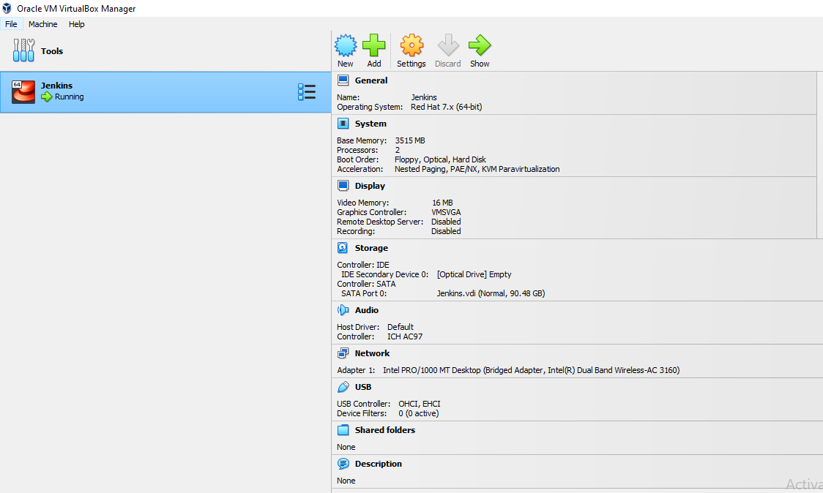

4) Once VM is ready with centos, you can install docker, but before that try ping google.com, because we need internet connection.

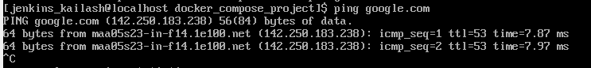

user name - jenkins_kailash

password - 123456

5)Now install docker in centos.

use the commands in https://docs.docker.com/engine/install/centos/

sudo systemctl start docker

6) once you are able to run hello-world image, it is working fine.

7) but docker ps commands gives permission denied, you need to add your user to docker using below command.

sudo usermod -aG docker jenkins_kailash

8) after this 'logout' and login again, docker ps command will work!

9)Docker Compose installation

sudo curl -L "https://github.com/docker/compose/releases/download/1.29.2/docker-compose-$(uname -s)-$(uname -m)" -o /usr/local/bin/docker-compose

binary is downloaded at /usr/local/bin/docker-compose

give executable permission to 'sudo chmod +x /usr/local/bin/docker-compose'

10) Now run docker-compose in unix terminal it will run without permission error

11)Install jenkins using docker

docker pull jenkins/jenkins

12) you can check downloaded images using 'docker images'

13) docker info | grep -i root

this will give the path where images are stored in the unix machine (/var/lib/docker)

14) install docker compose (for orchestration)

sudo curl -L "https://github.com/docker/compose/releases/download/1.29.2/docker-compose-$(uname -s)-$(uname -m)" -o /usr/local/bin/docker-compose

15)create docker-compose.yml file (configuration file)

Volumes in config file is where the backup of container is available in case of failure.

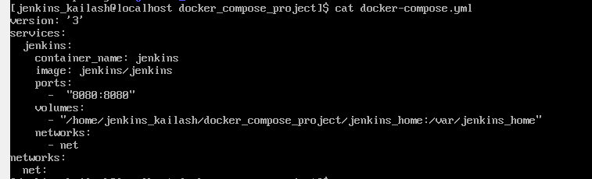

16) Docker will write the volume to Jenkins_home, hence the user should be the owner.



Sudo chown 1000:1000 jenkins_home/ -R

1000 is uid



17) after docker compose is installed using curl and configuration is completed, run the docker compose using below command.



Docker-compose up -d

18) Now you can see the container is running using the Jenkins image which was started using docker -compose



19)

Now we need to know admin password so that we can connect to Jenkins web using VM IP address.

Docker logs -f Jenkins (container name) will provide the pwd.

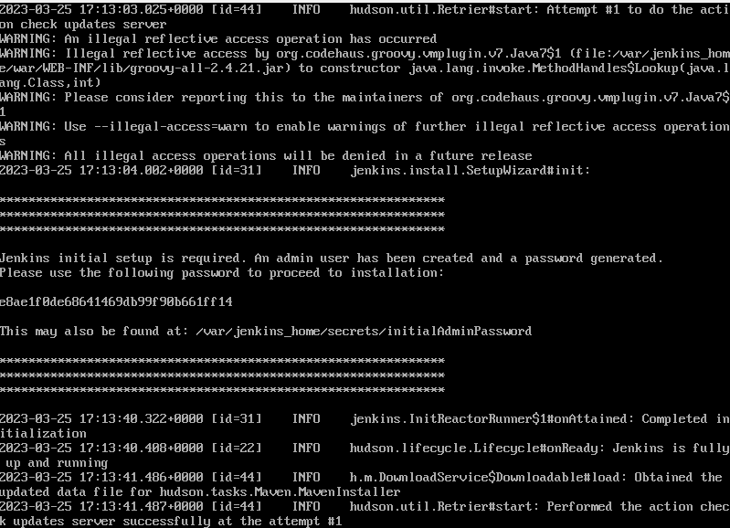

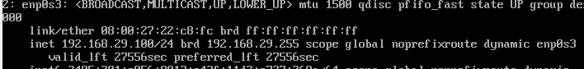

Ip address in web browser with port 8080

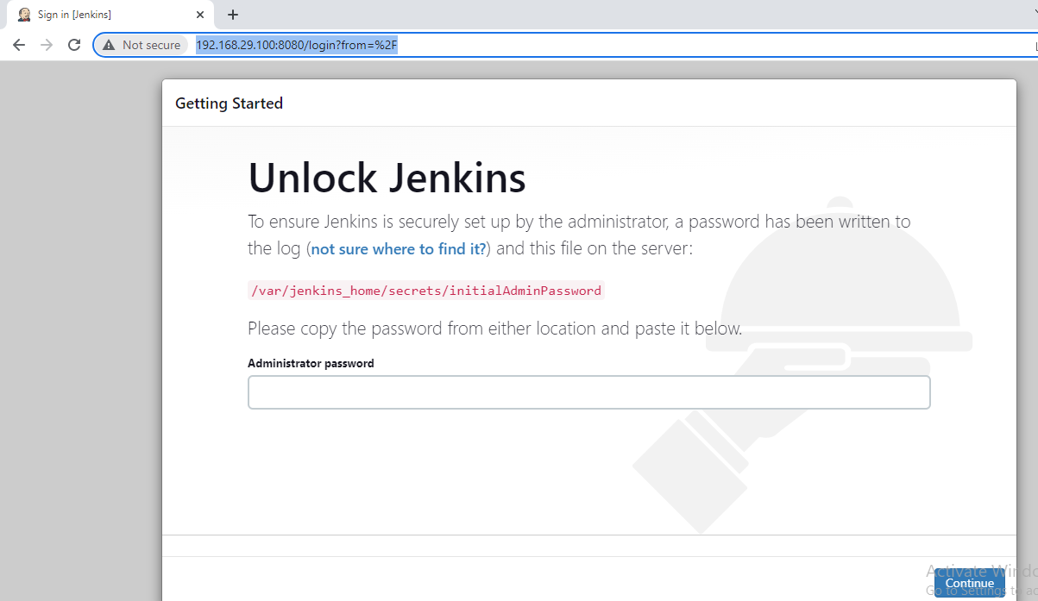

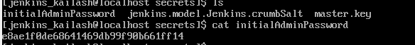

Login successful

20) Play with docker compose

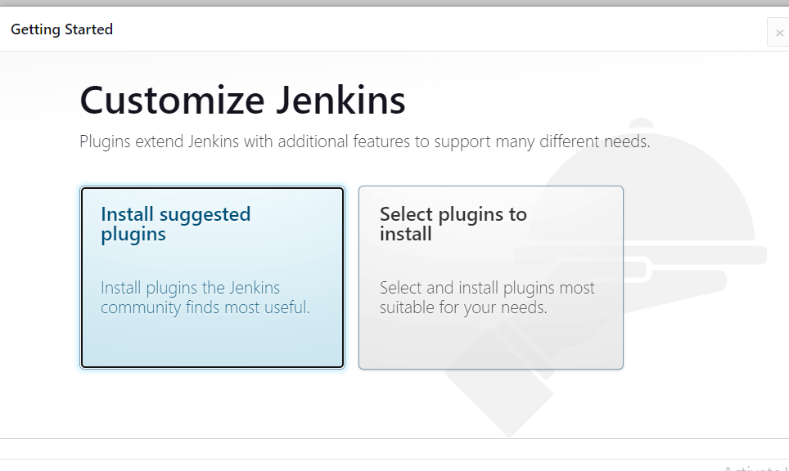

Proceed with suggested plugins

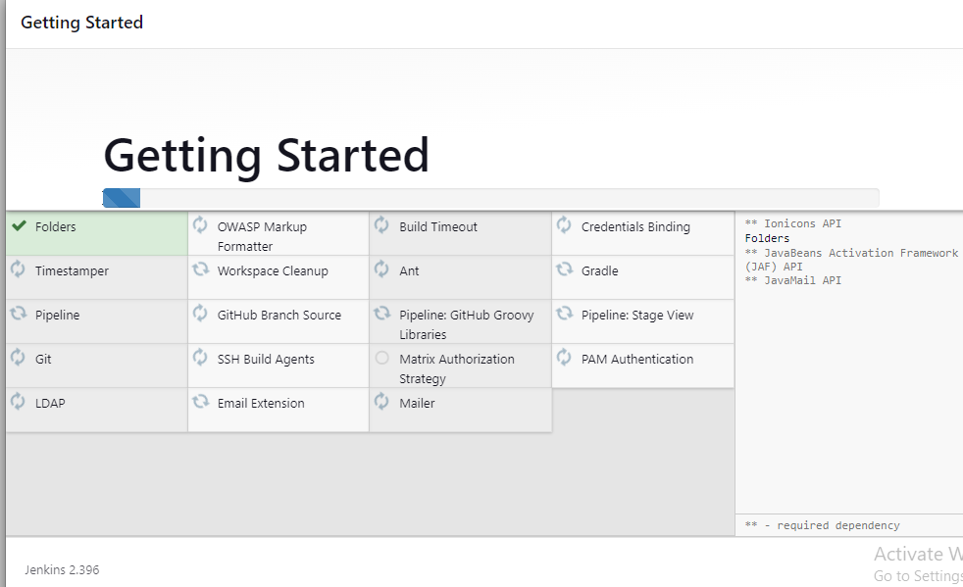

Admin setup:

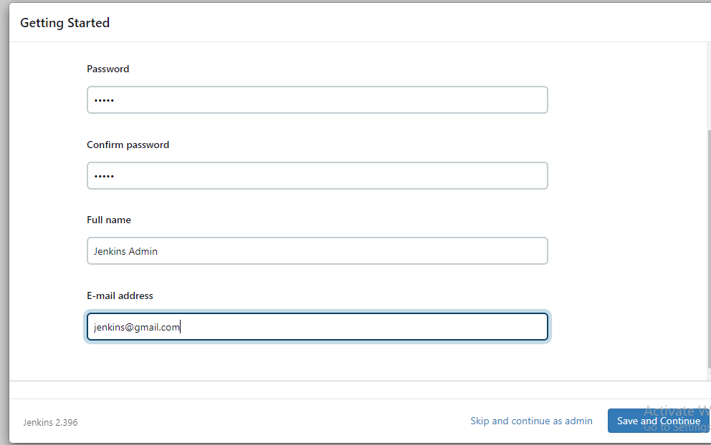

Username : admin

Pwd: admin

Use the same URL, Jenkins is now ready!!!

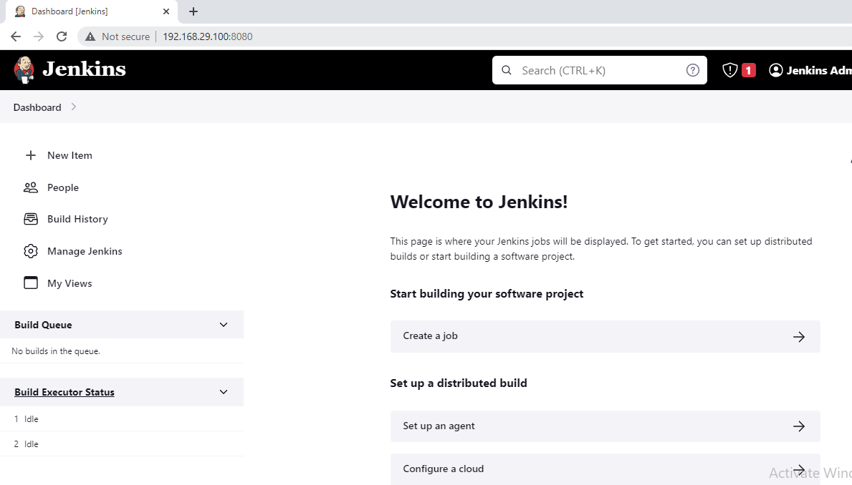

** Play with docker-compose







To completely delete your service?



But can be start again using the Volume (you see how important is this now!)

UP Again!!!(Thanks to the Volume)

