**Jenkins Dashboard**

** Create your first Jenkins job

New Item

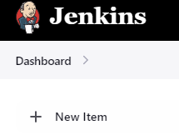

Free Style project and OK

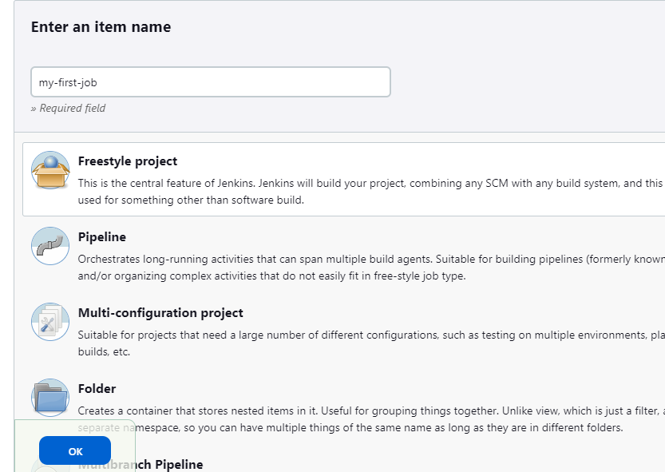

We are going to build the steps using Shell (this shell is part of the container which is running in oracle VM which has java as well but not in actual kernel of VM)

See the difference below!!

Second whoami is actually the container name it has Java as well but not in actual kernel of VM only in docker container shell

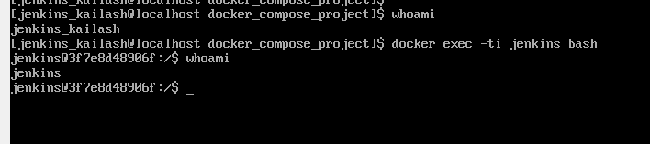

Now build it in Jenkins

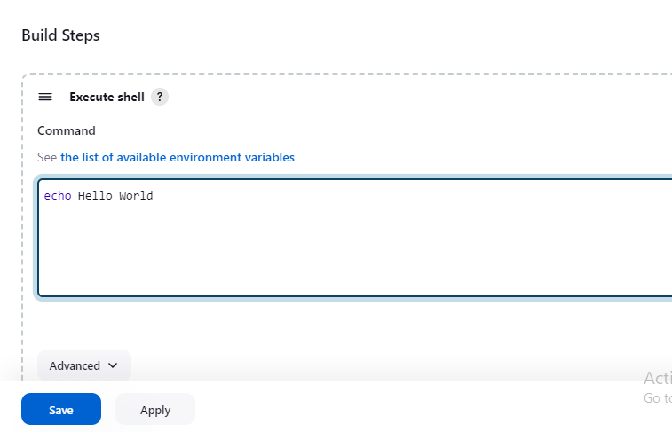

Save and do ‘Build Now’

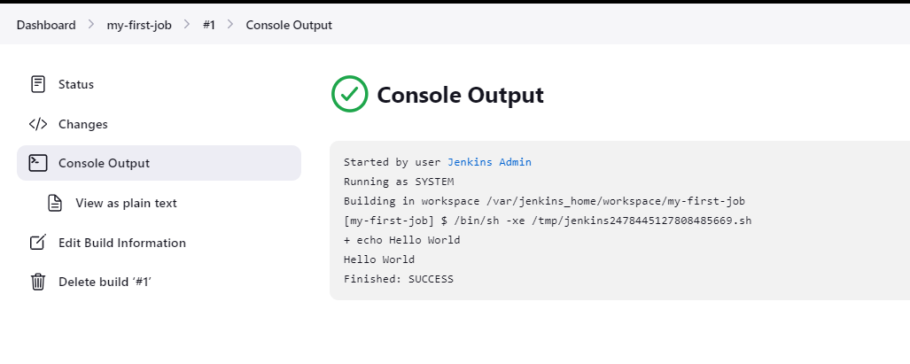

** Keep playing with first job

Adding date in shell

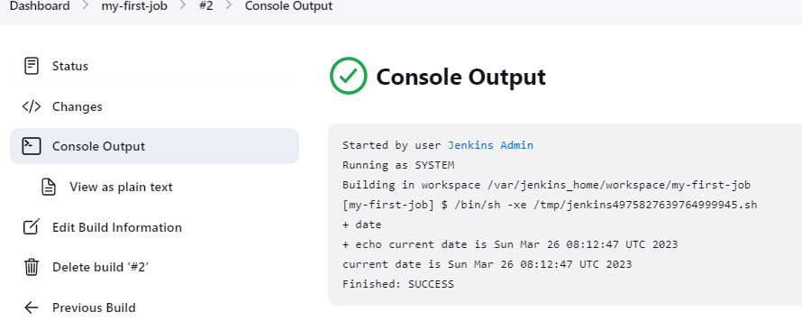

Vi not available in container shell



Create a file in unix host (not container)

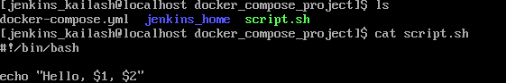

Copy that file to the container



Now configure the job to run this script

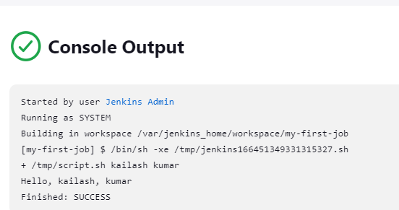

If any problem in script command, build will fail like this.

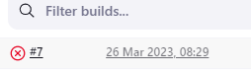

Check console output

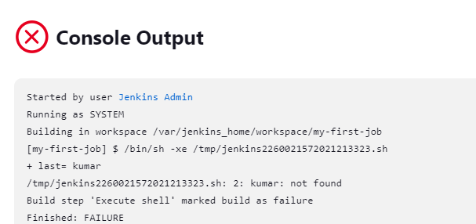

** Add parameter to your job

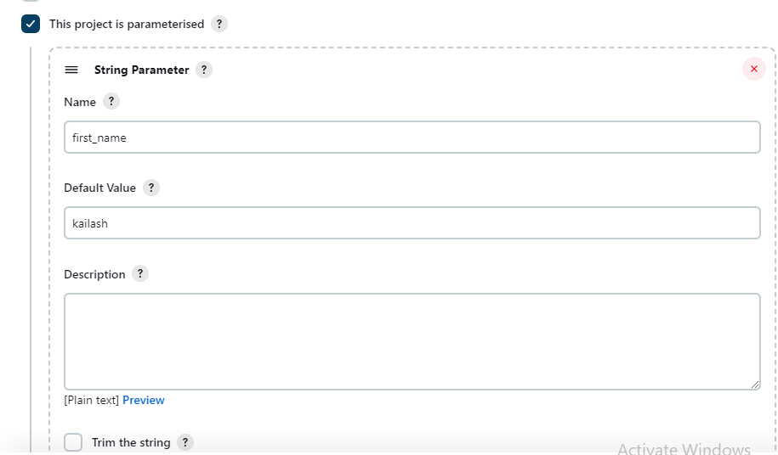

So now job is build with default parameters,

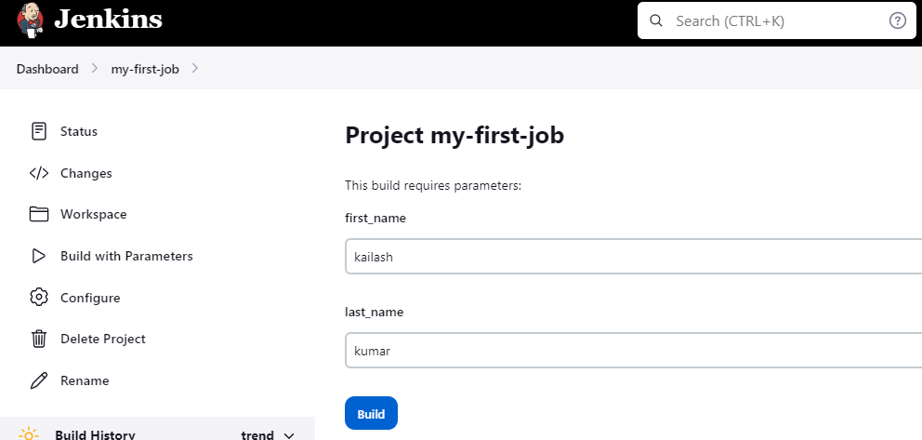

Parameter with choices,

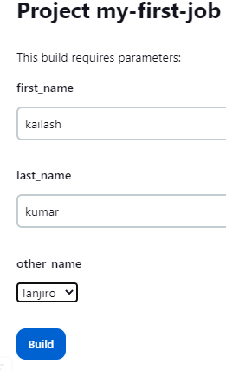

Show option is Boolean parameter (True or false)

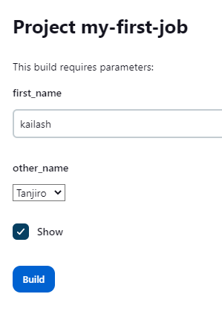

Script

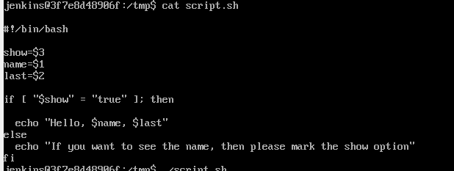

Console output (when show is not selected)

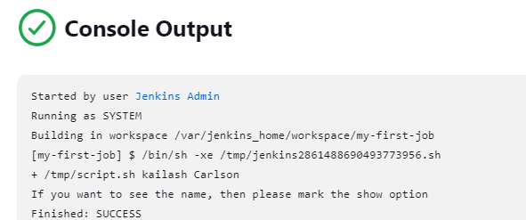

When show is selected,

