**Docker Jenkins SSH**

** Docker file to create Centos 7 image

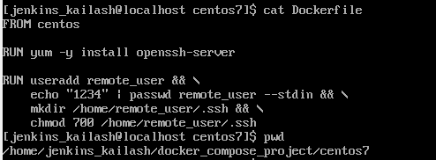

Create a SSH key

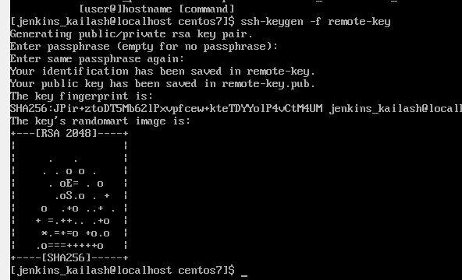

It creates certificates key (private and public)

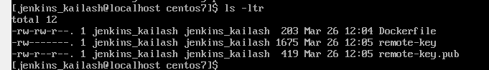

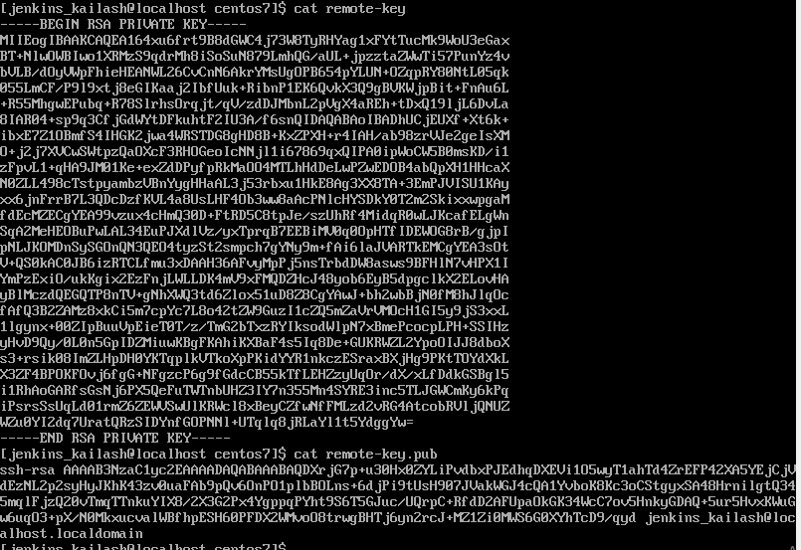

Docker File updated

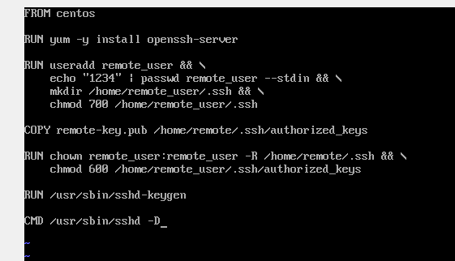

Docker compose configuration file update to include remote_host(ssh)

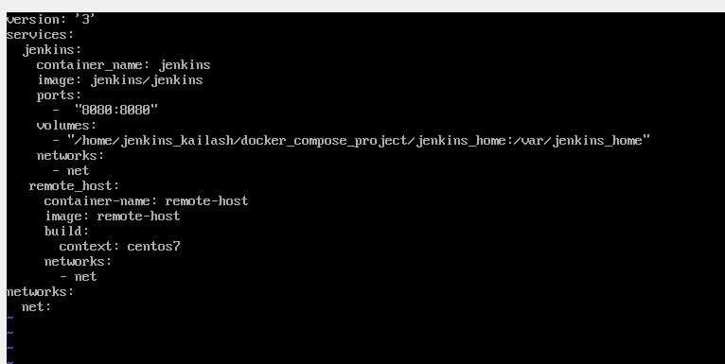

Got this error, while building the docker-compose

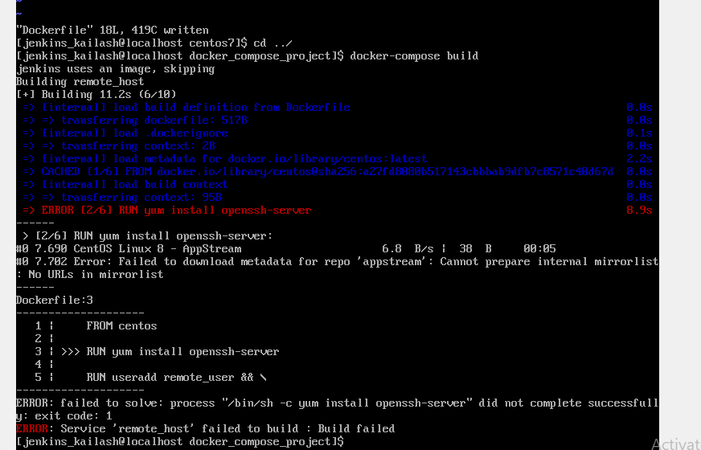

Changed FROM centos to centos: 7 and yum -y install openssh-server to fix the above issue

And also check the folders in DockerFile , it has been updated, correct docker file below,

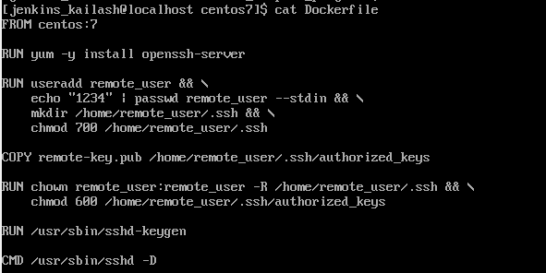

Great!! Now remote-host image is created…

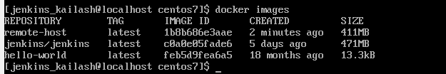

Now, container is created using the docker compose

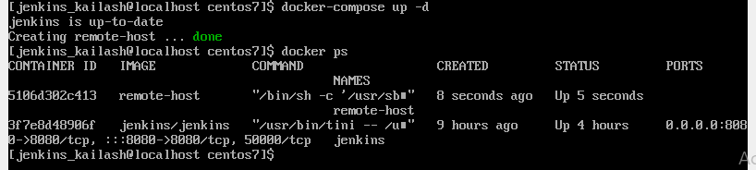

Now we can logon-to ssh container from Jenkins!!

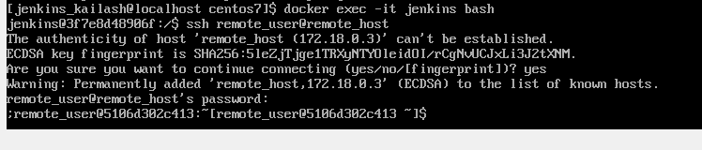

The remote-key is copied from localhost centos 7 to Jenkins container and use ssh to connect remote_host without using password

