EchoSphere Digital Assignment 3
Software Engineering Project Report and Testing Evidence
Name KAILASH P Register Number 24BRS1382
Review 3 14 October 2026

Project Overview
EchoSphere is a personal learning environment that organises study documents and notes and provides AI summaries, explanations, flashcards, exam questions, knowledge graphs and knowledge-base chat. The current release combines a React interface, an Express API, MongoDB persistence, LanceDB retrieval and local Ollama models.

Problem Statement
Students and researchers keep useful knowledge across separate documents and notes. Finding relevant passages, revising long materials and connecting related concepts takes time. EchoSphere brings these materials into one workspace and provides study outputs derived from selected documents or retrieved knowledge-base context.

Users and Objectives
The primary users, carried forward from DA1, are university students preparing for assessments and researchers reviewing a collection of papers. The objective is to reduce retrieval and revision effort while keeping the source material available for checking AI output.

Report Scope
This report combines the project requirements and design with the recorded DA3 testing evidence. The recorded results are 64 passing Jest tests, 33 passing live Postman assertions across 22 requests, a 92.28 percent mutation score for input validation, and successful frontend and container builds.
Project repository and code

User Stories and Priorities
DA1 records 25 user stories as GitHub issues. The following table consolidates representative priorities for the current single-user release; local model configuration supersedes the earlier Gemini API-key requirement.
Priority | User story | Current scope
Must | As a learner, I want to upload study documents so I can work from my own materials. | PDF, DOCX and TXT ingestion.
Must | As a learner, I want extracted text so AI tools can process document content. | pdf-parse, mammoth and TXT reading.
Must | As a learner, I want notes stored across sessions so I can retrieve them later. | MongoDB note persistence.
Must | As a learner, I want summaries so I can revise long materials quickly. | Selected-document summarisation.
Must adapted | As a learner, I want to choose a local AI model so study tools use my preferred model. | Ollama selection; no Gemini key required by active routes.
Should | As a learner, I want folders so I can organise related documents. | Hierarchical folders and browsing.
Should | As a learner, I want adjustable output length and explanation depth. | Summary and explanation settings.
Should | As a learner, I want extracted concepts and relationships to see connections. | AI graph generation and persistence.
Should | As a learner, I want consistent navigation between workspaces. | Persistent React sidebar.
Could | As a learner, I want to inspect an interactive two-dimensional knowledge graph. | Force-directed graph view.
Could | As a learner, I want saved prompts and a theme preference. | Prompt workspace and light/dark mode.
Current extension | As a learner, I want flashcards, practice questions and knowledge-base chat. | Flashcards, exam predictor and RAG chat.
Outside release | Multi-user JWT login and OCR for scanned documents. | Remain outside the DA1 single-user scope.

Full user-story issue catalogue

System Architecture and System Design
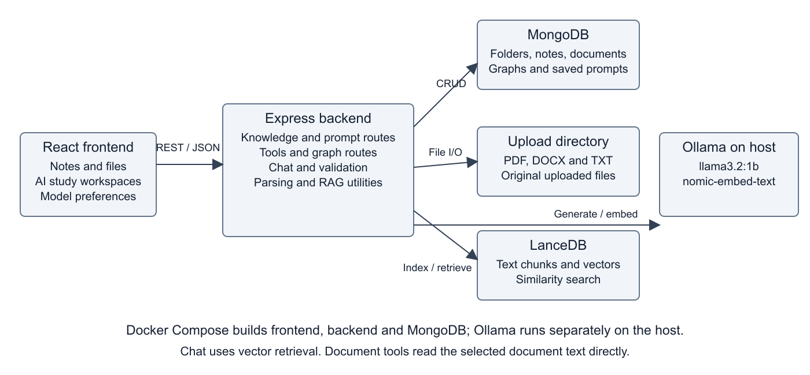
Current architecture: MongoDB holds application records; uploaded files remain on disk; LanceDB stores indexed text chunks; Ollama provides local generation and embeddings.
The modular frontend and REST API separation follow the principles described in DA2. Knowledge routes manage folders, documents and notes; tools routes generate study outputs; graph and prompt routes persist their own records. RAG utilities handle chunking, embeddings and retrieval.
Uploaded files and notes are saved first, then vector ingestion runs in the background. Chat retrieves relevant LanceDB chunks; summarisation, explanation, flashcards, exam questions and graph generation read selected document text directly. Ollama is a host service outside the frontend/backend/MongoDB Compose services.
Original DA2 architecture drawing on Google Drive

Design Principles and Report Continuity
Principle from DA2 | Application in the current release
Modularity and cohesion | React workspaces and dedicated route modules separate notes, graphs, prompts and AI tools.
Loose coupling | The frontend exchanges HTTP/JSON with Express. Persistence and model generation sit behind backend routes.
Abstraction | Learners select documents and study settings; backend utilities handle parsing, chunking and vector retrieval.
Usability | The persistent sidebar, familiar file browser, source/summary view and graph workspace preserve the Figma design direction.
Maintainability | Shared validation, configurable database/model addresses, repeatable tests and Docker builds support diagnosis and change.

Changes Carried into DA3
Earlier description | DA3 description
Gemini and browser API-key storage | Active AI routes use Ollama. Browser storage holds the selected model preference.
PDF DOCX TXT MD upload labels | The current backend accepts PDF, DOCX and TXT; Markdown display support does not establish MD ingestion support.
All study tools use RAG | Chat uses vector retrieval. Document tools use the selected document text directly.
Synchronous processing before persistence | Records are saved and acknowledged before background vector ingestion.
Everything inside Docker Compose | Frontend, backend and MongoDB are Compose services; Ollama runs separately on the host.
Three to five seconds and near-zero hallucinations | These were DA1 targets. The live run averaged 7.6 seconds and reached 59.8 seconds; factual accuracy, uptime and retention are not established by these tests.

Design of Tests
The repeatable suite combines Express and real MongoDB integration with focused validation regression tests. AI calls are stubbed in Jest for repeatability. The separate Postman collection uses real MongoDB and Ollama; browser checks verify that a saved note and generated flashcards are displayed.
Case | Action or input | Expected result | Recorded evidence
TC01 | GET /api/health | HTTP 200 and connected database | Jest and Postman pass.
TC02 | Create, browse and rename a folder | Created record appears with the updated name | Jest and Postman pass.
TC03 | Create note, edit content and reindex | Content persists and index refresh is invoked | Jest pass; creation also verified in browser.
TC04 | Upload TXT, download it, list DOCX metadata | TXT is extracted; files are visible and downloadable | Jest pass. PDF/DOCX parser accuracy is not comprehensively measured.
TC05 | Blank fields, unsupported upload, invalid IDs | HTTP 400 JSON error | Jest and applicable Postman checks pass.
TC06 | Create, list and delete a saved prompt | Correct persistence and deletion | Jest pass; create/list also pass in Postman.
TC07 | Save graph and retrieve metadata | Nodes and metadata are retained | Jest and Postman pass.
TC08 | Generate summary, explanation, cards, exam, graph and chat | Non-empty outputs with expected response shapes | Six live AI flows pass in Postman; five cards displayed in browser.
TC09 | Delete folder; invoke clear-all in test database | Contents preserved at root; isolated data cleared | Jest pass; no production database is used.
TC10 | Change validation conditions, strings and boundaries | Regression tests detect behavioral changes | 227 killed, 19 survived, zero uncovered mutations.

Test-only storage uses MongoDB on port 27018 and separate upload/vector directories. Response-shape tests do not prove the factual correctness of every AI answer.

Integration Testing
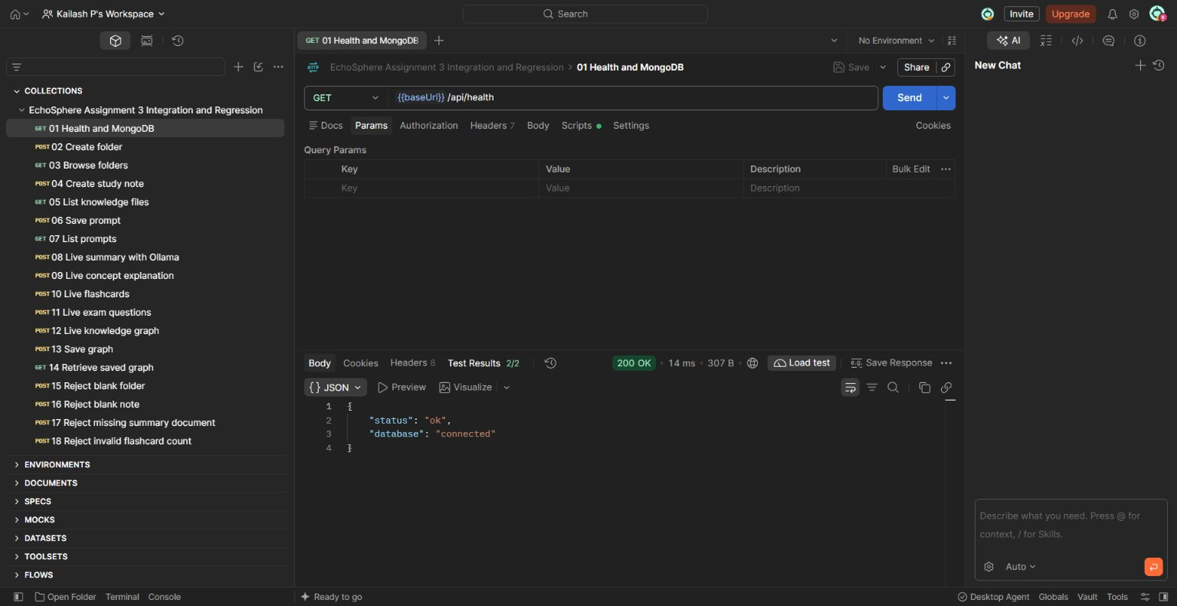
Postman returns HTTP 200 and shows both health checks passing, confirming an available Express API and connected MongoDB database.

Integration Testing with Live AI
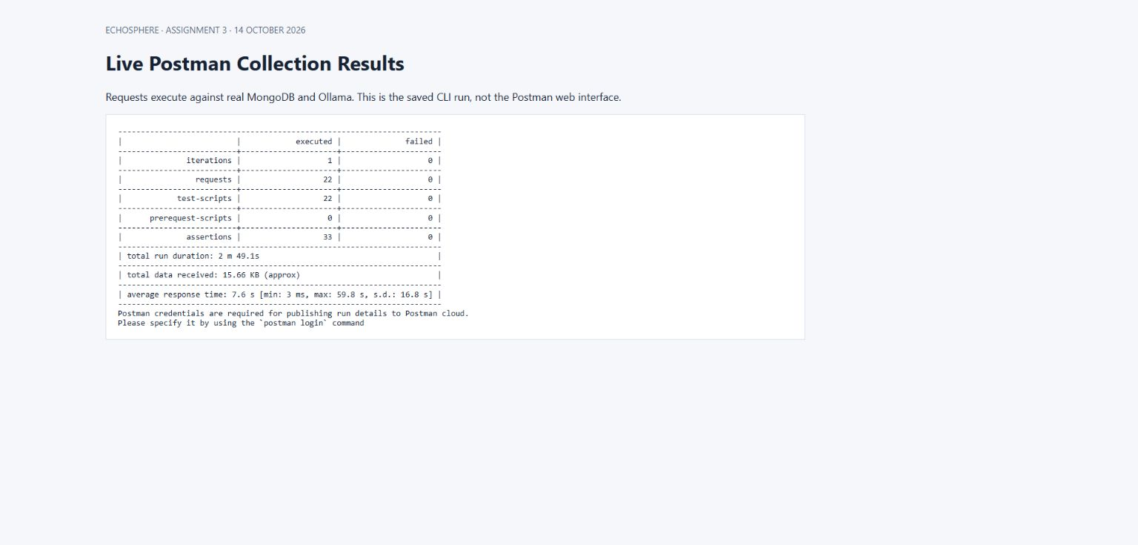
The recorded live Postman CLI execution passes all 33 assertions across 22 requests against MongoDB and Ollama.
This screenshot displays the saved CLI result. The previous page is captured from the actual Postman web interface.

Regression Testing
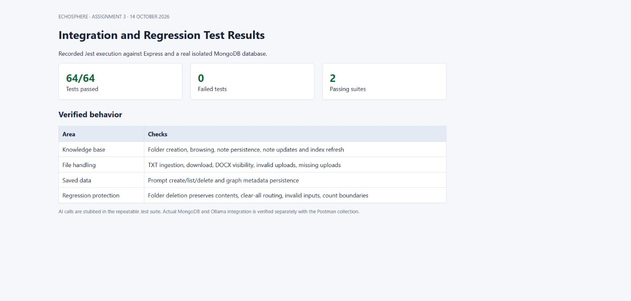
Jest passes 64 tests covering persistence, upload handling, validation and corrected workflows.
The integration suite uses real MongoDB and stubs AI calls; actual AI integration is exercised separately by Postman.

Mutation Testing
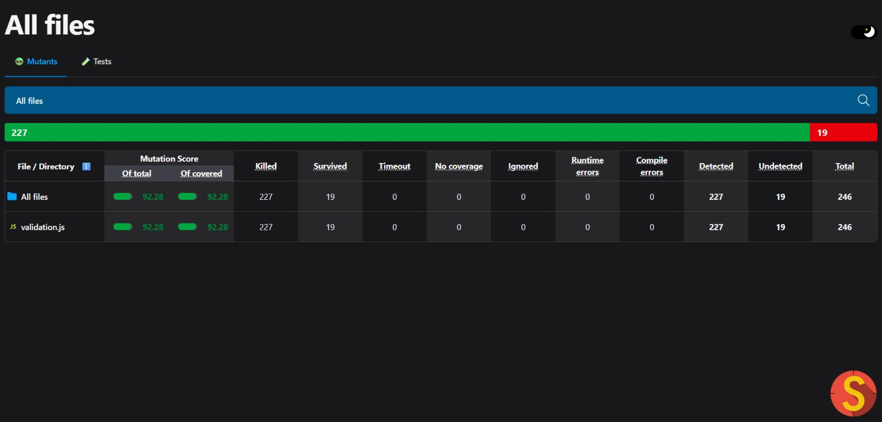
Stryker detects 227 of 246 mutations in request validation, producing a 92.28 percent score.
The scope is backend/validation.js. Nineteen mutations survive; this is not a project-wide score.

Version Management and System Building
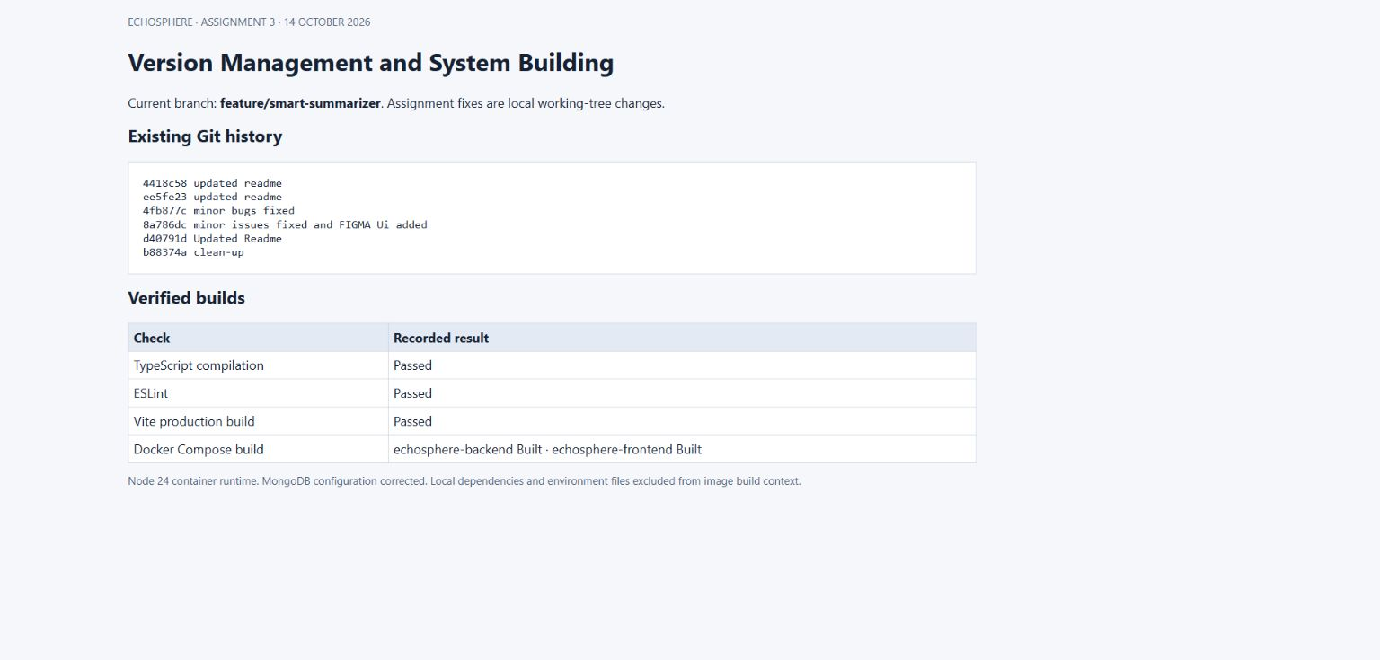
Git history is recorded and TypeScript, ESLint, Vite and both Docker image builds pass.
DA2 shows an earlier smart-summarizer pull request merged into main. The DA3 fixes are local changes on the existing feature branch and have not been committed or pushed.

Developed Functionality Knowledge Base
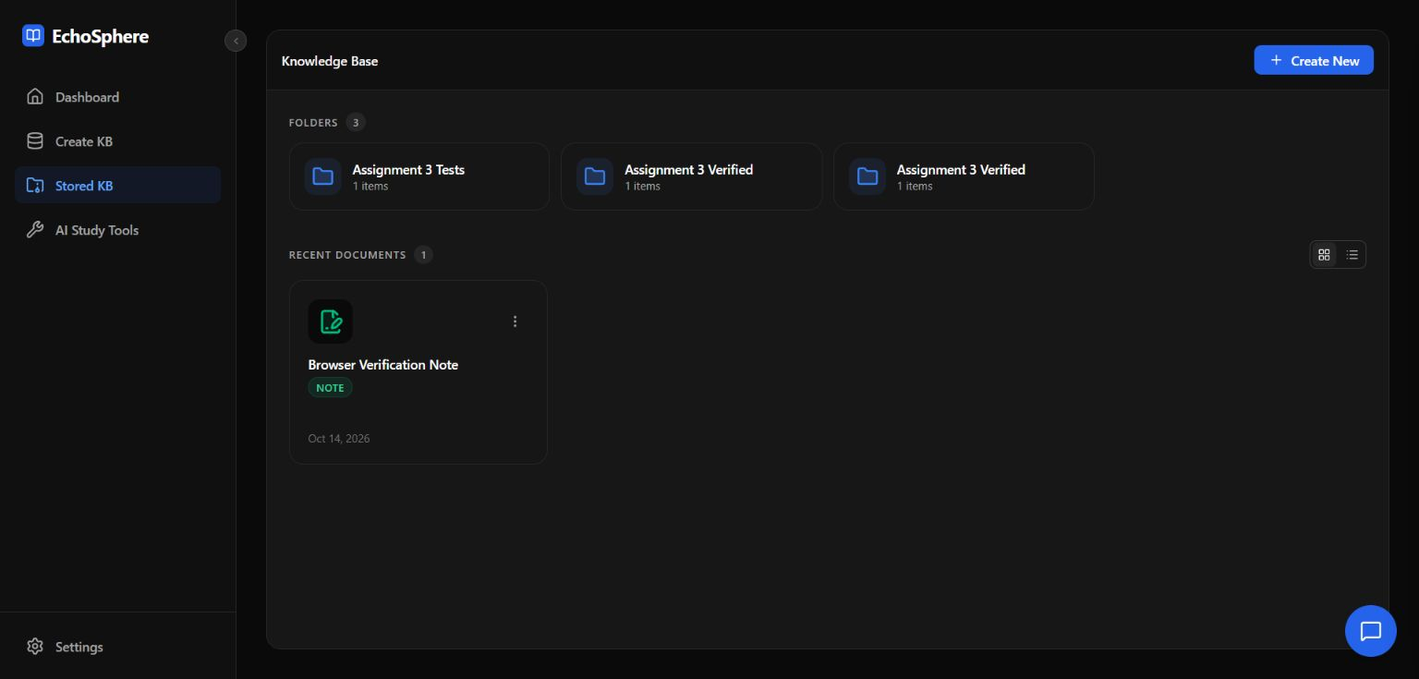
A note created through the browser appears in the stored knowledge base after the API saves it to MongoDB.

Developed Functionality Flashcards
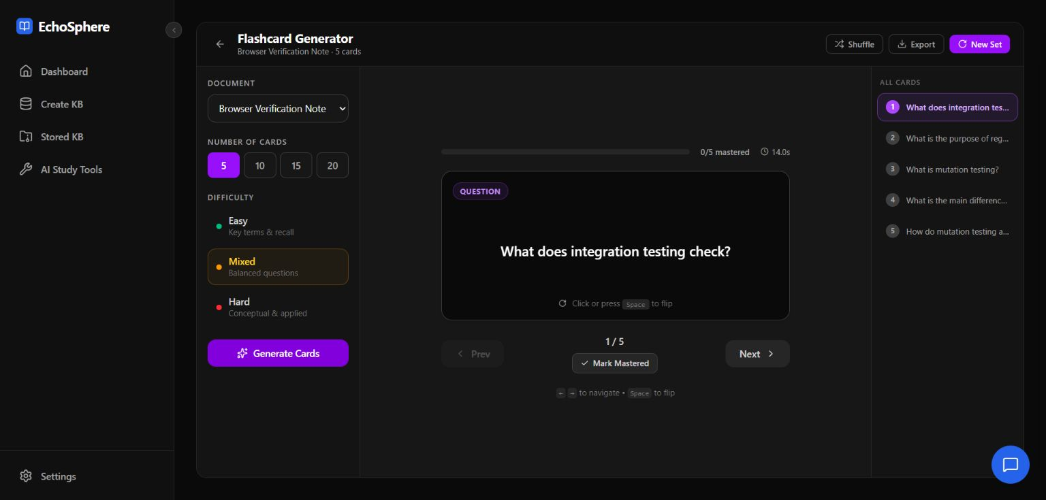
Ollama generates five study flashcards from the selected note, and the browser displays their questions.

Appendix A Software Requirements Specification
Purpose: provide a single-user local workspace for storing personal study materials and creating AI-assisted revision outputs. The requirements below describe the current release and its intended operation.
ID | Functional requirement
FR01 | Accept PDF, DOCX and TXT uploads and store their metadata and original files.
FR02 | Create, edit, list and delete notes; organise records within hierarchical folders.
FR03 | Extract readable text and perform background chunking, embedding and vector indexing.
FR04 | Generate selected-document summaries, explanations, flashcards, exam questions and graphs.
FR05 | Persist and retrieve graph nodes/links and saved prompts.
FR06 | Answer knowledge-base chat queries using retrieved context where available.
FR07 | Allow local model selection, theme preference and consistent workspace navigation.
FR08 | Validate supported request inputs and return clear JSON errors for rejected operations.

Constraints and Nonfunctional Requirements
The system requires local MongoDB and Ollama with the generation and embedding models installed. File uploads are limited to 50 MB. OCR, multi-user authentication and performance prediction are outside the implemented release. Existing automated tests cover specified behaviors; they do not establish security for public deployment, arbitrary-document parsing accuracy or guaranteed hallucination-free answers.

Tools and Technologies
React 19, TypeScript, Vite, Tailwind CSS, Express 5, Node.js 24, MongoDB/Mongoose, LanceDB/Apache Arrow, pdf-parse, mammoth, cheerio, Ollama, react-force-graph-2d, Git, Docker Compose, Postman, Jest, Supertest and Stryker.

Appendix B Data Flow Diagram
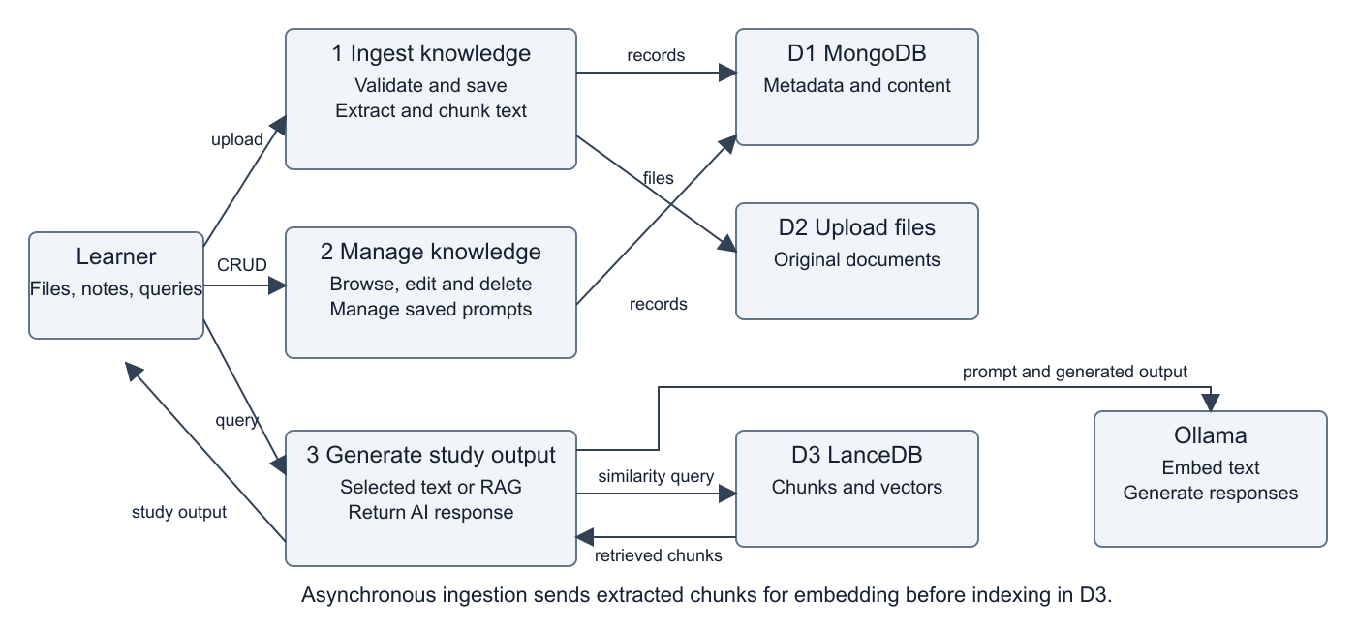
The DFD summarises learner inputs, knowledge ingestion, record management and study-output generation, with MongoDB, file storage and LanceDB as data stores.
Ingestion validates and saves input, extracts text and indexes embedded chunks asynchronously. Study tools obtain selected document text or retrieved context and call Ollama. Web clipping fetches a supplied web page and stores readable content as a note; this workflow requires network access.

Appendix C Entity Relationship Diagram
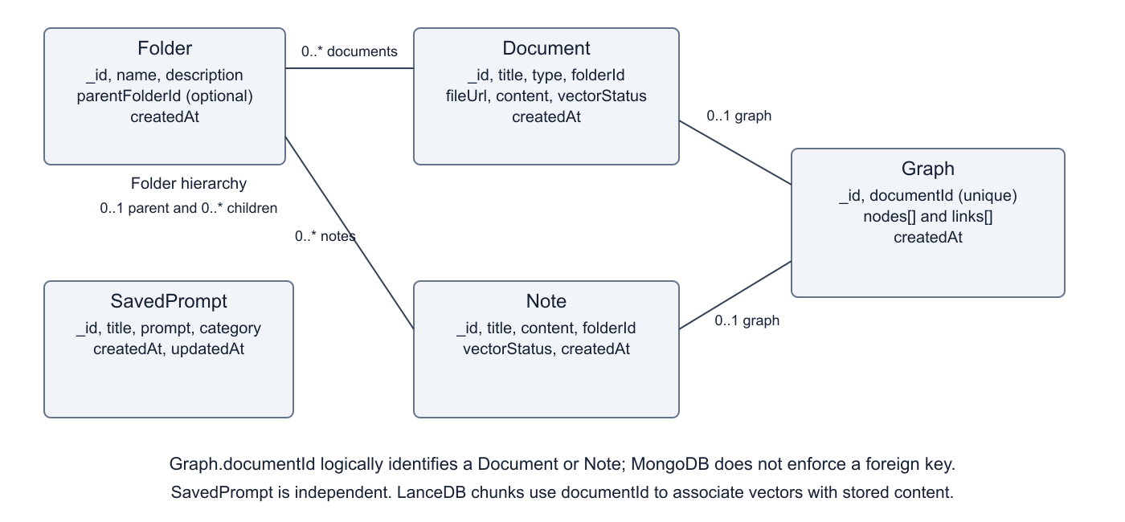
Logical relationships reflect the current MongoDB schemas. A document or note can belong to one optional folder, while a folder can contain many records.
Folder.parentFolderId models nesting. Graph.documentId is unique and logically identifies a document or note, although MongoDB does not enforce a foreign key. Nodes and links are embedded in Graph; SavedPrompt is independent. Vector chunks reside in LanceDB and carry documentId associations.

Appendix D UML Use Case Diagram
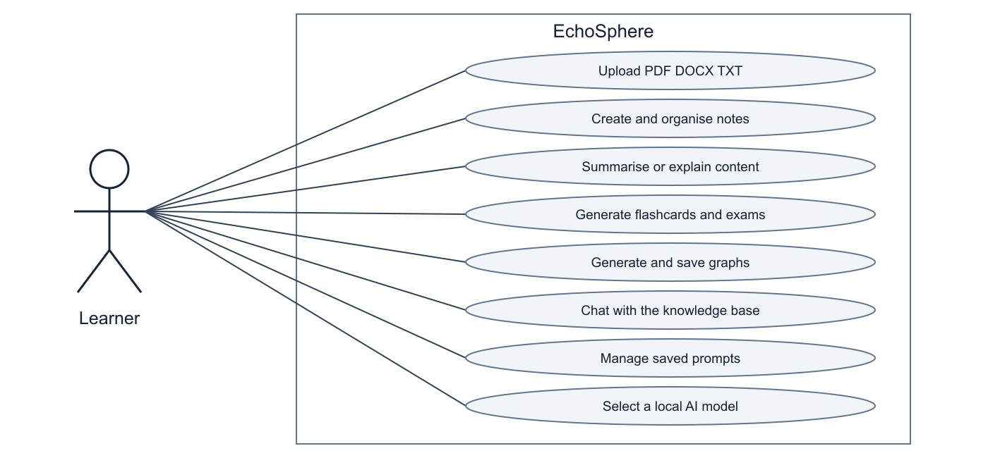
The learner interacts with document management, study tools, knowledge-base chat, saved prompts and local model configuration.
The single-user actor follows the DA1 scope. Multi-user JWT login and image OCR are excluded from this release. Flashcards, exam questions and chat extend the original summary, explanation and graph workspaces.

Appendix E UML Sequence Diagram
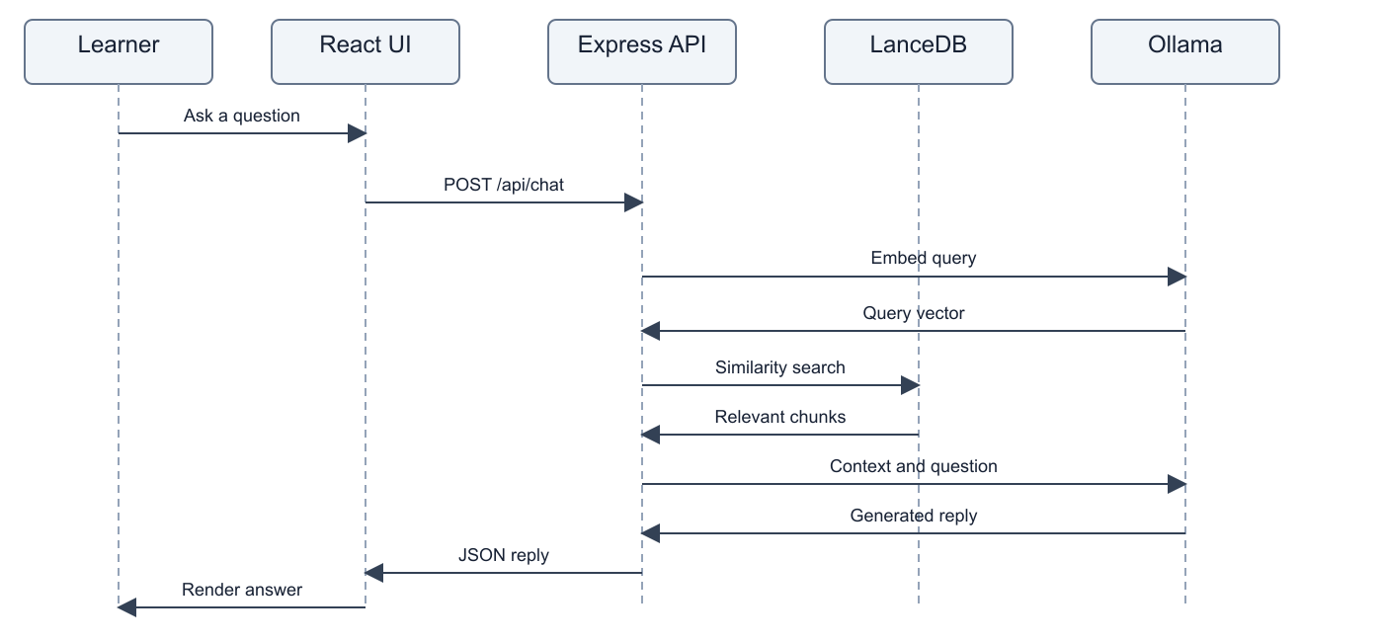
The sequence shows the successful knowledge-base chat path from the browser request through query embedding, vector retrieval and response generation.
The main chat request is POST /api/chat. If no relevant vector chunks are returned, the implementation falls back to document titles or an empty-knowledge-base message. That fallback does not establish the contents of a document; users should check generated answers against their sources.

References and Project Links
The prior submissions establish the project goals, user-story priorities, Figma design direction and architecture rationale. The links below preserve those references and provide access to the project code.
GitHub repository and code listing
Vision document and project README
User stories as GitHub issues
Figma prototype from DA2
Draw.io architecture file on Google Drive

