EchoSphere Digital Assignment 3
Software Engineering Project Report and Testing Evidence
Name KAILASH P Register Number 24BRS1382
Review 3 Updated 21 October 2026

Project Overview
EchoSphere is a personal learning environment that organises study documents and notes and provides AI summaries, explanations, flashcards, exam questions, knowledge graphs and knowledge-base chat. The current release combines a React interface, an Express API, MongoDB persistence, LanceDB retrieval and local Ollama models.

Problem Statement
Students and researchers keep useful knowledge across separate documents and notes. Finding relevant passages, revising long materials and connecting related concepts takes time. EchoSphere brings these materials into one workspace and provides study outputs derived from selected documents or retrieved knowledge-base context.

Users and Objectives
The primary users, carried forward from DA1, are university students preparing for assessments and researchers reviewing a collection of papers. The objective is to reduce retrieval and revision effort while keeping the source material available for checking AI output.

Report Scope
This report combines the project requirements and design with the recorded DA3 testing evidence. The baseline evidence recorded on 14 October contains 64 passing Jest tests, 33 passing live Postman assertions across 22 requests, a 92.28 percent mutation score for input validation, and successful frontend and container builds. Later browser checks on 20 October cover 12 functional areas and the recorded demonstration. These are separate verification runs.
Project repository and code

User Stories and Priorities
DA1 records 25 user stories as GitHub issues. The following table consolidates representative priorities for the current single-user release; local model configuration supersedes the earlier Gemini API-key requirement.
Priority | User story | Current scope
Must | As a learner, I want to upload study documents so I can work from my own materials. | PDF, DOCX and TXT ingestion.
Must | As a learner, I want extracted text so AI tools can process document content. | pdf-parse, mammoth and TXT reading.
Must | As a learner, I want notes stored across sessions so I can retrieve them later. | MongoDB note persistence.
Must | As a learner, I want summaries so I can revise long materials quickly. | Selected-document summarisation.
Must adapted | As a learner, I want to choose a local AI model so study tools use my preferred model. | Ollama selection; no Gemini key required by active routes.
Should | As a learner, I want folders so I can organise related documents. | Hierarchical folders and browsing.
Should | As a learner, I want adjustable output length and explanation depth. | Summary and explanation settings.
Should | As a learner, I want extracted concepts and relationships to see connections. | AI graph generation and persistence.
Should | As a learner, I want consistent navigation between workspaces. | Persistent React sidebar.
Could | As a learner, I want to inspect an interactive two-dimensional knowledge graph. | Force-directed graph view.
Could | As a learner, I want saved prompts and a theme preference. | Prompt workspace and light/dark mode.
Current extension | As a learner, I want flashcards, practice questions and knowledge-base chat. | Flashcards, exam predictor and RAG chat.
Outside release | Multi-user JWT login and OCR for scanned documents. | Remain outside the DA1 single-user scope.

Full user-story issue catalogue

System Architecture and System Design
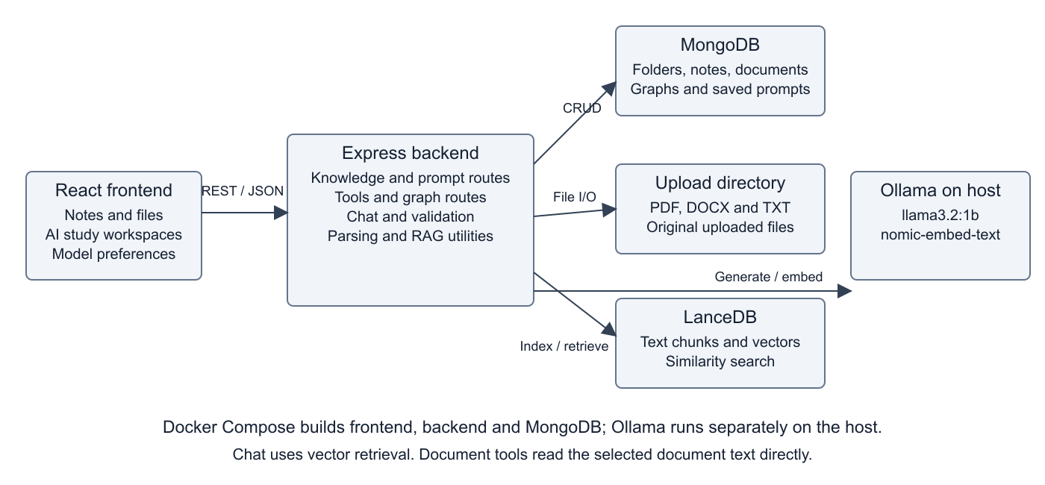
Current architecture: MongoDB holds application records; uploaded files remain on disk; LanceDB stores indexed text chunks; Ollama provides local generation and embeddings.
The modular frontend and REST API separation follow the principles described in DA2. Knowledge routes manage folders, documents and notes; tools routes generate study outputs; graph and prompt routes persist their own records. RAG utilities handle chunking, embeddings and retrieval.
Uploaded files and notes are saved first, then vector ingestion runs in the background. Chat retrieves relevant LanceDB chunks; summarisation, explanation, flashcards, exam questions and graph generation read selected document text directly. Ollama is a host service outside the frontend/backend/MongoDB Compose services.
Original DA2 architecture drawing on Google Drive

Implementation and Module Responsibilities

Frontend and user interaction
React and TypeScript implement the dashboard, knowledge base and study workspaces. Tailwind CSS provides the layout and light/dark presentation. The persistent sidebar keeps navigation consistent with the DA2 wireframes. Each workspace holds its selection, loading, result and error states; HTTP requests connect it to Express. The summary workspace displays source text beside generated output so the learner can compare them.

Knowledge ingestion and storage
A learner creates a folder, uploads a supported file or writes a note. Multer receives uploads with a 50 MB limit. PDF text is extracted using pdf-parse, DOCX text using mammoth, and TXT files are read as text. MongoDB stores metadata and notes, while original uploads remain in the configured upload directory. Web clipping uses fetch and cheerio to extract readable page content and save it as a note; success depends on network access and page structure.

Generation and retrieval
Document tools obtain the selected record and extract its text before calling Ollama. The concept explainer also accepts a topic without a document. Flashcards, exam questions and graphs request structured JSON so their outputs can be rendered as interactive components. Chat follows a separate RAG path: text is split into overlapping chunks, nomic-embed-text creates embeddings, LanceDB retrieves relevant chunks, and the selected generation model composes an answer from the retrieved context.
Module | Main responsibility
knowledge.js | Folder, file, note, download and web-clipping operations.
tools.js | Summary, explanation, flashcards and exam-question generation.
graph.js and prompts.js | Graph generation/persistence and reusable prompt storage.
rag.js and validation.js | Chunking, embeddings, retrieval, shared generation and request validation.

The generation model used in the recorded demo is llama3.2:1b. Local Ollama calls do not require a Gemini API key. Model selection and the theme preference are stored in the browser; application records remain in MongoDB.

Design Principles and Report Continuity
Principle from DA2 | Application in the current release
Modularity and cohesion | React workspaces and dedicated route modules separate notes, graphs, prompts and AI tools.
Loose coupling | The frontend exchanges HTTP/JSON with Express. Persistence and model generation sit behind backend routes.
Abstraction | Learners select documents and study settings; backend utilities handle parsing, chunking and vector retrieval.
Usability | The persistent sidebar, familiar file browser, source/summary view and graph workspace preserve the Figma design direction.
Maintainability | Shared validation, configurable database/model addresses, repeatable tests and Docker builds support diagnosis and change.

Changes Carried into DA3
Earlier description | DA3 description
Gemini and browser API-key storage | Active AI routes use Ollama. Browser storage holds the selected model preference.
PDF DOCX TXT MD upload labels | The current backend accepts PDF, DOCX and TXT; Markdown display support does not establish MD ingestion support.
All study tools use RAG | Chat uses vector retrieval. Document tools use the selected document text directly.
Synchronous processing before persistence | Records are saved and acknowledged before background vector ingestion.
Everything inside Docker Compose | Frontend, backend and MongoDB are Compose services; Ollama runs separately on the host.
Three to five seconds and near-zero hallucinations | These were DA1 targets. The live run averaged 7.6 seconds and reached 59.8 seconds; factual accuracy, uptime and retention are not established by these tests.

Design of Tests
The repeatable suite combines Express and real MongoDB integration with focused validation regression tests. AI calls are stubbed in Jest for repeatability. The separate Postman collection uses real MongoDB and Ollama; browser checks verify that a saved note and generated flashcards are displayed.
Case | Action or input | Expected result | Recorded evidence
TC01 | GET /api/health | HTTP 200 and connected database | Jest and Postman pass.
TC02 | Create, browse and rename a folder | Created record appears with the updated name | Jest and Postman pass.
TC03 | Create note, edit content and reindex | Content persists and index refresh is invoked | Jest pass; creation also verified in browser.
TC04 | Upload TXT, download it, list DOCX metadata | TXT is extracted; files are visible and downloadable | Jest pass. PDF/DOCX parser accuracy is not comprehensively measured.
TC05 | Blank fields, unsupported upload, invalid IDs | HTTP 400 JSON error | Jest and applicable Postman checks pass.
TC06 | Create, list and delete a saved prompt | Correct persistence and deletion | Jest pass; create/list also pass in Postman.
TC07 | Save graph and retrieve metadata | Nodes and metadata are retained | Jest and Postman pass.
TC08 | Generate summary, explanation, cards, exam, graph and chat | Non-empty outputs with expected response shapes | Six live AI flows pass in Postman; five cards displayed in browser.
TC09 | Delete folder; invoke clear-all in test database | Contents preserved at root; isolated data cleared | Jest pass; no production database is used.
TC10 | Change validation conditions, strings and boundaries | Regression tests detect behavioral changes | 227 killed, 19 survived, zero uncovered mutations.

Test-only storage uses MongoDB on port 27018 and separate upload/vector directories. Response-shape tests do not prove the factual correctness of every AI answer.

Test Execution Method and Acceptance Criteria

Repeatable automated checks
Jest runs the backend suite in one worker and Supertest sends requests directly to the exported Express application. The integration tests connect to a real MongoDB instance at 127.0.0.1:27018 using the echosphere_jest database. AI generation and indexing are stubbed in this suite so failures can be attributed to application behavior rather than varying model output. The test upload directory is artifacts/jest-uploads; the suite drops its disposable database after execution.

Live integration checks
The Postman collection runs in order because later requests reuse identifiers created by earlier requests. It creates a folder and note, saves a prompt, calls the live study tools, saves/retrieves a graph, updates a note and exercises invalid inputs. A request passes only when its assertions pass: for example, a folder must return HTTP 201, appear in the subsequent list, and provide an identifier for dependent operations. MongoDB and Ollama are real services in this run.

Expected results and negative cases
A successful summary or explanation must return HTTP 200 with non-empty result text. Flashcards must contain question/answer fields, exam responses must contain questions, and graphs must contain nodes and links. Blank names, missing document selections, invalid counts and malformed chat history should return HTTP 400 with JSON error information. Unknown API paths should return JSON 404. These checks establish response behavior; they do not grade the educational correctness of every generated statement.

Regression and mutation checks
Regression tests repeat the expected workflows after fixes to detect unintended changes. Stryker then mutates backend/validation.js and reruns the tests. A killed mutant means the tests detected a changed behavior; a surviving mutant identifies a possible test weakness or equivalent behavior requiring review. This gives additional evidence about the validation tests, rather than measuring the whole application.

Reproduction commands
With the disposable MongoDB service available, run npm test and npm run test:mutation from backend. Import EchoSphere.postman_collection.json into Postman and run its requests in order against the configured local backend. Use the Desktop Agent for Postman web because the Cloud Agent cannot reach localhost. TESTING.md records the isolated service configuration and the original run instructions.
The 64 Jest tests, 33 Postman assertions and mutation score are retained baseline results from 14 October. The later browser recording verifies selected user flows after the Ollama and graph changes; it is not a rerun of the entire automated suite or a new mutation measurement.

Integration Testing
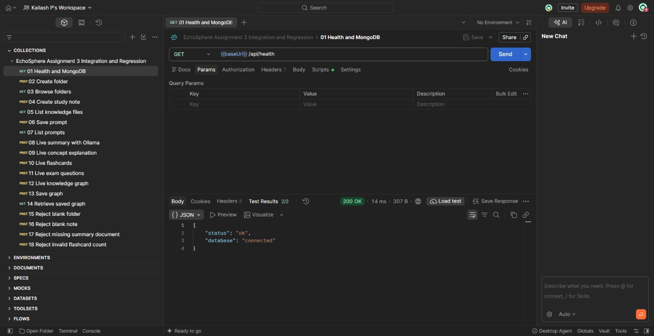
Postman returns HTTP 200 and shows both health checks passing, confirming an available Express API and connected MongoDB database.

Integration Testing with Live AI
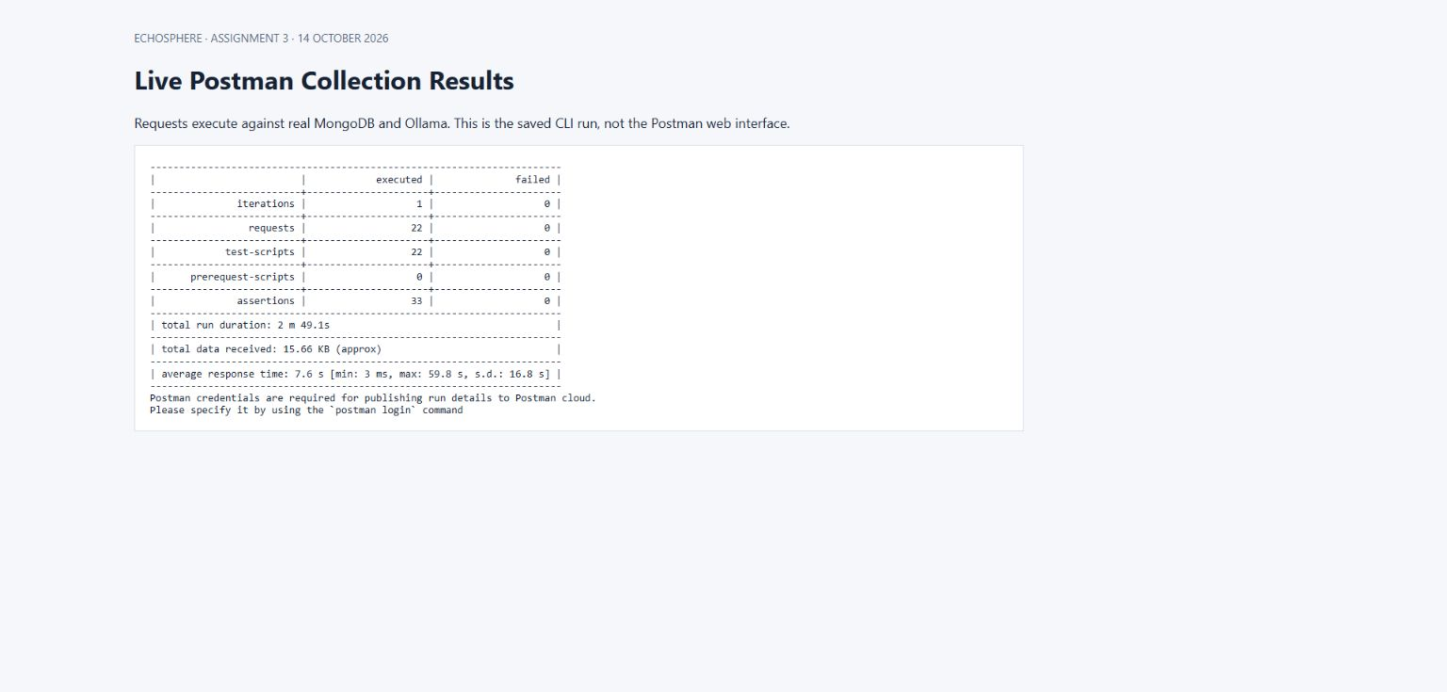
The recorded live Postman CLI execution passes all 33 assertions across 22 requests against MongoDB and Ollama.
This screenshot displays the saved CLI result. The previous page is captured from the actual Postman web interface.

What the integration evidence demonstrates
The health request checks that Express responds and MongoDB is connected. The full collection checks a longer chain: create data, list it, use it in a tool and retrieve saved output. This is important because a successful model response alone would not demonstrate correct storage or document selection.

How the output was obtained
Postman sends HTTP requests to the local API, evaluates the pm.test assertions and records statuses and response times. The health image is from the actual Postman web interface. The collection-results image is a viewer of the saved CLI log; it is labelled separately and should not be described as a screenshot of the Postman application interface.

Regression Testing
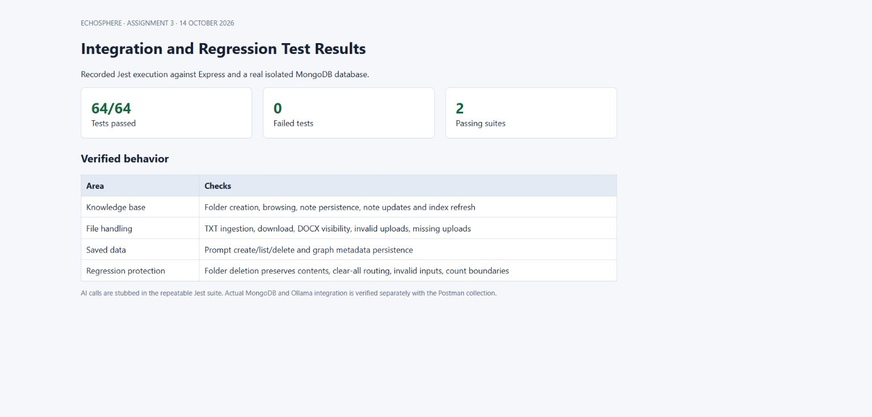
Jest passes 64 tests covering persistence, upload handling, validation and corrected workflows.
The integration suite uses real MongoDB and stubs AI calls; actual AI integration is exercised separately by Postman.

Regression coverage
The suite checks folder creation and browsing, note persistence and editing, TXT extraction and download, supported file listing, saved-prompt round trips, graph metadata preservation and error responses. It also verifies that editing a note invokes index refresh and that the clear-all request reaches the dedicated route in the disposable test setup.

Example of a meaningful assertion
After creating a note, the test reads the MongoDB record and checks its content. After editing the note, it verifies the indexing helper is called with the updated text. This detects a defect that a status-code-only check could miss: returning success while leaving stored content or the search index stale.

Mutation Testing
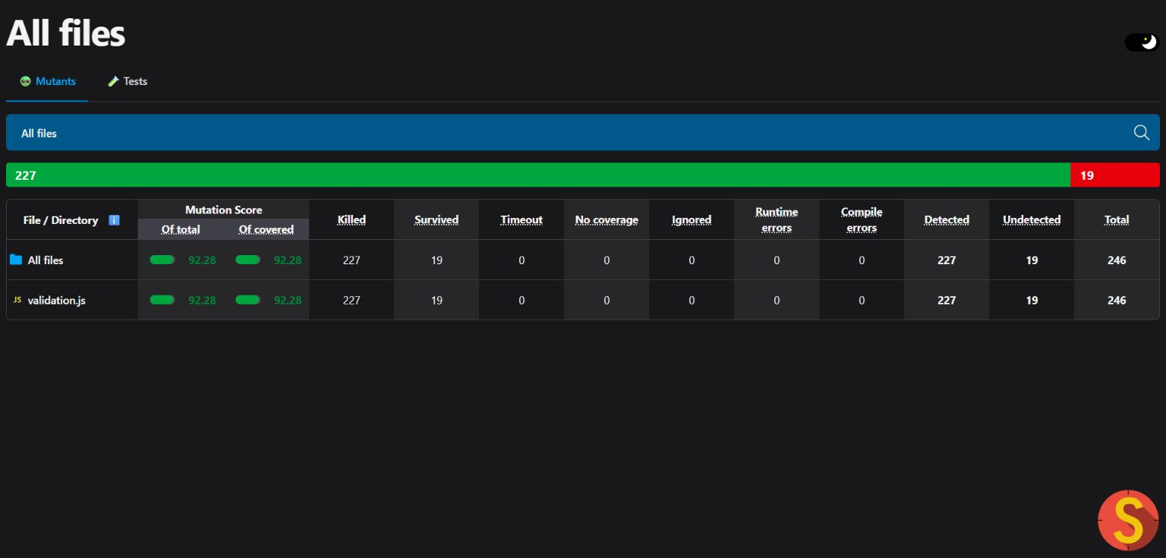
Stryker detects 227 of 246 mutations in request validation, producing a 92.28 percent score.
The scope is backend/validation.js. Nineteen mutations survive; this is not a project-wide score.

Interpretation of the score
The recorded score is 227 divided by 246, multiplied by 100, giving 92.28 percent. All recorded mutants were covered, but 19 survived. Consequently, the validation tests detected most introduced changes while leaving cases for further investigation. A high mutation score does not prove that all business logic, AI behavior or UI behavior is correct.

Remaining mutation work
Review surviving changes individually, identify whether they alter observable behavior, and add an assertion where the behavior matters. Equivalent mutations should be explained rather than increasing the score through tests that merely duplicate implementation details. The full suite and mutation run should be repeated after relevant validation changes.

Version Management and System Building
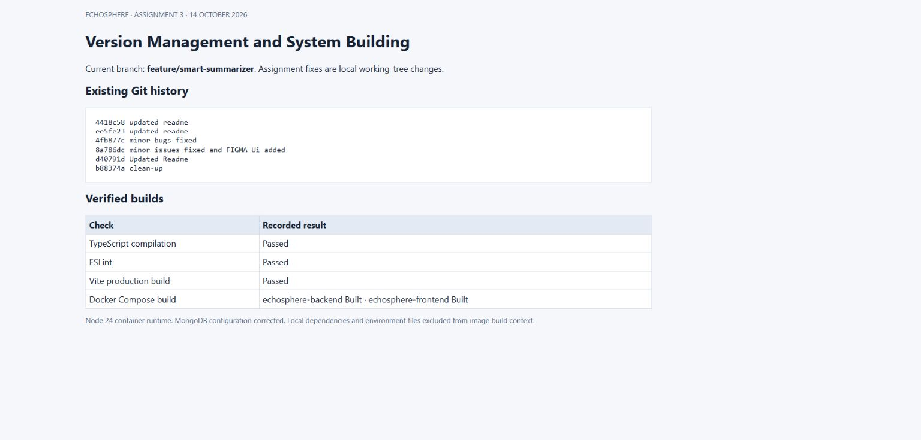
Git history is recorded and TypeScript, ESLint, Vite and both Docker image builds pass.
DA2 shows an earlier smart-summarizer pull request merged into main. The inspected local revision is 2a321a0 on feature/smart-summarizer. The later Ollama memory and graph-prompt corrections remain uncommitted. The local tracking reference reports the branch one commit ahead; the published repository must be checked before submission.

Build pipeline
TypeScript checks frontend types, ESLint checks configured code-quality rules and Vite produces the production frontend bundle. Docker image builds verify that the frontend and backend can be packaged with their declared dependencies. Successful builds do not by themselves establish deployment health; MongoDB, upload storage and the host Ollama service still need correct runtime configuration.

Version management evidence
Git records the feature branch and earlier commit history. DA2 documents the earlier smart-summarizer pull request. Source control supports comparison and rollback, while a commit that includes the final fixes is needed to associate submitted evidence with a reproducible source revision. No new push or deployment is implied by the screenshots.

Developed Functionality Knowledge Base
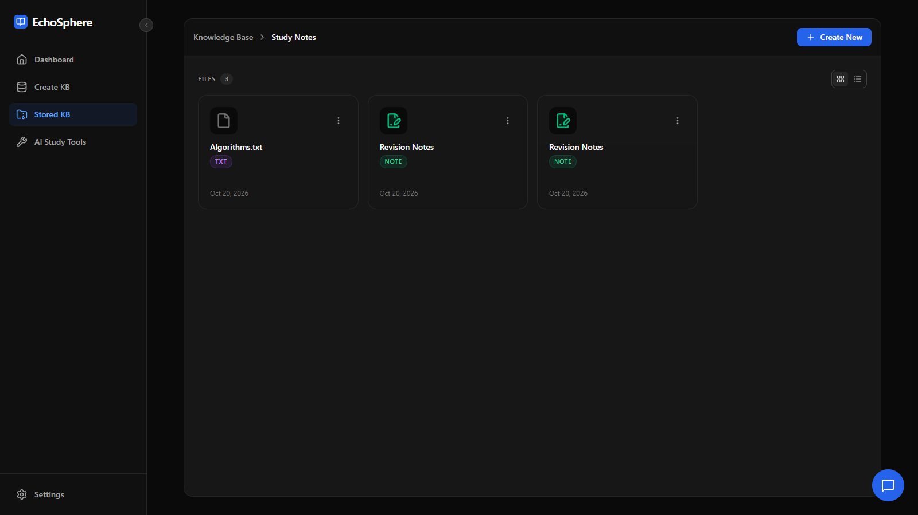
Revision Notes is saved in Study Notes and its content is edited through the interface during the later browser verification.

Developed Functionality Flashcards
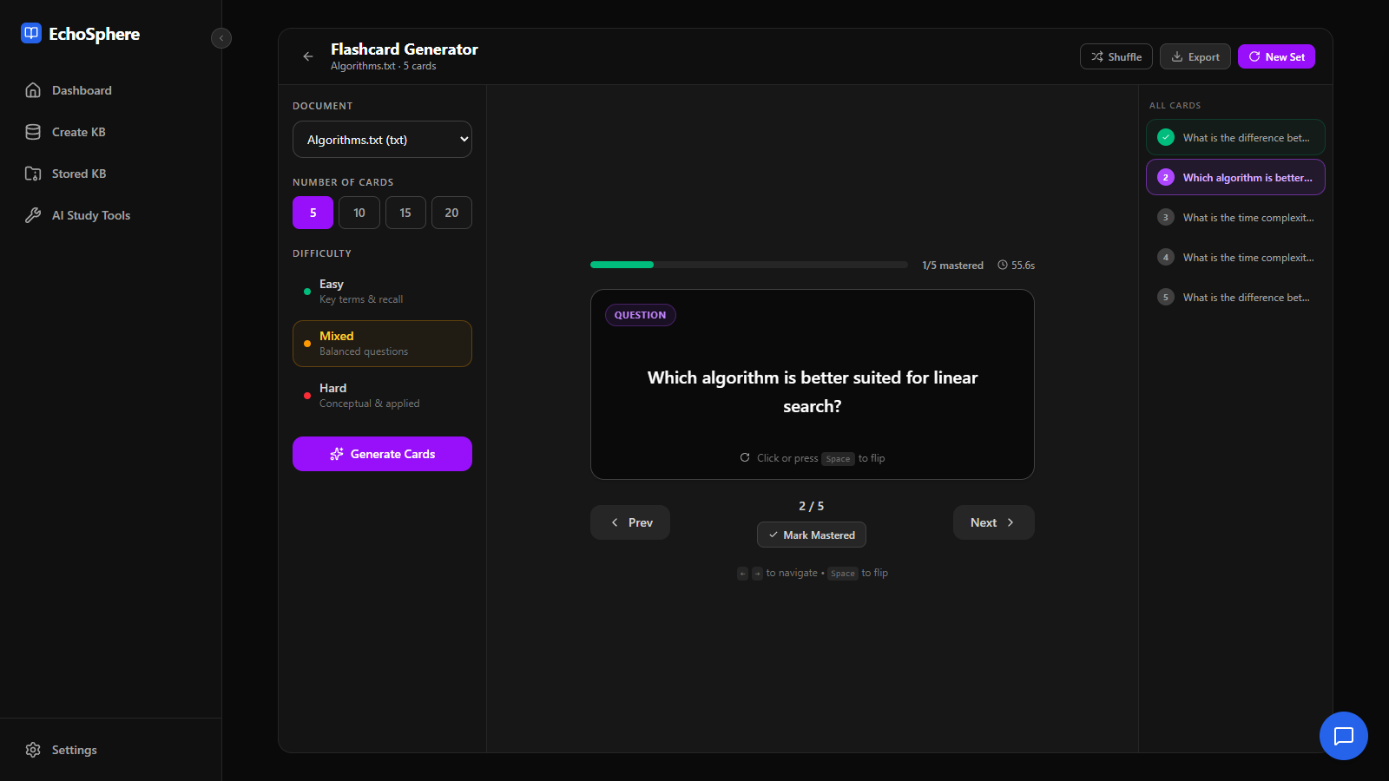
Ollama generates five cards from Algorithms.txt; the browser shows navigation, mastery progress and the export control.

Defects Corrected and Final Verification

Persistence and request handling
The implementation corrections include using the configured MongoDB connection variable consistently, validating identifiers and required fields, making TXT records available to study tools, refreshing vectors after note edits and keeping clear-all routing ahead of identifier-based handling. Graph metadata and source/target identifiers are retained when graph objects pass between the force-graph UI and the API.

Ollama model loading
On 20 October, generation failed with Internal Server Error. The upstream error identified a failed CPU buffer allocation of about 1.31 GB, with roughly 550 MB of free physical memory. This was a model-loading memory failure, rather than a missing API key. Shared generation calls now request memory mapping, a 4096-token context, a smaller batch size and a short model keep-alive. Embedding requests release their model after use. The backend also exposes detailed upstream errors instead of only the HTTP status text.
A targeted live retry summarised Module 2 Part 2.pdf using llama3.2:1b and returned non-empty output in 54 seconds. This verifies that one failing path recovered under the observed conditions. It is not a guarantee that any model or document will fit in the available memory. Longer inputs may be truncated or constrained by the model context.

Knowledge graph labels
Visual inspection of the demo revealed that the model copied example field descriptions into node labels. The prompt was rewritten without placeholder examples and now asks for actual concepts from the source. The parser rejects empty/placeholder names and edges that reference absent nodes. A later live browser check generated and saved a six-node graph from Revision Notes with meaningful labels. Relationship accuracy and classification still require source review.

Verification boundary
The later recorded browser checks cover 12 functional areas, including upload persistence, note editing, AI outputs, graph saving, prompt search, chat and appearance settings. The graph chapter was repeated after its prompt correction. The original 64-test Jest run, Postman collection run, frontend/container builds and Stryker result were not repeated after the final prompt change. They remain dated baseline evidence, and a final full rerun is recommended before release.

Browser Verification and Demonstration
The 20 October recording starts at the dashboard and uses ordinary study data: Study Notes, Algorithms.txt and Revision Notes. A visible result is required for each demonstrated operation. A reload confirms that the uploaded material remains available. These are user-flow smoke checks, not exhaustive coverage of every setting or input.
Area | Observed result
Dashboard | Navigation and study shortcuts are displayed.
Folder and upload | Folder created; Algorithms.txt uploaded and visible after reload.
Notes | Revision Notes created and edited through the menu.
Web clipping | The public example.com page is fetched and saved.
Summary | Selected-document summary returns non-empty text.
Explanation | A binary-search topic explanation is displayed.
Flashcards | Five cards generated; flip, next, mastery and export exercised.
Practice exam | Five short-answer questions generated and one answer revealed.
Graph | Six nodes generated from a note and saved.
Saved prompts | Quick Revision saved and found through search.
Chat | A question is sent and a non-empty model answer displayed.
Settings | Configuration saved and light/dark themes switched.

The edited demonstration lasts about 2 minutes 44 seconds. It is a silent screen recording with chapter labels. Approximately nine minutes of AI processing waits are removed; the application results are actual outputs. The video therefore demonstrates the flow and must not be used as evidence of real-time generation speed.
Recorded project demonstration

Additional Functionality Evidence

Document Summary
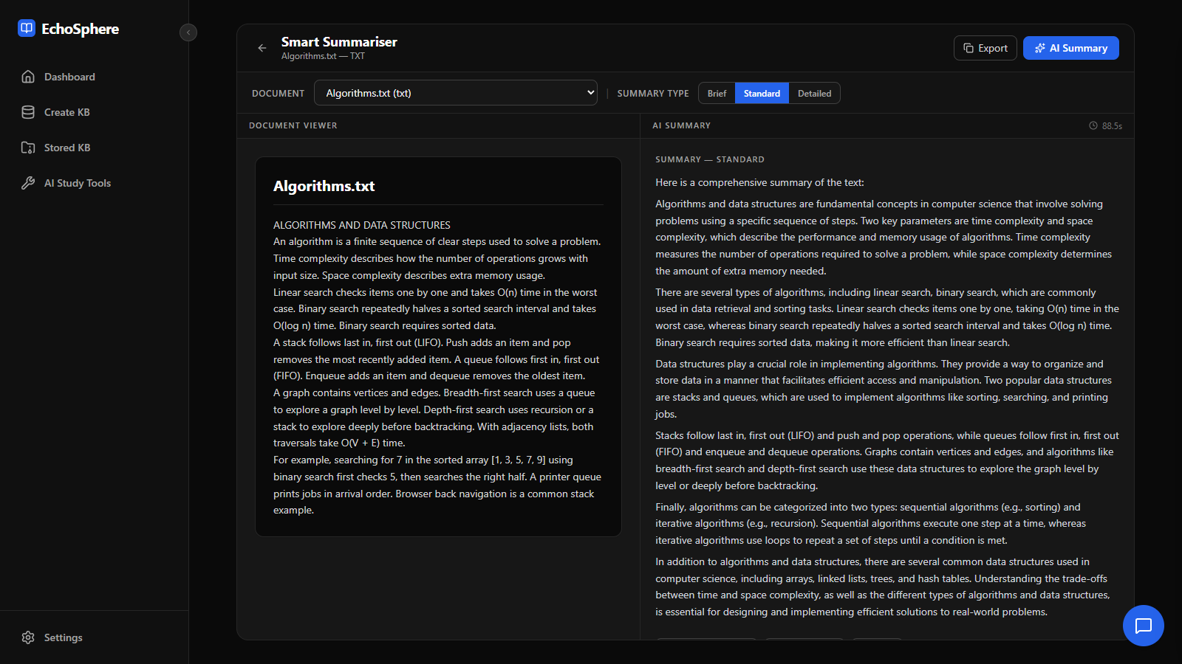
Algorithms.txt is shown beside the summary returned by the local model.

Practice Questions
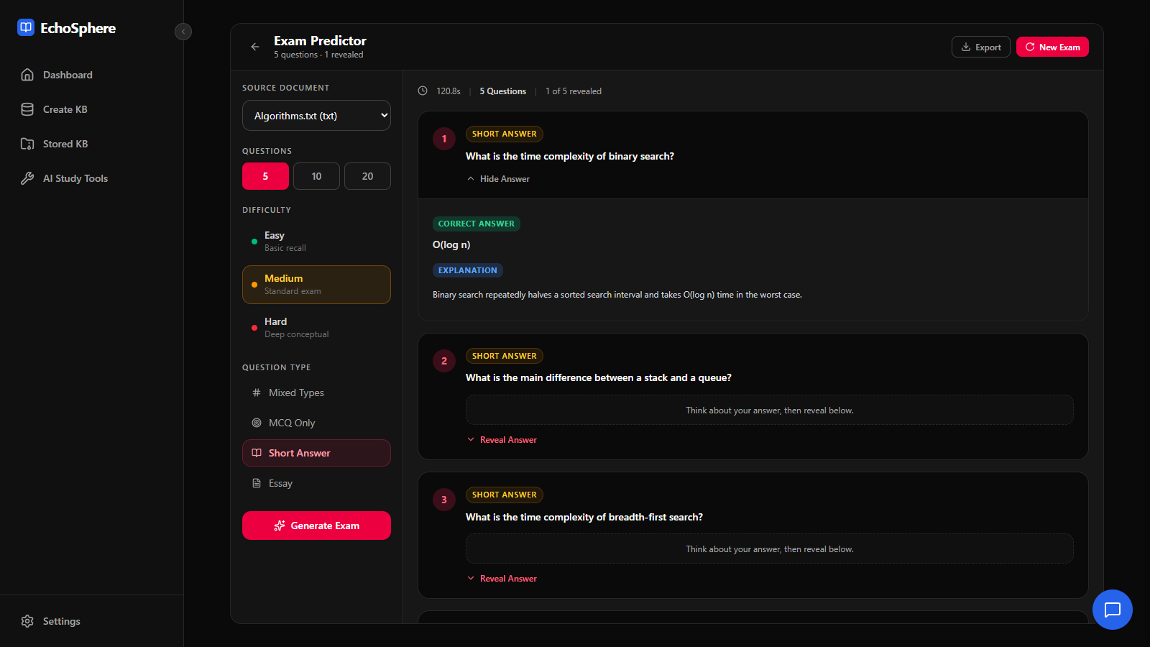
Five short-answer questions are generated and the first answer is revealed.

Graph and Chat Evidence

Saved Knowledge Graph
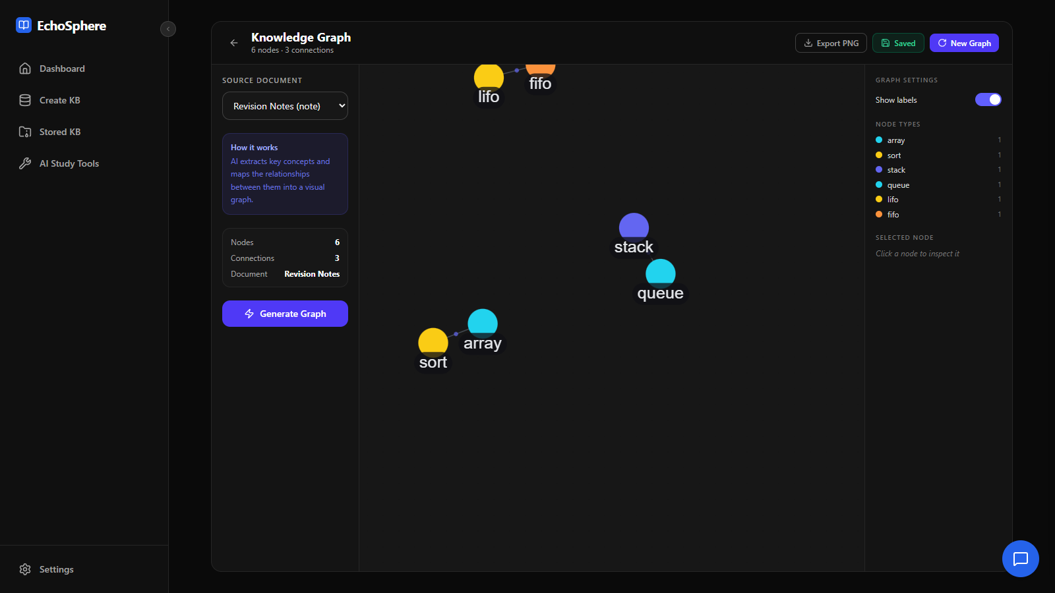
The revised prompt produces concept labels and the graph is saved for the note.

Knowledge Base Chat
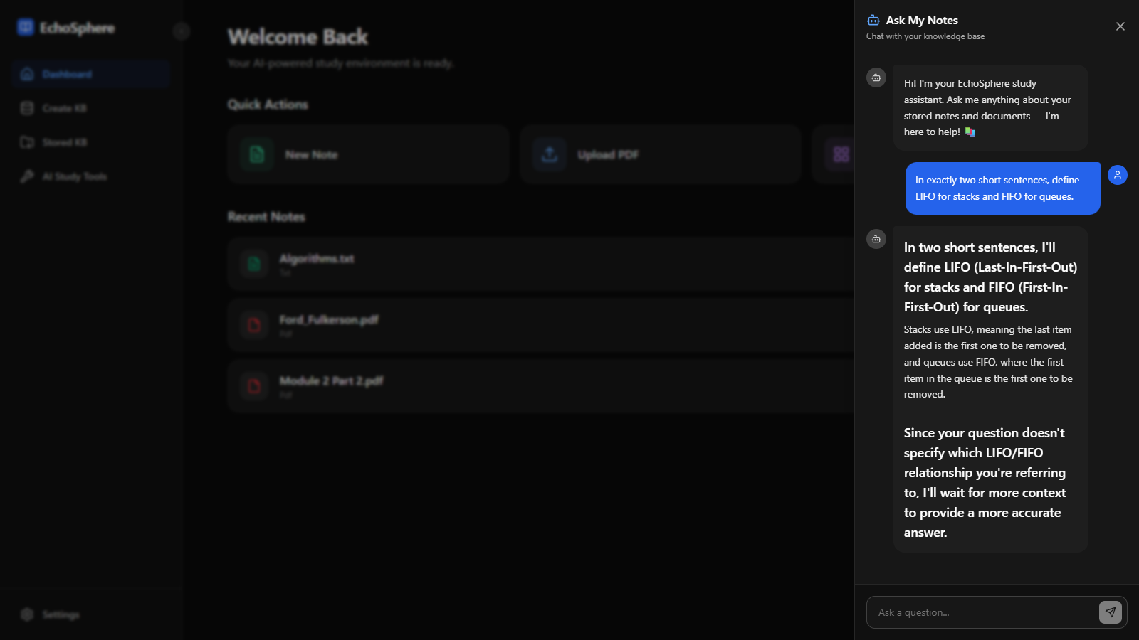
The question and the model response appear in the chat panel; factual accuracy remains subject to source checking.

Appendix A Software Requirements Specification
Purpose: provide a single-user local workspace for storing personal study materials and creating AI-assisted revision outputs. The requirements below describe the current release and its intended operation.
ID | Functional requirement
FR01 | Accept PDF, DOCX and TXT uploads and store their metadata and original files.
FR02 | Create, edit, list and delete notes; organise records within hierarchical folders.
FR03 | Extract readable text and perform background chunking, embedding and vector indexing.
FR04 | Generate selected-document summaries, explanations, flashcards, exam questions and graphs.
FR05 | Persist and retrieve graph nodes/links and saved prompts.
FR06 | Answer knowledge-base chat queries using retrieved context where available.
FR07 | Allow local model selection, theme preference and consistent workspace navigation.
FR08 | Validate supported request inputs and return clear JSON errors for rejected operations.

Constraints and Nonfunctional Requirements
The system requires local MongoDB and Ollama with the generation and embedding models installed. File uploads are limited to 50 MB. OCR, multi-user authentication and performance prediction are outside the implemented release. Existing automated tests cover specified behaviors; they do not establish security for public deployment, arbitrary-document parsing accuracy or guaranteed hallucination-free answers.

Tools and Technologies
React 19, TypeScript, Vite, Tailwind CSS, Express 5, Node.js 24, MongoDB/Mongoose, LanceDB/Apache Arrow, pdf-parse, mammoth, cheerio, Ollama, react-force-graph-2d, Git, Docker Compose, Postman, Jest, Supertest and Stryker.

Quality requirements and current status
Usability is supported by consistent navigation, visible loading states and source/output views. Maintainability is supported by route modules, shared validation, environment configuration and saved tests. Reliability is assessed through the recorded request and persistence checks. The original speed, uptime and near-zero hallucination goals remain targets: no load test, long-duration availability measurement or systematic factual-accuracy benchmark is included.

Appendix B Data Flow Diagram
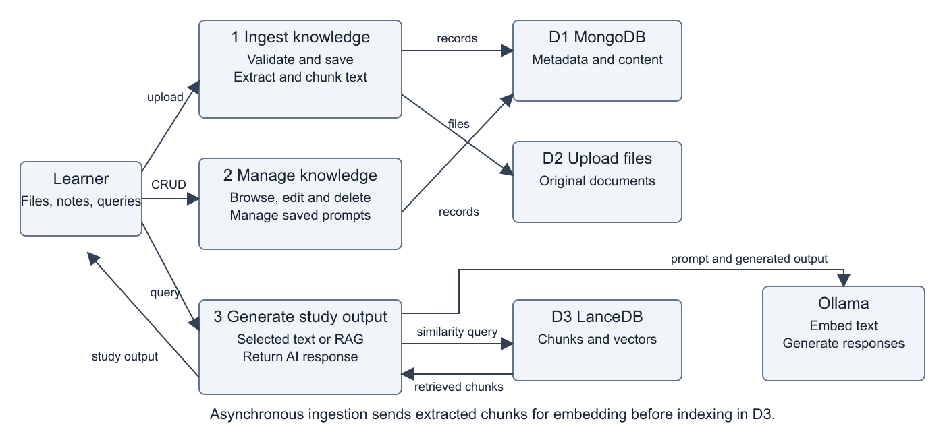
The DFD summarises learner inputs, knowledge ingestion, record management and study-output generation, with MongoDB, file storage and LanceDB as data stores.
Ingestion validates and saves input, extracts text and indexes embedded chunks asynchronously. Study tools obtain selected document text or retrieved context and call Ollama. Web clipping fetches a supplied web page and stores readable content as a note; this workflow requires network access.

Inputs and outputs
The learner supplies a file, note, topic or question. Ingestion produces stored records, original files and vector chunks. Study generation produces text, structured cards/questions or graph nodes and relationships. Only chat depends on retrieved vector context; selected-document tools read source text directly.

Failure and timing considerations
A stored note can appear before its background vector ingestion completes. Therefore, immediate chat availability must not be inferred from a successful save response. Missing files, unsupported formats, unavailable models and generation errors are distinct failure paths. The UI should show the returned error while preserving the learner selection so it can be retried.

Appendix C Entity Relationship Diagram
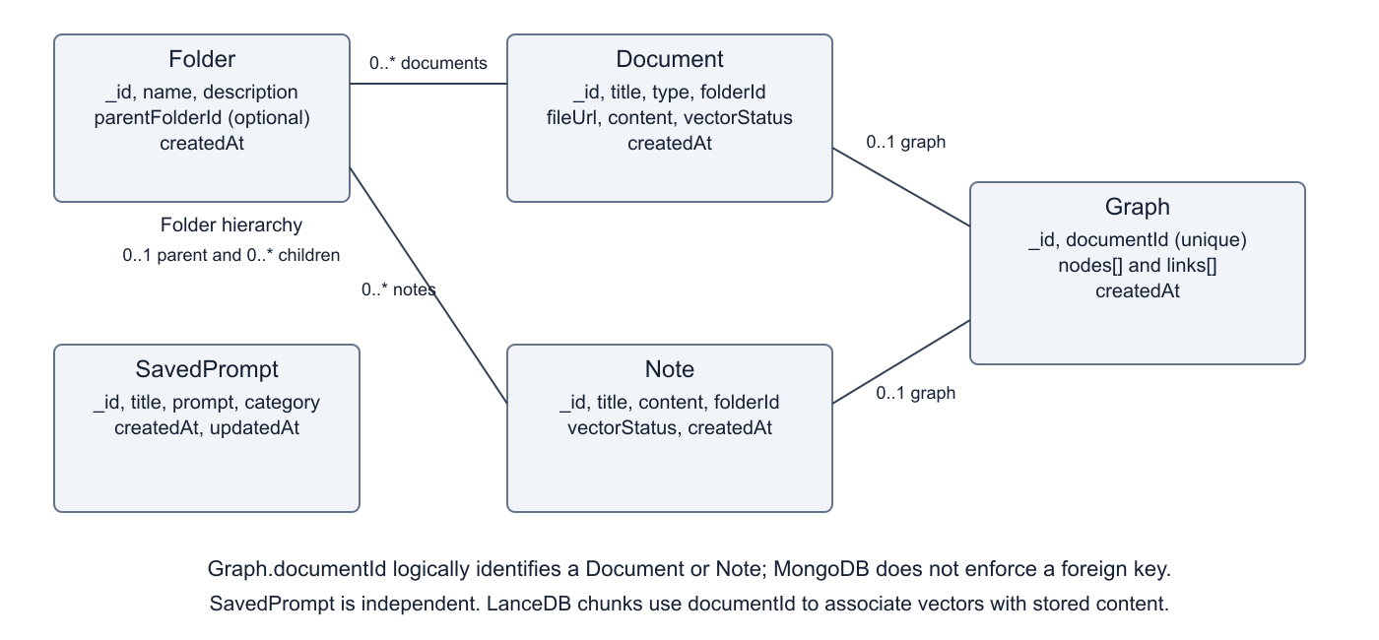
Logical relationships reflect the current MongoDB schemas. A document or note can belong to one optional folder, while a folder can contain many records.
Folder.parentFolderId models nesting. Graph.documentId is unique and logically identifies a document or note, although MongoDB does not enforce a foreign key. Nodes and links are embedded in Graph; SavedPrompt is independent. Vector chunks reside in LanceDB and carry documentId associations.

Record responsibilities
Document records identify uploaded source material and its type; Note records contain editable text, including the current web-clipping output. Folder records provide names and optional parent links. A Graph embeds nodes and links for its source document identifier. SavedPrompt records hold reusable prompt text and category information. LanceDB chunks associate vector content with the originating document identifier for retrieval.

Consistency considerations
The relationships are logical rather than enforced relational foreign keys. Application routes must handle deletion and movement consistently, retain graph metadata and refresh note vectors when content changes. The automated suite checks selected lifecycle cases, but it does not establish correctness for every possible interrupted indexing or concurrent-update scenario.

Appendix D UML Use Case Diagram
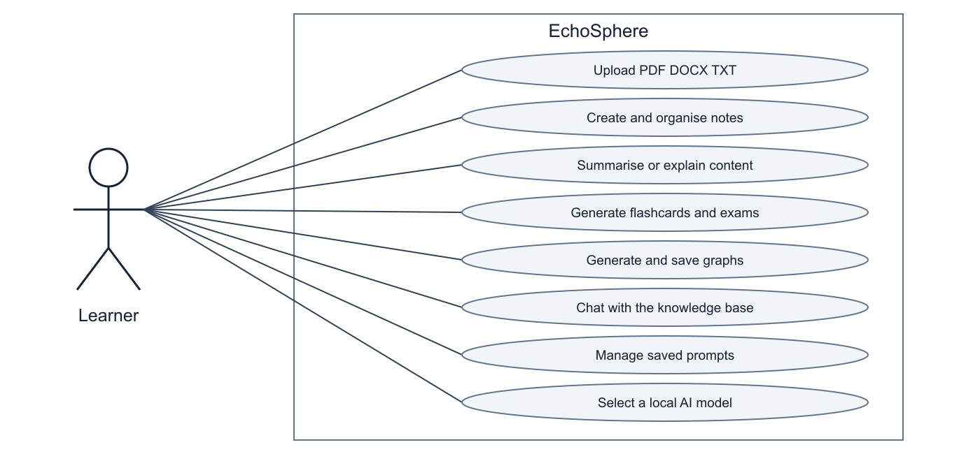
The learner interacts with document management, study tools, knowledge-base chat, saved prompts and local model configuration.
The single-user actor follows the DA1 scope. Multi-user JWT login and image OCR are excluded from this release. Flashcards, exam questions and chat extend the original summary, explanation and graph workspaces.

Example use case
To revise a document, the learner uploads it, confirms that it appears in the knowledge base, selects it in a study workspace and requests an output. The system reads its text, calls the chosen model and renders the result. The learner can then check the source, flip generated flashcards, reveal an exam answer or save the generated graph.

Preconditions and exceptions
The backend and MongoDB must be reachable, a supported source must be stored, and Ollama must have suitable generation/embedding models available. If a document is missing or input is invalid, the API should reject the request. If model loading fails, the error must be shown rather than presenting an empty output as successful completion.

Appendix E UML Sequence Diagram
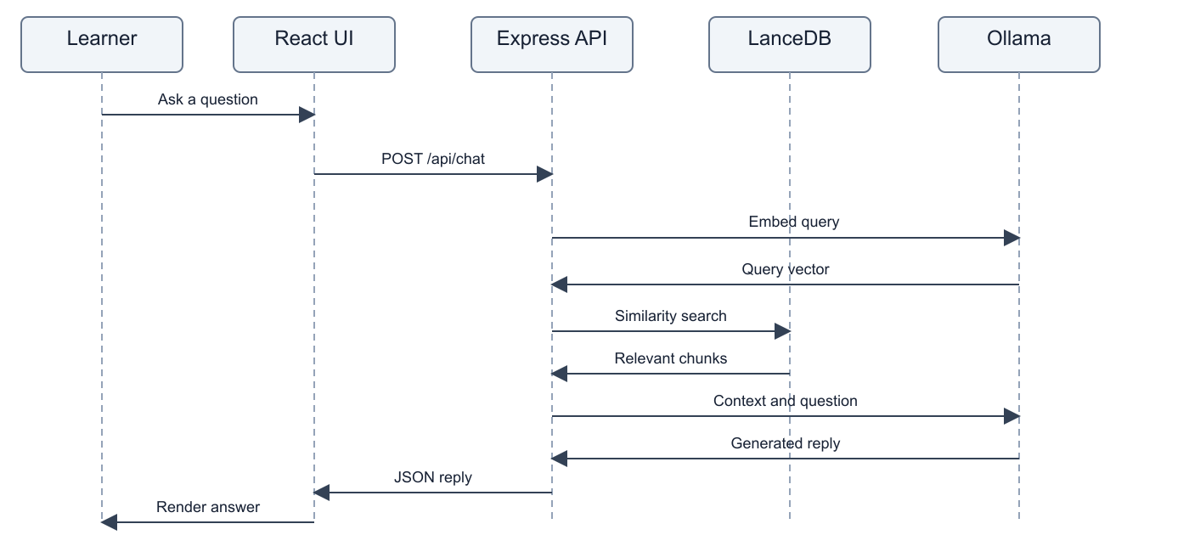
The sequence shows the successful knowledge-base chat path from the browser request through query embedding, vector retrieval and response generation.
The main chat request is POST /api/chat. If no relevant vector chunks are returned, the implementation falls back to document titles or an empty-knowledge-base message. That fallback does not establish the contents of a document; users should check generated answers against their sources.

Sequence responsibilities
The browser submits a question and bounded chat history to Express. The backend embeds the query, searches the vector store, builds a context prompt and requests generation. The completed answer is returned as JSON and appended to the conversation. Generation latency is separate from the UI action, and the recorded video shortens that waiting interval for presentation.

References and Project Links
The prior submissions establish the project goals, user-story priorities, Figma design direction and architecture rationale. The links below preserve those references and provide access to the project code.
GitHub repository and code listing
Vision document and project README
User stories as GitHub issues
Figma prototype from DA2
Draw.io architecture file on Google Drive
Prior Digital Assignment 1 PDF
Prior Digital Assignment 2 PDF
Reproducible Postman test collection
DA1 and DA2 are included beside this report so their relative links can be used when the report package is kept together. Online design links retain their existing access permissions. The repository link represents published code. The later corrections must be committed and pushed if this link is to reproduce the final local demonstration.

Evidence and Reproduction
The report combines the required project sections and testing screenshots. The Postman JSON, TESTING.md, saved result logs and demonstration video provide supporting evidence. Keep the linked files beside this document when sharing the package; relative links require that directory structure. The recorded demonstration supplements the live presentation and does not replace the viva or college submission.
Demonstration video

Remaining Work
Commit and push the later fixes, repeat the full automated checks against the final revision, review the 19 surviving validation mutants and address the recorded dependency vulnerabilities before any public deployment. Confirm examiner access to the online design links. Performance Prediction, OCR and multi-user authentication remain outside the implemented scope.

