**Module -1**

1. **What is SDLC (Software Development Life Cycle)?**

* SDLC is a methodology or step by step approach to produce software with high quality, lowest cost in the shortest possible time by defining the phases like planning & analysis & design & coding & implementation & testing & maintenance.

**The Software Development Cycle**

1. **What is software testing?**

* Testing is process which is used to identify the correctness, completeness, quality of the developed software.
* Testing Types:-

Manual Testing: In manual testing, Human perform the testes step by step without the help of tools.

Automation Testing: In Automation Testing, execute test case with using any automation tool.

E.g. Selenium

We can use below languages for automation testing script.

* Java
* c#
* python

**3. What is Agile Methodology?**

* Agile SDLC is a combination of iterative and incremental process models with focus on process adaptability and customer satisfaction by rapid delivery of working software product.

**4. What is SRS? (Software Requirement Specification)**

* SRS is a complete description of the behavior of the system to be developed.
* **Types of Requirements:**
* Customer Requirement
* Functional Requirement
* Non-Functional Requirement

**5. What is OOPS?**

* Object oriented programming is viewed as a collection of objects. It is used to structure the software program into simple reusable code. Here it is referred as functional testing or black box testing.

**6. Write Basic Concepts Of OOPS?**

1. Class
2. Object
3. Encapsulation
4. Abstraction
5. Polymorphism
6. Inheritance

**7. What is object?**

* An object is the basic unit of OOP which is accessed by its properties called data member & member function. It creates the memory for the class.

**8. What is class?**

* Class is a collection of a data member and member function with its behavior.
* Class is a blueprint or a template to describe the properties and behavior of the objects.

**9. What is encapsulation?**

* A wrapping up of data and function in to a single unit is called encapsulation. IT hide/include private access of data member & member function.

1. **What is inheritance?**

* One class inherits the properties of another class. This is also called a relationship.

1. **What is polymorphism?**

* An ability to take one name having many different forms.

1. Compile time polymorphism
2. Run time polymorphism

**12. Draw Use Case on online book shopping.**

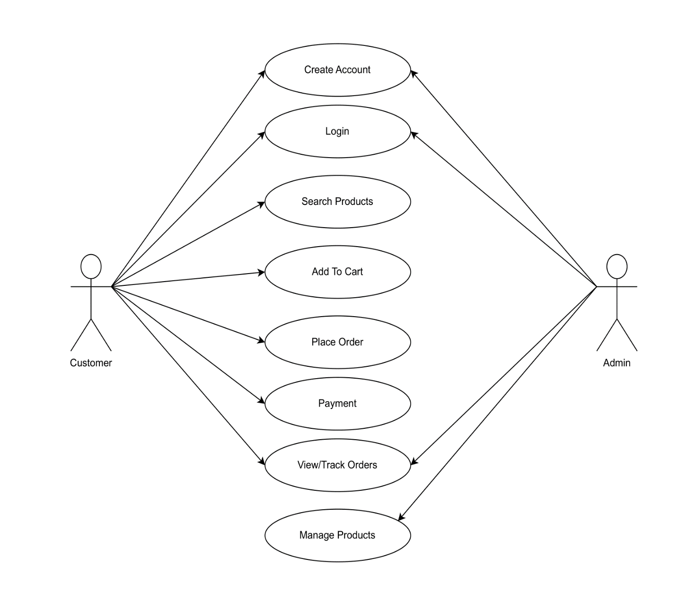

1. **Draw Use case on online bill payment system ( paytm ):**

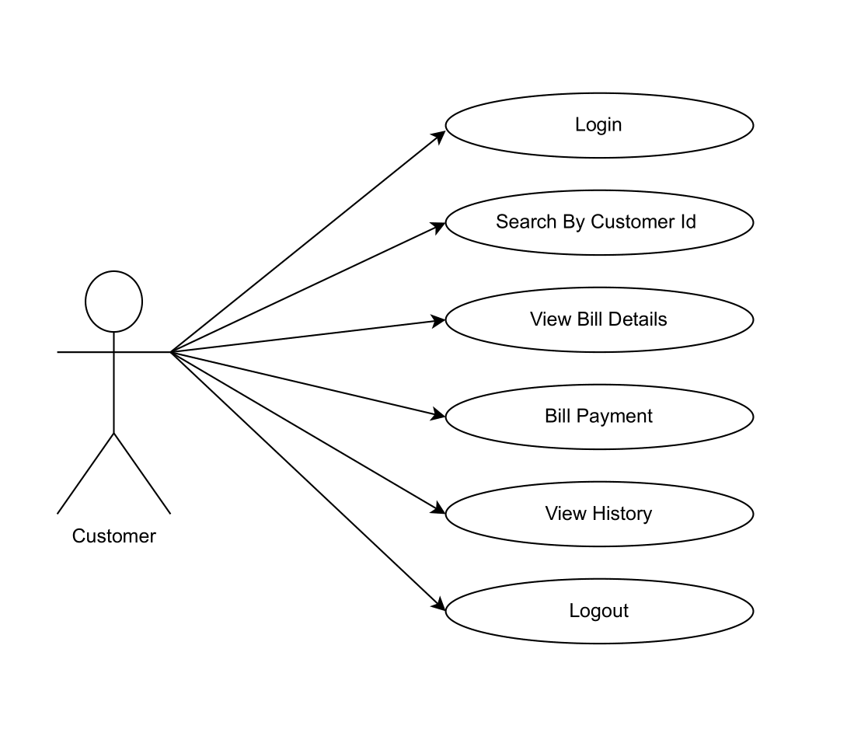

**14. Write SDLC phases with basic introduction.**

**- Requirements collection /Gathering -** Establish customer needs

**- Analysis -** Model and specify the requirements what

**- Design -** Model and specify a solution –why

**- Implementation**  - Construct a solution against the

Requirements.

-**Maintenance -** Repair defects and adapt the solution to

The new requirements.

**15. Explain phases of the waterfall model?**

* The waterfall model is a classical software life cycle that models the software development as a step by step waterfall between the various development phases.
* Applications: (when to use)?

* Requirements are very well documented, clear & fixed.
* Product definition is stable.
* Technology is understood & not dynamic.
* The project is short.

**Pros:**

* Simple and easy to understand and use.
* Phases are processed and completed one at a time.
* Works well for smaller projects where requirements are very well understood.
* Process and result are well documented.
* Clearly defined stages.
* Easy to arrange tasks.

**Cons:**

* Lack of flexibility & adaptability.
* High amounts of risky.
* Not good model for complex.

1. **Write phases of spiral model.**

* Spiral model is very widely used in the software industry as it is in synch with the natural development process of any product learning with maturity also involves minimum risk for the customer as well as the development firms.

1. **Planning /** Requirement Gathering / Feasibility study
2. **Risk Analysis /** Design
3. **Engineering /** Coding
4. **Customer Evaluation /** Testing
5. **Write agile manifesto principles.**

* **Individuals and interactions** over processes and tools
* **Working software** over comprehensive documentation
* **Customer collaboration** over contract negotiation
* **Responding to change** over following a plan

1. **Explain working methodology of agile model and also write pros and cons.**

* Agile model is a combination of iterative and incremental process models with focus on process adaptability and customer satisfaction by rapid delivery of working software product.

**Pros:**

* Very realistic approach.
* Rapid delivery.
* Functionality can be developed rapidly.
* Resource requirements are minimum.
* Little or no planning required.
* Promotes teamwork and cross training.
* Suitable for fixed or changing requirements.
* Gives flexibility to developers.

**Cons:**

* More risk of sustainability, maintainability and extensibility.
* Depends heavily on customer interactions.
* Very high individual dependency.
* Minimum documentation generated.
* Not useful for small projects.
* Not suitable for handling complex dependencies.

1. **Draw use case on online shopping product using COD.**

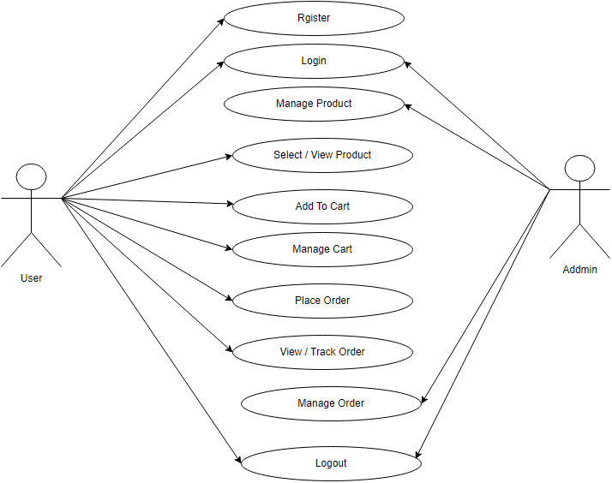

1. **Draw use case on online shopping product using payment gateway.**

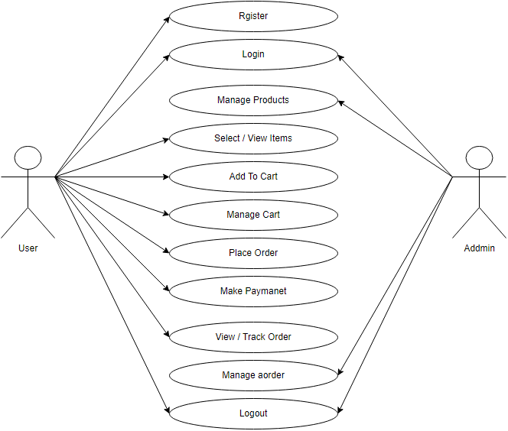

1. **7 Key principle.**
2. Testing shows presence of defects.
3. Exhaustive testing is impossible.
4. Early testing.
5. Defect clustering.
6. The pesticide paradox.
7. Testing is context dependent
8. Absence of errors fallacy.

* **Testing shows presence of defects**
* Testing can show that defects are present but cannot prove that there are no defect.
* Testing reduces the probability of undiscovered defects.
* We test to find faults.
* **Exhaustive testing is impossible**
* Testing everything including all combinations of inputs and preconditions is not possible.
* **Early Testing**
* Testing activities should start as early as possible in the software or system development life cycle.
* Testing activities should start as early as possible in the development life cycle.
* **Defect clustering**
* A small number of modules contain most of the defects.
* Defects are not evenly spread in a system.
* Similarly most operational failures of a system are usually confined to a small number of modules.
* **Pesticide paradox**
* If the same tests are repeated over and over again eventually the same set of test cases will no longer find any new defects.
* **Testing is context dependent**
* Testing is basically context dependent.
* Testing is done differently in different contexts.
* Differed kind of sites are tested differently.

E.g. Safety-critical software is tested differently from an e-commerce site.

s

* **Absence of errors fallacy**
* If the system built is unusable and does not fulfill the user’s needs and expectations then finding and fixing defects does not help.
* It doesn’t make it a good system.

1. **Verification v/s Validation.**

|  |  |
| --- | --- |
| **Verification** | **Validation** |
| -verification is a process which is performed at development level. | -validation is a process which is performed at testing level. |
| -verification phases are business requirement analysis system design architecture design, module design. | -validation phases are unit testing, integration testing, system testing, acceptance testing. |
| -Development to check whether the specified requirements meet or not. | -Development to check whether it satisfied business requirements or not. |
| -Verification are you building a product right? | -Validation have you building a right product? |
| -Verification can be achieved by planning requirement specification, design specification, code specification & test cases. | -validation can be achieved as an actual product. |