**Module – 2**

1. **What is Exploratory Testing?**

* Exploratory testing is a concurrent process for test design, execution and simultaneously.
* If is like exploratory thinking kind of activity to explore application.
* Testing is often not recorded.
* Makes use of experience, heuristics and test patterns.

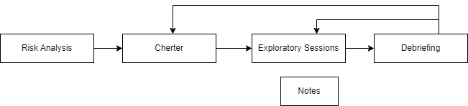

1. **What is traceability matrix?**

* Traceability matrix means combination of Row, Column in table format.
* Test conditions should be able to be linked back to their sources

In the test basis, this is known as traceability.

* To protect against changes you should be able to trace back from every

System component to the original requirement that caused its presence.

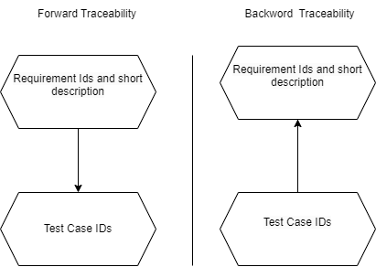

1. **What is Boundary value testing?**

* It is batter version of equivalent partitioning to valet the boundary like upper &lower.
* Boundary value analysis is a methodology for designing test cases that concentrates software testing effort on cases near the limits of valid ranges
* Boundary value analysis is a method which refines equivalence partitioning.

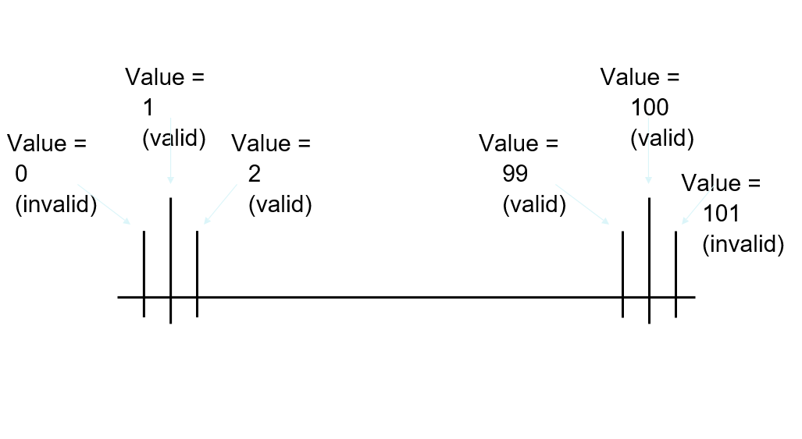

1. **What is Equivalence partitioning testing?**

* Equivalence partitioning is a methodology to design the test cases like to divide the range into equivalent partitions and select repetitive input value to test each partitions.
* If representative value will be parts there the how partition passed. If the represented value will be failed then the hall partition will be failed.

**EX:** If value is between **1 and 100 then value >=1 and value <=100**

**Equivalence Partitioning: Check the range: 1 to 100**

|  |  |  |
| --- | --- | --- |
| **Partitions** | **Representative Value** | **Result(Valid/Invalid** |
| 1-20 | 12 | Pass (Valid Partition) |
| 21-40 | 30 | Pass (Valid Partition) |
| 41-60 | 55 | Pass (Valid Partition) |
| 61-80 | 69 | Pass (Valid Partition) |
| 81-100 | 99 | Pass (Valid Partition) |
| 101-120 | 112 | Fail (Invalid Partition) |

1. **What is Integration testing?**

101

* Integration Testing is a level of the software testing process where individual units are combined and tested as a group.
* Integration Testing is done by a specific integration tester or test team.

* Two Type of Integration.

1. Component Integration Testing.
2. System Integration Testing.
3. **What determines the level of risk?**

* Any future negative consequences.
* A factor that could result in future negative consequences usually expressed as impact and likelihood.

Project Risk

Product Risk

1. **What is Alpha testing?**

* Alpha Testing is definitely performed and carried out at the developing organizations location with the involvement of developers.
* It is always performed by the developers at the software development

Site.

1. **What is beta testing?**

* Beta Testing (field testing) is performed and carried out by users or you can say people at their own locations and site using customer data**.**
* It is always performed by the customers at their own site. It is not performed by Independent Testing Team.
* Beta Testing is always open to the market and public. It is usually conducted for software product.

1. **What is component testing?**

* Component Testing is a level of the software testing process where individual units/components of a software/system.
* Unit testing will be performed by developer only.

1. **What is functional system testing?**

* Functional system testing the attribute (features) of the system directly related to the functionality.

**EX.** Login form

* Login will be always possible by entering user name and password otherwise with any warring message.

1. **What is Non-Functional Testing?**

* Non-Functional testing the attribute (features) of the system not directlyrelated to the functionality.

**EX.** The application will handle limited number of user’s .so we need to check performance of the application by Appling load.

1. **What is GUI Testing?**

* **GUI (Graphical User Interface)** GUI testing involves checking the screens with the controls like menus, buttons, icons, and all types of bars: tool-bar, menu-bar, dialog boxes and windows etc.

**Approach of GUI testing type:**

1. Manual based testing.
2. Record and replay.
3. Model based testing.
4. **What is Adhoc testing?**

* Adhoc testing does not follow any structured way of testing and it is randomly done on any part of application.
* Three types of Adhoc testing:

1. Buddy testing
2. Pair testing
3. Monkey testing

* It is and informal testing with and aim to break the system.
* Adhoc testing does not follow any structure way of testing and it is randomly done on any part of application.
* Main aim of this testing is to find defects by random checking.
* Adhoc testing can be achieved with the testing technique called error guessing.

1. **What is load testing?**

* Load testing is a performance testing to check system behavior under load. Testing an application under heavy loads, such as testing of a website undera range of load to determine at what point the system response time degrades or fails.
* Load testing is stability + response time + applying load (app will withstand with designed number of users).

**Ex:** app will handle 1000<no of user at every 5 sec.

1. **What is stress Testing?**

* Stress testing is used to test the stability & reliability of the system. This test mainly determines the system on its robustness and error handling under extremely heavy load conditions.
* Stress testing is stability + response time + applying load (app will withstand with designed no. of users).

**Ex:** app will handle 1000 users at every 5 sec.

1. **What is white box testing and list the types of white box testing?**

* White box testing is also called glass testing or open box testing. In order to perform white box testing on an application, the tester needs to possess knowledge of the internal working of the code.

**The different types of white box testing:**

1. Statement coverage
2. Decision coverage
3. Condition coverage
4. **What is black box testing? What are the different black box testing techniques?**

* A testing can be performed knowing internal structure of the application or system.
* The testers have no know of the how the system or components is structured inside the box.
* **Black box testing technique** is also known as black-box or input/output driven testing techniques because they view the software as a black-box with inputs and outputs.
* Techniques are appropriate at all levels of testing where a specification exists.
* For example: when performing system or acceptance testing, the requirements specification or functional specification may form the basis of the tests.

1. Equivalence partitioning.

2. Boundary value analysis.

3. Decision tables.

4. State traction testing.

1. **Mention what are the categories of defects?**

* Defect is the variance from a desired product attribute.
* Defect is some kind of error flaw or some kind of mistake from the development team which prevent the software from the smooth working.
* It directly affect the software, quality software quality is something how smooth and reliable your software is.

**Categories of defects:**

1. Errors of commissions
2. Error of clarity
3. Error of omission
4. Error of speed and capacity

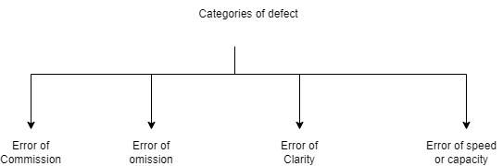

1. **Mention what big bang testing is?**

* Big Bang testing all components or modules is integrated simultaneously after which everything is tested as whole.
* Big Bang testing has the advantage that everything is finished before integration testing starts.
* The major disadvantage is that in general it is time consuming and

Difficult to trace the cause of failures because of this late integration.

**Advantages:**

* Convenient for small systems.

**Disadvantages:**

* Fault Localization is difficult
* Given the sheer number of interfaces that need to be tested in this Approach, some interfaces links to be tested could be missed easily.

1. **What is the purpose of exit criteria?**

* Run out of time.
* Run out of budget.
* The business tells you it went live last night.
* Boss says stop.
* All defects have been fixed.

1. **When should "Regression Testing" be performed?**

* Testing unchanged features of an app.

Add, update, delete, defect fixing is not impacting the unchanged feature of app.

- Lower priority

- Execute all test cases without any planning.

- Automated (regression test cases)

- Done on the passed test cases

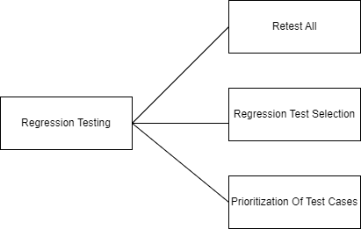

1. **Difference between QA v/s QC v/s Tester**.

|  |  |  |
| --- | --- | --- |
| **QA(Quality Assurance)** | **QC(Quality Control)** | **Testing** |
| Focuses on processes rather than conducting the actual testing of the software. | Focuses on actual testing by executing software. | Focuses on actual testing. |
| Process oriented activities. | Product oriented activities. | Product oriented activities. |
| It is a preventive activities. | It is a corrective process. | It is a preventive process. |
| It is a subset of a SDLC. | It is a subset of a QA. | Testing is a subset of a QC. |

1. **Difference between Smoke and Sanity?**

|  |  |
| --- | --- |
| **Smoke** | **Sanity** |
| Smoke testing is performed by developer or tester. | Sanity testing normally performed by tester. |
| Smoke testing is a sub set of acceptance testing. | Sanity testing is a sub set of regression testing. |
| Smoke testing is documented. | Sanity testing is not documented. |
| Smoke testing is scripted. | Sanity testing is not scripted. |
| Smoke testing is a general health check-up. | Sanity testing is a specialized health check-up. |

1. **Explain types of Performance testing.**

* **Six type of performance testing like:**

1. **Load Testing**
2. **Stress Testing**
3. **Scalability Testing**
4. **Volume Testing (Flood Testing)**
5. **Endurance Testing (Soak Testing)**
6. **Spike Testing**
7. **Load testing**

Load testing is a performance testing to check system behavior under load. Testing an application under heavy loads, such as testing of a web site under a range of loads to determine at what point the system’s response time degrades or fails.

Stability + response time + applying load (app will withstand with designed no. of users)

**Ex:** app will handle 1000 users at every 5 sec.

You have to check 1000 or <=1000 users with your app.

1. **Stress testing**

Most prominent use of stress testing is to determine the limit, at which the system or software or hardware breaks.

It also checks whether system demonstrates effective error management under extreme conditions**.**

Stability + response time + applying load (app will withstand with designed no .of users)

**Ex:** app will handle 1000 users at every 5 sec.

You have to check 1000 or >=1000 users with your app.

1. **Scalability testing**

Stability + response time + applying load (app will withstand with designed no. Of users).

**Ex:** You are checking the performance of the app. Continue with load until your system will be crashed.

App will handle 1000 users at every 5 sec.

1500 users: 10 sec

2000 users: 20sec

…………

1, 00,000 users …crashed

1. **Volume testing**

Stability + response time + applying load (app will withstand with designed no. of users)

To check the capacity or volume of database.

1. **Endurance testing**

Stability + response time + applying load (app will withstand with designed no. of users)

**Ex:** To check how the system will run continuously.

1. **Spike testing**

Stability + response time + applying load (app will withstand with designed no. of users)

Ex: To check extreme increment or decrement of load according to the response time.

1. **What is Error, Defect, Bug and failure?**

* **Error:** A mistake in coding is called error.
* **Defect:** Error found by tester is called defect.
* **Bug:** Defect accepted by development team it is called bug.
* **Failure:** Build does not meet the requirements it is a failure.
* **Fault:** An incorrect step, process is called fault.

1. **Difference between Priority and Severity**

|  |  |
| --- | --- |
| **Priority** | **Severity** |
| Priority is a parameter to decide the order in which defects should be fixed. | Severity is a parameter to do note the impact of a particular defect on the software. |
| Its value is subjective. | Its value is objective. |
| Its value change from time to time. | Its value does not change from time to time. |
| It is driven by business value. | It is driven by functionality. |
|  |  |

1. **What is Bug Life Cycle?**

* A computer bug is an error, flaw, mistake, failure, or fault in a computer program that prevents it from working correctly or produces an incorrect result. Bugs arise from mistakes and
* Error made by people in either a program’s source code or its design.
* When a bug is discovered, it goes through several states and eventually reaches one of the terminal states, where it becomes inactive and closed.

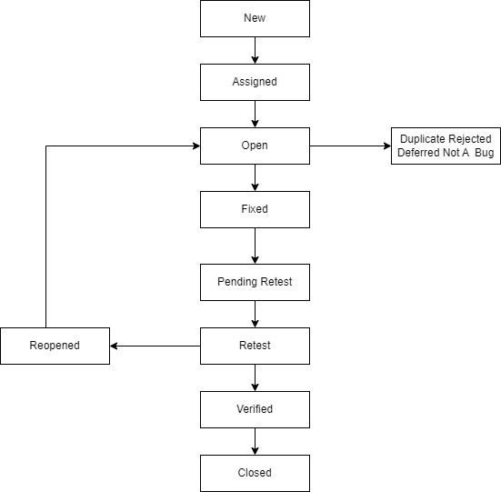

1. **Explain the difference between Functional testing and Non-functional testing.**

|  |  |
| --- | --- |
| **Functional** | **Non-Functional** |
| Execute first. | Executed after functional testing. |
| To check the features that are directly related to the functionality.  Ex. Click on at to cart button to add the items to the cart. | To check the features that are not directly related to the functionality. But it will important to the check. |
| Functional testing can be possible by manually testing and automation tools. | Non-Functional testing can be always performed using tools. |
| Business requirements are input for the functional testing. | Performance parameters like speed, load are input on the non-functional testing. |
| Easy to do manual testing. | Tough to do manual testing. |
| Ex. unit testing, integration testing, smoke testing, sanity testing, regression testing, white-box testing, black-box testing, UAT. | Ex. Load testing, volume testing, and security testing, and stress testing. |

1. **To create HLR & Test Case of**
2. **(Instagrams, Facebook) only first page.**

|  |  |
| --- | --- |
| HLR_INSTAGRAM | [**CLICK HERE**](../HLR/HLR_INSTAGRAM.xlsx) |
| TEST CASE FOR INSTAGRAM | [**CLICK HERE**](../HLR/TESTCASE_INSTAGRAM.xlsx) |

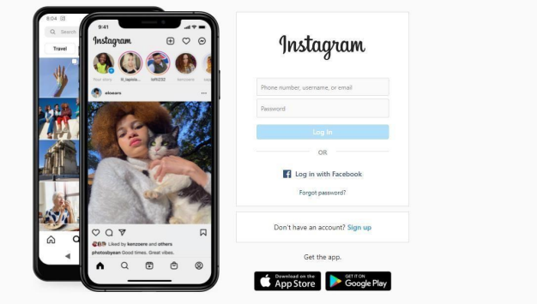

1. **Facebook Login Page:** [**https://www.facebook.com/.**](https://www.facebook.com/.)

|  |  |
| --- | --- |
| HLR_FACEBOOK | [CLICK HERE](HLR_FACEBOOK.xlsx) |
| TESTCASE FOR FACEBOOK | [CLICK HERE](TESTCASE_FACEBOOK.xlsx) |

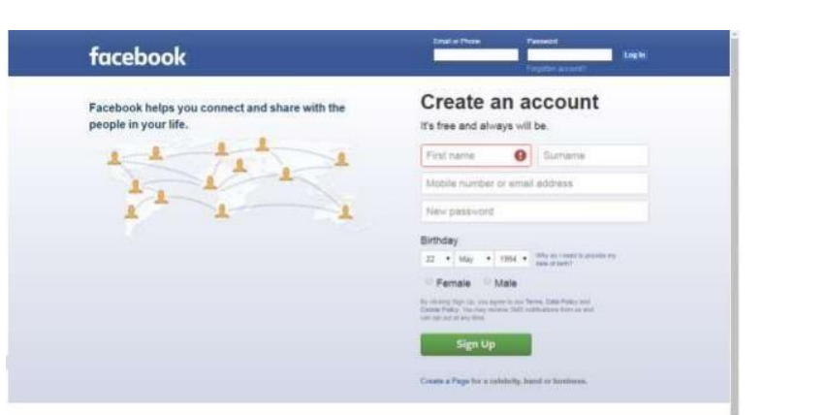

1. **What is the difference between the STLC (Software Testing Life Cycle) and SDLC (Software Development Life Cycle)?**

|  |  |
| --- | --- |
| **STLC** | **SDLC** |
| STLC is mainly related to software testing. | SDLC is mainly related to software development. |
| Goal of STLC is to complete successful testing of software. | Goal of SDLC is to complete successful development of software. |
| It helps in making the software defects free. | It helps in developing good quality software. |
| STLC phases are performed SDLC phases. | SDLC phases are completed before the STLC phases. |

1. **What is the difference between test scenarios, test cases, and test script?**

|  |  |  |
| --- | --- | --- |
| **Test Scenarios** | **Test Cases** | **Test Script** |
| A scenario is any functionality that can be tested. | Test cases are set of input and output given to the system. | A set of sequential instruction to execute business function. |
| It focuses on more what to test than how to test. | A complete an phases on what to test and how to test. | Test script is an automatic approach of software testing. |
| Test scenario are derived from test artifacts like SRS. | Test case is mostly derived from test scenario multiple test case can be derived from a single test scenario. | Test script is used in automatic testing environment. |
| Test scenario are high-level actions. | Test cases are low-level action. | Test script is done by scripting format. |

1. **Explain what Test Plan is? What is the information that should be covered?**
2. Test planning process.
3. Test plan & strategy.
4. Test planning factors.
5. Test planning activities.
6. Exit criteria.
7. **Test planning process:**

* A document describing the scope, approach, resources, and test activities.

1. **Test plan & strategy:**

* All project require a set of plans and strategy which define how the testing. Test policy, master test plan, functional test plan, system integration plan, and UAT test plan.

1. **Test planning factors:**

* Scope of the testing.
* Testing objectives.
* Project risk.
* Availability or resources.

1. **Test planning activities:**

* Decide approach integrating and cording the testing activities in to the SDLC activities.
* **Decide :** Who will test

What will be tested?

How it will be tested

When will be tested

1. **Exit criteria:**

* Run out of time.
* Run out of budget.
* Boss says stop.
* All defects have been fixed.

1. **What is priority?**

* Priority is Relative and Business-Focused. Priority defines the order in which we should resolve a defect. The priority status is set based on the customer requirements.

**Ex:** If the company name is misspelled in the home page of the website, then the priority is high and severity is low to fix it.

1. **What is severity?**

* Severity is absolute and Customer-Focused. It is the extent to which the defect can affect the software.

**Ex:** If an application or web page crashes when a remote link is clicked, in this case clicking the remote link by a user is rare but the impact of application crashing is severe. So the severity is high but priority is low.

1. **Bug categories are…**

* Categories of defects are errors of commissions, errors of omissions, errors of clarity, and error of speed and capacity.
* Software defects is some kind of error, flaw or some kind of mistake from the development team which prevent the software from the smooth working, It directly affects software quality , software quality is something how smooth and reliable your software is smoothness and reliability is how less defects your software have.

1. **What are the different Methodologies in Agile Development Model?**

* Agile is a philosophy set of values and principle to make a decision for developing a software.
* Agile is based on iterative-incremental approach for project management and software development that helps a team to deliver faster values to their Customers .Requirements, plans, and results are evaluated continuously so teams have a natural mechanism for responding to change quickly.
* **Individuals and interactions** over processes and tools
* **Working software** over comprehensive documentation
* **Customer collaboration** over contract negotiation
* **Responding to change** over following a plan

**Agile Methodologies**: Scrum, Kanab, XP

* Scrum is a framework though which we build software product by following agile principles.
* Crum is an agile development method which concentrates particularly on how to manage tasks within a team based development environment.
* Scrum includes group of people called a scrum team, normally contains 5 to 9 members. Scrum team can involve the people like product owner, scrum master, DEV team, QA team etc.

|  |  |
| --- | --- |
| **Authorization** | **Authentication** |
| While in authorization process the user’s authorization are checked for accessing the resources. | In the authentication process the identify of users are checked for providing the access to the system. |
| While in this process users are validated. | In the authentication process users are verified. |
| The user authorization is not visible at the user end. | The user authentication is visible at user end. |
| While this process is done after the authentication process. | It is done before the authorization process. |
| While it needs the user’s security levels. | It needs usually the users’ login details. |

1. **Explain the difference between Authorization and Authentication in Web testing. What are the common problems faced in Web testing?**
2. **To create HLR & Test Case of Web Based (What’s App web, Instagram)**
3. **What’s App Web :** [**https://web.whatsapp.com/**](https://web.whatsapp.com/)

|  |  |
| --- | --- |
| HLR_WHATSAPP WEB | [**CLICK HERE**](HLR_WHATSAPPWEB.xlsx) |
| TEST CASE FOR WHATSAPP WEB | [**CLICK HERE**](TESTCASE_WHATSAPPWEB.xlsx) |

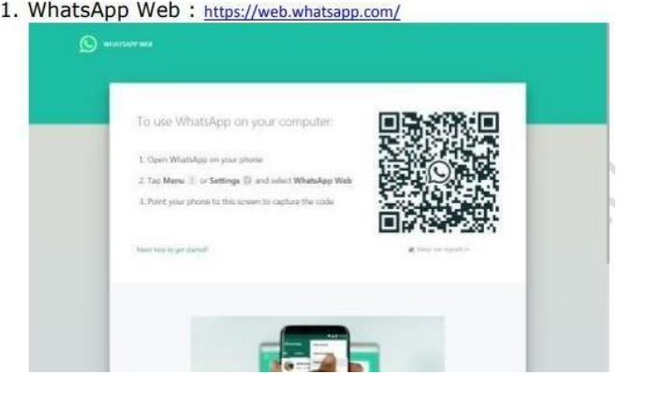

1. **Instagram Web :**

|  |  |
| --- | --- |
| HLR_INSTAGRAM | [**CLICK HERE**](../HLR/HLR_INSTAGRAM.xlsx) |
| TEST CASE FOR INSTAGRAM | [**CLICK HERE**](../HLR/TESTCASE_INSTAGRAM.xlsx) |

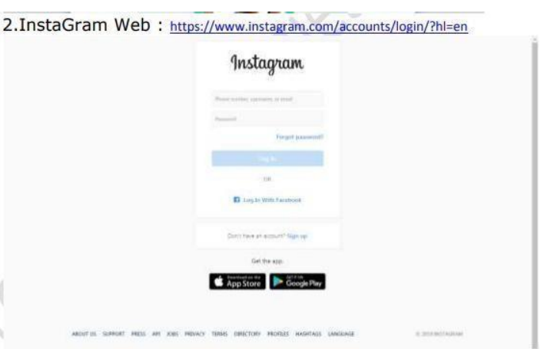

1. **To create HLR and Test Case on this Link.** [**https://artoftesting.com/•**](https://artoftesting.com/•)

|  |  |
| --- | --- |
| HLR_ARTOFTESTING | [**CLICK HERE**](HLR_ARTOFTESTING.xlsx) |
| TESTCASE FOR ARTOFTESTING | [**CLICK HERE**](TESTCASE_ARTOFTESTING.xlsx) |

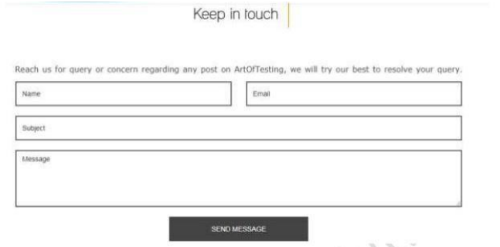

1. **Write a scenario of only Whatsup chat messages**

|  |  |
| --- | --- |
| Whatsup Chat Scenario | [**click here**](WHATSAPP%20CHAT%20Scenario.xlsx) |

1. **Write a Scenario of Pen**

|  |  |
| --- | --- |
| Pen Scenario | [**click here**](PEN%20Scenario.xlsx) |

1. **Write a Scenario of Pen Stand**

|  |  |
| --- | --- |
| Pen Stand scenario | [**click here**](PEN%20STAND%20Scenario.xlsx) |

1. **Write a Scenario of Door**

|  |  |
| --- | --- |
| Door Scenario | [**click here**](DOOR%20Scenario.xlsx) |

1. **Write a Scenario of ATM**

|  |  |
| --- | --- |
| ATM Scenario | [click here](ATM%20Scenario.xlsx) |

1. **When to used Usability Testing?**

* To check the user friendliness of the application.

**Ex**: radio button, text box, drop-down list, all the controls should be alien properly. If drop-down list is available then user can select the particular item without typing.

1. **What is the procedure for GUI Testing?**

* GUI (Graphical User Interface)
* GUI testing involves checking the screens with the controls like menus, buttons, icons, and all types of bars tool-bar, menu-bar, dialog boxes, and windows etc.

**Approach of GUI testing type:**

1. Manual based testing.
2. Record and replay.
3. Model based testing.
4. **Write a scenario of Microwave Oven.**

|  |  |
| --- | --- |
| Microwave Oven Scenario | [**click here**](MICROWAVE%20OVEN%20Scenario.xlsx) |

1. **Write a scenario of Coffee vending Machine.**

|  |  |
| --- | --- |
| Coffee Vending Machine scenario | [**click here**](COFFEE%20VENDING%20MACHINE%20Scenario.xlsx) |

1. **Write a scenario of chair.**

|  |  |
| --- | --- |
| Chair Scenario | [**click here**](CHAIR%20Scenario.xlsx) |

1. **To Create Scenario (Positive & Negative).**
2. **Gmail (Receiving mail) Scenario.**

|  |  |
| --- | --- |
| **Gmail Scenario** | [**click here**](GMAIL%20Scenario.xlsx) |

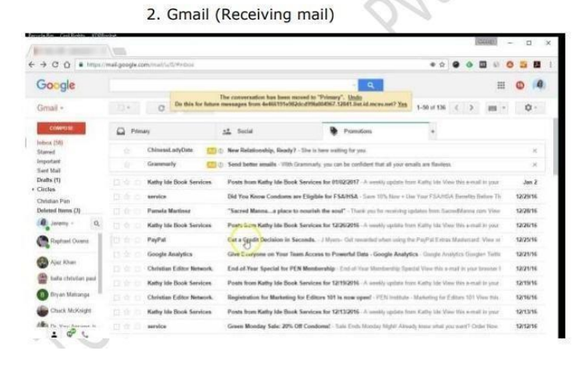

1. **Online Shopping to Buy Product (Flip kart).**

|  |  |
| --- | --- |
| **Flip kart online shopping Scenario** | **click here** |

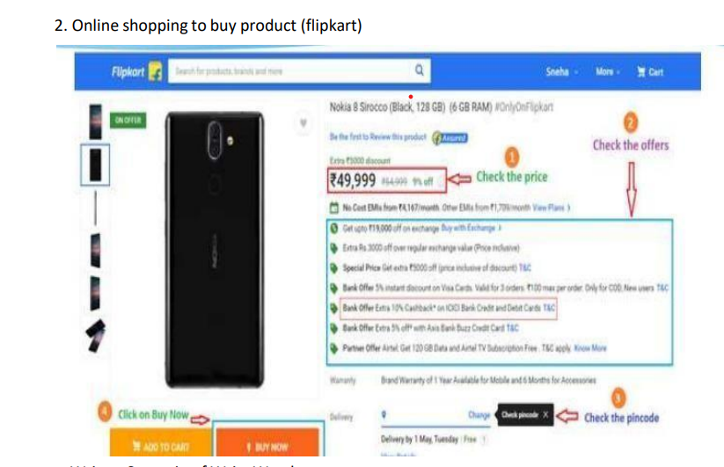

1. **Write a Scenario of Wrist Watch**

|  |  |
| --- | --- |
| Wrist Watch Scenario | [**click here**](WRIST%20WATCH%20Scenario.xlsx) |

1. **Write a Scenario of Lift(Elevator)**

|  |  |
| --- | --- |
| Lift Scenario | [**click here**](LIFT%20Scenario.xlsx) |

1. **Write a Scenario of Whatsapp Group (generate group)**

|  |  |
| --- | --- |
| Whatsapp Group Scenario | [**click here**](WHATSAPP%20GROUP%20Scenario.xlsx) |

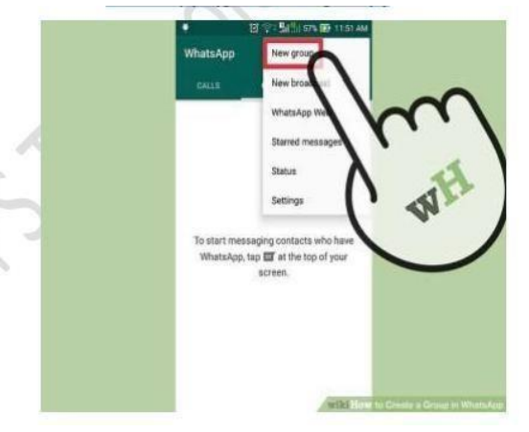

1. **Write a Scenario of Whatsapp payment**

|  |  |
| --- | --- |
| **Whatsapp Payment Scenario** | [**clcik here**](WHTASAPP%20PAYMENT%20Scenario.xlsx) |

