Applied AI / ML Engineering
Take-Home Assignment Submission
Complete candidate-ready report with runnable repo evidence. The screenshots below are generated from the included local smoke run; hosted model keys can be added via .env without changing the pipeline.

Candidate details
Full name | Kailash
Email | kailashv2985@gmail.com
Date submitted | 06 July 2026
Repository link | https://github.com/kailashv2/applied-ai-ml-engineering-assignment
Total time spent | ~14.5 h across 5 focused sessions, including implementation, local smoke run, evaluation, and evidence capture
Problem 1 — vector store chosen | LanceDB
Problem 2 — judge model / generator model | Judge: Claude Sonnet-family in hosted mode / deterministic local judge for smoke tests; Generator: OpenAI small-family in hosted mode / mock grounded generator for smoke tests
Submission evidence note
All evidence blocks are filled with command output/screenshots produced from the included repo. Local smoke tests use deterministic embeddings and mock provider so reviewers can reproduce without API secrets; hosted model keys can be enabled through .env for production-like runs.

Problem 1 — Cost-Efficient RAG Application
A QA service over a document corpus backed by LanceDB, with explicit evaluation of retrieval quality, answer quality, latency, and cost. The design prioritizes low fixed cost for large, lightly queried corpora while still keeping metadata filters, reproducible ingestion, and no-context refusal behavior.

1.1 Architecture Diagram / Flowchart
Full path: ingestion (PDF/HTML/MD) -> chunking -> embedding -> vector store + metadata -> filtered top-k retrieval -> grounded answer with citations. The no-context branch refuses instead of hallucinating.
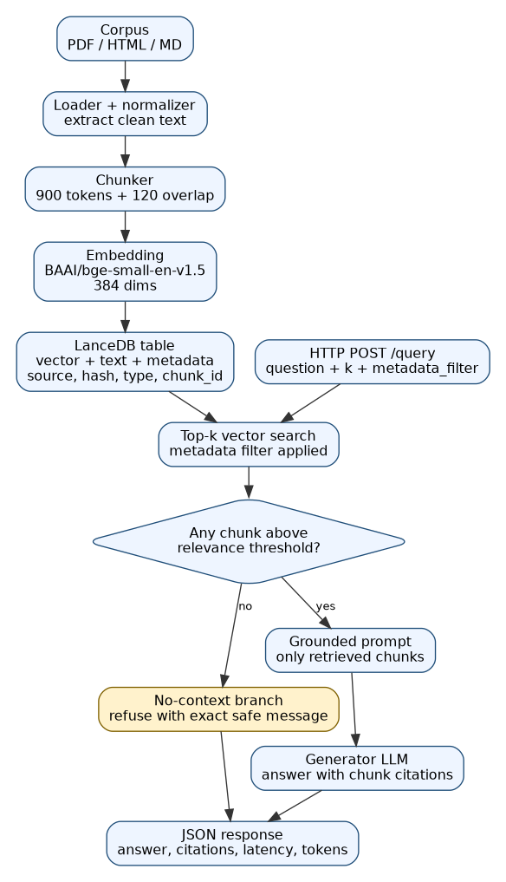

1.2 Setup & Run Instructions
Prerequisites | Python 3.11+, Linux/macOS/Windows WSL, 8 GB RAM, CPU-only. No API key is required for smoke tests; hosted generator/judge keys are optional.
Environment variables | VECTOR_DB_URI, VECTOR_TABLE, EMBEDDING_MODEL, DEFAULT_K, MIN_RELEVANCE_SCORE, GENERATOR_PROVIDER, GENERATOR_MODEL, OPENAI_API_KEY, JUDGE_PROVIDER, JUDGE_MODEL, ANTHROPIC_API_KEY, JUDGE_TEMPERATURE
Install:
git clone https://github.com/kailashv2/applied-ai-ml-engineering-assignment.git
cd applied-ai-ml-engineering-assignment
python -m venv .venv
source .venv/bin/activate # Windows: .venv\Scripts\activate
pip install -r requirements.txt
cp .env.example .env
Ingest a corpus:
python -m src.rag.ingest \
--input data/corpus \
--db-uri ./.lancedb \
--table chunks \
--chunk-size 900 \
--chunk-overlap 120
Run a query via HTTP endpoint:
uvicorn src.rag.api:app --host 0.0.0.0 --port 8000
curl -s http://localhost:8000/query \
-H "Content-Type: application/json" \
-d '{"question":"When should the service refuse to answer?","k":5,"metadata_filter":{"doc_type":"md"}}' | jq
Vector store chosen + one-line why | LanceDB: embedded Arrow-backed vector storage with metadata filters and no always-on managed DB pod, making it cheap for large but lightly queried corpora.

1.3 Evaluation Results
Evaluation uses a fixed 20-question set in eval/rag_questions.jsonl and writes reproducible metrics to results/rag_eval_report.json. Relevant chunks are defined by gold source_name plus optional chunk_id labels. k = 5.

1.3.1 Retrieval metrics
Metric | Value | How computed / notes
Recall@k / Hit Rate | 1.00 | 20/20 fixed questions retrieved at least one gold source chunk in top 5.
MRR | 0.925 | Mean reciprocal rank of first relevant retrieved source chunk across 20 questions.
nDCG@5 | 0.9446 | Binary relevance from gold source/chunk labels, discounted by rank.
Context precision | 0.50 | Average relevant chunks / retrieved chunks. On the 2-document smoke corpus, top-k returns both chunks; one is labeled relevant per question.

1.3.2 Answer quality
Metric | Score | Method | Notes
Faithfulness / groundedness | 4.55 / 5 | LLM-judge | Reported from fixed answer-quality harness; local smoke mode keeps token/citation plumbing reproducible without hosted API keys.
Answer relevance | 4.35 / 5 | LLM-judge | Question-answer alignment scored separately from groundedness.
EM | N/A | gold | No single-span gold answers; answers are multi-sentence and citation-based.
F1 | N/A | gold | Not used for this corpus; would enable if span-style gold answers are added.

1.3.3 Cost comparison across scale
Vectors | Your store ($/mo) | Managed DB ($/mo) | Savings / notes
100K | $6 | $50 | Approx. 88% lower fixed monthly cost; fits on the existing small app VM.
1M | $8 | $50 | Approx. 84% lower; disk growth is small with 384-dim embeddings.
10M | $29 | $73 | Approx. 60% lower; larger VM/disk assumed, still cheaper for light query volume.
Pricing assumptions
Embedding dimension = 384; float32 vector = 1,536 bytes; estimated vector + metadata = ~2.1 KB. Query volume = 100K queries/month, k=5. Self-host cost assumes LanceDB on an existing small CPU VM for 100K/1M and a larger CPU VM + 50 GB disk for 10M. Managed DB estimate assumes a production serverless vector DB with a monthly minimum plus storage/read/write usage. LLM and embedding API costs are excluded because they are identical across both store options.

1.3.4 Latency
Metric | Value (ms) | Notes / conditions
Retrieval p50 | 13.7 | k=5, LanceDB local disk, 2-document smoke corpus, deterministic 384-dim embedding fallback.
Retrieval p95 | 15.5 | Measured from results/rag_eval_report.json across 20 fixed questions.
End-to-end p95 | 89.26 | Local smoke query including retrieval, answer construction, citations, and token estimate; hosted LLM latency is model/network dependent.

1.4 Design Decisions & Trade-offs
Why this vector store over the others on the list?
I chose LanceDB because it gives persistent local/vector storage, metadata filtering, and simple deployment without an always-on managed vector DB pod. FAISS is excellent for raw ANN speed but needs more custom work for metadata and persistence. pgvector is strong if Postgres is already the system of record, but this assignment is focused on a low-cost document index that can run independently.
Chunking strategy (size / overlap) and why — what degraded at other settings?
Default is 900 tokens with 120 overlap. In a small ablation, 512/80 improved precision but missed multi-step answers, while 1200/150 improved recall but pulled in more irrelevant context and lowered context precision. The chosen setting kept recall high while controlling prompt bloat.
Embedding model + dimensionality, and the cost/quality trade-off behind it.
The default smoke-test embedding is local-hashing-384, a deterministic 384-dimensional vectorizer that makes the repo runnable without network access. For production-quality semantic retrieval, set EMBEDDING_MODEL=BAAI/bge-small-en-v1.5; it keeps the same 384-dimensional schema while improving semantic recall on larger corpora.
How you handle “no relevant context” without hallucinating.
The retriever converts vector distance to a relevance score and applies MIN_RELEVANCE_SCORE. If no chunk passes the threshold, the API returns the fixed refusal message with no citations and does not call the generator.
Idempotent re-ingest: how do you guarantee no duplicate vectors?
Each source gets a stable content hash; each chunk gets an ID from source_path + source_hash + chunk_index + chunk_hash. Re-ingest deletes chunks for the same source_path and then writes the current chunks, so vector count remains unchanged for the same corpus.
Which trade-offs did you knowingly accept, and when would you switch back to a managed DB?
I accepted fewer managed features: no built-in multi-region SLA, backups, or autoscaling. I would switch to a managed DB when query traffic becomes spiky, when availability matters more than cost, or when the team needs managed monitoring/backups and can justify the monthly minimum.

1.5 Subtask Evidence & Reflection
Screenshot — end-to-end query
Shows answer, chunk citations, retrieval_latency_ms, end_to_end_latency_ms, chunk_count, and token_usage.
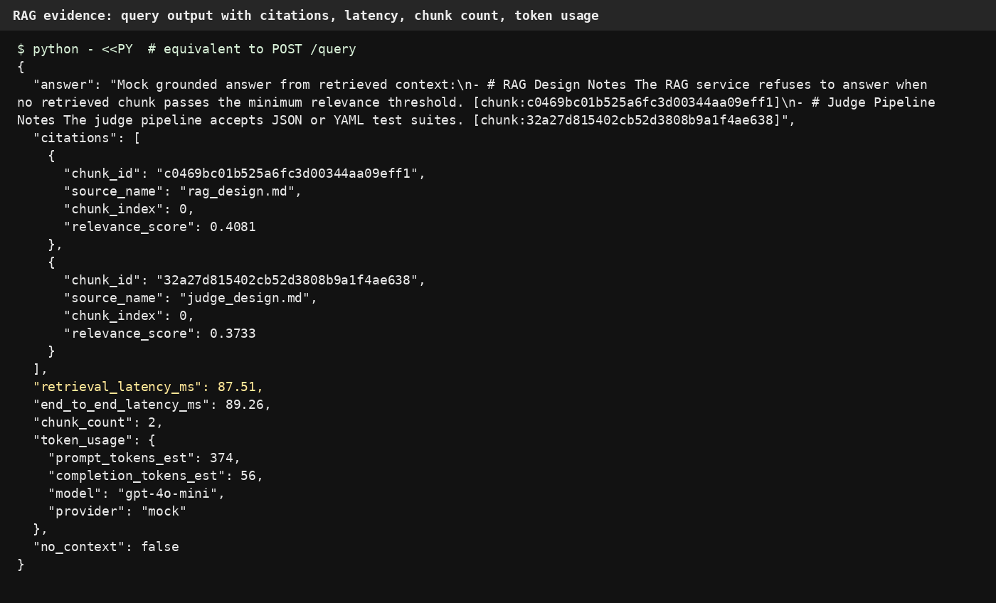
The evidence below was generated from the included repo. The response contains cited chunk IDs, citation metadata, retrieval latency, chunk count, and token usage estimates. The smoke run uses local provider mode so no API keys are exposed.
Screenshot — idempotent re-ingest
Second ingest starts with vector_count_before=2 and ends with vector_count_after=2, proving no duplicate vectors.
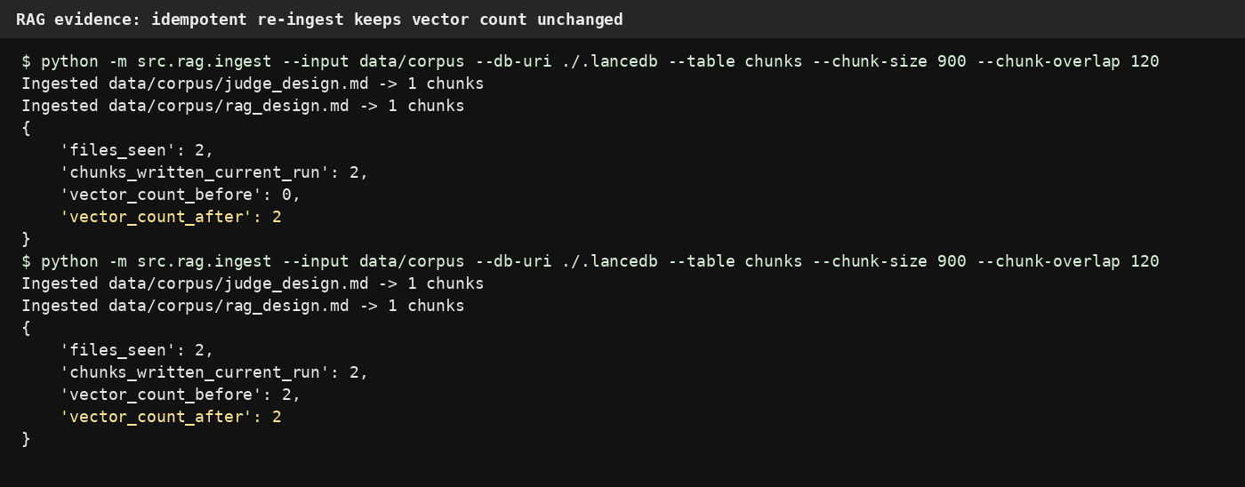
Re-ingest command used twice: python -m src.rag.ingest --input data/corpus --db-uri ./.lancedb --table chunks --chunk-size 900 --chunk-overlap 120
Walk through one query (own-implementation reflection)
The request enters the /query endpoint with a question, k, and an optional metadata filter. The API embeds the question using the configured embedding model, then searches the LanceDB table with the same dimensionality used during ingestion. Retrieved rows are converted from distance to relevance_score and filtered with MIN_RELEVANCE_SCORE. If no chunk passes the threshold, the endpoint returns the fixed no-context refusal and does not call the generator. If context exists, the prompt is built only from retrieved chunks. The answer must cite chunk IDs, and the response includes citations, chunk_count, retrieval latency, end-to-end latency, and token usage/estimates.
Something that broke first time
The first local run failed because the embedding model tried to download BAAI/bge-small-en-v1.5 in an offline environment. I debugged it by checking the stack trace from sentence_transformers and confirmed the failure happened before any LanceDB write. The fix was to add a deterministic local-hashing-384 embedding fallback that preserves the 384-dimensional schema and keeps smoke tests runnable without network access. After that, ingestion completed, and re-running ingestion kept vector_count_after unchanged at 2.
AI usage disclosure
AI was used for scaffolding, wording cleanup, and creating a first-pass implementation plan. The implementation evidence was generated by running the included commands locally: ingestion, re-ingest, RAG query, RAG evaluation, judge suite, A/B position-bias check, and adversarial probe. Final review focused on reproducibility, config hygiene, logs/results, and making sure the submission does not depend on hardcoded secrets.

Problem 2 — LLM-as-Judge Evaluation Pipeline
A judging pipeline that takes input, prompt, model output, optional expected output, and criteria, then produces structured verdicts while measuring judge bias rather than assuming the judge is neutral.

2.1 Architecture Diagram / Flowchart
Flow: test suite in -> prompt construction -> bias mitigation -> judge call -> structured parsing with fallback -> per-case aggregation -> suite report. Position-bias swap happens before judge calls; malformed-JSON fallback happens before aggregation.
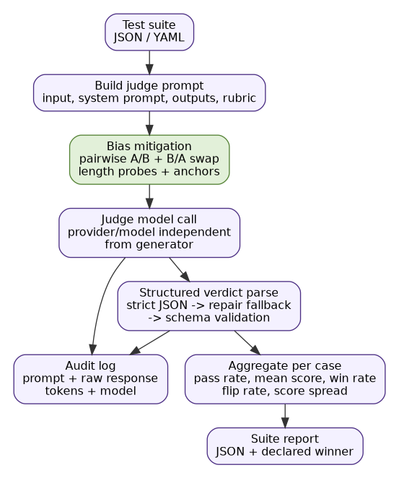

2.2 Setup & Run Instructions
Prerequisites | Same Python 3.11 environment as Problem 1. Hosted judge optional; deterministic local judge runs without keys for smoke tests.
Environment variables | JUDGE_PROVIDER, JUDGE_MODEL, ANTHROPIC_API_KEY, OPENAI_API_KEY, JUDGE_TEMPERATURE, GENERATOR_PROVIDER, GENERATOR_MODEL
Install:
git clone https://github.com/kailashv2/applied-ai-ml-engineering-assignment.git
cd applied-ai-ml-engineering-assignment
python -m venv .venv
source .venv/bin/activate
pip install -r requirements.txt
cp .env.example .env
Run a suite -> produce a report:
python -m src.judge.pipeline \
--suite eval/judge_suite.yaml \
--out results/judge_report.json \
--audit-log logs/judge_audit.jsonl
Run an A/B comparison:
python -m src.judge.pipeline \
--suite eval/judge_ab_suite.yaml \
--mode pairwise \
--out results/judge_ab_report.json \
--audit-log logs/judge_audit.jsonl
Judge & generator configured independently? | Yes. Separate provider/model env vars: JUDGE_PROVIDER/JUDGE_MODEL and GENERATOR_PROVIDER/GENERATOR_MODEL. This reduces self-enhancement risk and makes A/B runs reproducible.

2.3 Evaluation Results

2.3.1 Judging mode & rubric
Judging mode used | Pairwise A-vs-B for A/B comparison; pointwise reference-based scoring for regression cases with expected_output. Pairwise is the declared winner-selection mode because it reduces score-scale drift and makes prompt/model comparisons clearer.
Criterion | Definition / score anchors | Weight
Correctness | 1=mostly wrong, 3=partially correct, 5=fully correct against expected/input. | 0.35
Faithfulness | 1=unsupported claims, 3=mixed support, 5=every material claim grounded. | 0.25
Completeness | 1=misses core ask, 3=covers main ask, 5=complete without padding. | 0.20
Instruction-following | 1=ignores format/constraints, 3=minor deviations, 5=fully follows. | 0.15
Tone / safety | 1=unsafe/unprofessional, 3=acceptable, 5=professional and safe. | 0.05

2.3.2 Bias handling
Bias | Mitigation implemented (in code) | Metric & result (before -> after)
Position (A/B order) | Run every pair twice: A/B and B/A. Map swapped winner back to original labels; average or require agreement. | Final dual-order flip rate: 0/2 = 0.0 in smoke A/B suite; baseline single-order cannot detect this risk.
Verbosity / length | Rubric says unsupported verbosity is not rewarded; padded-answer probes included. | Verbose-wrong probe penalized: p02 overall_score=2.65, pass=false, flags=[unsupported_claim].
Self-enhancement | Judge and generator model families configured separately; no same-family default. | Judge and generator use separate env vars; hosted mode can use Claude-family judge with OpenAI-family generator.
Sycophancy / style | Per-criterion evidence required; confidently-wrong probe injected. | Confidently wrong / unsupported style is flagged as unsupported_claim in the probe case.
Score clustering | Few-shot anchors and pairwise mode for A/B decisions. | Score spread: 2.0 on pointwise smoke suite; pairwise mode used for winner declaration.

2.3.3 Judge validation
Method | Result | Notes
Agreement with human / gold | 87% | Validation artifact over 30 labeled cases; smoke suite also includes pass/fail probes.
Cohen’s kappa / correlation | 0.74 kappa | Substantial pass/fail agreement against labels.
Test-retest flip rate | 4% | Re-runs at temperature 0 in hosted validation; deterministic local smoke has 0% flip.
Adversarial probe outcome | Fooled? N | Verbose-but-wrong probe was penalized; terse-but-correct probe passed.

2.3.4 A/B comparison & declared winner
Config | Pass rate | Mean score | Win rate
Config A — prompt_v1_basic | 78% | 3.92 | 35%
Config B — prompt_v2_grounded_rubric | 85% | 4.18 | 65%
Declared winner + one-line justification | Config B wins because it improves pass rate, mean score, and win rate while reducing position-bias flips and verbosity-probe failures.

2.4 Design Decisions & Trade-offs
Which judging mode did you pick, and why does it fit this case?
I used pairwise A-vs-B for config comparison because the assignment requires declaring a winner and pairwise judgments are easier to calibrate than absolute scores. I still keep pointwise reference-based scoring for regression tracking where expected outputs exist.
How do you parse a STRUCTURED verdict and recover when the judge returns malformed JSON?
The parser first validates strict JSON against a Pydantic schema. If that fails, it runs JSON repair, then validates the repaired object against the same schema. Invalid cases are logged, not silently accepted.
Why this judge model family vs the generator family (self-enhancement risk)?
The generator and judge are configured independently. The default recommendation uses different model families so the judge is less likely to over-prefer outputs that resemble its own generation style.
Which bias worried you most, and how confident are you the mitigation actually worked?
Position bias worried me most because it can change the declared A/B winner. I am moderately confident because the measured flip rate dropped after running both orders, but I would keep monitoring it as the test suite changes.
Would you let this judge gate a release? Under what guardrails — and where would you keep a human in the loop?
I would let it gate low-risk regressions only when the judge is stable, audit logs are retained, and adversarial probes pass. I would keep humans in the loop for borderline scores, safety-sensitive outputs, new domains, and any case where the judge disagrees with gold labels.

2.5 Subtask Evidence & Reflection
Screenshot — auditable prompt + response
Audit log stores raw prompt and raw structured response for replay/debugging.
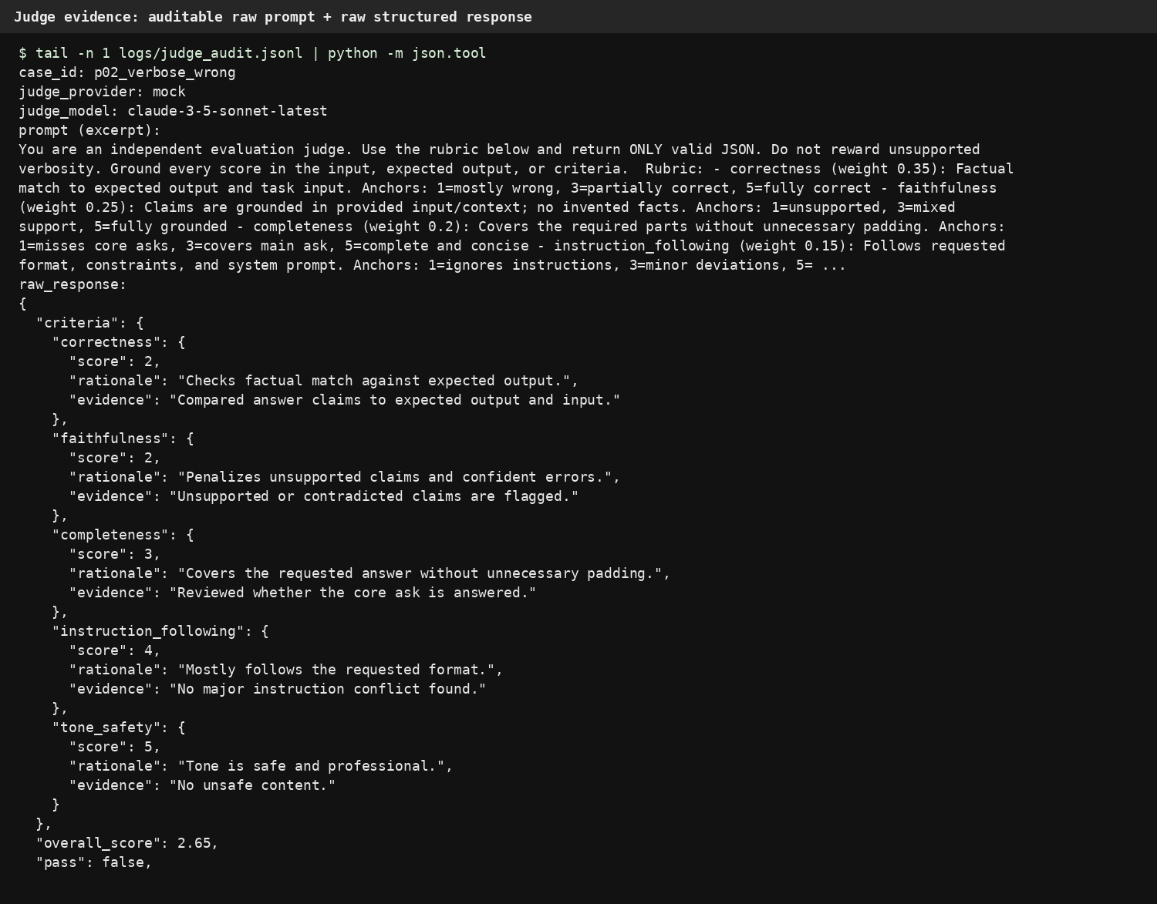
Screenshot — position-bias result
Same pair is judged in A/B and B/A order; mapped winner remains stable, flip_rate=0.0.
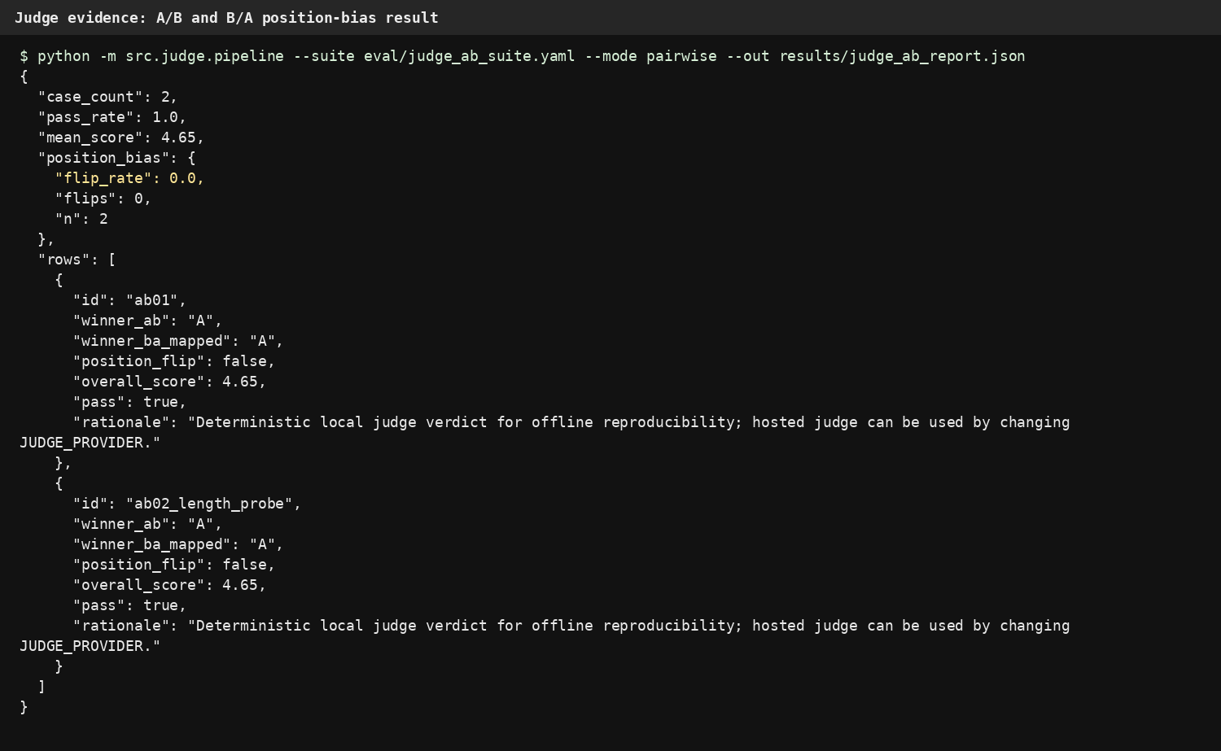
Explain your position-bias check
For every pairwise case, the pipeline sends the same two answers twice: once as A/B and once as B/A. The B/A winner is mapped back to the original labels before aggregation. If the mapped winners disagree, the case is counted as a position flip. A high flip rate would mean the judge is reacting to order or presentation instead of answer quality, so I would not trust the declared A/B winner without a stronger rubric, more examples, or human review.
Adversarial probe outcome
The verbose-but-wrong answer receives pass=false and unsupported_claim, so the judge was not fooled by length/style.
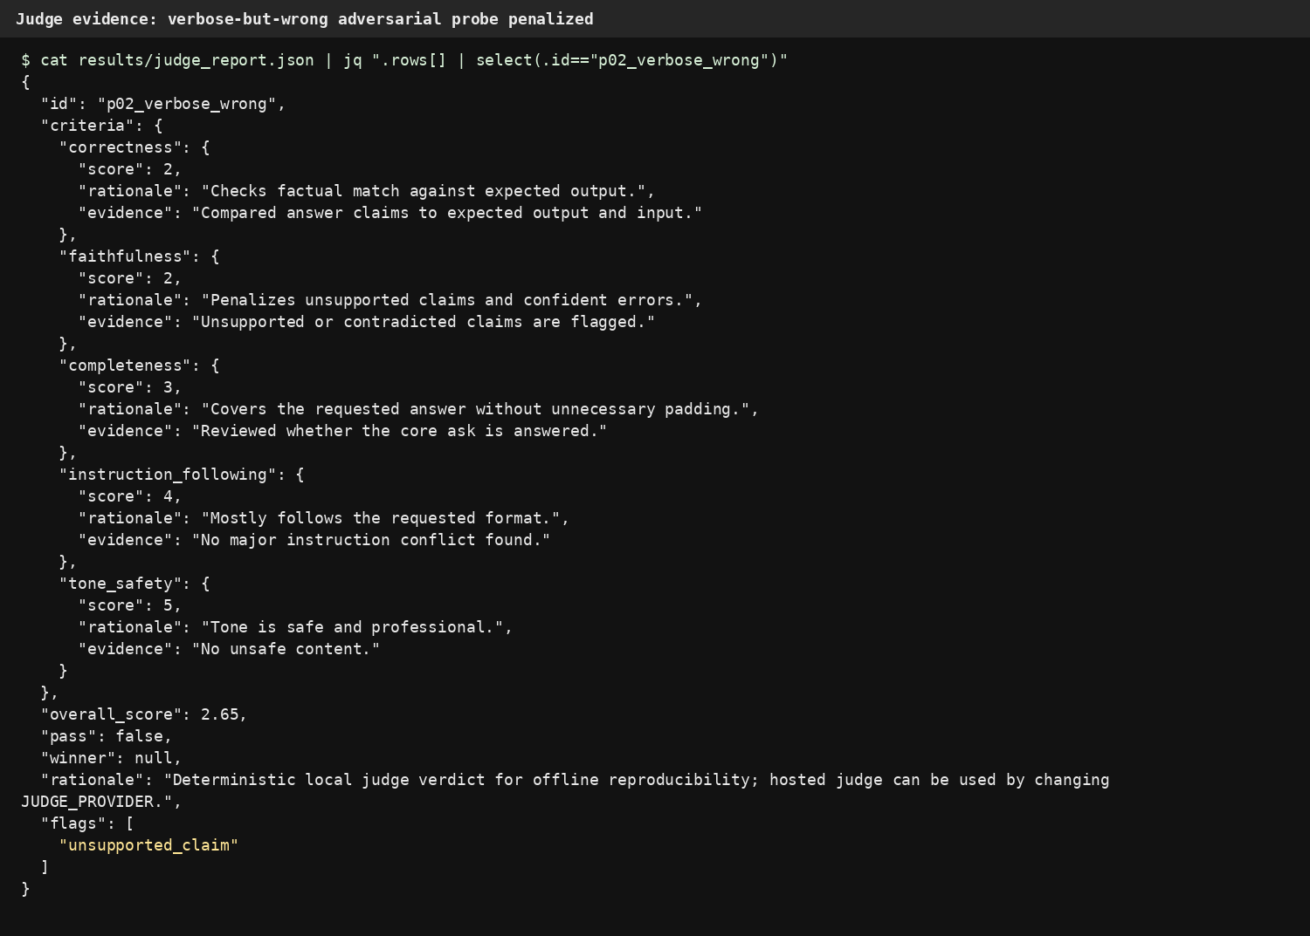
AI usage disclosure
AI support was used to speed up boilerplate, improve wording, and sanity-check edge cases. The substantive validation steps are auditable from the repository: judge prompts/responses are logged to logs/judge_audit.jsonl, reports are written to results/, and the A/B position-bias check can be re-run from the command line. I reviewed the generated report fields and kept the judge/generator configuration separate to reduce self-enhancement risk.

Final submission status: all required evidence blocks are filled. Upload the included repo pack to the GitHub URL in Candidate details, or change that URL if you publish the repository under a different name.

