1. What is Performance Testing?

Software Performance testing is type of testing perform to determine the performance of system to major the measure, validate or verify quality attributes of the system like responsiveness, Speed, Scalability, Stability under variety of load conditions.
The system is tested under a mixture of load conditions and check the time required responding by the system under varying workloads. Software performance testing involves the testing of application under test to ensure that application is working as expected under variety of load conditions.
The goal of performance testing is not only find the bugs in the system but also eliminate the performance bottlenecks from the system.

2. Types of Performance Testing?

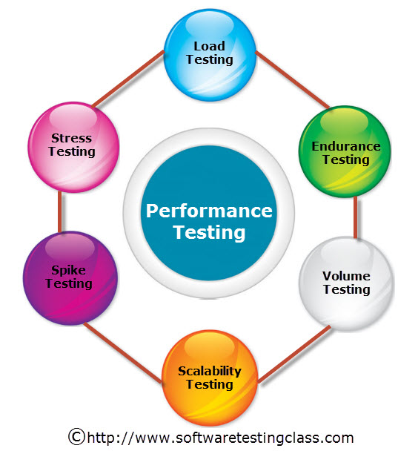
- Load Testing: Load Testing is type of performance testing to check system with constantly increasing the load on the system until the time load is reaches to its threshold value. Here Increasing load means increasing number of concurrent users, transactions & check the behavior of application under test.
The main purpose of load testing is to monitor the response time and staying power of application when system is performing well under heavy load.Load testing is perform to make sure that what amount of load can be withstand the application under
test. The successfully executed load testing is only if the specified test cases are
executed without any error in allocated time.

Simple examples of load testing:

- Testing printer by sending large job.
- Editing a very large document for testing of word processor.
- Continuously reading and writing data into hard disk.
- Running multiple applications simultaneously on server.

Stress Testing: Stress Testing is performance testing type to check the stability of software when hardware resources are not sufficient like CPU, memory, disk space etc.Stress testing is Negative testing where we load the software with large number of concurrent users/processes which cannot be handled by the systems hardware resources. This testing is also known as Fatigue testing, this testing should capture the stability of the application by testing it beyond its bandwidth capacity.
The main idea behind stress testing is to determine the failure of system and to keep an eye on how the system gracefully get recover back, this quality is known as recoverability.

Spike testing: Spike testing is subset of Stress Testing. A spike test is carried out to validate the performance characteristics when the system under test subjected to workload models and load volumes that repeatedly increase beyond anticipated production operations for short periods of time.

Endurance testing: Endurance testing is a non functional type of testing. Endurance testing involves testing a system with a expected amount of load over a long period of time to find the behavior of system. Let’s take a example where system is designed to work for 3 hrs of time but same system endure for 6 hrs of time to check the staying power of system. Most commonly test cases are executed to check the behavior of system like memory leaks or system fails or random behavior. Sometimes endurance testing is also referred as Soak testing.

Scalability Testing: Scalability Testing is type of non-functional tests and it is the testing of a software application for determine its capability to scale up in terms of any of its non-functional capability like the user load supported, the number of transactions, the data volume etc. The main aim if this testing is to understand at what peak the system prevent more scaling.

Volume testing: Volume testing is non-functional testing which refers to testing a software application with a large amount of data to be processed to check the efficiency of the application. The main goal of this testing is to monitor the performance of application under varying database volumes.

3. What is Jmeter and Advantages of Jmeter over other performance testing tools.

JMeter is an software that can be used to execute performance testing, load testing and functional testing of your web applications. JMeter can also simulate a heavy load on a server by creating tons of virtual concurrent users to web server.
JMeter is an open source application. This means that you can download JMeter’s source code to analyze and modify it if you want.
Stefano Mazzocchi of the Apache Software Foundation first designed it. He is now a software engineer at Google. Nowadays, JMeter has become one of the most popular testing tools in the world, beside Selenium and Load Runner.

Advantages of using Jmeter:

- Open Source: JMeter is an open source software. This means that it can be downloaded free of cost. It is also a 100% pure Java application. The developer can use its source code, can modify and customize it as per their requirement. They can also contribute their code to make a better Jmeter.

- Ease of Use: The user can install and use JMeter easily. Just download it from internet, install and run. As a pure Java desktop application, it comes ready to use with default settings. It does not require you to have any specific skills or domain knowledge to use it.

- Platform independent: JMeter is developed in Java, which is the most popular programming language in the world. Therefore, it can run in any OS be it Window, Linux or Mac.

- Robust Reporting: JMeter can generate the effective reporting. The test result can be visualized by using Graph, Chart, and Tree View. JMeter supports different formats for reporting like text, XML, HTML and JSON.

- Ultimate Testing: With JMeter, user can do any kind of testing they want. Load Test, Stress Test, Functional Test, Distributed Test, all in one tool.

- Flexibility: You can customize JMeter as per your requirement and apply the automation testing to JMeter. You can save the effort of executing test cases manually.

- Multi Protocol Support: JMeter supports several protocols like HTTP, FTP, SOAP, JDBC, JMS, and LDAP. It can also be used for testing the performance of your database.

4. What is Thread Group in Jmeter?

A Thread Group is the starting point of any Jmeter Test Plan. All the elements of a Test plan must be defined under Thread Group. In simple words, a thread group stores the configuration required for Jmeter script execution.
Below are configuration settings you can do under Thread Group:
- Action to performed after a sampler hits an error.
- Thread Count (Number of users you want for execition)
- Setting the Ramp-Up Time.
- Loop Count (Defined or Forever).
- Schedular Configuration.
5. Write down and explain any 5 listeners present in Jmeter?
Performance testing is all about analyzing server responses in various form and then presenting the same to the client.
Listeners are used to display the results of test execution so that testers get to know the stats. We have around 15 listeners in Jmeter but mostly used ones are table, tree, and Graph.

- View Results in Table: This is the most commonly used and easily understandable form of listeners. It displays the result in form of table with some important performance parameters.Please Note that View Results In TableSHOULD NOT BE USED during Load/Stress test as it consumes a lot of resources like memory and CPU. It is recommended to use it with functional testing or debugging purposes.

- View Results in Tree: This is another most commonly used listeners and provides detailed information with request and response. One can also view the HTML page rendered in response apart from viewing Json, XML, Text, RegEx.

Aggregate Graphs: Aggregate graphs allow us to generate bar graphs easily and let us select graph display settings. The generated graph and table data can be saved explicitly in the form of PNG and CSV.

Aggregate Report: Aggregate report shows a separate table row for each differently named sampler request in the test.

Assertion Results: Assertion Results displays the results of assertions applied on the Sampler.

6. Explain How do you recorded/made your script in your language.
Following steps are performed for recording the script.
- Install the Apache Jmeter in the system.
- Then launch the Jmeter by using terminal use the command ./jmeter.sh.
- Then after in Jmeter right click on Test Plan ->Add->Therads(User)->Thread Gruop Give name Login as group.
- Then again add Test Plan->Add->Non-Test-Element->HTTP (S) Test Script Recorder.
- Then again add Test Plan->Add->Listener->View Result Tree.
- Then again add Login->Add->Logic Controller->Recording Controller.
- Then open the Firefox Web Browser, Open menu and then click on Preferences then go into network proxy setting.
- Then choose manual proxy configuration. Give HTTP proxy as Localhost and port as 8888.
- Then go to Jmeter then start HTTP (S) Test Script Recorder.
- Go to Browser and add Cerificates in the Certificate Manager->Authorities .
- Then In browser enter the URL and then login using user name and password, stay on the page and then logout.
- Now in the Jmeter click on View Results Tree and then click on play button on uper side.
- Now add regular expression extractor under recoding controller.
- Now add regular expressions.
- Save the file.

7. Why do we need to do performance testing?
Performance Testing is done to provide stakeholders with information about their application regarding speed, stability and scalability. Performance testing will determine whether or not their software meets speed, scalability and stability requirements under expected workloads.
The focus of Performance Testing is checking a software program's
- Speed - Determines whether the application responds quickly.
- Scalability - Determines maximum user load the software application can handle.
- Stability - Determines if the application is stable under varying loads.
Performance Testing is popularly called as “Perf Testing” and is a subset of performance engineering.

