**Topics: Normal distribution, Functions of Random Variables**

1. The time required for servicing transmissions is normally distributed with  = 45 minutes and  = 8 minutes. The service manager plans to have work begin on the transmission of a customer’s car 10 minutes after the car is dropped off and the customer is told that the car will be ready within 1 hour from drop-off. What is the probability that the service manager cannot meet his commitment?

* 1. 0.3875
  2. 0.2676
  3. 0.5
  4. 0.6987

Soln:

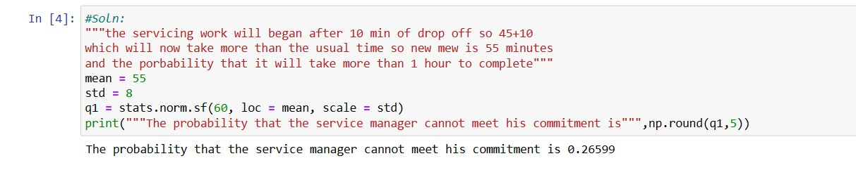

1. The current age (in years) of 400 clerical employees at an insurance claims processing center is normally distributed with mean  = 38 and Standard deviation  =6. For each statement below, please specify True/False. If false, briefly explain why.
   1. More employees at the processing center are older than 44 than between 38 and

44.

* 1. A training program for employees under the age of 30 at the center would be expected to attract about 36 employees Soln:

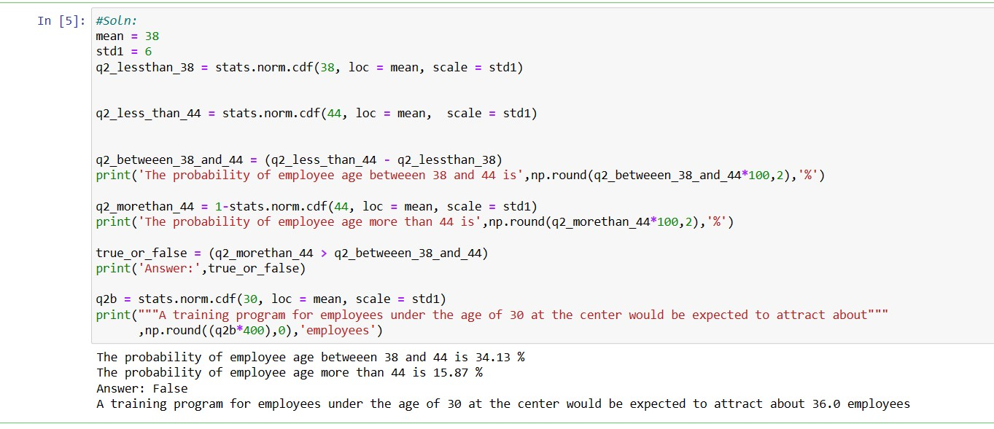

1. If *X1* ~ *N*(μ, σ2) and *X*2 ~ *N*(μ, σ2) are *iid* normal random variables, then what is the difference between 2 *X*1 and *X*1 + *X*2? Discuss both their distributions and parameters.

Soln:

As we know that if X  N(µ1, σ1^2 ), and Y  N(µ2, σ2^2 ) are two independent random variables then X + Y  N(µ1 + µ2, σ1^2 + σ2^2 ) , and X − Y  N(µ1 − µ2, σ1^2 + σ2^2 ) .

Similarly if Z = aX + bY , where X and Y are as defined above, i.e Z is linear combination of X and Y , then Z  N(aµ1 + bµ2, a^2σ1^2 + b^2σ2^2

).

Therefore in the question 2X1~ N(2 u,4 σ^2) and X1+X2 ~ N(µ + µ, σ^2 + σ^2 ) ~ N(2 u, 2σ^2 ) 2X1-(X1+X2) = N( 4µ,6 σ^2)

1. Let X ~ N(100, 202). Find two values, *a* and *b*, symmetric about the mean, such that the probability of the random variable taking a value between them is 0.99.

* 1. 90.5, 105.9
  2. 80.2, 119.8 C. 22, 78
  3. 48.5, 151.5
  4. 90.1, 109.9 Soln:

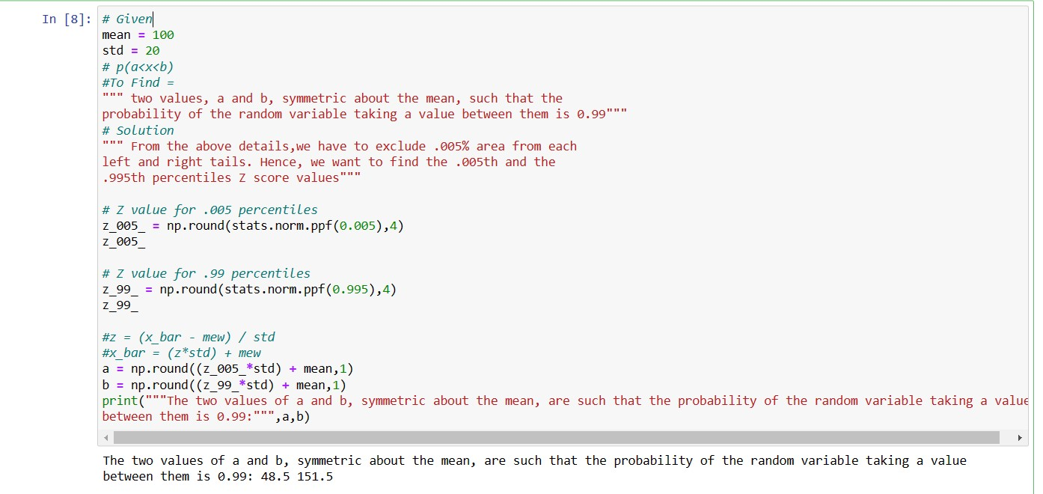

1. Consider a company that has two different divisions. The annual profits from the two divisions are independent and have distributions Profit1 ~ N(5, 32) and Profit2 ~ N(7, 42) respectively. Both the profits are in $ Million. Answer the following questions about the total profit of the company in Rupees. Assume that $1 = Rs. 45
   1. Specify a Rupee range (centered on the mean) such that it contains 95% probability for the annual profit of the company.
   2. Specify the 5th percentile of profit (in Rupees) for the company
   3. Which of the two divisions has a larger probability of making a loss in a given year? Soln:

Given that:

$1 = Rs. 45



Thus,

Company's profit:



A):

95% of the probability lies between 1.96 standard deviations of the mean.

Thus range is:

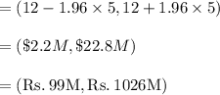

B): Fifth percentile is calculated as:



From p values of z score table, we get:



Thus at $3.78M dollars, or Rs. 170.1M amount, 5th percentile of profit lies.

Or 5th percentile of profit is Rs. 170.1 Million.

C): Loss is when profit < 0

Thus: p < 0

The first division of company, thus have larger probability of making a loss in a given year