GC MVP Batch 4

# Evernote API

In this sprint, we created 8 interfaces for users to control their evernote.

The interfaces’ functions are insert note, edit note, delete note, list notes, insert notebook, edit notebook, expunge notebook and list notebooks.

Besides that, we also offered some test file for you to do basic test about the interfaces.

These functions will run on the php command:

$ php /GC_MVP/vendor/epalsAPIs/evernoteInterface/evernoteApiTest/test***.php

Update

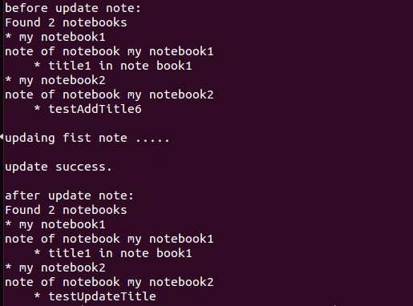

create：

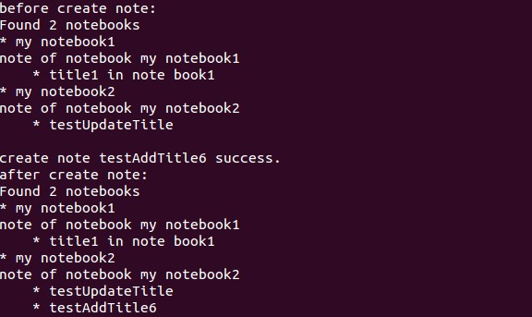

# Evernote authentication

In this sprint, we also finished authorize & re-authorize for user so that they can control their evernote if they finish the authentication successfully. Before that , they must have an account of evernote.

This function will run on the website:

<http://Zhili.dev.epals.com/testOauth.php>

Authentication steps:

1 obtains temporary credentials.

2 authorize the temporary credentials

3 exchange the authorized temporary credentials for token credentials

4 list all notebooks in the authorizing user’s Evernote account.

For user convent, we put the access token in database by UserAttribute/add(), so that if user have this token, they can get their notebook list without do the step before.

If any exception in the process be catched, the user will required do re-authorize.

Re-authorize:

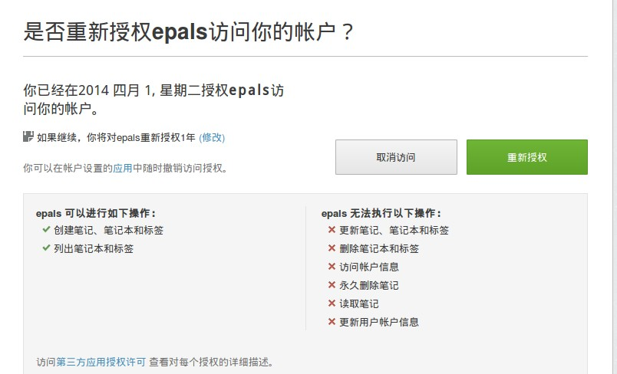

Result:

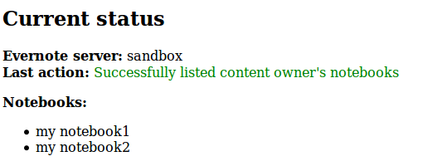

In this sprint, we install a new php extension named Oauth. The new function of this sprint cannot run rightly without this extension.

The way to install the extension:

apt-get install libpcre3 libpcre3-dev

wget <http://pecl.php.net/get/oauth-1.1.0.tgz>

tar -zxf oauth-1.1.0.tgz && cd oauth-1.1.0

/usr/bin/phpize

./configure --with-php-config=/usr/bin/php-config

make&&make install

vi /etc/php5/cgi/php.ini

extension=oauth.so // append to the end of the file

service nginx restart

// reboot the virtual machine in order to make Oauth extension in use.

// modify the nginx.conf file

root /var/www/html/epals/GC_MVP/vendor/epalsAPIs/evernoteInterface/evernoteApiTest