**Question 2:**

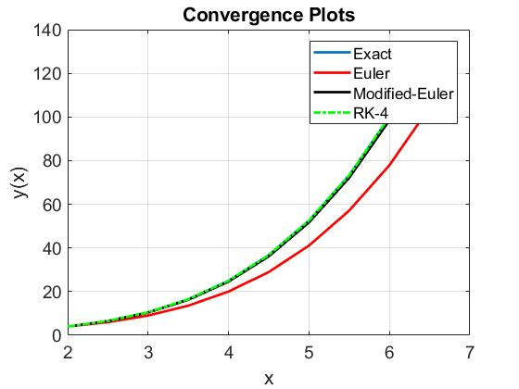

Included plots for Euler and RK-4 for comparison.

Derivation of method and confirmation of second-order accuracy are handwritten.

**Question 3:**

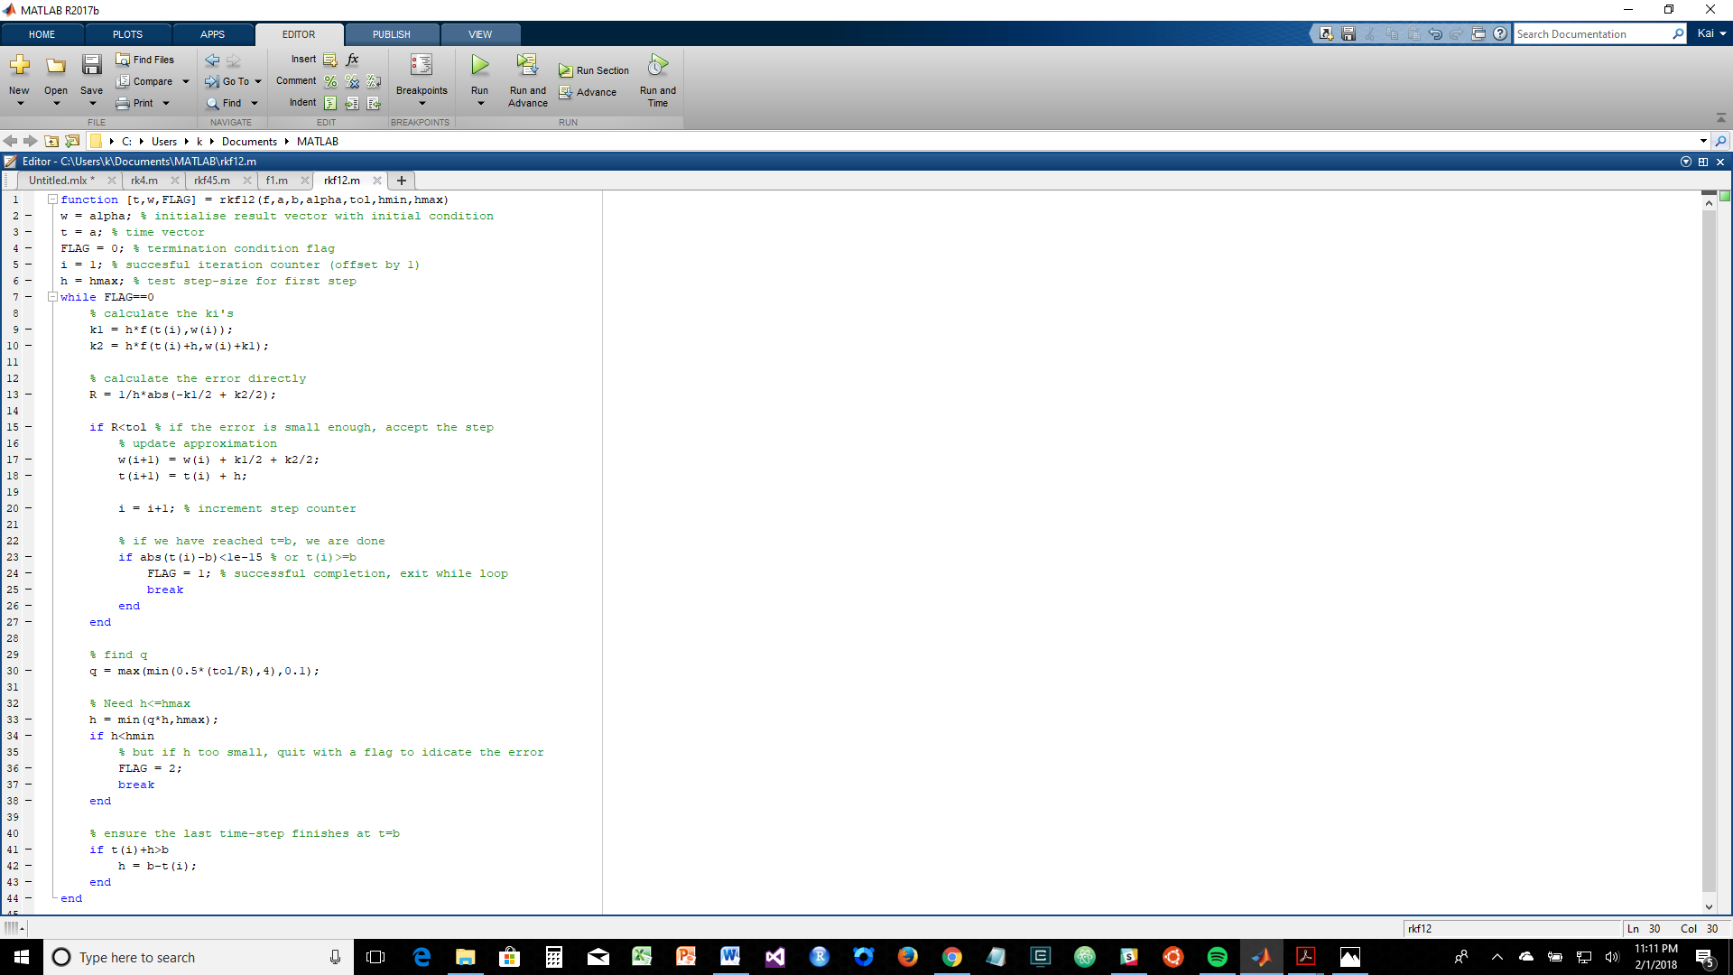

The RKF12 method required more time-steps to achieve a similar level of accuracy as the RKF45 method. Across different accuracy levels, I found that the running time and computational costs were greater for the RKF45 method compared to the RKF12 method. The cause for this is apparent when we examine the equations of the two methods. For the RKF12 method, each step only requires 2 evaluations of the function ‘f’ whereas for the RKF45 method each step requires 6 evaluations. So the RKF12 method has at least a 66% decrease in the number of function evaluations which take up the bulk of running time and computational costs. For the RKF12 method, runtime = 0.000002s whereas for the RKF45 method, runtime = 0.000006s.