**Question 1:**

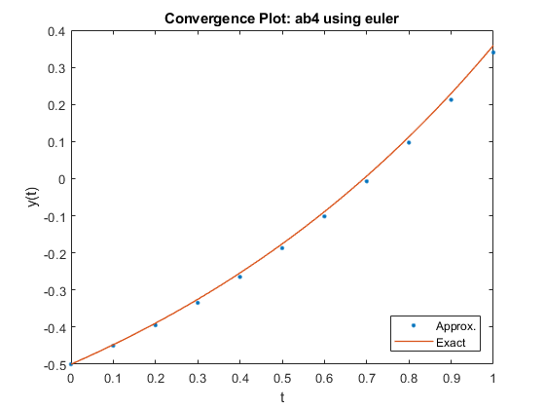

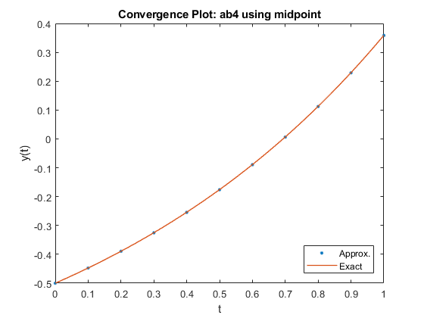

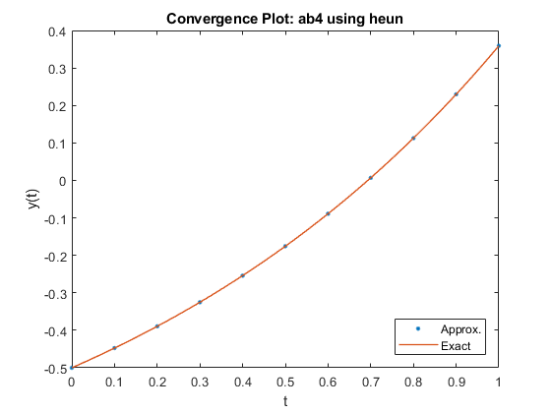

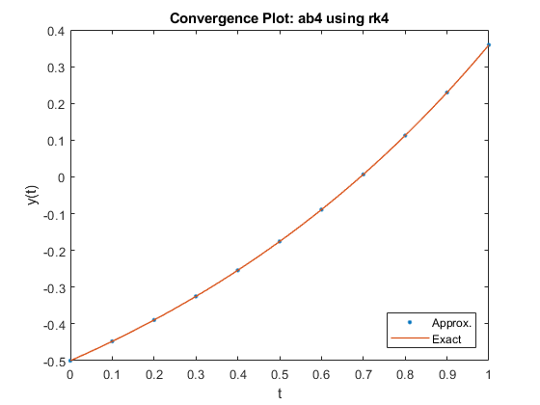

We see that the performance of ab4 improves as we use higher order methods to find the starting values. While it is less noticeable when using methods of second order and above, the improvement in ab4’s approximation when going from a first order (euler) to second order (midpoint) method is apparent.

**Question 2:**

f = @(t,y) 1+y; % RHS of the ODE

h = .1; % step size

t = 0:h:5; % vector of time points

alpha = -1/2; % initial condition

exact = @(s) exp(s)/2-1; % exact solution

T = 0:.01:5; % fine grid for plotting exact solution

for i = 2:length(t)-1

% predict using midpoint method

wp = w(i) + h*f(t(i) + h/2, w(i) + h*f(t(i), w(i))/2);

% correct using 1-step implicit method (trapezoidal rule)

w(i+1) = w(i)+h/2*(f(t(i+1),wp)+f(t(i),w(i)));

end

figure(1)

plot(T,exact(T),t,w,'.')