Adafruit 1528-4699-ND
https://www.digikey.ca/en/products/detail/adafruit-industries-llc/4699/13170954?s=N4IgTCBcDaIIwFYwA4C0AWAbATm6gcgCIgC6AvkA
https://www.adafruit.com/product/4699#description
https://cdn-shop.adafruit.com/product-files/4699/4699_C14656_diagram.jpg
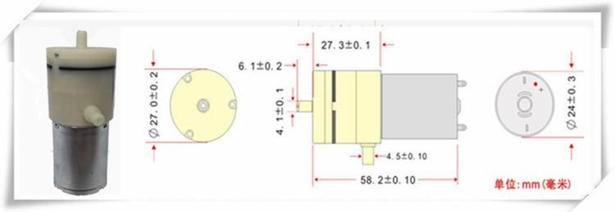
Adafruit 1528-4663-ND
https://www.digikey.ca/en/products/detail/adafruit-industries-llc/4663/13170960?s=N4IgTCBcDaIIwFYwA4C0AWAbJgzKgcgCIgC6AvkA
https://cdn-shop.adafruit.com/product-files/4663/diagram.pdf
https://www.adafruit.com/product/4663?srsltid=AfmBOoqt5e1SdDEJn2isgbLql8vumaZ-9krsNxTDdMLAktHA74u-1s52
