TrapSync Final Design Report

Kailyn Isaac  Electrical Engineering | Noah Tull  Mechanical Engineering | Chara-Ruth Ward  Mechanical Engineering | Tyren Collins  Mechanical Engineering

Introduction
Collaborative Design Lab at John Brown University is a project-based engineering course focused on giving students a realistic and interdisciplinary product development experience. Students work in cross-functional teams including engineering, business, computer science, and graphic design majors to bring a product from concept to prototype. Throughout the semester, teams follow a complete design cycle involving ideation, research, prototyping, and documentation, all while navigating real-world constraints such as budget, manufacturability, sustainability, and user needs.
Within this context, our engineering team proposed and pursued the development of a humane, connected mouse trap system designed to detect, contain, and notify users when a rodent has been caught. This emerged from initial team brainstorming, where we identified a need for more ethical, hygienic, and convenient pest control solutions, especially for users who may need to place traps in hard-to-reach or frequently unmonitored areas. While commercial humane traps exist, they typically require manual checks and offer no automation or remote feedback.

Problem Statement
This project addresses rodent infestation issues by developing a humane mouse trap with an integrated alert system for quick response. The design must meet several constraints, including fitting into tight spaces, being reusable, and having no sharp edges, all while ensuring safety for both the mouse and the user when the trap is activated. To evaluate the trap's efficiency and effectiveness, a series of tests will be conducted (see Testing section). These will include drop tests, closing speed assessments, motor control evaluations, sensor accuracy checks, Wi-Fi connectivity, and low power mode performance.

Initial Design

Mechanical Process
The main functions of the trap's mechanical systems are in a mechanical Morph chart in Table 1.

Table 1:Mechanical Functions Morph Chart
Function​ | 1​ | 2​ | 3​ | 4​
Closes Trap | Indirect Motor | Direct Motor | Propeller Trapdoor | Spring-loaded
Opens Trap | Motor Winding | Manual Lever | Latch Release | Solenoid Release
Material for Cage | ABS | Wood | PLA | PETG

Using these functions, four main trap ideas were created. The first being to create a box that had a propeller trap door at the top. The idea behind this being that when a mouse would stand on the trap, the mouse’s weight would cause the propeller to spin, dropping the mouse into the container below. There would then be another method for opening a hatch inside of that container that would let the mouse out in a different way than it came in. This idea had the advantage of being the simplest and cheapest, due to having the fewest components needed.
The second idea was dubbed, the “Solenoid Drawbridge.” Simply put, this solution involved creating a box that had a hinged door at the front, which was held closed by a spring and could be opened/closed by the pushing and releasing of two solenoid motors. This trap would have a fast activation speed and would be the easiest to clean due to having the largest opening.
The third idea was a Double-Pin door. This door created a way to both open and close a door using only a single directional spring. It did this by having pins that would stop the door in place at various points in its closing. When the trap was set, a pin would hold the door completely open. Upon a mouse setting off the trap, the first pin would be released causing the door to swing to the second pin, which would be at a 90-degree angle, effectively closing the trap. When the user expresses a desire to release the mouse, the second pin would release causing the pin to swing fully open and the mouse to escape.
The fourth and final idea was a box that had a door mounted to a servo on the front. This design allowed for the same method to be used in opening and closing the trap, while also being simple in its creation. This method used few mechanical components and contained tons of space to position everything.
By applying our objectives and constraints to these designs, some were able to be quickly ruled out. The propeller trap, while the cheapest and most efficient, had the very limiting factor of being the largest design, which went against the objective of needing to fit in tight spaces. The solenoid drawbridge ended up being the most expensive, and there were worries as to if the solenoids would be able to keep the door shut at such a distance. Initially, the Double-Pin door had the most promise, but once some rudimentary modeling of the system was done, it was determined that it would not actually work because the friction caused by the spring clamping on the first pin would be too much for the method of weight activation that was decided on. This narrowed it down to the Servo door model, the best solution, and the one further explained in the final design section.

Electrical Process
The main functions and the different options for their design are summarized in a Morph Chart in Table 2. The main ideas were chosen with different types of trap systems in mind so those choices could not be finalized until the final mechanical close trap and open trap systems were chosen first.
Table 2:Electrical Functions Morph Chart
Function | Detects Mouse​ | Control System​ | Communication​
1 | Electrical  Weight sensors​ | Arduino Uno​ | Bluetooth​
2 | Motion Sensors​ | Raspberry Pi Pico​ | Wi-Fi​
3 | Laser/ Distance detection​ | Raspberry Pi Zero​ | UART​
4 | Image  Recognition​ | Arduino Nano​ | SPI​

The concerns when looking at all these options were power consumption, size, and price; more specific ones were chosen for range, control pins, or speed. Some overarching choices were the use of Wi-Fi for better range; the Arduino Nano ESP32 for its accessibility to Wi-Fi, low-power modes, and pin capabilities; and a rechargeable 9V battery for portability and long-term use. After making the final mechanical choice, more electrical components were chosen to create a complete functional circuit. The final choices and their reasoning were summarized in Table 3.
Table 3: Electrical Component Design Choices
Component | Type | Why this?
Microprocessor | ESP32 Nano | Wi-Fi access, cheapest, LPM for battery life, inbuilt PWM
Servo Motor | 4Pcs SG90 9g | Fastest, lowest power needed
Beam-Break Sensor | ADA2167 | Cheapest, smallest, and least power needed
Battery Life Sensor | Voltage Sensor DC | Most available, cheapest, least power needed
Switches | SLW-1276864-4A-D | Smallest, cheapest, less easily accessed by a mouse
Voltage regulators | MPM3610 | Thermal and over-current protection included, large range of V and I input
Battery | Rechargeable 9V | 9V and large capacity
Wires | MF, MM, FF 20cm | Cheapest, strippable wires
Breadboard | Half Breadboard | Small enough and cheapest for testing
Battery clip | N/A | Cheap
LEDs | RGB LEDs | Multi-colored, low-cost

Final Design

Mechanical Model
For the trap system's final design, the Servo Door design was used, shown in Figure 1.
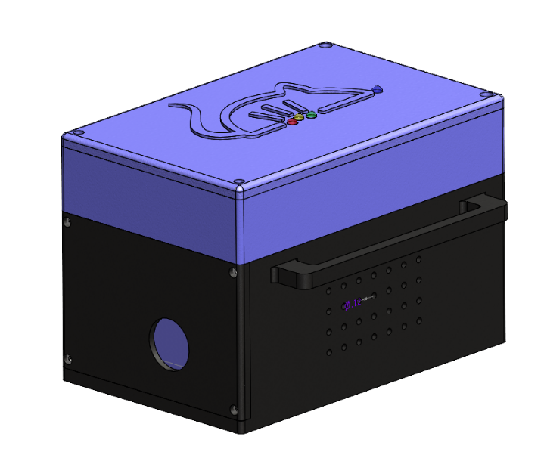
Figure 1: External View of Trap
As can be seen, this 4.5” x 7” x 5” exterior box contains a simple hole in the front through which a mouse could be baited through. Inside the doorway, a servo motor is attached to a custom printed door rotator mount. When the trap is set, the servo has the door held in the “up” position, waiting for an input signal from the microcontroller. To send the detection signal, a break-beam laser is used to know when there is an animal inside the cage. When the mouse travels between the two sensors, the beam between them is broken, notifying the microcontroller. When that signal is sent, the motor rotates 90 degrees in an ideal time between 0.1 and 0.5 seconds, blocking the exit and containing the mouse. The hole and door are also positioned so that there are no edges of the door accessible, which makes it much harder for the door to be opened from the inside. Upon receiving the open signal from the microcontroller, the servo returns to its original position, allowing the mouse to be freed and the trap to be ready to set again.

Electrical Schematic
The overall electrical schematic can be viewed in Appendix A. The circuit starts with the power system that can be seen in Fig.2
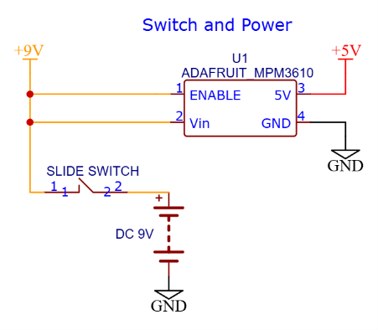
Figure 2: Battery, Voltage Regulator and Switch Schematic
A 9V battery rechargeable via USB-C is connected to a slide switch and provides the 9V power source. Going through the MPM3610 voltage regulator bucks the voltage down to a steady 5V source. The 9V source is then connected directly to the Arduino Nano ESP32 as seen in Fig.3.
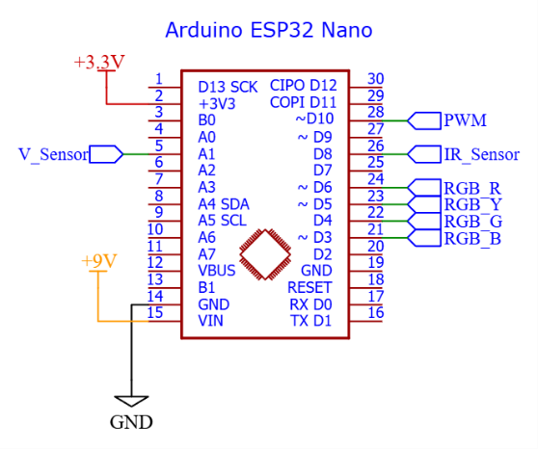
Figure 3: Arduino Nano ESP32 Schematic
The Arduino board provides the 3.3V for the ESP32 microcontroller and outputs the 3.3V to power the sensors. The board is used for its digital pins such as controlling the motor through a PWM signal, controlling the LEDs, and getting the trap status from the IR sensors. The only analog pin is used to read the battery levels and inform the user.
The battery sensor is directly connected to the battery through its reading pins and sends the information through the V_Sensor pin to the ESP32. This can be seen in Fig. 4.
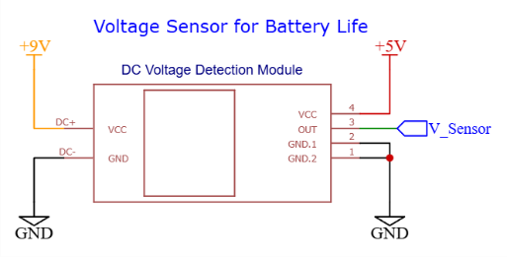
Figure 4: Battery Voltage Sensor Schematic
Both parts of the IR sensor are connected to the Arduino’s 3.3V and ground through a centralizing PCB. The receiver is also connected to the digital pin and will be used during ultra-low power mode to wake up the system and start the trapping mechanism. This will also activate the connected blue LED. These can be seen in Fig. 5.
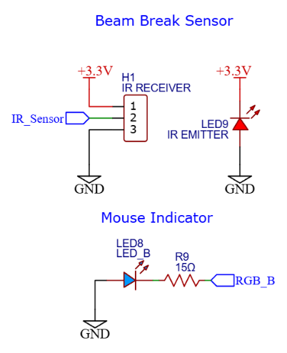
Figure 5: Beam Break Sensor Schematic
The servo motor is connected to the voltage regulator’s 5V output and the PWM signal output of the Arduino board. This can be seen in Fig. 6
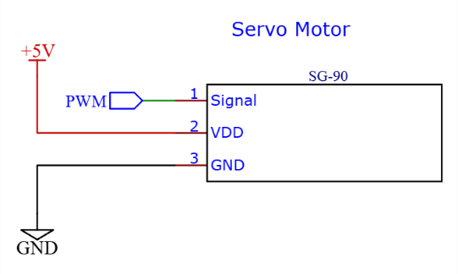
Figure 6: Servo Motor Schematic
Finally, LEDs were added on top of the initial design to create a physical option to view both battery levels and trap status instead of solely on the app. These are all connected to the Arduino and will be soldered onto a PCB with their resistors as summarized in table 7, assuming a maximum 20mA current output from the Arduino.

Table 4: LED Specifications and Resistors Needed
LED | Forward Voltage | Resistor value
Red | 2V-2.2V | 62Ω
Yellow | 2V-2.2V | 62Ω
Green | 2V-2.2V | 62Ω
Blue | 3V-3.1V | 15Ω

The overall LED connection schematic can be seen in Fig.7.
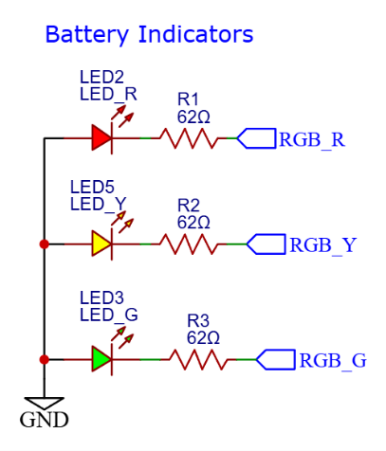
Figure 7: LED Schematic for Battery Indication
This final coding design will be divided into three different modes within the ESP32: an ultra-low power mode during the main time, where only the IR sensor connected to the GPIO pin will be able to awaken the processor. This will account for 99.9% of the time. The time for the servo motor to be rotated will account for the second it is powered on at full activation, before returning to a light sleep MODEM mode.
This is where Wi-Fi is activated, the blue LED is turned on, and the Firebase database is accessed. The mouse in variable is set HIGH, and the microprocessor is set to an idle counter-based sensor check back in a MODEM low-power mode allowing Wi-Fi connection.
When the user decides to open the trap, the variable open trap will be set HIGH and at the next check, the ESP32 goes back into full activation to open the trap and go back into standard ultra-low power mode, changing back the mouse sensed to LOW. The trap is reset and can be powered off for cleaning. This can be seen in Fig. 8
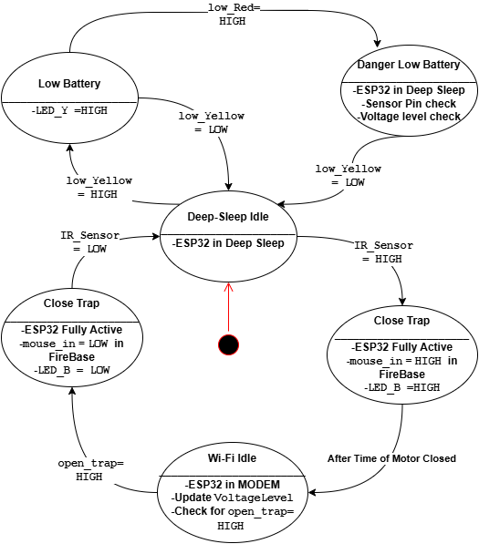
Figure 8: State Diagram
The overall power consumption of the trap in the main three stages can be seen in Tables 5 and 6. With the chosen 9V battery, the 12800mAh capacity renders this design capable of lasting about 100 days without needing a recharge, assuming about 99.9% Deep-Sleep, 0.0998% Modem, and 0.0002% Active
Component | I(A) | V(V) | Power(W)
NANO Esp432 | 150 μA deep sleep mode with ULP on | 3.3V | 0.000495
 | Wi-Fi MODEM:  18.33mA on average | 3.3V | 0.06039
Beam Break Sensor | 10mA | 3.3V | 0.033
Servo | .19A | 5V | 0.95
LEDs | 40mA | 5V | 0.2
Table 5:Main Components Power Consumptions
Table 6: Power Consumption Stages
Stages | Power consumption (W)
Deep-Sleep: only IR sensors and the ESP32 ULP | 0.033495
Active: Motor activated, Wi-Fi connecting, LEDs on | 1.243885
Modem: with Wi-Fi & LEDs | 0.293885

Impact
TrapSync’s purpose is to establish a way to safely relocate mice in a humane manor that is not only effective but implements safety concerns of public health, safety, and welfare and in global, economic, environmental, and societal contexts. Below are some key aspects of these values:

Public Health, Safety, and Welfare - Protection of fingers and tail– designed to be safe in reset, no sharp edges that could harm the user, and detection far enough away to not bring harm to the mouse on closing. Mice removal –mice carry diseases which our product is designed to solve that problem. However, the relocation process could lead to carrying the diseases elsewhere. Another safety feature to be aware of are electrical azards - damage to wires or poor electrical set up could lead to fire hazards.

Global - Some countries are prohibited from killing animals which makes our product best suited for these countries. TraspSync will also provide an avenue for future expansion towards trapping other animals.

Economic

Graphics - Graphics and branding focused on a blend of sleek professionalism and fun. Some other logos that didn’t include an animal were looked into, but they often looked too techy and bland, as seen in Fig. 9.

Figure 9: Iterations of Graphical Designs
The mouse represents the fact that TrapSync designs animal traps. The exclamation points represent the alert system that TrapSync provides. The main company colors convey both the sleek tech components of the brand and the peaceful, humane approach to animal traps. We chose the typeface DM Sans because it is a clear, tidy font. It is very professional while still being a fun, bouncy typeface.


Figure 10: Colors and Typeface

Business – Incorporating a Buy-it-model – The initial startup of the company would buy the materials and trap itself from other manufactures before switching to a Build-it-model (long-term), which would encompass TrapSync to manufacture its own product. Cost to Replace – poor manufacturing could lead to additional costs for replacement of the trap

Environmental Impact - Recyclable plastics provide a positive impact on the ecosystem. App recommending release centers - released at pet shops or zoos (but could be released improperly, multiply, and infest more). Non-Target Species – may catch other species of animal not intended for the trap

Societal Impact - Accessibility to WiFi/Bluetooth/Phone can’t be assumed. Possible creation of jobs we don’t want (i.e. sweatshops). Animal Welfare Concerns – Some groups of people are concerned for the safety of the animals. Hence, why this humane trap is catch and release oriented. The Buy-It model requires outside building spaces which could cause problems ethically on how they manufacture their resources.

Implementation
For the prototype model, the casing of the trap will be 3D printed out of PLA. This is due to the ease of use and acquirement for testing and refining a design. In actual manufacturing, however, once the exact design specifications can be confirmed for testing, the product would be created using an injection-molded HDPE. This is because HDPE injection mold can produce many parts cheaply and efficiently.
For assembly, the servo door will first be mounted to the servo, which will then be placed inside the slot within the trap. The front casing will then be screwed to the front, locking the servo mechanism in place. In the electronics casing, the battery pack will be held in place by a printed holder, and the rest of the electronic components will be attached to a breadboard, which will just be stuck in the middle of the box. In the future, if it is decided to pursue PCB creation, an extra holder will be created to keep that in place as well. The different sections of this printed trap will be held together by M3 x 4mm screws and threaded inserts that will be set into the trap piece by means of a heat set press.
On the inside of the trap, the break-beam sensors will be housed within slotted containers that connect to the top of the trap, which serve a dual purpose in allowing space for a wired connection as well as protecting the sensor from being damaged by its mouse occupants. An exploded view of each of these assembly steps is shown in Figures 11,12, and 13.
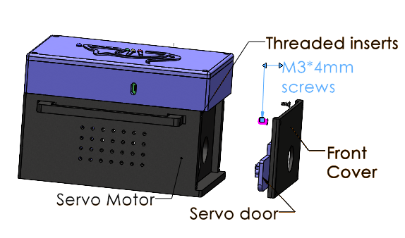
Figure 11: Exploded View of Door Mechanism

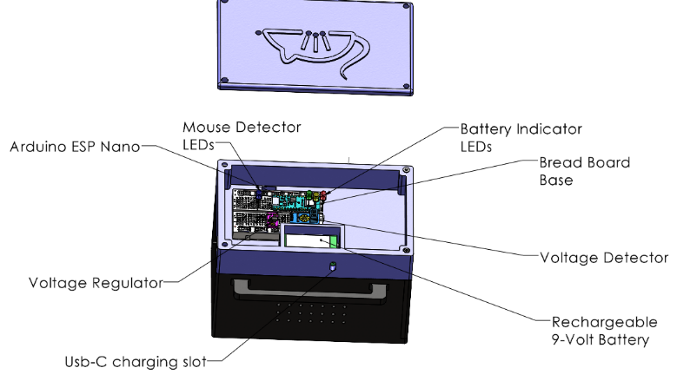 Figure 12: Exploded View of Electronics Casing
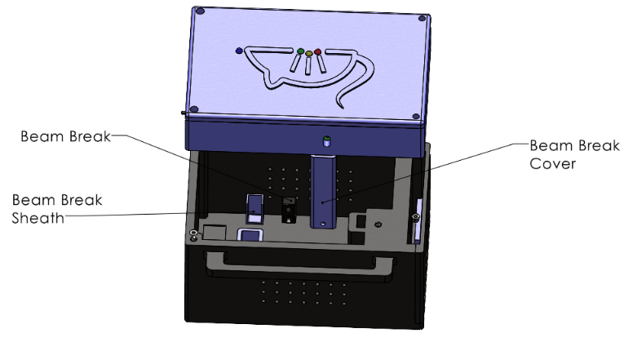 Figure 13: Exploded View of Inner Sensors
A full exploded view can be seen in Appendix B.
On the electrical side of things, the main connector PCB will be locally made, starting as a schematic, and proportioned according to the printed model to fit the LEDs under the logo at the top of the box, or alternatively clasped onto the bottom of the box and wired up to the LEDs. This will first be a breadboard, connected to the Arduino board, voltage regulator, grounds, and power sources in a centralized circuit for troubleshooting, before being transferred and soldered to the PCB. There will be a ground, 3.3V, 5V, and input voltage

Beyond its immediate functionality, this project aims to contribute to open-source development, encouraging community-driven modifications for broader applications. Future iterations of this design could extend beyond mice to accommodate other small animals, making it a versatile tool in humane pest management and wildlife research.
This project aligns with broader engineering efforts in automation, IoT integration, and smart animal management solutions. By leveraging embedded systems and wireless communication, this design serves as a foundation for further innovation in humane trapping technology.

Budget
Table 7: Complete Budget
Item | Cost | Amount | Source | Purchases
PLA plastic | 13$/kg | 1kg | Amazon | $13.00
Microprocessor | $21 | 1 | Arduino | $21.00
Servo Motor | $7.99 | 1 | Amazon | $7.99
Beam-Break Sensor | $2.95 | 1 | Adafruit | $2.95
Battery Life Sensor | $4.99 | 1 | Amazon | $4.99
Switches | $0.83 | 1 | AliExpress | $0.83
Voltage regulators | $6.95 | 1 | Adafruit | $6.95
Battery | $11.06 | 1 | AliExpress | $11.06
Wires | $3.80 | 1 | AliExpress | $3.80
Protoboard | $4.95 | 1 | AliExpress | $4.95
Battery clip | $1.15 | 1 | AliExpress | $1.15
LEDs | $2.79 | 1 | AliExpress | $2.79
Threaded Inserts | $8.98 | 1 | Amazon | $8.98
Screws |  |  | C3D | $ -
Shipping |  |  |  | $9.08
Tax |  |  |  | $6.39
Remaining Budget: |  |  |  | $144.09

Testing

Prototype Testing
For the testing of the mechanical side of this device, two variables will be studied: the closing speed of the door and the strength of the outer case. To properly test the closing speed of the door, a sample signal will be created that will tell the servo to rotate 90 degrees. A stopwatch will be used to measure the time it takes for the servo to rotate along this path. This will be done after the servo has been mounted with its door fixture part, allowing this test to consider the extra weight added by the door. Using our metrics previously shown, the goal speed is 0.1 seconds, or instantaneously, however, since the reaction speed of a mouse is measured at around 0.4 seconds, anything under half a second would still be considered fast enough.
To test the strength of the case, a drop test will be performed using a 3D printed model without the electrical components. The weight of all the electronic components will be measured, and an equivalent weight will be added to the box. This model will then be dropped repeatedly from a height of 4 feet, to simulate the amount of deformation that could occur from being dropped while the device is being carried. If any deformation occurs that is deemed dangerous, likely to be a point of structural failure, or provides a mouse with a means to escape, those areas will be reinforced before a second version of the model is reprinted.
The cleanability of the product is embedded within the design. By making the top removable and limiting the number of hard cracks and edges within the trap itself, it allows for easier cleaning to be done. This is especially important when the reusability of the design is paramount.

Code Testing
The IR sensor control and reading will be the first code made and tested through basic object crossing. This will be followed by the code for motor control. They will then be implemented together to check for the basic functionality of an un-synced trap using a mouse-like object. The next step will be to access and modify the variables in the Firebase database, that the CS team created, through Wi-fi connection and test the detection ability of the ESP32 while in MODEM mode. The final part will be coding in the low-power modes and testing the switch between modes on the oscilloscope to have a finalized longevity.

Schedule
Slight timeline delays did occur when determining the optimal design of the trap. Simple ways that we worked toward resolving this issue incorporated morph charts to solve for constraints of the design, minor calculations on specific parts that would hinder effectivity, as well as the involvement with other class disciplines of the team to ensure a consensus for the best way to move forward with the design process. The semester-long Gantt Chart can be seen in Appendix C, and the key milestones can be seen in Table 8.
Table 8: Important Design Dates
Key Milestones | Deadline | Actions for Progress
Design Report | 3/20/2025 | Each member will work on designated sections of the report
Order Parts | 3/20/2025 | Submit an order form of all part necessary for the trap
Model Printing | 4/4/2025 | Submit to 3D printer
Computer Science Integration | 4/4/2025 | Before any progress is made for EE testing, CS is tasked with creating Wi-Fi connection through Firebase
Electronics and Software Integration | 4/4/2025 | Pseudocode and individual electronics testing
Build | 4/11/2025 | Assembly of all electrical and mechanical components
Overall Testing and Optimization | 4/18/2025 | Various tests will be conducted on both ME and EE sides to ensure proper functionality
Demonstrate Completed Prototype | 4/24/2025 | Print 3D pieces and assemble electronic components. Then go through testing checklist before demonstrating completed prototype
Final Presentation | 5/1/2025 | Each member will work on designated sections of the report
Prototype Design & Build Presentation | 5/8/2025 | Conduct additional tests if needed to Ensure the prototype is working effectively and efficiency

Conclusion
The TrapSync mousetrap represents a multi-disciplinary engineering solution that integrates mechanical design, embedded electronics, and wireless communication into a compact, humane rodent trap. The design space was narrowed through morphological analysis and constraint-based evaluation, with factors such as size, cost, simplicity, and user safety. Several mechanical designs were evaluated before selecting the servo-actuated door as the most reliable and space-efficient solution. Similarly, the choice of the ESP32 Nano microcontroller was guided by power efficiency, integrated Wi-Fi capabilities, and adequate I/O resources to interface with beam-break sensors, servo motors, and RGB status LEDs. PLA was chosen for initial prototyping due to its printability and availability, with plans to migrate to injection-molded HDPE for production to enhance durability and reduce per-unit cost.
On the electrical side, the circuit design emphasized modularity and fault isolation, using discrete, easily replaceable components such as voltage regulators, IR sensors, switches, and indicator LEDs. These components will initially be tested on breadboards and will later be integrated into a centralized PCB, reducing wiring complexity and improving robustness.
Power management was always a key design focus. A tiered power mode structure included: Ultra-low power, MODEM sleep, and active operation. These were considered to maximize energy efficiency and enable long-term usage of the device. Based on theoretical power modeling, the system is projected to achieve up to 100 days of battery life per charge, using a rechargeable 9V supply.
At this stage, detailed testing procedures have been developed to validate system performance across mechanical, electrical, and software domains. These include drop tests to assess structural integrity, timing measurements for door actuation, signal reliability checks for IR sensing, and Wi-Fi connection stability. Testing outcomes will inform iterative hardware redesigns and firmware tuning to meet user-focused design metrics such as reliability, response time, and ease of use.
Looking forward, TrapSync aims to serve as a foundation for extensible, open-source smart trapping solutions. The modular architecture of both the hardware and software systems is intended to support future integration of advanced sensing methods (e.g., weight sensors, image recognition), telemetry features, and support for other species beyond rodents. By enabling community-driven development and releasing documentation openly, TrapSync has the potential to evolve into a broader platform for ethical wildlife interaction, research, and automated pest management.

Appendix
Appendix A: Full Electrical Schematic
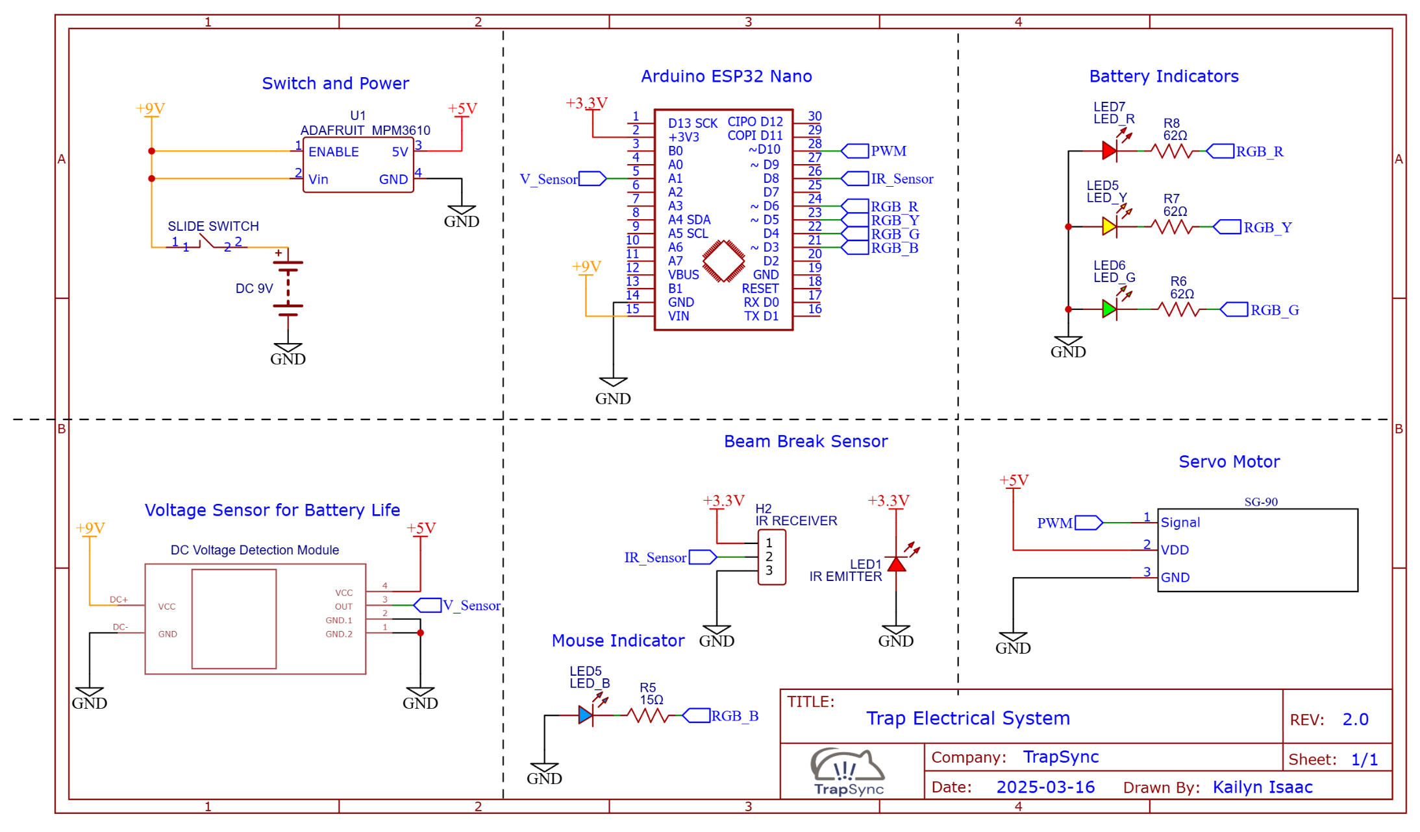 Figure 14: Full Electrical Schematic

Appendix B: Complete Exploded View of Trap
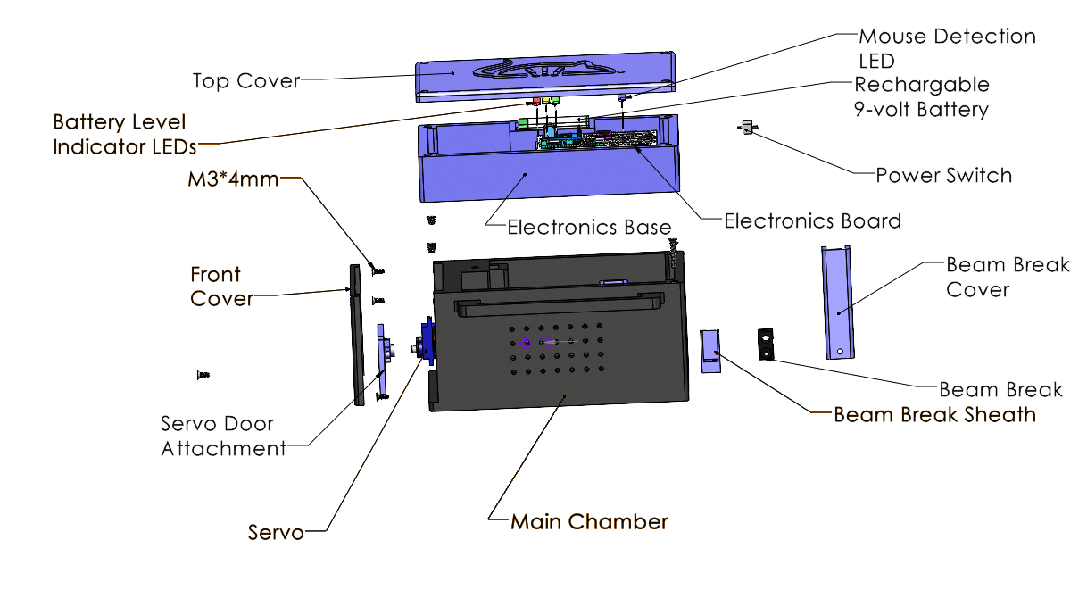
Figure 15: Full Exploded View

Appendix C: Full Gantt Chart
