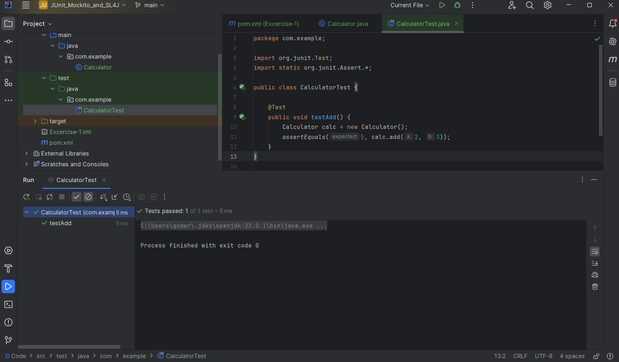**Pom.xml**

<project xmlns="http://maven.apache.org/POM/4.0.0"  
 xmlns:xsi="http://www.w3.org/2001/XMLSchema-instance"  
 xsi:schemaLocation="http://maven.apache.org/POM/4.0.0  
 http://maven.apache.org/xsd/maven-4.0.0.xsd">  
  
 <modelVersion>4.0.0</modelVersion>  
  
 <groupId>com.example</groupId>  
 <artifactId>Excercise-1</artifactId>  
 <version>1.0-SNAPSHOT</version>  
  
 <dependencies>  
 <!-- Add JUnit dependency here -->  
 <dependency>  
 <groupId>junit</groupId>  
 <artifactId>junit</artifactId>  
 <version>4.13.2</version>  
 <scope>test</scope>  
 </dependency>  
 </dependencies>  
  
</project>

**MainClass:**

package com.example;  
  
public class Calculator {  
 public int add(int a, int b) {  
 return a + b;  
 }  
}

**TestClass:**

package com.example;  
  
import org.junit.Test;  
import static org.junit.Assert.*;  
  
public class CalculatorTest {  
  
 @Test  
 public void testAdd() {  
 Calculator calc = new Calculator();  
 *assertEquals*(5, calc.add(2, 3));  
 }  
}

**Terminal Output:**

C:\Users\godar\.jdks\openjdk-22.0.1\bin\java.exe -ea -Didea.test.cyclic.buffer.size=1048576 "-javaagent:C:\Program Files\JetBrains\IntelliJ IDEA Community Edition 2024.1.1\lib\idea_rt.jar=52971:C:\Program Files\JetBrains\IntelliJ IDEA Community Edition 2024.1.1\bin" -Dfile.encoding=UTF-8 -Dsun.stdout.encoding=UTF-8 -Dsun.stderr.encoding=UTF-8 -classpath "C:\Program Files\JetBrains\IntelliJ IDEA Community Edition 2024.1.1\lib\idea_rt.jar;C:\Program Files\JetBrains\IntelliJ IDEA Community Edition 2024.1.1\plugins\junit\lib\junit5-rt.jar;C:\Program Files\JetBrains\IntelliJ IDEA Community Edition 2024.1.1\plugins\junit\lib\junit-rt.jar;C:\Users\godar\OneDrive\Desktop\Cognizant Deep Skilling\Week-2-JUnit_Mockito_SL4J_and_PL-SQL\JUnit_Mockito_and_SL4J\JUnit_Basic\Exercise-1-Setting_Up_JUnit\Code\target\test-classes;C:\Users\godar\OneDrive\Desktop\Cognizant Deep Skilling\Week-2-JUnit_Mockito_SL4J_and_PL-SQL\JUnit_Mockito_and_SL4J\JUnit_Basic\Exercise-1-Setting_Up_JUnit\Code\target\classes;C:\Users\godar\.m2\repository\junit\junit\4.13.2\junit-4.13.2.jar;C:\Users\godar\.m2\repository\org\hamcrest\hamcrest-core\1.3\hamcrest-core-1.3.jar" com.intellij.rt.junit.JUnitStarter -ideVersion5 -junit4 com.example.CalculatorTest

Process finished with exit code 0