
TECHNICAL PROPOSAL
Phase 2 — Technical Submission

Team / Project Name | ToneBridge — Offline Medical Voice Interpreter with Vocal-Urgency Awareness
Submission Date | 21 / 08 / 2026
Version | v3.1 — Revised Technical Architecture
Confidentiality | Restricted — Challenge Review Only
1. Executive Summary

1.1 Problem Overview
Language barriers in emergency and intensive-care settings can make short, time-sensitive exchanges difficult, while the acoustic environment itself is challenging. WHO guidance recommends keeping noise below 35 dB in most rooms where patients are treated or observed, whereas ICU studies commonly report average levels around 55–70 dBA with peaks above 80 dBA [1], [2]. ToneBridge therefore treats noisy speech as an engineering robustness problem rather than assuming clean microphone input. The challenge uses reproducible clean/10/5/0 dB SNR conditions as stress tests; these values are not presented as universal ICU microphone SNRs.
1.2 Proposed Solution
ToneBridge is an offline-first VI↔KO / VI↔EN medical communication prototype. A shared PTT capture is split into two concurrent paths: a Meaning branch performs speech enhancement, VAD/endpointing, Zipformer ASR, terminology-aware OPUS-MT translation, and an independent semantic-safety check; a Vocal-Urgency branch preserves the corresponding speech segment for SwiftF0, eGeMAPS acoustic features, and a lightweight advisory MLP. Both branches terminate at a Fusion & Safety Gate that selects SPEAK, SPEAK + URGENCY CUE, REQUEST REPEAT, REQUEST CONFIRMATION, or ABSTAIN rather than forcing an output when evidence is weak.
1.3 Key Value Proposition
- Fully offline core inference: models, glossary, thresholds, and required voice assets are stored locally; offline operation is verified rather than assumed.
- Dual-path audio design separates ASR-oriented enhancement from pitch/prosody preservation; its benefit will be tested by ablation rather than claimed as already proven.
- Medical semantic guardrails explicitly check negation, medication names, numerical dosage/units, allergy status, and critical symptom terms after translation.
- Vocal urgency is an advisory acoustic cue, not medical triage or diagnosis; low-quality acoustic evidence yields UNKNOWN instead of a forced class.
- Challenge acceptance target: end-to-end p50 ≤ 1.5 s and p95 < 2.0 s after the speech endpoint on the physical MVP, with component latency reported separately.
2. Problem Definition & Target Users

2.1 Problem Statement
ToneBridge targets short medical exchanges where meaning can be safety-critical and network access may be undesirable or unreliable. Noise can create insertions, substitutions, missed endpoints, or unstable pitch estimates. Translation can also remain fluent while changing a clinically important relation such as negation; prior NMT analysis identifies under-translation as a major negation error type [3]. ToneBridge therefore separates intelligibility processing from prosodic analysis and adds a post-translation semantic preservation check. The system is an assistive communication tool only; it does not replace a clinician or qualified interpreter.
2.2 Impact Analysis
Impact Area | Current Pain Point | Consequence
Semantic safety | Misrecognised or mistranslated negation, dose, allergy, or symptom information | A fluent but meaning-changing output can mislead the interaction
Acoustic robustness | Alarms, equipment, reverberation, overlapping speech | Higher ASR/VAD error and unreliable prosodic cues
Latency / connectivity | Network-dependent processing is variable and may be unavailable | Delayed or interrupted point-of-care communication
Privacy / governance | Off-device speech creates additional data-handling obligations | More complex deployment, consent, and security requirements
Urgency expression | Text translation does not preserve every vocal cue | Distress expression may be lost unless separately represented

2.3 Target Users & Use Cases
User Segment | Language Need | Primary Context | Priority
Vietnamese clinicians / nurses | VI ↔ KO; VI ↔ EN | Short symptom intake, allergies, pain, routine instructions | Critical
Korean patients / families | KO ↔ VI | Report symptoms, discomfort, allergy information, urgent concerns | Critical
Foreign trainees / staff | EN ↔ VI | Handover, training, QA, non-emergency coordination | High

2.4 Key Design Constraints
Constraint | Target / Requirement
Internet dependency | Zero network required for core runtime inference; verify with airplane-mode and network-activity test
End-to-end latency | Challenge target: p50 ≤ 1.5 s; p95 < 2.0 s after speech endpoint
Acoustic evaluation | Clean / 10 / 5 / 0 dB SNR stress-test grid; multiple hospital-like backgrounds
Language scope | VI ↔ KO primary; VI ↔ EN secondary/supporting pivot
Safety behavior | Repeat / confirm / abstain on low-quality or semantic-safety failure
Clinical scope | Assistive communication only; no diagnosis, autonomous triage, or treatment recommendation

3. Business Solution & Innovation

3.1 Industry Problem & Solution Fit
ToneBridge is positioned between a general translation application and a professional medical-interpreter workflow. The challenge MVP does not claim to replace professional interpretation. Its specific product hypothesis is that a constrained, local communication channel can add value when three requirements coincide: offline operation, medically sensitive semantic preservation, and an independent advisory vocal-urgency cue. This scope is narrower than a general-purpose translator but more explicitly safety-gated for the selected use case.
3.2 Innovation & Competitive Strengths
Dimension | Typical General Translator | ToneBridge
Connectivity | Cloud/offline capability varies by product | Core inference intentionally local and offline-verified
Domain semantics | General vocabulary; no dedicated critical-slot acceptance gate | Medical glossary + explicit post-translation semantic preservation check
Noise treatment | Usually a single audio path | Dual-path design: ASR-oriented enhancement and pitch-preserving path
Vocal urgency | Normally outside the translation pipeline | Separate advisory acoustic channel with UNKNOWN/abstain state
Failure behavior | A translation is usually returned | Selective gate can repeat, confirm, or abstain
Evaluation | General translation quality | ASR + safety-slot preservation + urgency + latency + robustness

The principal technical differentiator is therefore not simply “offline translation.” It is the combination of independent semantic and acoustic evidence with a selective safety gate. Terminology-constrained decoding is retained because constrained NMT is an established mechanism for enforcing required terms [4], but it is not treated as a semantic guarantee; the separate safety checker exists specifically because constraint satisfaction can coexist with other translation errors.
3.3 Application Roadmap
- Phase 1 — Challenge/MVP: VI↔KO and VI↔EN short medical communication on an Android phone, measured under controlled noise.
- Phase 2 — Productisation: exact asset/license freeze, governed bilingual/clinical review, additional hospital workflows, and target-QCS6490 integration.
- Phase 3 — Extension: additional languages and other high-noise, high-stakes communication domains such as emergency response, industrial safety, and field operations; each new domain requires its own vocabulary, data, and safety policy.
4. AI Approach & Technical Design

4.1 System Pipeline Overview
ToneBridge uses a dual-path, on-device pipeline. For the Android MVP, the application acquires low-latency native-rate PCM and performs one controlled conversion to a 16-kHz mono model stream; Android guidance recommends using the device's natural sample rate or the Oboe sample-rate converter to avoid unnecessary latency paths [5]. The same utterance is then fanned out to a Meaning branch and a Vocal-Urgency branch.
The Meaning branch performs configurable WebRTC APM speech enhancement, Silero VAD/endpointing, Zipformer ASR through sherpa-onnx, terminology-aware OPUS-MT/Marian translation, and a separate Semantic Safety Check. The Vocal-Urgency branch uses the corresponding pitch-preserving speech segment. VAD timestamps are shared as metadata so that both branches analyse the same utterance, while denoised Branch-A audio is never fed into Branch B. SwiftF0 supplies F0/voicing/pitch-quality evidence; eGeMAPS supplies standardized acoustic descriptors [6], [7]; and a lightweight MLP produces an advisory vocal-urgency posterior. The gate then decides which outputs are safe enough to expose.
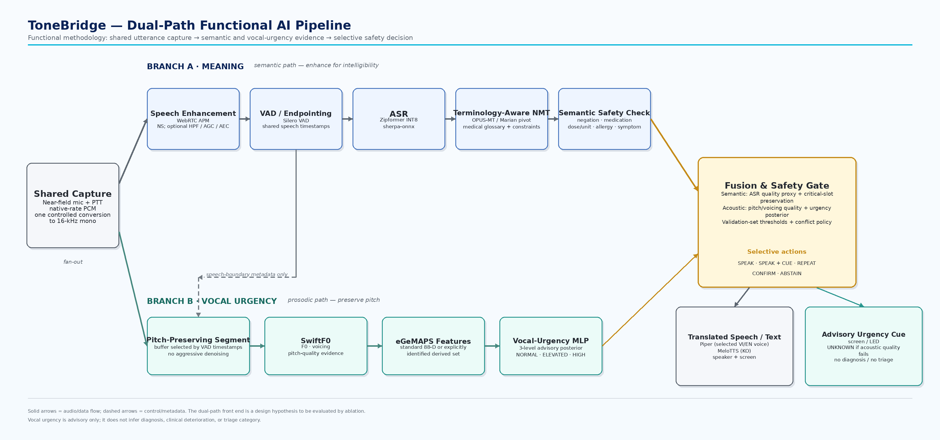
Figure 1. Revised functional pipeline. Solid arrows show audio/data; dashed arrows show timing/control metadata. Translation and urgency are gated independently.
4.2 Module-by-Module Design
Module | Model / Framework | Size / Status | Latency Target | Key Technique
Capture / SRC | Android Oboe/AAudio + C/C++ | Platform component | Low-latency path | Native-rate capture → one 16-kHz conversion
Speech enhancement | WebRTC APM | Platform library | <10 ms/frame target | NS; optional HPF/AGC/AEC only where required
VAD / endpointing | Silero VAD ONNX | Small model; exact package measured W1 | <10 ms/frame target | Shared speech timestamps for both branches
ASR | Zipformer INT8, sherpa-onnx | Candidate pack ~80–120 MB/lang; pin W1 | <450 ms tail target | QNN/HTP target; CPU fallback
NMT | OPUS-MT / Marian pivot + glossary | Checkpoint-dependent; exact assets pin W1 | <600 ms total pivot target | Neural inference + CPU tokenization/constrained decoding
Semantic safety | Critical-slot preservation logic | Rules / lightweight NLP | <50 ms target | Negation, medication, dose/unit, allergy, symptom
Pitch / voicing | SwiftF0 | 95,842 parameters reported by authors [7] | Concurrent; before output decision | F0, voicing, pitch-quality evidence
Acoustic features | eGeMAPS / explicit derived set | No neural model | Concurrent | Standardized utterance-level descriptors
Vocal urgency | Compact MLP | <1 MB design target | <10 ms target | 3-level advisory posterior + UNKNOWN via gate
Fusion | Selective rule/confidence layer | No neural model | <10 ms target | SPEAK / CUE / REPEAT / CONFIRM / ABSTAIN
TTS | Pinned Piper VI/EN voice + MeloTTS KO | Voice-dependent; pin before release | <400 ms first-audio target | CPU baseline; accelerator only after profiling

4.3 On-Device Optimisation & Memory Management
- Model-specific acceleration, not blanket NPU mapping. ONNX Runtime QNN can use Qualcomm HTP, but HTP requires supported operators, fixed shapes, and quantized models; unsupported or control-flow-heavy parts remain on CPU [8].
- Zipformer ASR is the primary QNN/HTP target because sherpa-onnx documents a Qualcomm QNN deployment path [9]. NMT neural kernels are accelerator candidates, while tokenization and constrained decoding remain CPU control logic.
- SwiftF0, eGeMAPS, the urgency MLP, and TTS use CPU baselines first. They are moved to HTP only if conversion compatibility and profiling show a net latency/power benefit.
- Direction-gated loading, memory-mapped assets, streaming ASR, and release of inactive language packs target a resident working set below 1.5 GB on the challenge MVP. This remains a target until measured.
- The active Piper runtime/voice and MeloTTS assets are version-pinned before release; the archived MIT Piper implementation and current GPL successor must not be treated as the same licensing artifact [10], [11].
4.4 Robustness, Safety & Edge-Case Handling
The dual-path front end is a design hypothesis to be evaluated by ablation. Aggressive enhancement is permitted only in the Meaning branch; the Vocal-Urgency branch receives the least-modified corresponding segment. If VAD fails, the system requests repetition rather than evaluating mismatched segments. If ASR quality is weak, the gate requests a repeat. If the Semantic Safety Check detects a missing, contradictory, or uncertain critical slot, automatic TTS is blocked and the user is asked to repeat or confirm. If only pitch/voicing quality is weak, a safe translation may still be spoken while the urgency state becomes UNKNOWN.
Edge Case | Detection / Evaluation | System Behavior
Heavy noise / overlapping speech | ASR quality proxy, VAD instability, SNR slice | Repeat/abstain; do not force translation
Negation or dosage mismatch | Critical semantic-slot preservation check | Block TTS; request confirmation/repetition
Low pitch/voicing quality | SwiftF0 quality evidence | Translation may proceed; urgency = UNKNOWN
Rapid or truncated speech | Endpoint timeout / incomplete ASR | Request repeat
OOV clinical term | Glossary hit/miss + semantic check | Constrained terminology if available; otherwise confirm
Runtime/model failure | Watchdog + inference exception | CPU fallback or safe error state
Network activity detected | Airplane-mode / runtime traffic verification | Release gate fails; offline claim withheld

4.5 Evaluation Framework & Success Metrics
Layer | Metrics / Protocol | Provisional Challenge Target
ASR | WER and CER by language; clean / 10 / 5 / 0 dB | WER ≤15% clean, ≤20% at 10 dB, ≤25% at 5 dB, ≤35% at 0 dB; targets, not results
Translation | BLEU/COMET secondary; terminology and safety-slot preservation primary | ≥95% medical-term preservation; target ≥99% negation and dosage/unit preservation on controlled safety set
Vocal urgency | Accuracy, Precision, Recall, Macro-F1, per-class F1, confusion matrix, abstain rate | Through 5 dB: Macro-F1 ≥0.80 and high-urgency Recall ≥0.90; otherwise widen UNKNOWN/disable cue
End-to-end | ASR tail, NMT, semantic check, fusion, TTS, p50/p95 total | p50 ≤1.5 s; p95 <2.0 s after endpoint on fixed ≥100-utterance test
Robustness | SNR, hospital-like backgrounds, available accents/dialects, code-switching, rapid speech, silence, OOV terms | Report sliced performance; no aggregate score may hide a failed safety slice
System | Peak RSS, model-load time, thermal state, network activity | Resident working set <1.5 GB target; zero required network calls

If a target is missed, the result is reported as measured rather than preserving the target as an achieved claim. Safety-critical phrase classes may be restricted, the abstention region widened, the urgency cue disabled, or the runtime moved to a smaller/CPU-first configuration.
4.6 Vocal-Urgency Data Strategy
The project does not claim access to a clinically validated Vietnamese/Korean emergency-urgency corpus. For the challenge, the MLP is framed as vocal-urgency/distress estimation. The planned data protocol uses controlled, consented adult recordings of scripted medically relevant but non-patient utterances, with instructed vocal-urgency labels and reproducible noise augmentation. Train/validation/test splits are speaker-disjoint to reduce speaker leakage. If speaker diversity or label quality is insufficient within six weeks, the urgency branch remains experimental and the gate returns UNKNOWN more aggressively rather than presenting overfit performance as clinical evidence.
5. Hardware & Device Concept

5.1 Platform Selection & Justification
Criteria | Option A — Snapdragon 712 Phone | Option B — QCS6490 Target | Selected?
Compute | Kryo 360 + Hexagon 685; no official comparable TOPS figure used | 8-core Kryo 670 + Hexagon 770; up to 12 dense TOPS [12] | A for MVP / B for target
Availability | On-hand physical device | Requires target module/dev kit | A
Runtime path | Android + ORT CPU/XNNPACK baseline; accelerator support profiled separately | Android/Linux + QNN/HTP + ORT CPU fallback | Both, by phase
Memory / storage | Phone-dependent; measured on device | Up to 16 GB LPDDR5; UFS supported [12] | B target
Form factor | Handheld phone; screen useful for debug/evaluation | Wearable/handheld product concept | A now / B later

The challenge prototype remains on the physical Snapdragon 712 phone because it is available immediately and supports end-to-end measurement. The product-oriented architecture targets QCS6490 because Qualcomm documents heterogeneous edge compute, Android/Linux support, Kryo 670, Hexagon 770, and up to 12 dense TOPS [12]. QCS6490 execution placement in this proposal is therefore a target deployment mapping, not evidence that every model has already been profiled on that SoC.
5.2 Key Hardware Components & Power Budget
The table below is a product-concept budget, not a measured badge BOM. Final power and battery sizing are frozen only after the target board, microphone front end, and measured inference duty cycle are known.
Component | Specification / Requirement | Power Status | Notes
SoC module | QCS6490-class target module | TBD by selected module; measured during product phase | CPU + HTP active only when required
Microphone front end | 2–3 near-field MEMS; capture at native rate | TBD by selected codec/mic | Directionality/beamforming is optional, not assumed
Speaker / audio out | Mono speaker or headset; local TTS | TBD | Playback only after safety gate approval
Battery | Capacity not frozen | Sized from measured active/idle duty cycle | Product requirement: ≥8 h; not yet demonstrated
Storage | 32–64 GB UFS/eMMC class | Low relative contribution | OS + models + glossary + local non-content logs
Controls / indicators | PTT + recording indicator + urgency LED/screen | Low | Urgency indicator remains advisory
Display | Phone screen for MVP; optional in product | Phone-dependent | Useful for transcript, timing, and safety state during challenge

5.3 MVP versus Product Scope
The six-week challenge deliverable is the measured Android phone MVP. A screen-free or low-UI wearable is a post-challenge product direction. Badge dimensions, weight, antimicrobial housing, battery life, ingress protection, and regulatory classification remain future engineering decisions and are not presented as achieved properties.
6. System Architecture & Integration

6.1 Software Stack
Layer | Component / Framework | Role
OS / Audio I/O | Android MVP; Kotlin + C/C++ / Oboe | PTT/session state, native-rate capture, resampling, local output
AI Runtime | ONNX Runtime; QNN EP where compatible; CPU/XNNPACK fallback | Model-specific heterogeneous inference
Audio Processing | WebRTC APM + Silero VAD; SwiftF0 + eGeMAPS | Enhancement/endpointing and pitch/prosody processing
Model Serving | sherpa-onnx Zipformer; OPUS-MT/Marian; urgency MLP; TTS | ASR, NMT, urgency, and speech synthesis
Safety Layer | Critical semantic-slot checker + Fusion & Safety Gate | Selective decision and output gating
Local Store | Model packs, tokenizer assets, glossary, thresholds, model/version metadata | Offline reproducibility and release control

6.2 Target QCS6490 Architecture
Figure 2 is a deployment view of the same methodology shown in Figure 1; it is not a second pipeline. Solid arrows denote audio/data transfer, while dashed arrows denote control, evidence, or scheduling. Execution tags indicate intended targets only. ONNX Runtime QNN/HTP is used for compatible, quantized, fixed-shape graphs, while CPU/XNNPACK remains the validated fallback [8].
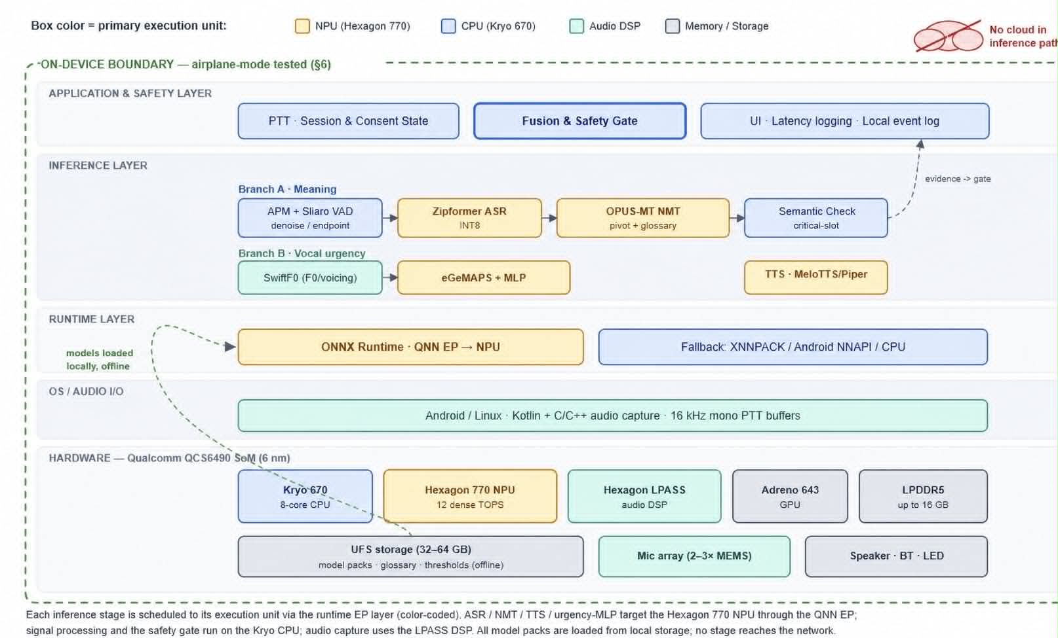
Figure 2. Revised target-QCS6490 deployment architecture. Hardware annotations represent intended execution targets subject to compatibility testing and profiling.
6.3 Offline-First, Recording Consent & Clinical-Safety Workflow
1. User initiates PTT; the device visibly or audibly indicates active capture.
2. Recording/processing consent and session state are checked before capture proceeds.
3. Audio is processed locally through both branches; no cloud service is part of the required inference path.
4. The Meaning branch generates transcript/translation; the Vocal-Urgency branch generates acoustic evidence.
5. The Semantic Safety Check verifies critical-slot preservation before the Fusion & Safety Gate evaluates all evidence.
6. Low ASR quality, semantic mismatch, or conflict triggers repeat, confirmation, or abstention. Low acoustic quality alone yields urgency UNKNOWN.
7. Only approved outputs reach TTS/text or the advisory urgency cue.
8. Raw audio is not retained by default in challenge mode. Local logs are limited to non-content evaluation metadata where possible.
9. ToneBridge never claims to replace a clinician/interpreter and does not perform autonomous diagnosis, treatment recommendation, or clinical triage.
This project-level recording workflow is not presented as legally sufficient medical informed consent in every jurisdiction. Institution-specific privacy, interpreter, safety, and regulatory requirements remain deployment dependencies.
6.4 Risk & Mitigation
Risk | Impact | Detection | Mitigation | Fallback
ASR error under noise | High | ASR quality proxy; WER/CER by SNR | Enhancement/VAD tuning; noise augmentation | Repeat / abstain
Negation / dosage loss | Critical | Semantic-slot preservation check | Glossary + independent post-NMT check | Block TTS; confirm
Translation ambiguity | High | Semantic/NMT evidence | Restrict domain; terminology constraints | Rephrase / repeat
False urgency cue | Med–High | Precision/F1; acoustic quality | Quality gate + conservative threshold | UNKNOWN / disable cue
Missed high vocal urgency | High for advisory value | High-class Recall | Recall-oriented threshold; monitor sliced results | Never rely diagnostically
Runtime/model failure | High | Watchdog / inference exception | Validated CPU fallback | Safe error state
QNN incompatibility | Medium | W1 conversion/operator test | CPU/XNNPACK baseline | Defer accelerator mapping
Battery/thermal issue | Medium | Power/temp logging | Duty-cycle loading; smaller model path | Low-power/text-first mode
Consent/privacy state invalid | Critical | Session state / network-storage audit | Disable capture; local-only design | No recording
License conflict | High | Pinned asset audit | Replace or isolate incompatible dependency | Block release

7. Team Profile & Project Timeline

7.1 Team Members
Name | Role | Expertise | Contribution Area
Khải | Team Lead / On-Device Audio & Systems | Dual-path audio, Android/QNN integration | Integration, latency, safety-gate ownership, feasibility/risk
Chi | Data & Acoustic / Vocal Urgency | Noise data, pitch/prosody, eGeMAPS | Urgency data protocol, Branch B, WER/CER QA support, recording consent
Trí | ML — NMT | OPUS-MT/Marian, terminology constraints | Medical glossary, pivot NMT, negation/semantic safety check
Thịnh | ML — ASR | Zipformer, INT8, noise augmentation | VI/KO ASR, WER/CER, robustness, ASR quality gate
Tân | ML — TTS | Piper/MeloTTS, local synthesis | TTS integration, fallback output, voice/runtime license pinning
Bảo | Deployment / Provisioning | Device config, logging, offline runtime | Session state, watchdog, local logs, offline verification

These are project responsibilities, not claims of professional clinical, legal, or regulatory expertise. External clinical/interpreter and regulatory review remains a post-challenge dependency.
7.2 Six-Week Execution Plan
Week | Deliverable | Measurable Milestone | Dependency / Risk | Fallback
1 | Baseline + asset freeze | Run ASR baseline; pin exact checkpoints/licenses; test QNN conversion on target candidates | Checkpoint availability / QNN operator coverage | CPU/XNNPACK baseline; replace incompatible asset
2 | Acoustic/data pipeline | Reproducible SNR mixer; VAD endpoints; first speaker-disjoint urgency data | Insufficient speaker diversity | Keep urgency experimental / widen UNKNOWN
3 | NMT + semantic safety | Pivot NMT + glossary + negation/dose/drug/allergy/symptom checker | Pivot quality / terminology mismatch | Restrict phrase classes; require confirmation
4 | Urgency + Fusion | Train/evaluate MLP; implement selective gate and five actions | Poor Recall/F1 | Disable cue or expand abstention region
5 | Phone integration | Physical-device latency, RSS, thermal, airplane-mode/network tests | Latency or memory over budget | Smaller models; text-first output; CPU profiling
6 | Fixed evaluation + demo freeze | Complete robustness matrix; ≥100-utterance latency test; documentation and demo | Unmet target | Report measured result; no feature creep

8. References

[1] World Health Organization, “Risks in ambient work environment,” Health-sector occupational hazards guidance, stating that noise in most rooms where patients are treated/observed should not exceed 35 dB. https://www.who.int/tools/occupational-hazards-in-health-sector/risks-in-ambient-work-environment
[2] M. C. H. et al., “The Effectiveness of the Interventions to Reduce Sound Levels in the ICU: A Systematic Review,” reporting ICU averages commonly up to 55–70 dBA and peaks above 80 dBA, 2023. https://pmc.ncbi.nlm.nih.gov/articles/PMC10047617/
[3] G. Tang, P. Rönchen, R. Sennrich, and J. Nivre, “Revisiting Negation in Neural Machine Translation,” Transactions of the Association for Computational Linguistics, vol. 9, pp. 740–755, 2021, doi:10.1162/tacl_a_00395.
[4] E. Hasler, A. de Gispert, G. Iglesias, and B. Byrne, “Neural Machine Translation Decoding with Terminology Constraints,” Proc. NAACL-HLT, pp. 506–512, 2018.
[5] Android Developers, “Low latency audio,” Oboe/AAudio guidance: use the natural device sample rate or Oboe sample-rate conversion. https://developer.android.com/games/sdk/oboe/low-latency-audio
[6] F. Eyben et al., “The Geneva Minimalistic Acoustic Parameter Set (GeMAPS) for Voice Research and Affective Computing,” IEEE Transactions on Affective Computing, vol. 7, no. 2, pp. 190–202, 2016, doi:10.1109/TAFFC.2015.2457417.
[7] L. Nieradzik, “SwiftF0: Fast and Accurate Monophonic Pitch Detection,” arXiv:2508.18440, 2025. The paper reports 95,842 parameters and evaluates noise robustness; ToneBridge does not reuse its latency as a device measurement.
[8] Microsoft, “ONNX Runtime Qualcomm QNN Execution Provider,” official documentation describing HTP backends, quantization, fixed-shape requirements, supported operators, profiling, and CPU fallback. https://onnxruntime.ai/docs/execution-providers/QNN-ExecutionProvider.html
[9] k2-fsa, “sherpa-onnx Qualcomm NPU (QNN/HTP) Build,” official deployment documentation. https://k2-fsa.github.io/sherpa/onnx/qnn/build.html
[10] rhasspy/piper, archived MIT-licensed Piper repository; development moved in 2025. https://github.com/rhasspy/piper
[11] Open Home Foundation Voice, “piper1-gpl,” active Piper successor, GPL-3.0-or-later. https://github.com/OHF-Voice/piper1-gpl
[12] Qualcomm Technologies, “Dragonwing QCS6490,” official product information: 8-core Kryo 670, Hexagon 770, up to 12 dense TOPS, Adreno 643, LPDDR5 support. https://www.qualcomm.com/internet-of-things/products/q6-series/qcs6490
[13] MyShell, “MeloTTS,” official documentation: multilingual local TTS including Korean; MIT software license. https://docs.myshell.ai/technology/melotts
[14] snakers4, “Silero VAD,” official repository and ONNX examples supporting speech timestamp generation. https://github.com/snakers4/silero-vad
[15] Y. Geifman and R. El-Yaniv, “Selective Classification for Deep Neural Networks,” Advances in Neural Information Processing Systems 30, 2017, establishing reject/abstain-style selective classification as a reliability trade-off.

