To do a graph display in Protege, we need to...

1. Open Graph display tab.

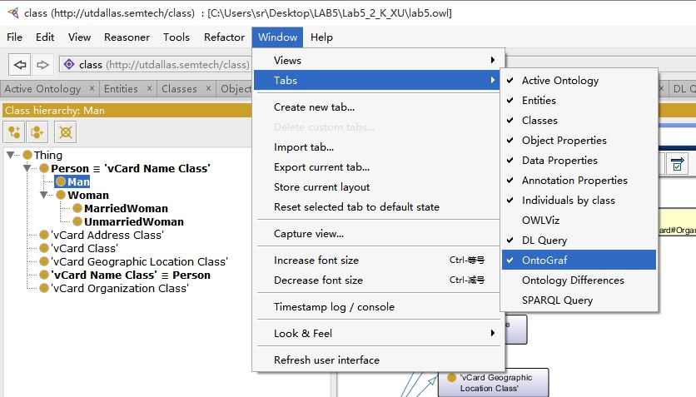

1. select a proper display mode and that’s done, we can also export this graph as an image by using this tab.

