LEGAL CONTRACT
ANALYZER
Machine Learning-Based Legal Contract Review SaaS
━━━━━━━━━━━━━━━━━━━━━━━━━━━━━━━━━━━━
FINAL PROJECT DOCUMENTATION
Prepared By | Kainat Arshad
Project Name | Legal Contract Analyzer
Project Type | ML-Based SaaS / Legal Technology
Current Phase | Final Phase - Post-Completion Enhancements, Evaluation, QA, and Submission
Date | July 20, 2026

Document Control
Item | Details
Document title | Legal Contract Analyzer - Project Documentation
Purpose | To document the design, implementation, testing, evaluation, and current status of the Legal Contract Analyzer.
Intended audience | Academic supervisor, examiner, software reviewer, project stakeholder, or future developer.
Technology domain | Legal technology, machine learning, natural language processing, OCR, and SaaS development.
Editing guidance | Replace bracketed placeholders, add screenshots, and update dates or metrics if the system changes.

Declaration and Disclaimer
This project provides automated contract analysis and general legal information. It is not a substitute for advice from a qualified lawyer. Model predictions, risk levels, recommendations, and generated answers should be reviewed by a legal professional before they are used for legal, financial, or contractual decisions.

Executive Summary
The Legal Contract Analyzer is an ML-based software-as-a-service prototype designed to assist users in reviewing legal contracts, with a current specialization in lease, rent, tenancy, and related commercial agreements. The application accepts PDF contracts, extracts selectable text, applies optical character recognition to scanned pages, cleans and segments the content into legal clauses, predicts clause risk, assigns legal clause categories, detects missing information, stores results, and supports contract-specific legal questions.
The system is implemented as a client-server application. A React/Vite frontend provides an interactive review workspace, while a modular FastAPI backend coordinates validated PDF uploads, document extraction, OCR, text cleaning, clause segmentation, machine-learning inference, deterministic legal validation, SQLite persistence, retrieval-augmented generation (RAG), and Gemini-powered question answering. The backend is divided into routers, services, database, and schema packages so that responsibilities are isolated and the application entry point remains small and maintainable.
Final Prototype Status
Frontend, modular backend, validated PDF upload, selective OCR, clause segmentation, risk classification, hybrid clause-type classification, missing-field detection, Gemini Q&A, SQLite history, contract reopening, deletion, proper HTTP status handling, and global exception handling are operational. The prototype is suitable for academic demonstration and further product development.

Key Outcomes
- A complete end-to-end legal contract review workflow was implemented.
- The clause classifier was improved from a 41.21% external accuracy baseline to 53.33% using a hybrid ML and rule-based approach.
- Mixed-document extraction was verified on a 103-page PDF, using selectable text on 102 pages and OCR on one page without OCR failure.
- A professional frontend presents summaries, clause cards, risks, missing information, saved contract history, and focused legal Q&A.
- Project assets were organized into active models, final datasets, evaluation reports, archived development files, and reproducibility scripts.
The backend was refactored from a large single file into routers, services, database, and schema modules. Upload limits and safe HTTP error handling were added to reduce denial-of-service and stability risks.
Contract-specific Q&A was upgraded from full-contract prompt stuffing to clause-aware RAG using SQLite chunk storage, TF-IDF retrieval, cosine-similarity ranking, top-source selection, and visible evidence snippets.
Post-completion workflow features were added: clause-level plain-English explanation, PDF/DOCX report export, and clause-level contract comparison with risk deltas.
A DistilBERT classifier was implemented and tested on the frozen 330-clause set. The reduced CPU feasibility run achieved 6.06% accuracy, so the existing 53.33% hybrid classifier was retained based on objective evaluation.

Table of Contents
In Microsoft Word, click inside this section and use References > Table of Contents to insert an automatic table of contents after final editing.
1. Introduction
2. Problem Statement and Objectives
3. Scope and Functional Requirements
4. System Architecture and Workflow
5. Backend Design and Implementation
6. Machine Learning Methodology

6.11 Transformer Fine-Tuning Experiment
A DistilBERT sequence-classification pipeline was implemented as a controlled experiment to determine whether a transformer should replace or augment the character TF-IDF classifier. The experiment reused the established 22-class label mapping, the existing train/validation/test splits, and the untouched frozen 330-clause external evaluation set.
The uploaded datasets were validated before training: 6,486 combined rows, 5,041 training rows, 749 validation rows, 696 test rows, 22 training labels, 330 external evaluation clauses, zero duplicate clause-label pairs, and zero normalized text overlap between training and external evaluation.
Model / experiment | Accuracy | Macro F1 | Weighted F1 | Decision
Character TF-IDF | 50.00% | 44.67% | 49.74% | Retained baseline
Current hybrid ML + rules | 53.33% | 46.86% | 53.13% | Production classifier
DistilBERT CPU feasibility run (0.2 epoch) | 6.06% | 2.61% | 4.48% | Not adopted
Table 12: Transformer feasibility experiment compared with the production classifiers
The result does not establish the upper limit of transformer performance because the model was severely undertrained. It does establish that this specific local feasibility model should not be integrated. The stronger and smaller hybrid classifier remains the production model, while full multi-epoch GPU training or a legal-domain pretrained transformer remains optional future research.
The reduced-duration run used a maximum sequence length of 96 on CPU and trained for approximately 0.20 epoch because of local time and hardware constraints. It reached 6.06% external accuracy, 2.61% Macro F1, 4.48% Weighted F1, and approximately 5.38% average confidence. The saved model occupied about 1.02 GB and required approximately 103-120 milliseconds of CPU inference per clause.
7. Frontend Design and User Experience
8. Database and API Design
9. Testing and Evaluation
10. Project Phases and Current Status
11. Limitations, Ethics, and Future Work
12. Installation and Demonstration Guide
13. Screenshot Checklist
14. Conclusion
Appendices

1. Introduction

1.1 Project Background
Legal contracts are often lengthy, repetitive, and written using specialized terminology. Manual review can require substantial time and legal expertise, particularly when a reviewer must identify risky obligations, missing terms, termination conditions, payment requirements, or unusual liability provisions. The Legal Contract Analyzer was created to reduce this initial review burden by combining document processing, machine learning, legal rules, and a legal-domain conversational assistant.

1.2 Project Definition
The Legal Contract Analyzer is an ML-based legal contract review SaaS agent. It is not designed as a general-purpose chatbot. Its primary function is to process legal contract PDFs and return structured analysis that helps users understand contract clauses, risk levels, missing fields, affected parties, and recommended review actions.

1.3 Target Documents
- Lease agreements
- Rent agreements
- Lease deeds
- Commercial tenancy agreements
- Residential tenancy agreements
- Month-to-month leases
- Short-term rental agreements

1.4 Core Technologies
The project integrates machine learning, legal rules, PDF processing, OCR, large language model assistance, persistent storage, and a web interface. The principal technologies are summarized below.
Layer | Technologies
Frontend | React.js, JavaScript, CSS, Vite, Fetch API
Backend | Python, FastAPI, Uvicorn, Pydantic, python-dotenv
Document processing | PyMuPDF/fitz, Tesseract OCR, pytesseract, Pillow
Machine learning | scikit-learn, pandas, joblib, TF-IDF, Logistic Regression
LLM integration | Gemini API using gemini-2.5-flash-lite
Persistence | SQLite database (contracts.db)
Development and testing | VS Code, Windows Command Prompt, virtual environment, Swagger UI, Postman

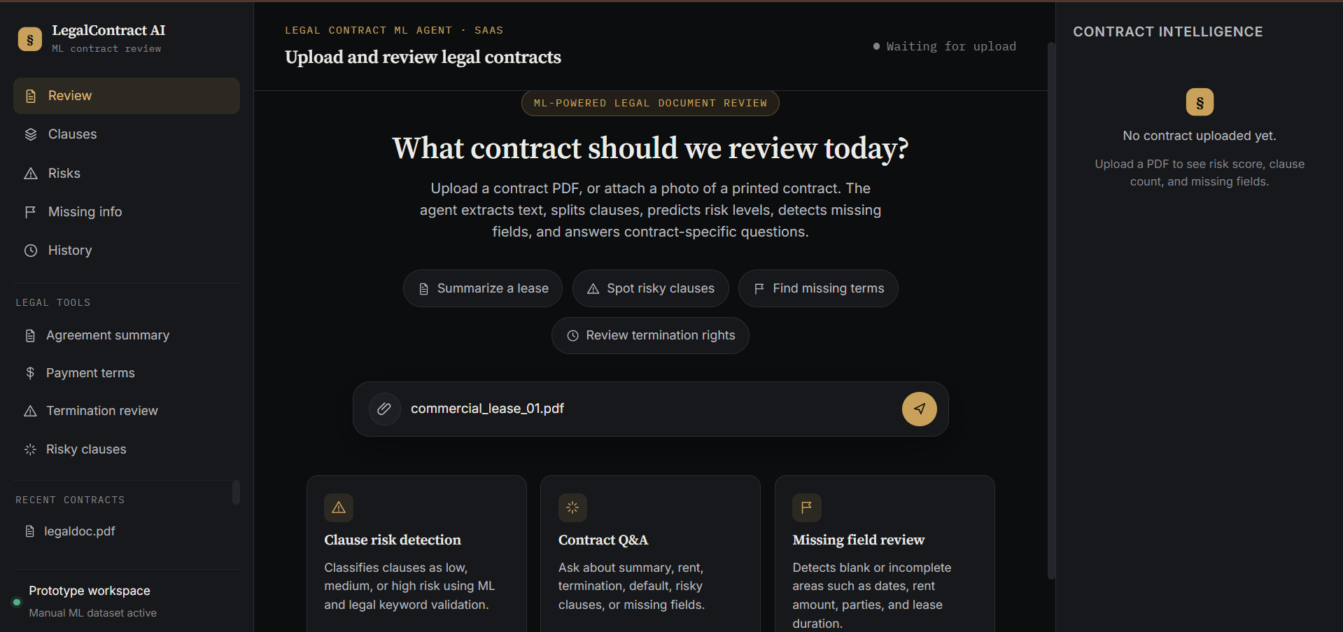
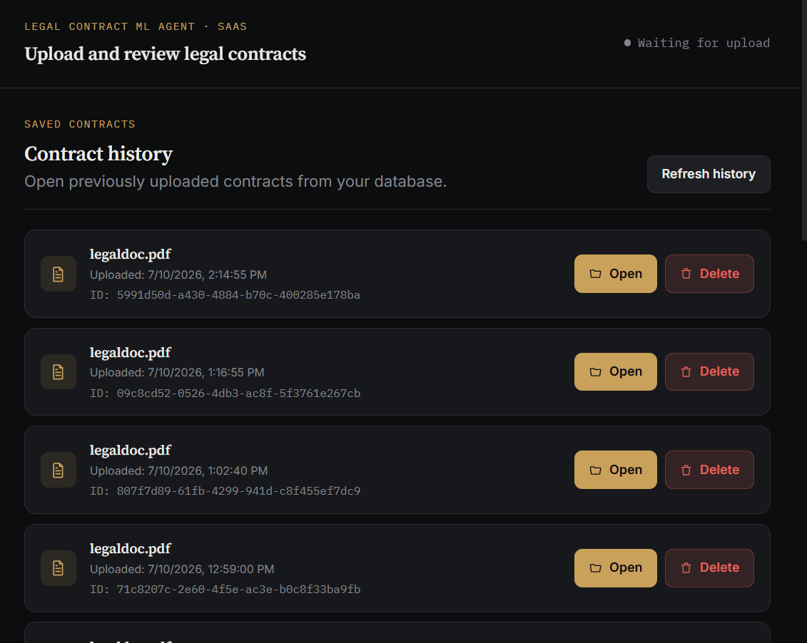
Figure 1: Legal Contract Analyzer home or upload screen

2. Problem Statement and Objectives

2.1 Problem Statement
Traditional contract review is time-consuming and can be inconsistent when performed without a structured checklist. Non-lawyers may struggle to identify legal risks, while legal professionals may spend significant time locating repetitive information. A practical system is therefore needed to extract, structure, classify, and summarize contract content while remaining transparent about uncertainty and the limits of automated legal analysis.

2.2 Main Aim
The main aim is to develop an intelligent legal contract analysis platform that can process lease-related documents and provide structured, explainable, and searchable results through a web application.

2.3 Project Objectives
- Accept legal contract PDFs through a user-friendly frontend.
- Extract selectable text and apply OCR only to pages that require it.
- Clean extracted text and preserve meaningful legal clause structure.
- Classify clause risk as Low, Medium, or High.
- Classify clauses into one of 22 legal categories.
- Combine ML predictions with high-precision legal rules.
- Detect missing contract details and unfilled placeholders.
- Identify the party primarily affected by a clause.
- Generate practical recommended review actions.
- Store contracts and analyses persistently in SQLite.
- Allow contract-specific and general legal Q&A through Gemini.
- Evaluate model performance on a frozen real-world test dataset.

2.4 Success Criteria
- A complete PDF can be uploaded and analyzed without manual preprocessing.
- Scanned and mixed PDFs are processed with OCR metadata.
- The frontend displays summaries, risk levels, clauses, missing fields, and recommendations.
- Saved contracts can be reopened and deleted.
- The ML and hybrid systems can be compared using reproducible evaluation metrics.
- The assistant rejects unrelated non-legal questions and avoids inventing contract terms.

3. Scope and Functional Requirements

3.1 In-Scope Features
Feature | Description
PDF upload | Upload and process legal contract PDFs.
Text extraction | Read normal PDF text using PyMuPDF.
OCR fallback | Run Tesseract on pages with insufficient extracted text.
Clause segmentation | Split cleaned text into meaningful legal clauses.
Risk analysis | Assign Low, Medium, or High risk with explanations.
Clause classification | Assign one primary and optional secondary legal categories.
Missing-field detection | Identify absent parties, dates, amounts, duration, and placeholders.
Legal Q&A | Answer questions using the contract and legal-domain constraints.
Contract history | Persist, reopen, and delete analyzed contracts.
Evaluation | Measure baseline, ML-only, rules-only, and hybrid performance.

3.2 Out-of-Scope or Deferred Features
- Providing binding legal advice or replacing a lawyer.
- Guaranteed interpretation across every jurisdiction or contract type.
- Production-grade authentication and role-based access control.
- Payment subscriptions and commercial billing.
- Cloud deployment and multi-tenant scaling.
- Full manual validation of all automatically labeled Phase 5 clauses.
- Advanced multilingual contract support.

3.3 Primary Users
- Individuals reviewing residential lease documents
- Small businesses reviewing commercial tenancy agreements
- Legal students and researchers
- Property managers and administrative staff
- Lawyers using the tool as an initial review assistant rather than a final decision-maker

4. System Architecture and Workflow

4.1 High-Level Architecture
The system follows a client-server architecture. The React frontend sends requests to a lightweight FastAPI application entry point. main.py configures middleware, initializes the database, registers the contract and Q&A routers, and defines the global exception handler. The routers delegate validation, extraction, OCR, text processing, classification, answer building, Gemini communication, and persistence to focused service and database modules.
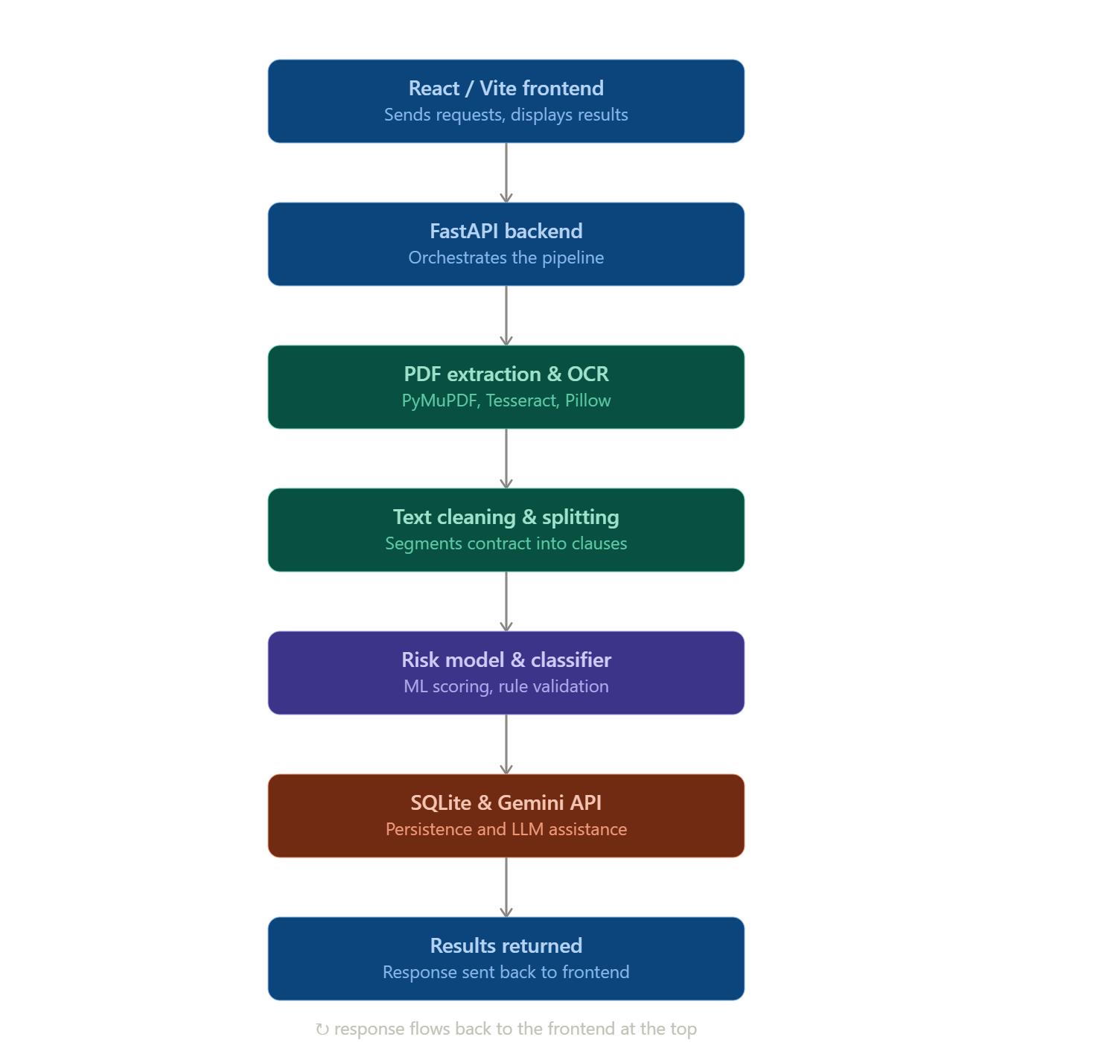
Figure 2: System architecture diagram

4.2 End-to-End Processing Workflow
- The user uploads a PDF contract.
- PyMuPDF attempts to extract selectable text from each page.
- Pages with little or no text are rendered as images and passed to Tesseract OCR.
- Extracted text is normalized and irrelevant template content is removed.
- The cleaned document is divided into legal clauses.
- The risk model assigns Low, Medium, or High risk.
- The clause-type model predicts one of 22 legal categories.
- High-precision legal rules validate or correct distinctive predictions.
- Missing fields, affected parties, reasons, and recommended actions are generated.
- Contract text and analysis are stored in SQLite.
- The frontend displays the structured analysis.
- For open-ended contract questions, the RAG layer retrieves the most relevant stored chunks and sends only those excerpts to Gemini; structured questions continue to use deterministic answer builders.
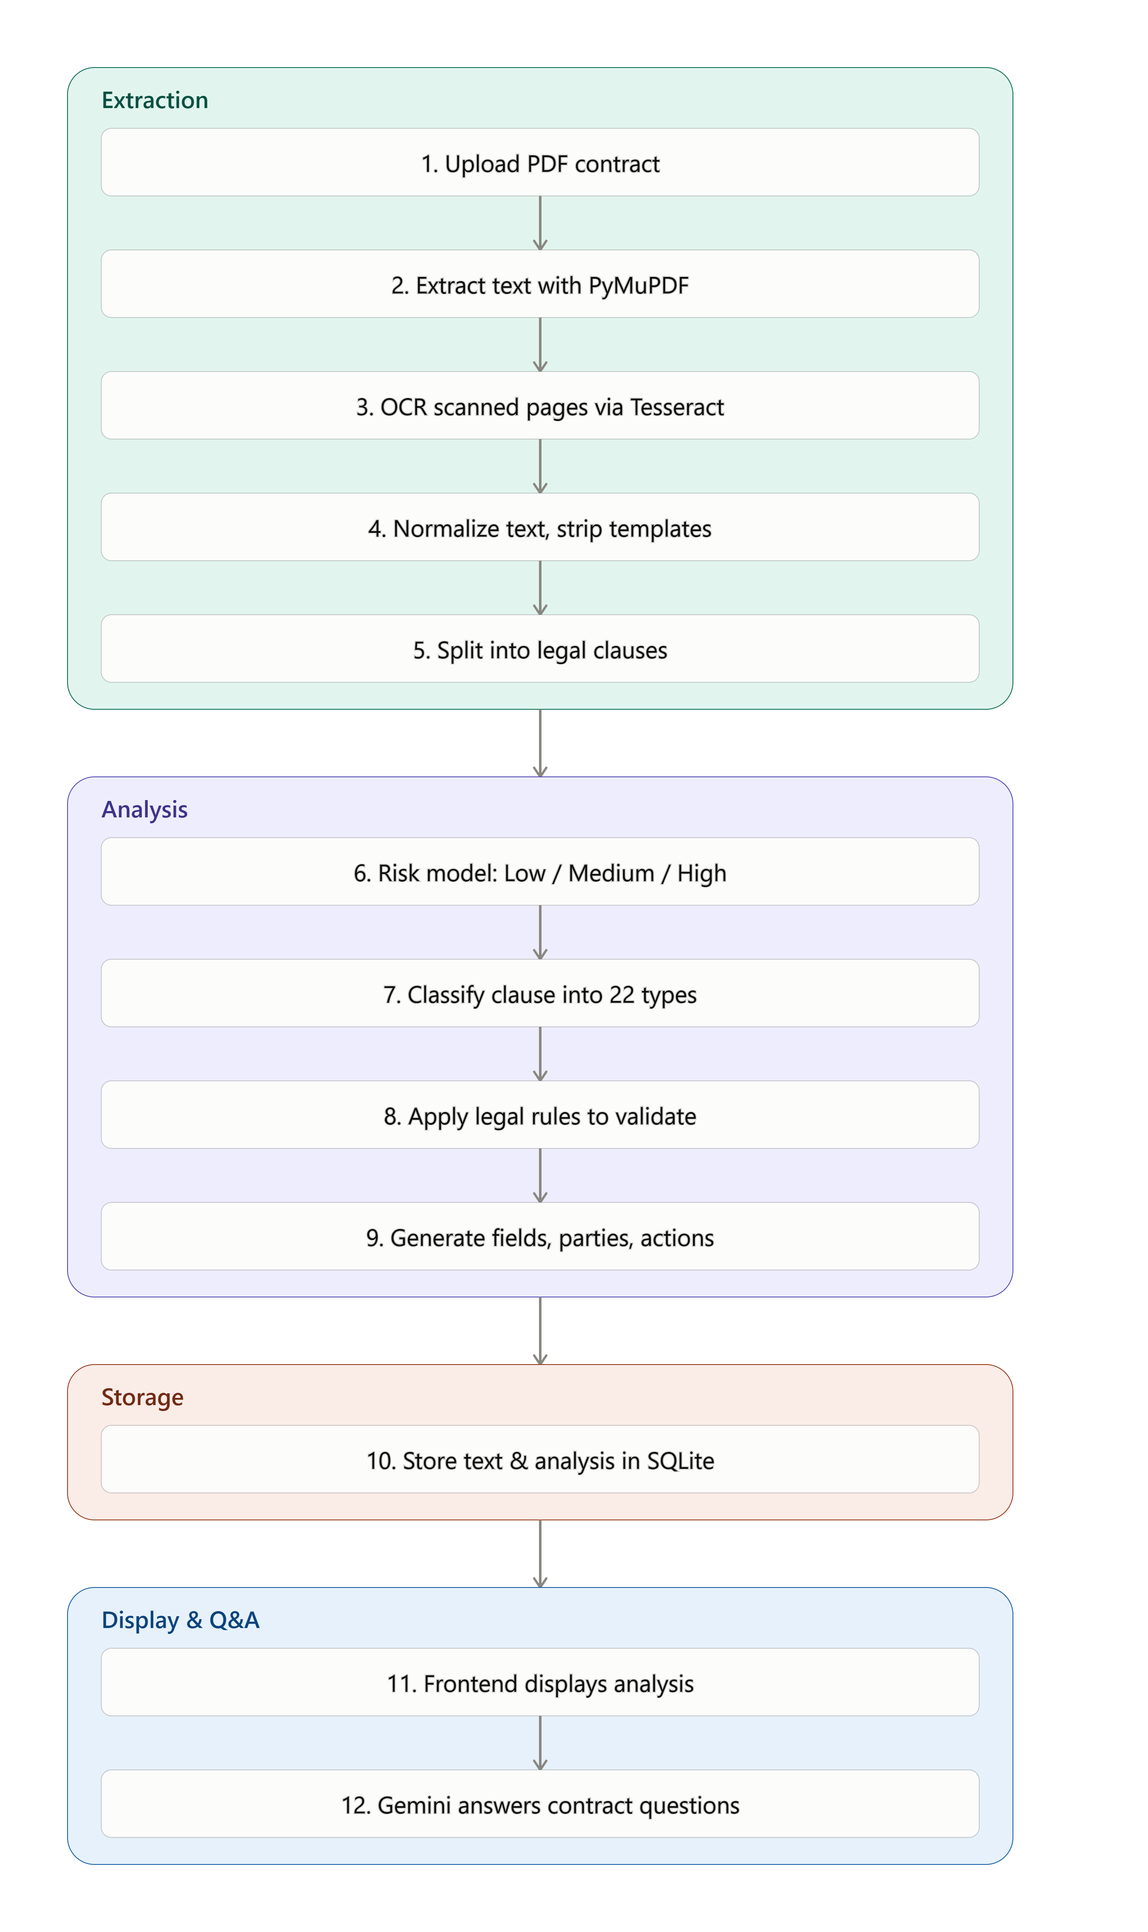

Figure 3: Complete processing workflow

4.3 Confirmed Mixed-PDF Test
Before the final upload-security cap was introduced, a real 103-page PDF was successfully processed using mixed extraction. PyMuPDF extracted text from 102 pages, Tesseract OCR processed one page, and no OCR pages failed. The final backend now applies a configurable page-count limit before OCR begins. The documented default is 100 pages and can be changed using MAX_PDF_PAGE_COUNT for controlled evaluation scenarios.

5. Backend Design and Implementation

5.1 FastAPI Application
FastAPI provides the REST API layer. The final main.py is a compact application entry point that loads environment settings, initializes SQLite, configures CORS, registers routers, and handles unexpected exceptions. Business logic is delegated to modular router and service files rather than concentrated in one large file.
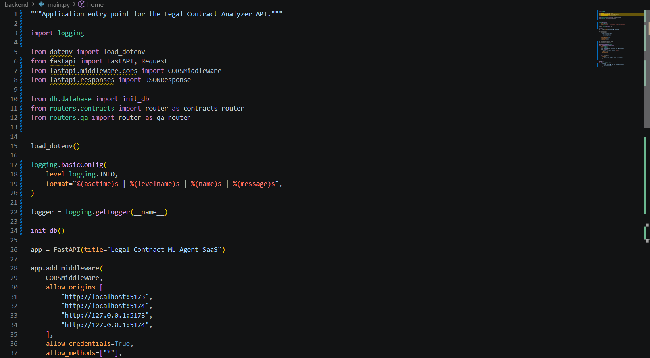
Figure 4A: Lightweight FastAPI application entry point and router registration

5.1.1 Modular Backend Architecture
The final backend separates responsibilities as shown below.
Module | Responsibility
routers/contracts.py | PDF upload, contract listing, retrieval, and deletion endpoints.
routers/qa.py | Contract-specific legal Q&A endpoint.
services/upload_validator.py | File-size, MIME-type, PDF-signature, corruption, and page-count checks before OCR.
services/pdf_extraction.py and services/ocr.py | Selectable-text extraction and page-level Tesseract OCR fallback.
services/text_processing.py | Text normalization, cleaning, previews, and clause segmentation.
services/clause_classifier.py and clause_rules.py | ML prediction and high-precision hybrid clause categorization.
services/risk_analyzer.py | Risk prediction, signals, explanations, affected party, and review actions.
services/contract_analysis.py | Clause analysis coordination and contract field extraction.
services/gemini_client.py | Gemini API configuration and requests.
db/database.py and schemas/qa.py | SQLite persistence and Pydantic request validation.
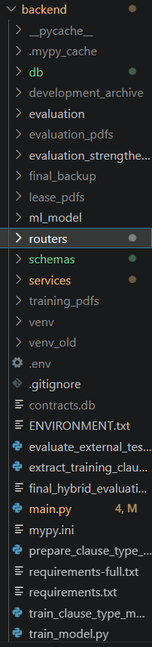 | 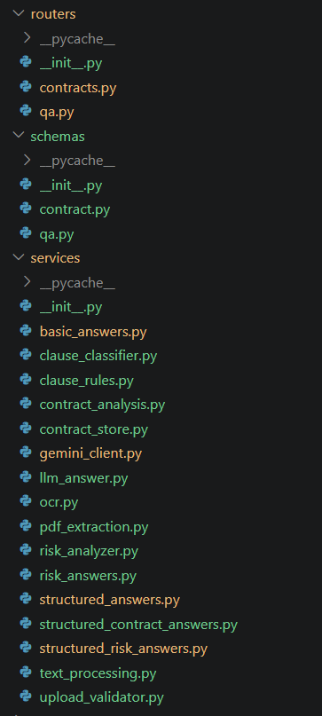
Figure 4B: Final modular backend directory structure and service modules

5.2 PDF Upload Endpoint
The POST /upload-contract endpoint validates the upload before extraction or OCR, then extracts and cleans text, segments clauses, analyzes risk and clause type, stores the record, and returns structured results and extraction metadata.

5.2.1 Upload Security Validation
The upload validator reduces denial-of-service and stability risks by enforcing a maximum file size, validating the PDF MIME type, checking the %PDF- signature, rejecting empty or corrupted documents, and applying a page-count cap before OCR begins. The default limits are 15 MB and 100 pages. They can be changed through MAX_PDF_FILE_SIZE_MB and MAX_PDF_PAGE_COUNT in the environment configuration.
Validation | Behavior
File size | Rejects files above the configured maximum before full processing.
MIME type | Accepts supported PDF MIME types only.
PDF signature | Requires a valid %PDF- signature.
PDF structure | Rejects empty, corrupted, or unreadable documents.
Page count | Rejects documents above the configured cap before OCR.
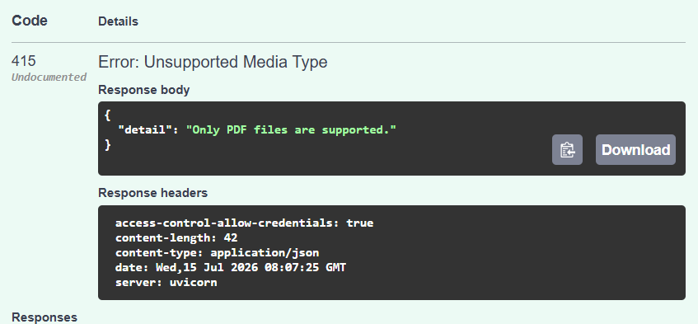
Figure 4C: Non-PDF upload rejected with HTTP 415 Unsupported Media Type
- Contract ID and filename
- Detected contract type
- Overall risk level
- Total and risky clause counts
- Missing fields
- Contract summary
- Per-clause analysis
- Page and OCR extraction metadata

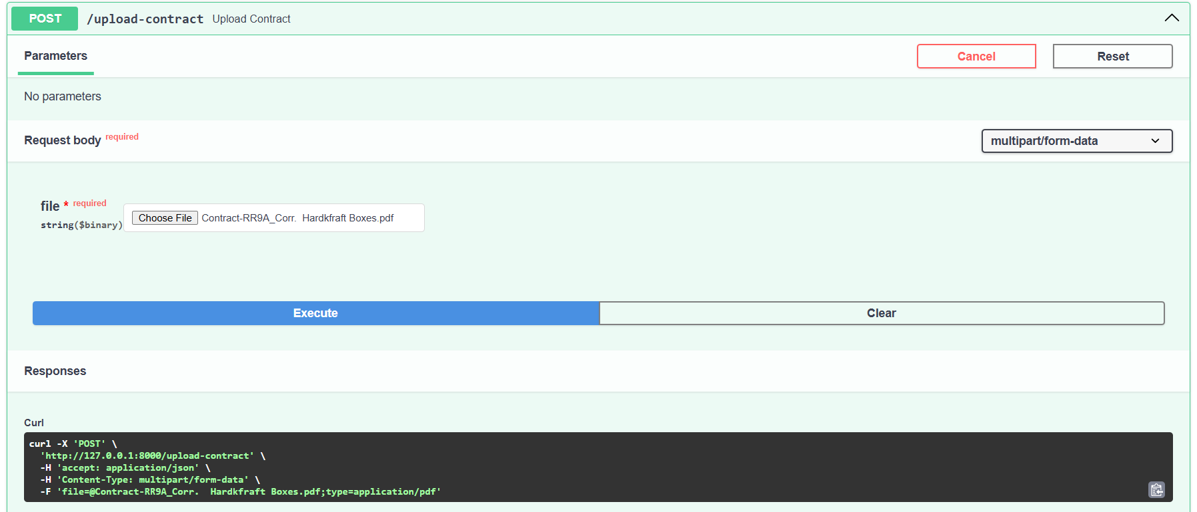
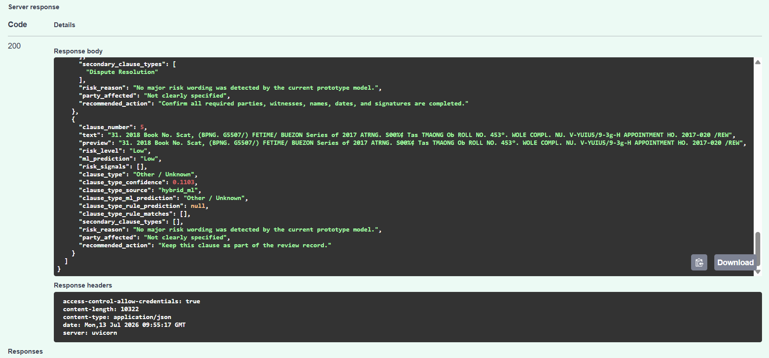
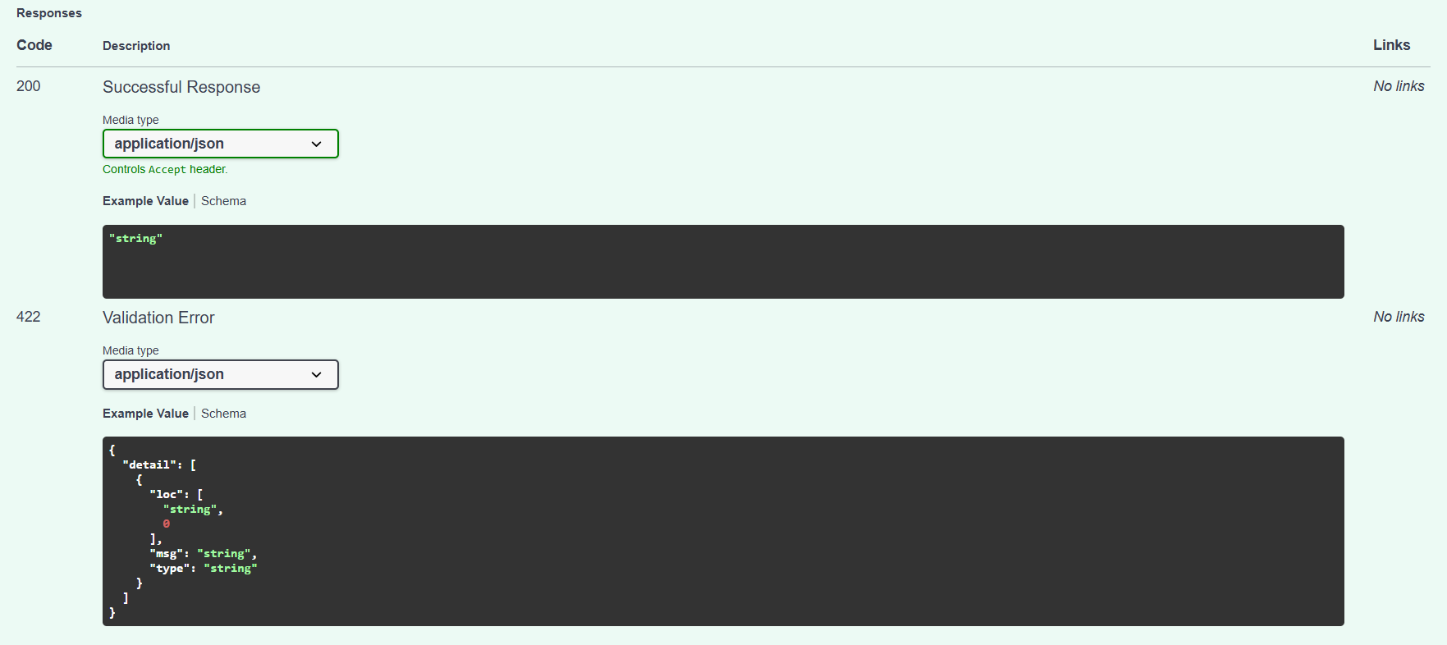
Figure 4: Swagger UI - upload-contract endpoint

5.3 PDF Text Extraction and OCR
PyMuPDF is the default extraction method because it is fast and preserves text from searchable PDFs. The extraction logic checks each page. When a page contains insufficient text, the page is rendered as an image and processed by Tesseract through pytesseract and Pillow. This selective OCR approach avoids the cost of applying OCR to every page.
Extraction value | Meaning
text | All pages were processed using selectable PDF text.
ocr | All pages required OCR.
mixed | The document contained both searchable and OCR-processed pages.

The response reports page_count, text_pages, ocr_pages, and failed_ocr_pages. The installed Tesseract version used during development was 5.4.0.
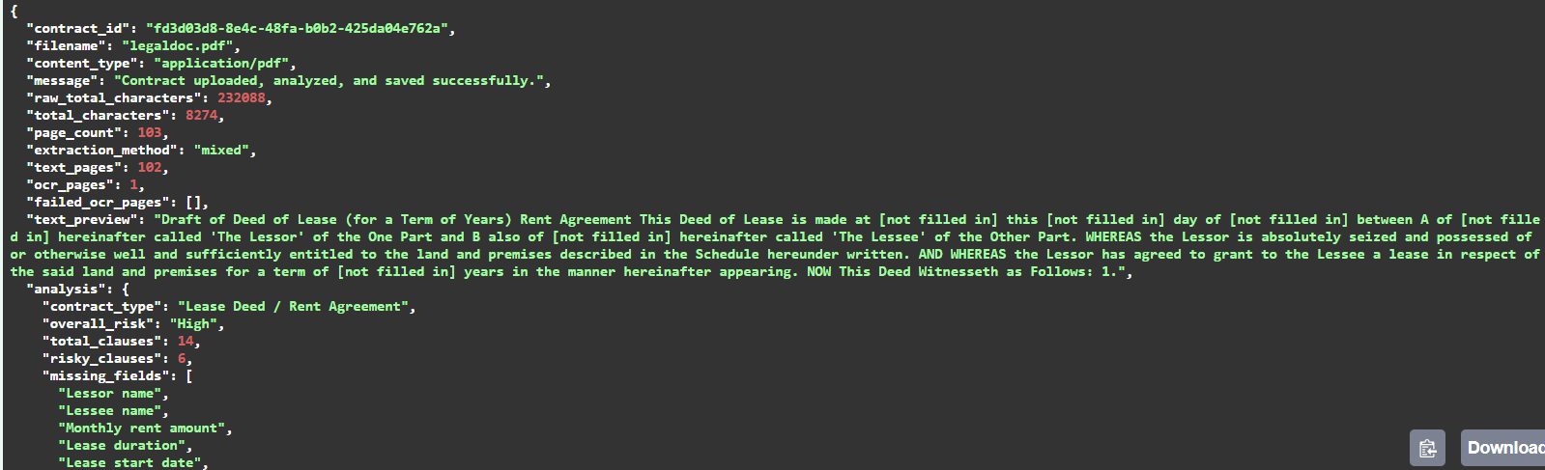
Figure 5: OCR extraction metadata

5.4 Text Cleaning
The text-cleaning layer normalizes spaces and line breaks, removes irrelevant website or template sections, corrects selected extraction errors, generates clean previews, and converts unfilled blanks into readable placeholders. For example, repeated dots or underscores become “[not filled in]”, while incomplete year patterns become “[year not filled in]”.

5.5 Clause Splitting
The clause splitter handles numbered clauses, lettered subclauses, headings, witness sections, schedules, long provisions, duplicate fragments, and broken extraction fragments. Its objective is to preserve complete legal meaning rather than split every sentence independently.

5.6 Risk Classification
A separate supervised model predicts Low, Medium, or High risk. The final risk decision combines the ML prediction with legal keywords and deterministic rules. Indicators include indemnity, unlimited liability, hold harmless, termination, default, arrears, breach, re-entry, penalties, damages, waiver, assignment restrictions, late payment, and legal costs.
- Risk level
- Original ML prediction
- Detected risk keywords
- Human-readable risk reason
- Recommended review action
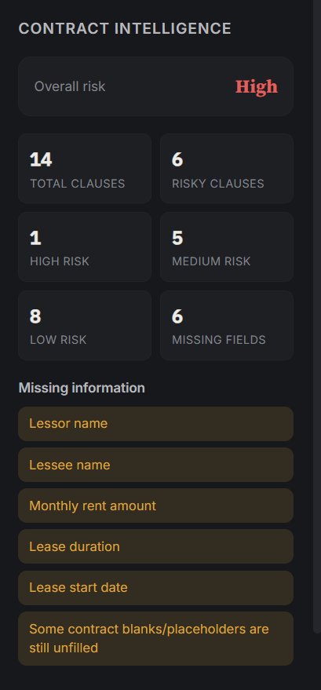
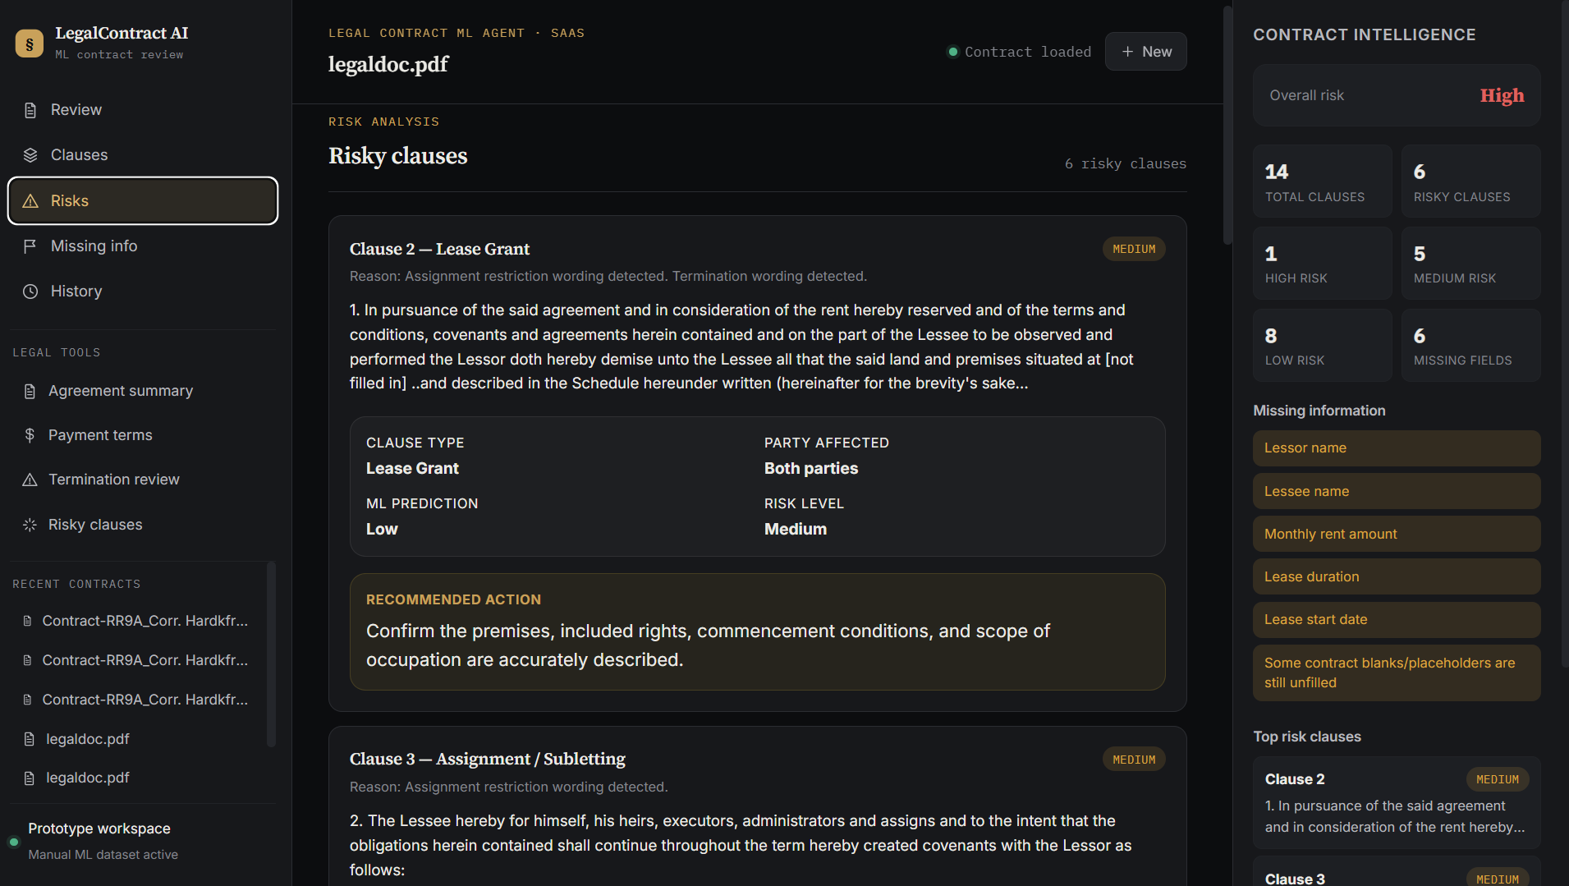
Figure 6: Risk analysis summary

5.7 Clause-Type Classification
Each clause is assigned one primary category from the following 22-class taxonomy. Long clauses may also receive secondary categories.
No. | Clause category | No. | Clause category
1 | Alterations / Improvements | 12 | Payment / Rent
2 | Assignment / Subletting | 13 | Possession / Surrender
3 | Confidentiality | 14 | Property / Premises
4 | Dispute Resolution | 15 | Quiet Enjoyment
5 | General Obligation | 16 | Repairs / Maintenance
6 | Governing Law | 17 | Signature / Execution
7 | Insurance | 18 | Taxes / Utilities
8 | Lease Grant | 19 | Term and Renewal
9 | Liability / Indemnity | 20 | Termination / Default
10 | Notice | 21 | Use of Premises
11 | Other / Unknown | 22 | Warranties / Representations

The clause response includes clause_type, clause_type_confidence, clause_type_source, secondary_clause_types, and the underlying ML and rule predictions when applicable.

5.8 Hybrid ML and Legal Rules
The final classifier uses the character TF-IDF model by default. When model confidence is low and one high-precision legal rule matches, the rule category may be used. Distinctive rules can also override the ML result for categories such as Signature / Execution, Quiet Enjoyment, Assignment / Subletting, Insurance, Liability / Indemnity, Governing Law, Dispute Resolution, and Confidentiality.
The output source is recorded as hybrid_ml or hybrid_rule, which improves traceability and allows the frontend or evaluator to distinguish model decisions from rule corrections.
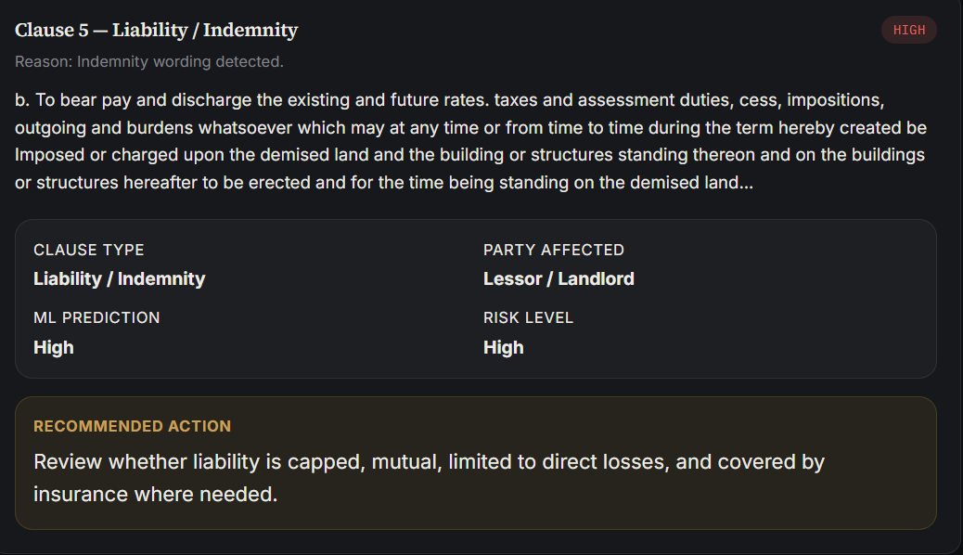
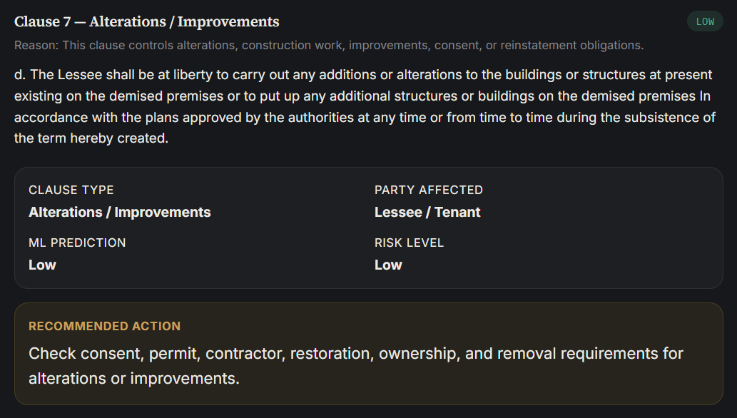
Figure 7: Detailed clause analysis card

5.9 Party-Affected Detection and Recommendations
Legal-party keywords are used to determine whether a clause mainly affects the Lessee/Tenant, Lessor/Landlord, both parties, or is not clearly specified. Each clause also receives a practical review action tailored to its category and risk. For example, a payment clause prompts the reviewer to check the amount, due date, grace period, late fee, interest rate, and payment method.

5.10 Missing-Field Detection
The backend checks for important contract information such as lessor name, lessee name, monthly rent, lease duration, lease start date, and unfilled placeholders. Results are returned through the missing_fields field and displayed in the frontend.
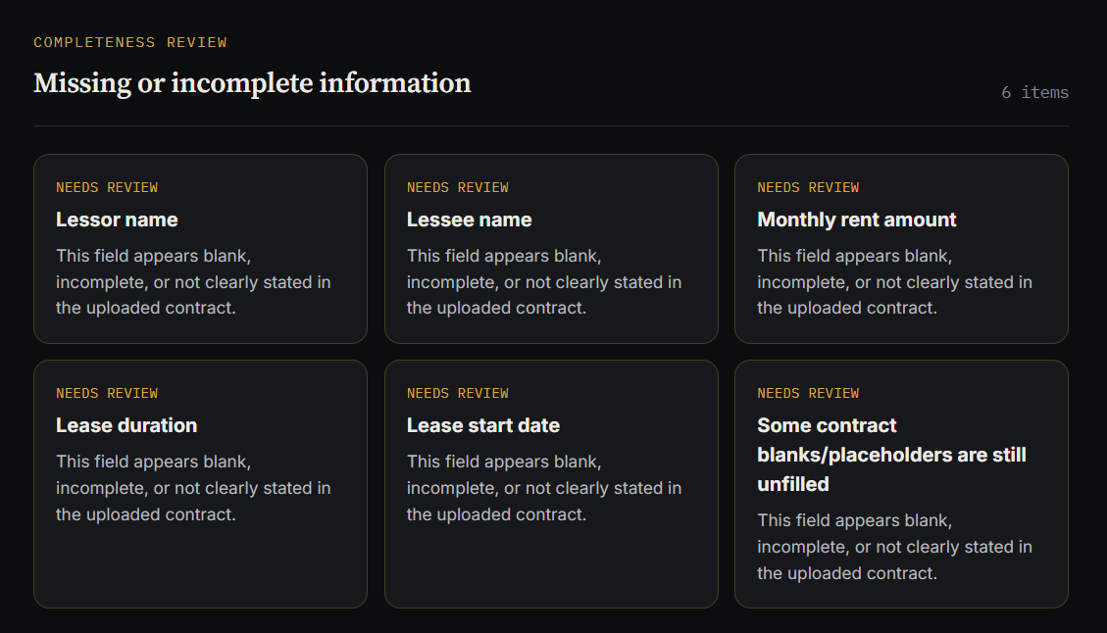
Figure 8: Missing contract information

5.11 Gemini Legal Q&A
The POST /ask-contract endpoint supports deterministic answers for contract summaries, payment terms, termination clauses, risky clauses, and missing information. Open-ended questions use retrieval-augmented generation rather than sending the complete contract to Gemini. The configured model is gemini-2.5-flash-lite through the google-genai package, with fallback support for google-generativeai.
- Use the uploaded contract as the primary source for contract-specific questions.
- Do not invent terms that are not present in the contract.
- State clearly when the contract is silent or evidence is insufficient.
- Reject unrelated non-legal questions.
- Provide a legal-information disclaimer rather than presenting generated text as legal advice.
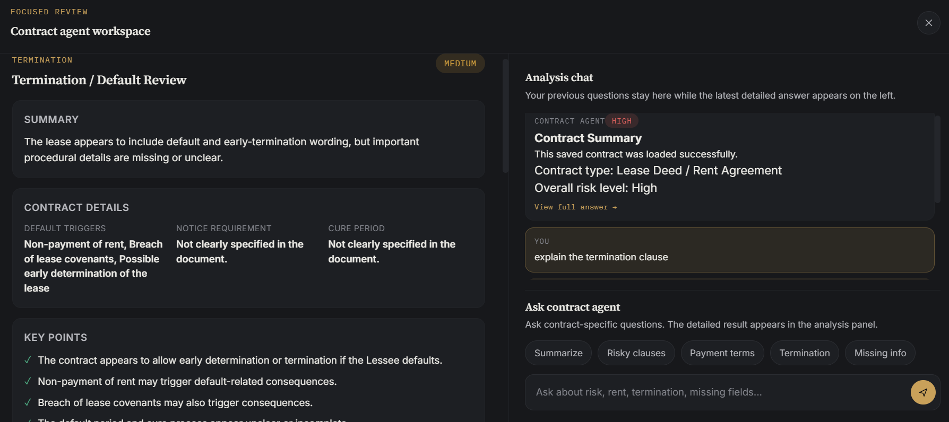
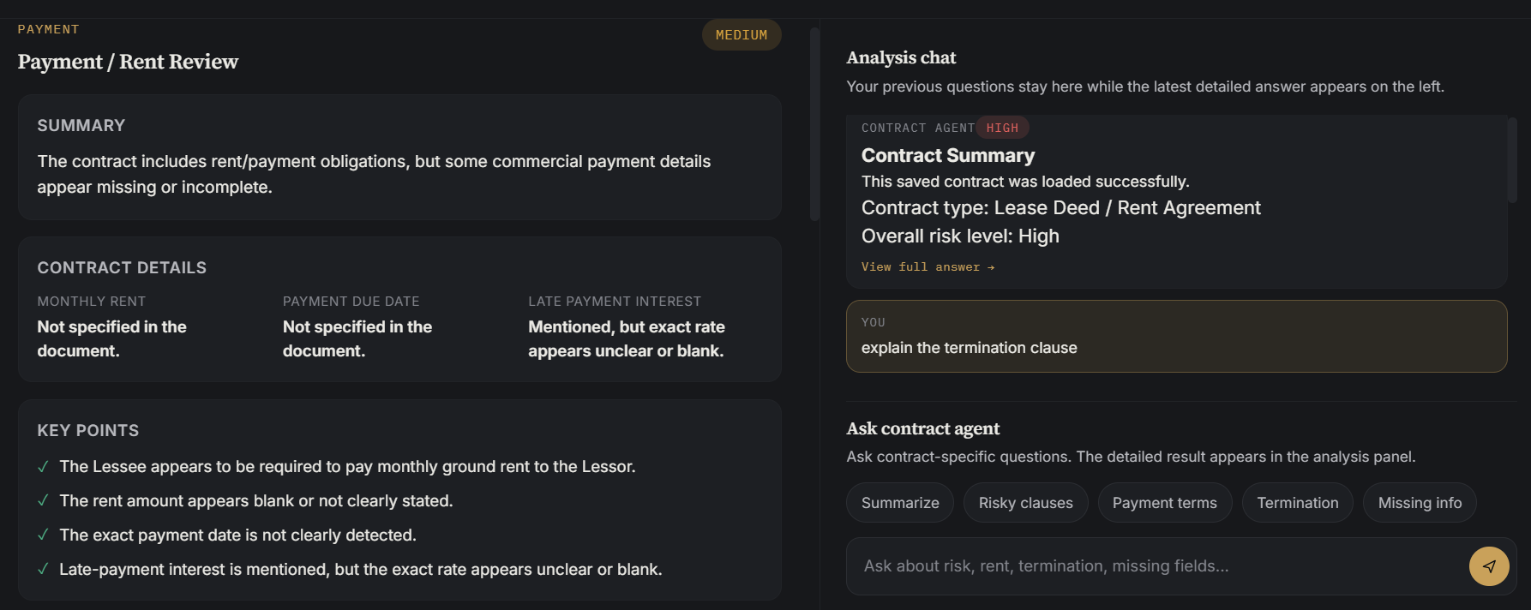
Figure 9: Legal Q&A conversation
Figure 9E: Contract analysis export controls and generated report
Insert screenshot here: show the export controls and one generated PDF or DOCX report.
FIGURE 9E PLACEHOLDER
Users can export the structured contract analysis as a shareable PDF or editable DOCX report. Exports include contract metadata, summary, overall risk, missing fields, clause categories, confidence, risk reasons, affected parties, and recommended actions. Export generation reuses the structured analysis already produced by the backend and does not require re-running model inference.

5.16 PDF and DOCX Analysis Export
Figure 9D: Contract comparison and clause-level risk differences
Insert screenshot here: compare two stored contracts and capture the clause-level differences and risk delta summary.
FIGURE 9D PLACEHOLDER
The frontend can compare two stored contracts at clause level. It aligns related provisions, identifies added, removed, and changed clauses, presents text differences, and reports changes in clause category or risk level. This supports workflows such as comparing a template with a signed agreement or reviewing successive vendor drafts.

5.15 Contract Comparison and Risk Delta
Figure 9C: Low-confidence clause flagged for manual review
Insert screenshot here: show a low-confidence clause card with the manual-review badge and confidence value.
FIGURE 9C PLACEHOLDER
Clause-type predictions now include a confidence label, review threshold, high-confidence threshold, and needs_manual_review flag. Predictions below the review threshold are visibly marked for human review rather than being presented with the same certainty as high-confidence predictions. The production configuration uses a manual-review threshold of 0.55 and a high-confidence threshold of 0.70.

5.14 Confidence-Based Manual Review
Figure 9B: Clause-level Gemini explanation
Insert screenshot here: open one analyzed clause and show the plain-English explanation response.
FIGURE 9B PLACEHOLDER
The /explain-clause workflow sends one selected clause and its structured metadata to Gemini. The explanation is limited to the selected text and returns a plain-English meaning, practical impact, important obligations, and points that may require legal review. This feature does not alter the ML classification or risk score.

5.11.2 Clause-Level Plain-English Explanation
Figure 9A: RAG-grounded legal Q&A with retrieved evidence
Insert screenshot here: ask an open-ended contract question and capture the answer together with the Sources panel showing clause numbers, match percentages, and retrieved snippets.
FIGURE 9A PLACEHOLDER
The Q&A response includes source number, clause number, clause type, similarity score, chunk index, and a source snippet. The React frontend renders these details in a Retrieved Evidence / Sources panel so the user can inspect the evidence used for the answer.
At question time, a TF-IDF vectorizer represents the stored chunks and the user question. Cosine similarity ranks the evidence, the top five chunks above the configured threshold are selected, and only those excerpts are included in the Gemini prompt. This reduces context size and prevents unrelated contract text from overwhelming the answer.
Each analyzed contract is converted into clause-aware chunks. Long clauses are divided with controlled overlap, while clause number and clause type metadata are preserved. Chunks are stored in the contract_chunks SQLite table and can be rebuilt automatically for contracts created before the RAG upgrade.

5.11.1 Retrieval-Augmented Generation

5.12 Type Safety and Static Analysis
Python type hints were extended consistently across the active FastAPI backend and the evaluation scripts. Annotations were added to database functions, PDF and OCR processing, clause splitting, risk and clause-type prediction, contract analysis, structured response builders, and API route handlers. Complex objects are represented using typed dictionaries and standard generic types such as list[str], dict[str, Any], tuples, optional values, and explicit return types.

5.13 HTTP Error Handling and Global Exception Safety
The refactored routes use FastAPI HTTPException instead of returning HTTP 200 with an embedded error field. Missing contracts return 404, unsupported uploads return 415, oversized files or excessive page counts return 413, malformed PDFs return 400, and documents with no readable text or clauses return 422. A global exception handler logs unexpected failures and returns a safe generic 500 response without exposing internal tracebacks.
HTTP status | Use in the application
400 Bad Request | Empty, corrupted, or structurally invalid PDF.
404 Not Found | Requested contract ID does not exist.
413 Request Entity Too Large | File exceeds the configured size or page-count limit.
415 Unsupported Media Type | Upload is not a supported PDF or lacks a valid PDF signature.
422 Unprocessable Entity | No readable text or analyzable clauses were extracted.
500 Internal Server Error | Unexpected failure handled by the global exception handler.
Static analysis was performed with mypy using Python 3.13 settings. The final command checked main.py, evaluate_external_test.py, validate_hybrid_clause_model.py, and the evaluation_strengthening package. The completed run reported: “Success: no issues found in 5 source files.” The same files also passed Python byte-code compilation, and the FastAPI application was started successfully after the changes. This confirms that the added annotations improved maintainability without changing runtime behaviour.

6. Machine Learning Methodology

6.1 Risk Dataset and Model
The first ML component was a manually created risk dataset containing legal clauses labeled Low, Medium, or High. TF-IDF vectorization and a supervised text classifier were trained and saved as risk_model.pkl and vectorizer.pkl. The prediction is supplemented by keywords and deterministic rules to provide more explainable risk outcomes.

6.2 Clause-Type Datasets
Dataset | Purpose | Approximate size / status
LEDGAR | General legal provision examples labeled by clause category. | 5,997 examples used.
Lease-specific dataset | Adaptation to rent, commercial lease, residential lease, and lease deed language. | Approximately 330 clauses.
Initial combined dataset | Training source for the 22-category classifier. | 6,327 clauses.
Frozen external evaluation set | Independent, manually reviewed real-world lease clauses; never used for training. | 330 clauses.
Additional Phase 5 lease PDFs | New residential, commercial, month-to-month, deed, short-term, and tenancy examples. | 188 final automatically labeled clauses; provisional.
Final combined dataset | Expanded and deduplicated training collection. | 6,486 rows; 5,041 training rows; 29 duplicates removed.

6.3 Initial Data Split
Split | Rows
Training | 4,874
Validation | 752
Test | 701

6.4 Model Experiments
Three clause-type variants were compared using the frozen external evaluation set. Balanced Logistic Regression was used to reduce the effect of class imbalance.
Model | Features | Accuracy | Macro F1 | Weighted F1
Word model | Word TF-IDF | 43.33% | 37.70% | Not selected
Character model | Character n-gram TF-IDF | 50.00% | 44.67% | 49.74%
Combined model | Word + character FeatureUnion | 48.48% | 40.22% | Not selected

The character n-gram model performed best because it is more robust to legal word variations, archaic drafting, spelling differences, partial phrases, word endings, and OCR noise.

6.5 Hybrid Evaluation
Approach | Accuracy | Macro F1 | Weighted F1
Rules only | 15.76% | 19.10% | 18.44%
ML only | 50.00% | 44.67% | 49.74%
Hybrid | 53.33% | 46.86% | 53.13%

The hybrid system used ML predictions for 288 clauses and rule predictions for 42 clauses. This confirms that rules acted as targeted corrections rather than replacing the ML system.

6.6 Improvement Over Baseline
Approach | Accuracy | Macro F1 | Weighted F1
Original external baseline | 41.21% | 36.49% | 44.89%
Word TF-IDF model | 43.33% | 37.70% | Not primary result
Character n-gram TF-IDF model | 50.00% | 44.67% | 49.74%
Combined word + character model | 48.48% | 40.22% | Not primary result
Final hybrid ML + rules | 53.33% | 46.86% | 53.13%

6.7 Evaluation Integrity
The 330-clause external dataset was frozen and excluded from training. This separation is important because it provides a more realistic measure of generalization. The additional 188 Phase 5 labels were automatically generated using the existing model and rules; therefore, they remain provisional and require manual legal review before production use.

6.8 Per-Class Classification Performance
Aggregate accuracy was not treated as sufficient evidence of classifier quality. The final hybrid classifier was therefore evaluated on the frozen 330-clause external set using per-class precision, recall, F1-score, and support for the complete 22-category taxonomy. Governing Law had zero support in the frozen set and is reported transparently with zero-valued class metrics.
Clause category | Precision | Recall | F1-score | Support
Alterations / Improvements | 0.375 | 0.400 | 0.387 | 15
Assignment / Subletting | 0.917 | 0.846 | 0.880 | 13
Confidentiality | 0.000 | 0.000 | 0.000 | 1
Dispute Resolution | 0.600 | 0.375 | 0.462 | 8
General Obligation | 0.429 | 0.130 | 0.200 | 23
Governing Law | 0.000 | 0.000 | 0.000 | 0
Insurance | 0.857 | 0.632 | 0.727 | 19
Lease Grant | 0.182 | 0.800 | 0.296 | 5
Liability / Indemnity | 0.600 | 0.500 | 0.545 | 12
Notice | 0.889 | 0.242 | 0.381 | 33
Other / Unknown | 0.242 | 0.571 | 0.340 | 14
Payment / Rent | 0.739 | 0.447 | 0.557 | 38
Possession / Surrender | 0.778 | 0.583 | 0.667 | 12
Property / Premises | 0.273 | 1.000 | 0.429 | 3
Quiet Enjoyment | 0.133 | 0.667 | 0.222 | 3
Repairs / Maintenance | 0.694 | 0.862 | 0.769 | 29
Signature / Execution | 0.000 | 0.000 | 0.000 | 8
Taxes / Utilities | 0.571 | 0.727 | 0.640 | 11
Term and Renewal | 0.500 | 0.647 | 0.564 | 17
Termination / Default | 0.595 | 0.714 | 0.649 | 35
Use of Premises | 0.591 | 0.591 | 0.591 | 22
Warranties / Representations | 0.667 | 0.444 | 0.533 | 9
Table 10: Final hybrid classifier per-class performance on the frozen evaluation set
The strongest class-level results were observed for Assignment / Subletting (F1 = 0.880), Repairs / Maintenance (F1 = 0.769), Insurance (F1 = 0.727), Possession / Surrender (F1 = 0.667), and Termination / Default (F1 = 0.649). Lower results were observed for sparse or semantically overlapping categories, including Confidentiality and Signature / Execution, both of which had zero recall on this frozen set. General Obligation also remained difficult because broadly worded duties overlap with several more specific lease categories. These findings show where additional manually reviewed training examples would provide the greatest benefit.

6.9 Confusion Matrix Analysis
A 22 × 22 confusion matrix was produced for the final hybrid classifier. Rows represent the manually reviewed actual categories and columns represent predicted categories. Diagonal cells are correct classifications, while off-diagonal cells show category confusions. The matrix complements accuracy by showing whether performance is distributed across categories or concentrated in a small number of frequent labels.
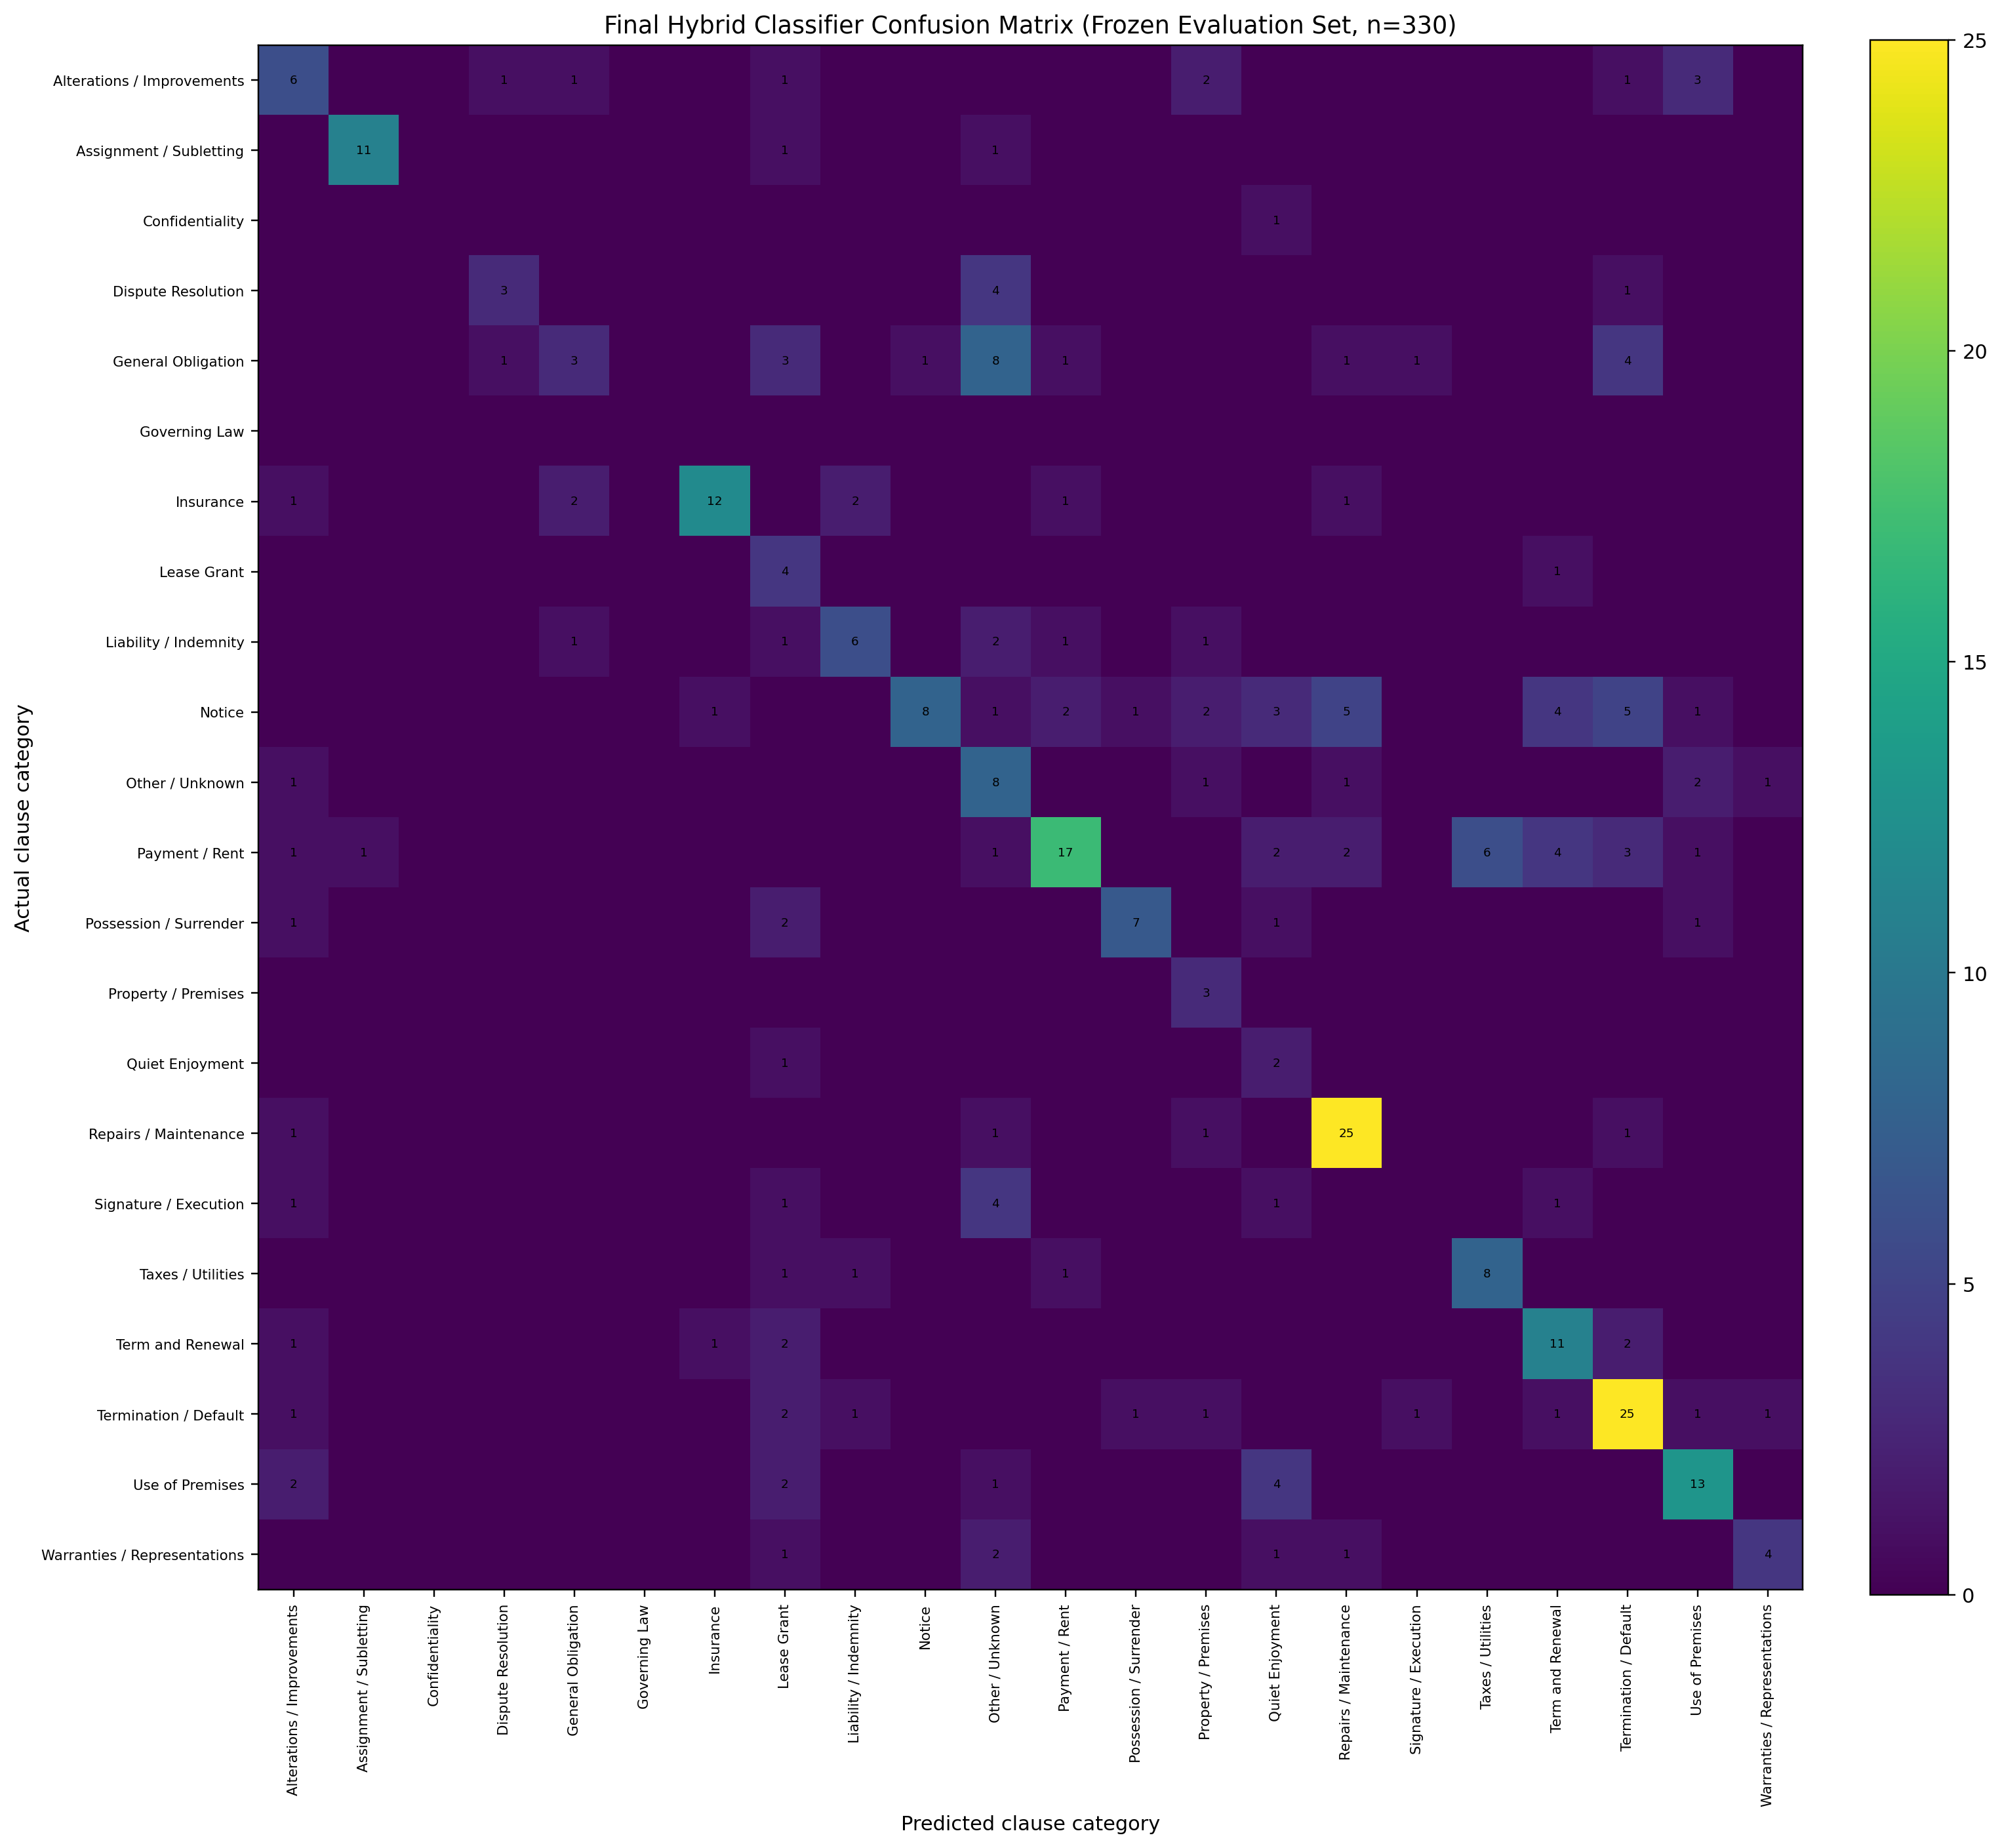
Figure 11: Final hybrid classifier confusion matrix
The matrix indicates that several errors arise from legally related concepts rather than random predictions. For example, broad General Obligation and Other / Unknown clauses can overlap with specific duties; Notice clauses may contain payment, default, or execution language; and Term and Renewal provisions may resemble Termination / Default when expiry or early-ending language appears in the same clause. The matrix therefore supports targeted future improvements through class-specific data collection and rule refinement.

6.10 Phase-5 Label Ablation Study
A controlled ablation study tested whether the 188 provisional Phase-5 automatically labelled lease clauses contributed useful information. Two character TF-IDF Logistic Regression models were trained with identical features, hyperparameters, preprocessing, random seed, class ordering, and frozen evaluation set. The only difference was whether the Phase-5 provisional rows were included in training.
Training configuration | Accuracy | Macro F1 | Weighted F1
Without Phase-5 provisional labels | 46.97% | 42.37% | 47.54%
With Phase-5 provisional labels | 50.00% | 44.67% | 49.74%
Difference (with minus without) | +3.03 pp | +2.30 pp | +2.20 pp
Table 11: Phase-5 provisional-label ablation results
Including the Phase-5 clauses improved accuracy by 3.03 percentage points, Macro F1 by 2.30 points, and Weighted F1 by 2.20 points. The result suggests that the additional lease-domain examples provided useful domain adaptation rather than degrading generalisation. Nevertheless, these labels remain provisional because they were generated automatically and have not been fully audited by a legal expert. They should therefore be manually reviewed before any production deployment or stronger legal-validity claim.

7. Frontend Design and User Experience

7.1 Frontend Stack
The frontend was developed using React.js, JavaScript, CSS, and Vite. It communicates with FastAPI through HTTP requests using the Fetch API.

7.2 Main User Functions
- Upload a contract PDF
- View the uploaded document and contract summary
- See overall risk and missing fields
- Inspect analyzed clauses and legal categories
- Review risk reasons and recommended actions
- Ask contract-specific legal questions
- View saved contract history
- Reopen a previous contract
- Delete a stored contract
Compare two stored contracts and review clause/risk differences
Export the analysis as PDF or DOCX
Request a plain-English explanation for an individual clause
Inspect RAG evidence sources and similarity scores

7.3 Main Interface Sections
Section | Purpose
Contract upload | Select and submit a PDF for analysis.
Contract summary | Display the high-level description, contract type, and key information.
Risk analysis | Show overall risk and risky clause statistics.
Clause analysis | List clause type, confidence, risk, affected party, reason, and action.
Legal Q&A | Allow the user to ask questions about the current contract.
Contract history | Display saved contracts and management actions.
Detailed clause view | Provide expanded legal text and model/rule metadata.

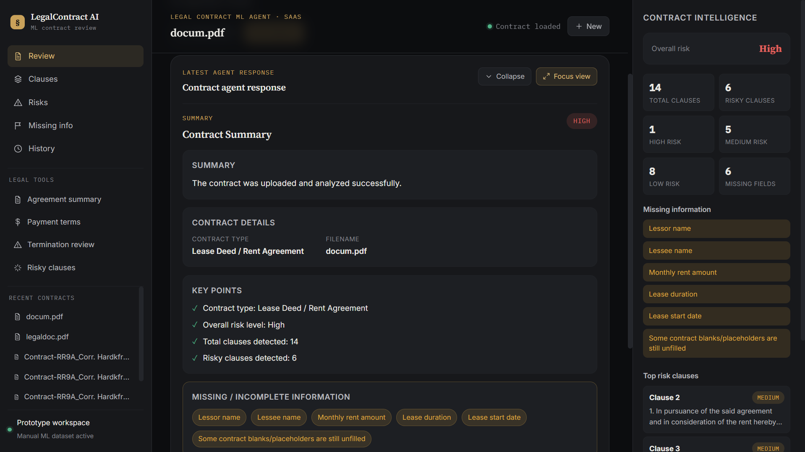
Figure 10: Contract analysis dashboard

7.4 Clause Card Information
- Clause number and text
- Clause preview
- Primary clause type
- Confidence score
- Risk level
- Affected party
- Risk reason
- Recommended action
- Secondary clause types
- ML/rule decision source

7.5 Usability Considerations
The interface should present the most important information first: contract summary, overall risk, missing information, and high-risk clauses. Technical metadata such as confidence and decision source should remain available for transparency without overwhelming a non-technical user. Risk colors should be accompanied by text labels so that meaning does not depend only on color.

8. Database and API Design

8.1 SQLite Persistence
The application uses SQLite through the contracts.db database. Storing the contract text and analysis allows records to remain available after the backend restarts.
- Contract ID
- Filename
- Content type
- Full extracted contract text
- Analyzed clauses
- Structured analysis results
- Creation date
RAG chunks with chunk index, clause number, clause type, and chunk text
Chunks are removed when the parent contract is deleted

8.2 Main API Routes
The public route paths remain stable for frontend compatibility, while their implementations now live in routers/contracts.py and routers/qa.py. Invalid and missing-resource cases use meaningful HTTP status codes rather than returning HTTP 200 with an error object.
Post-completion routes also support clause explanation, contract comparison, and PDF/DOCX report export. Exact paths follow the active router implementation and are consumed by the React frontend.
Method and route | Purpose
POST /upload-contract | Upload, extract, analyze, store, and return a contract.
POST /ask-contract | Answer a legal or contract-specific question.
GET /contracts | Return the list of saved contracts.
GET /contracts/{contract_id} | Return one saved contract and its analysis.
DELETE /contracts/{contract_id} | Delete a saved contract.
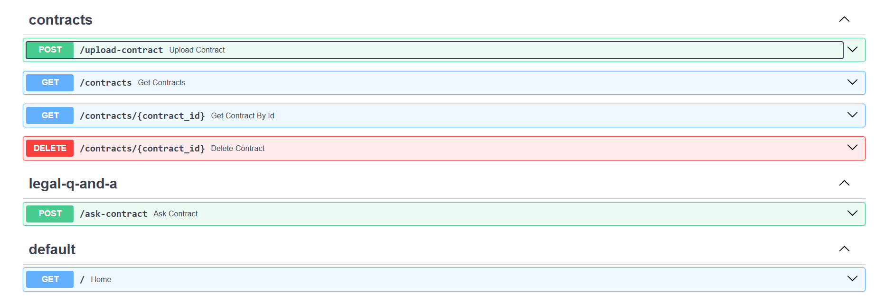
Figure 11A: Swagger UI showing modular contract and legal Q&A routes

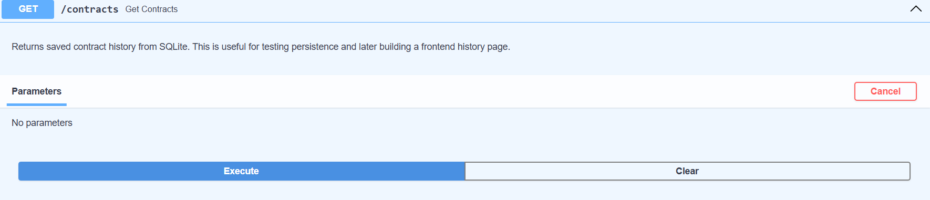
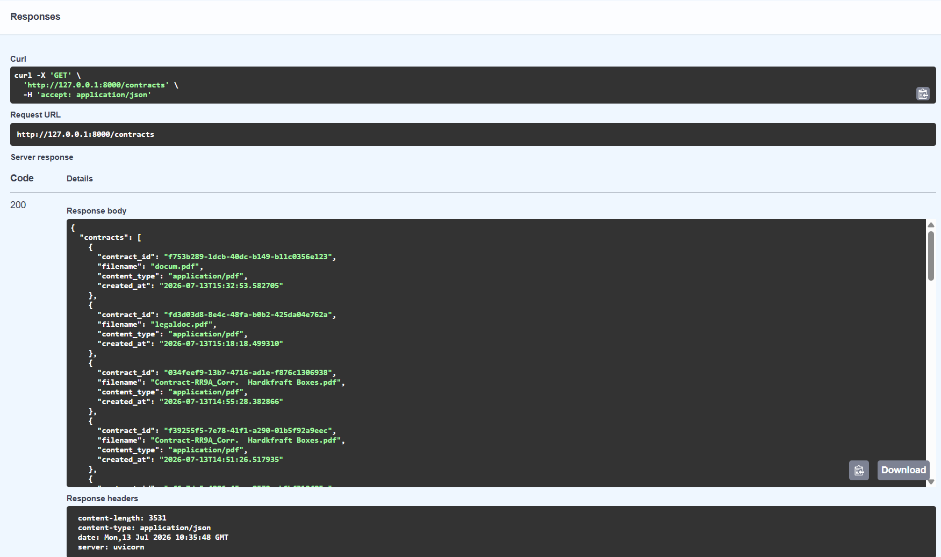
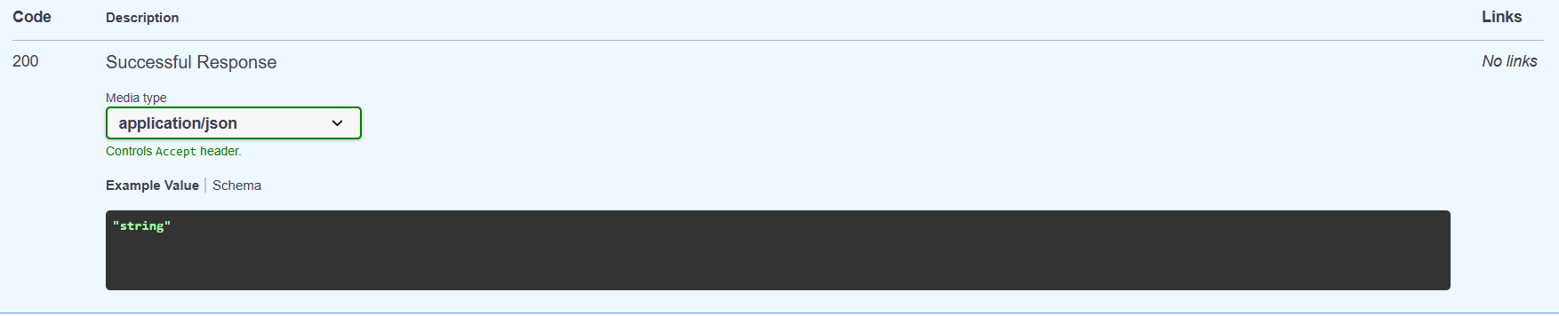
Figure 11: Contracts API or database persistence proof

8.3 Example Structured Response
{
"contract_id": "generated-contract-id",
"filename": "sample_lease.pdf",
"overall_risk": "Medium",
"extraction_method": "mixed",
"page_count": 103,
"text_pages": 102,
"ocr_pages": 1,
"failed_ocr_pages": 0,
"missing_fields": ["lease start date"],
"clauses": [
{
"clause_type": "Termination / Default",
"clause_type_source": "hybrid_rule",
"risk_level": "High"
}
]
}

9. Testing and Evaluation

9.1 Testing Strategy
Testing covered API behavior, modular imports, document extraction, OCR fallback, upload validation, HTTP error responses, contract persistence, frontend/backend integration, model evaluation, and real PDF processing. Valid PDF uploads continued to return HTTP 200 after refactoring, while unsupported uploads returned HTTP 415 before OCR was invoked.

9.2 Functional Test Cases
Test case | Expected result | Status
Upload searchable PDF | Text extracted using PyMuPDF and analysis returned. | Passed
Upload scanned or mixed PDF | OCR applied only where needed and metadata returned. | Passed
Analyze clauses | Risk, type, affected party, reason, and action returned. | Passed
Ask contract question | Answer grounded in contract or states that information is absent. | Passed
Ask unrelated question | Assistant rejects or redirects the non-legal request. | Implemented
Restart backend | Previously stored contracts remain available. | Passed
Delete contract | Selected record is removed from history/database. | Passed
External model evaluation | Metrics and classification report generated on frozen test set. | Passed
Upload non-PDF file | Request is rejected before OCR with HTTP 415. | Passed
Upload file above configured size | Request returns HTTP 413 before extraction or OCR. | Implemented
Upload PDF above configured page cap | Request returns HTTP 413 before OCR. | Implemented
Retrieve or delete missing contract | Request returns HTTP 404 rather than HTTP 200 with an error object. | Implemented
Unexpected backend exception | Failure is logged and a safe HTTP 500 response is returned. | Implemented
Start refactored modular backend | Routers and service modules import; models load and the API starts. | Passed
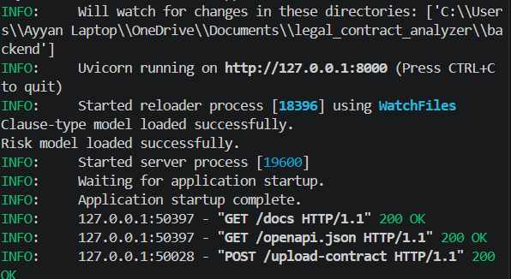
Figure 12A: Successful modular backend startup, model loading, and valid PDF upload

Clause explanation, PDF/DOCX export, and contract comparison were exercised through the frontend and backend. Transformer scripts passed syntax checks, completed training, generated frozen evaluation artifacts, and produced an explicit model-adoption recommendation.
RAG retrieval was tested with contract-relevant and unsupported questions. Relevant questions returned grounded answers with source snippets and similarity metadata; unsupported questions returned an insufficient-context response rather than invented contract content.

9.2.1 Post-Completion Enhancement Tests

9.3 Model Evaluation Results
The original external baseline achieved 41.21% accuracy and 36.49% Macro F1. Character-level retraining improved accuracy to 50.00%, and the final hybrid classifier reached 53.33% accuracy and 46.86% Macro F1. Although the result is suitable for a prototype and demonstrates measurable improvement, it is not sufficient for unsupervised production legal decision-making.
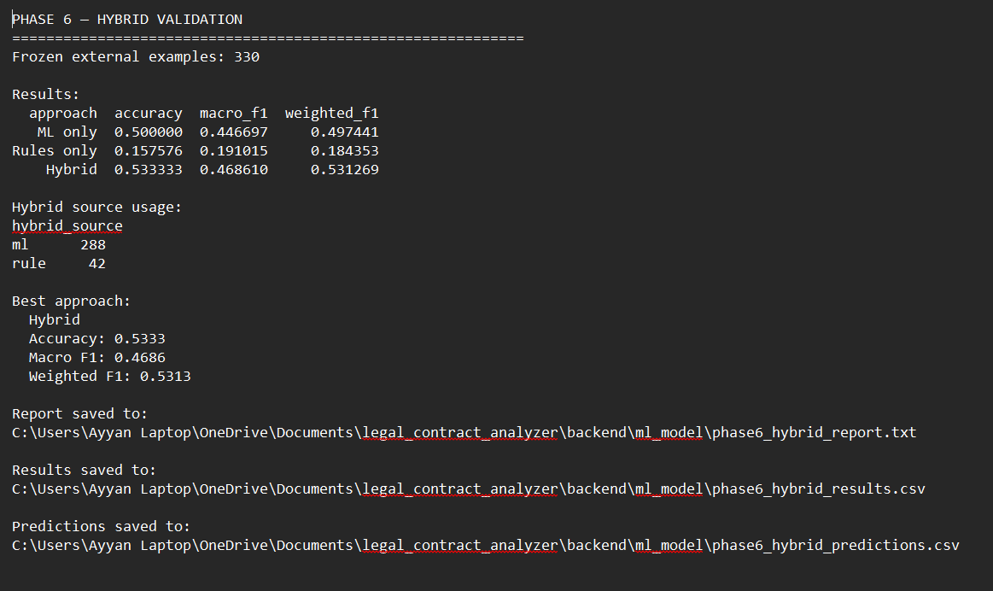
Figure 12: External evaluation terminal output

9.4 OCR Validation
The strongest historical extraction test used a 103-page mixed PDF and reported 102 selectable-text pages, one OCR page, and zero OCR failures. After security hardening, the final system performs configurable size and page-count validation before OCR. The default documented page cap is 100 pages, so larger controlled tests require an explicit environment override.

9.5 Final QA Checklist
- Test upload with at least one searchable PDF.
- Test upload with at least one scanned PDF.
- Test a mixed PDF and verify extraction metadata.
- Confirm all frontend sections render without errors.
- Verify every API route in Swagger UI.
- Verify contract history after restarting the backend.
- Verify deletion and missing-contract handling.
- Ask at least five representative legal questions.
- Check that unrelated questions are rejected.
- Save a final requirements.txt and backup of stable model files.

10. Project Phases and Current Status

Phase | Main work | Status
Phase 1 - SaaS foundation | React frontend, FastAPI backend, PDF upload, analysis/Q&A endpoints, SQLite history, Gemini. | Complete
Phase 2 - Risk model | Manual risk dataset, TF-IDF model, Low/Medium/High labels, rules, reasons, actions. | Complete
Phase 3 - Clause classification | 22 categories, LEDGAR + lease data, Logistic Regression, primary and secondary types. | Complete
Phase 4 - External evaluation | Frozen 330-clause set, predictions, error analysis, baseline report. | Complete
Phase 5 - Dataset improvement | New lease PDFs, extraction, deduplication, provisional labeling, model comparison. | Complete for prototype
Phase 6 - Hybrid validation | High-precision rules, rules/ML/hybrid comparison, integration and API tests. | Complete
OCR enhancement | Selective OCR, Tesseract integration, mixed extraction, metadata, real document test. | Complete
Phase 7 - Final QA and submission | Documentation, modular backend refactor, upload security, HTTP error handling, exception safety, final demonstration, and submission preparation. | Complete
Backend refactoring and security hardening | Routers/services/db/schemas split, upload validation, proper HTTP errors, global exception handling, and line-count reduction. | Complete

After the original seven phases, six targeted enhancements were implemented and evaluated: confidence-based review flags, clause explanation, analysis export, contract comparison, RAG-grounded Q&A, and a transformer classification experiment.

10.0.1 Post-Completion Enhancements
Enhancement | Implementation | Status
Confidence-based flagging | Low/Medium/High confidence labels and needs_manual_review metadata | Complete
Clause-level explanation | Gemini plain-English explanation for a selected clause | Complete
PDF/DOCX export | Shareable structured analysis reports | Complete
Contract comparison | Clause changes and risk deltas between stored contracts | Complete
RAG-based Q&A | SQLite chunks, TF-IDF retrieval, cosine ranking, top-source Gemini context | Complete
RAG source display | Clause metadata, similarity, and snippets in the frontend | Complete
Transformer experiment | DistilBERT feasibility training and frozen external evaluation | Complete; not adopted

10.1 Current System Status
Component | Status
Backend API | Working
Frontend | Working
PDF upload | Working
Text extraction | Working
OCR | Working
Risk classification | Working
Clause classification | Working
Hybrid classifier | Working
Gemini Q&A | Working
SQLite persistence | Working
Contract history | Working
Delete functionality | Working
External evaluation | Complete
Final QA | Complete
Modular backend architecture | Working
Upload size, type, and page validation | Working
HTTPException error responses | Working
Global exception handler | Working

11. Limitations, Ethics, and Future Work

11.1 Current Limitations
- The clause classifier achieves 53.33% external accuracy, so errors and category confusion remain.
- The system is mainly trained and tested on lease-related English-language documents.
- The 188 Phase 5 auto-labels have not received a complete manual legal audit.
- OCR quality depends on scan resolution, orientation, noise, and page layout.
- Gemini output may still require verification even though RAG restricts ordinary Q&A to retrieved contract evidence.
- Rules are high precision but may miss clauses written using unexpected language.
- The current prototype does not include production authentication, subscription billing, or cloud deployment.
- Legal interpretation can vary by jurisdiction and factual context.

11.2 Ethical and Legal Considerations
Users must be informed that the application provides decision support and general legal information, not legal advice. Sensitive contracts should be protected through secure storage, access controls, encrypted transmission, and clear retention policies before production deployment. Evaluation should also consider class imbalance and the risk that a model may underperform on uncommon clause types.

11.3 Recommended Future Improvements
- Manually audit and correct the 188 provisional Phase 5 labels.
- Expand lease data with more jurisdictions, drafting styles, and manually reviewed real contracts.
- Run full multi-epoch transformer training on a GPU and compare legal-domain pretrained models without replacing the production hybrid unless frozen-set metrics improve.
- Calibrate confidence scores and validate abstention thresholds on a larger external set.
- Create a human review interface for correcting clause labels and risk decisions and feeding approved corrections back into training.
- Add authentication, user accounts, role-based permissions, encrypted storage, and retention controls.
- Deploy the frontend, backend, database, OCR, and model services to a secure cloud environment.
- Add automated unit, integration, regression, performance, and security testing.
- Support DOCX input, multilingual documents, and additional legal document types after lease-domain performance improves.

12. Installation and Demonstration Guide

12.1 Suggested Project Structure
LEGAL-CONTRACT-ANALYZER/
├── backend/
│ ├── main.py
│ ├── routers/
│ │ ├── contracts.py
│ │ └── qa.py
│ ├── services/
│ │ ├── upload_validator.py
│ │ ├── pdf_extraction.py
│ │ ├── ocr.py
│ │ ├── text_processing.py
│ │ ├── clause_classifier.py
│ │ ├── clause_rules.py
│ │ ├── risk_analyzer.py
│ │ ├── contract_analysis.py
│ │ └── gemini_client.py
│ ├── db/database.py
│ ├── schemas/qa.py
│ ├── ml_model/
│ ├── contracts.db
│ └── requirements.txt
├── frontend/
│ ├── src/
│ ├── package.json
│ └── vite.config.js
├── README.md
└── documentation/

12.2 Backend Startup
cd backend
venv\Scripts\activate
uvicorn main:app --reload

12.3 Frontend Startup
cd frontend
npm install
npm run dev

12.4 Demonstration Script
- Start the FastAPI backend and open Swagger UI to confirm the API is online.
- Start the React frontend and open the Legal Contract Analyzer.
- Upload a lease PDF that contains searchable text.
- Show the summary, overall risk, missing fields, and clause count.
- Open one high-risk clause and explain its category, source, reason, and action.
- Ask: “What are the payment terms?”
- Ask: “Explain the termination clause.”
Ask an open-ended question and show the retrieved Sources panel.
Open a clause and demonstrate the plain-English explanation.
Compare two contracts and show one changed clause or risk delta.
Export the analysis as PDF or DOCX.
- Open contract history and reopen the analyzed document.
- Upload or demonstrate the mixed 103-page PDF and show the OCR metadata.
- Conclude with the external evaluation results and explain the current limitations.

14. Conclusion
The Legal Contract Analyzer demonstrates a complete end-to-end legal technology pipeline: validated PDF upload, searchable text extraction, selective OCR, cleaning, clause segmentation, risk analysis, legal category classification, deterministic rule validation, confidence-based review flags, missing-field detection, persistent storage, contract comparison, report export, frontend visualization, clause explanation, and RAG-grounded legal question answering with visible evidence sources.
The project also demonstrates an evidence-based ML improvement process. The original external accuracy of 41.21% increased to 50.00% through character n-gram modeling and reached 53.33% after high-precision legal rules were integrated. A DistilBERT feasibility classifier was then trained and evaluated on the same frozen set; because it achieved only 6.06% accuracy under the reduced CPU run, it was not integrated. This preserves the stronger production model and documents a defensible model-selection decision.
The prototype is technically functional and suitable for demonstration, academic evaluation, and continued research. Before production deployment, the provisional labels should be manually audited, model coverage should be expanded, security and authentication should be implemented, and all automated conclusions should remain subject to qualified legal review.

Appendix A - Final Metrics Summary
Measure | Value
External evaluation clauses | 330
Original accuracy | 41.21%
Original Macro F1 | 36.49%
Character-model accuracy | 50.00%
Character-model Macro F1 | 44.67%
Hybrid accuracy | 53.33%
Hybrid Macro F1 | 46.86%
Hybrid Weighted F1 | 53.13%
Accuracy improvement | +12.12 percentage points
Macro F1 improvement | +10.37 percentage points
Hybrid ML decisions | 288 clauses
Hybrid rule decisions | 42 clauses

Post-completion measure | Value
RAG retrieval | Top 5 TF-IDF/cosine-ranked contract chunks
Manual-review threshold | 0.55
High-confidence threshold | 0.70
Transformer external accuracy | 6.06%
Transformer Macro F1 | 2.61%
Transformer Weighted F1 | 4.48%
Transformer average confidence | 5.38%
Transformer model size | Approximately 1.02 GB
Transformer CPU inference | Approximately 103-120 ms per clause
Transformer adoption decision | Not adopted; hybrid retained

Appendix A.1 - Post-Completion Enhancement Metrics

Appendix B - Glossary
Term | Definition
API | Application Programming Interface; the backend routes used by the React frontend to communicate with the FastAPI server.
Clause | A distinct provision or obligation within a legal contract.
Confidence | The model’s estimated probability or certainty for a predicted class.
F1 score | A metric that balances precision and recall. Macro F1 gives equal weight to every class.
Hybrid classifier | A classifier that combines machine-learning predictions with deterministic legal rules.
LEDGAR | A labeled dataset of legal contract provisions used for clause classification research.
LLM | Large Language Model, used here for controlled legal and contract Q&A.
OCR | Optical Character Recognition, used to convert scanned page images into text.
PyMuPDF | A Python library used to read and render PDF documents.
TF-IDF | A text feature method that measures how informative words or character sequences are.
Weighted F1 | An F1 score weighted according to the number of examples in each class.

