**ASSIGNMENT 1**

**TOPICS IN SOFTWARE ENGINEERING**

KAINAT ASHFAQ (FA19-BSE-103)

MAHAM IJAZ (FA19-BSE-039)

ANUSHA RAZZAQ (FA19-BSE-035)horizontal line

# 

**b) Use PMD to help identify potential coding errors and customize the rules you use to make sure only pertinent rules are applied to your source code.**

* 1. **Create & view code issues directly from your editor**
  2. **Track & prioritize code improvements like technical debt**
  3. **Check your code quality**

The PMD Plugin allows you to automatically run the PMD code analysis tool on your project's source code and generate a site report with its results. It also supports the separate Copy/Paste Detector tool (or CPD) distributed with PMD.

We have used Java PMD in vsCode and following are the problems generated by the tool for the respective files.

**CanteenManagement.java**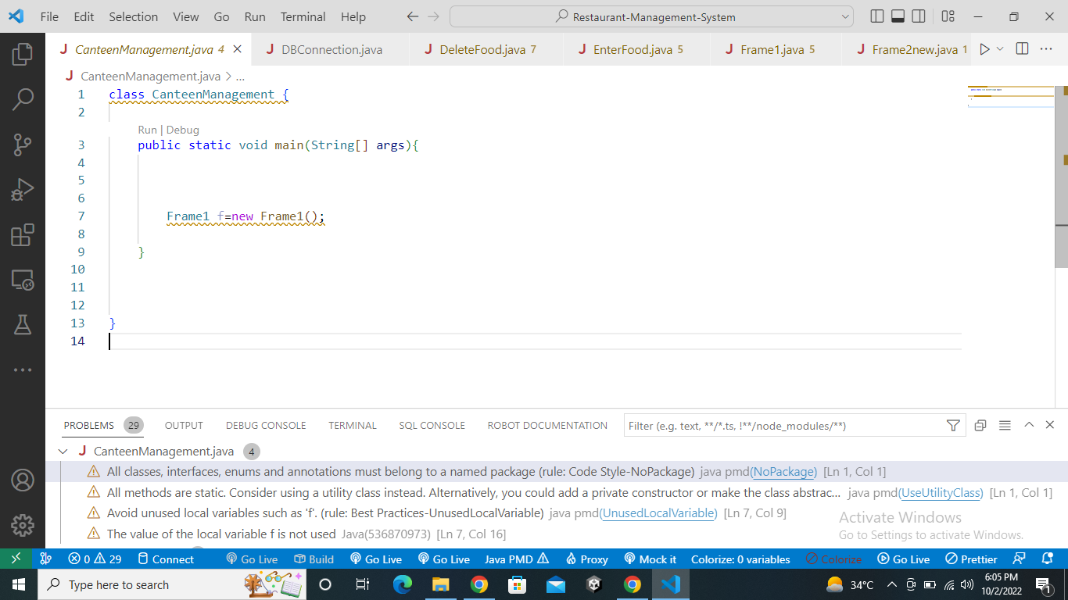

**DBConnection.java**

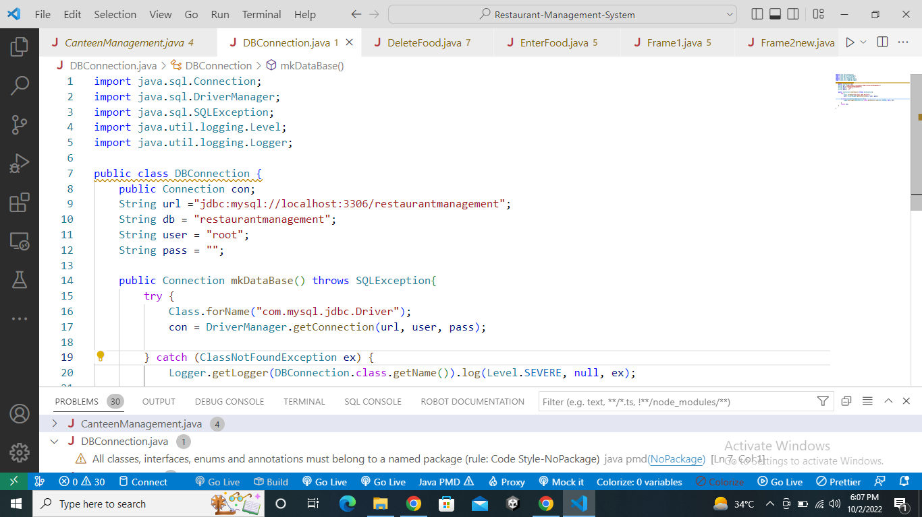

**EnterFood.java**

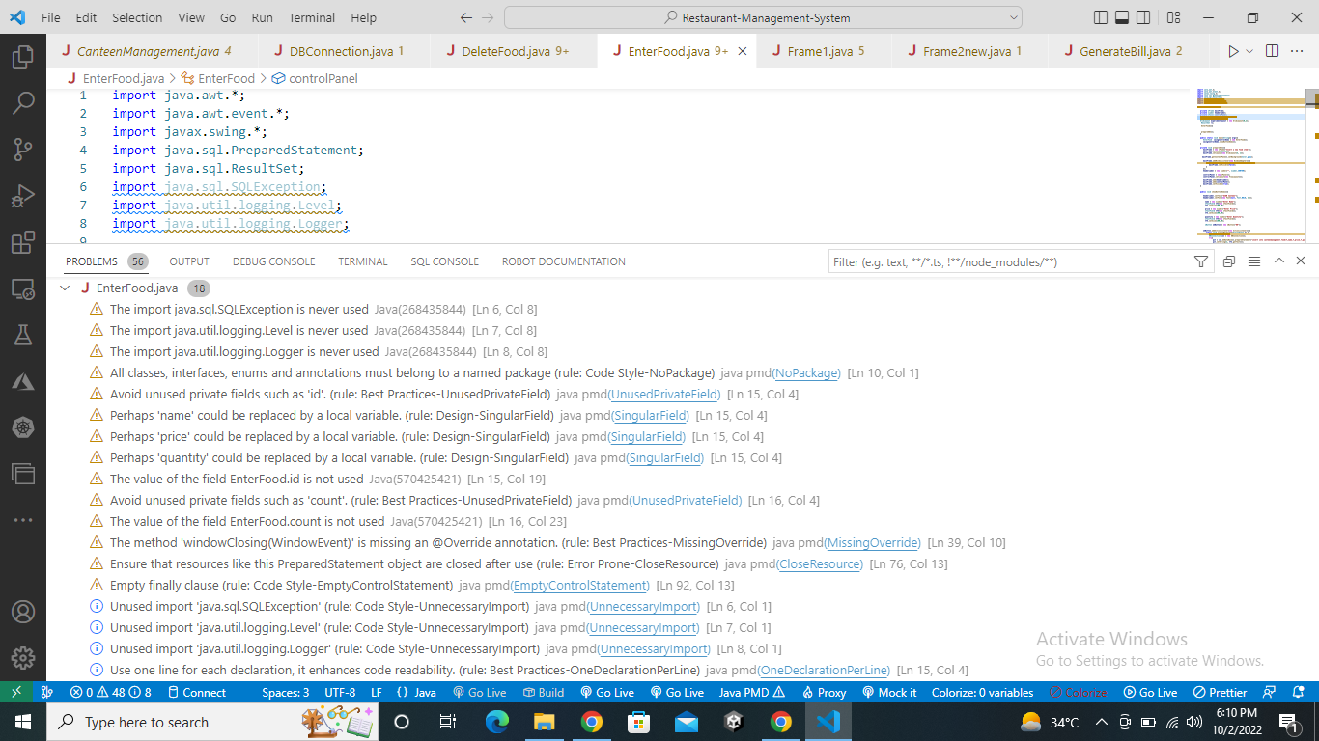

**DeleteFood.java**

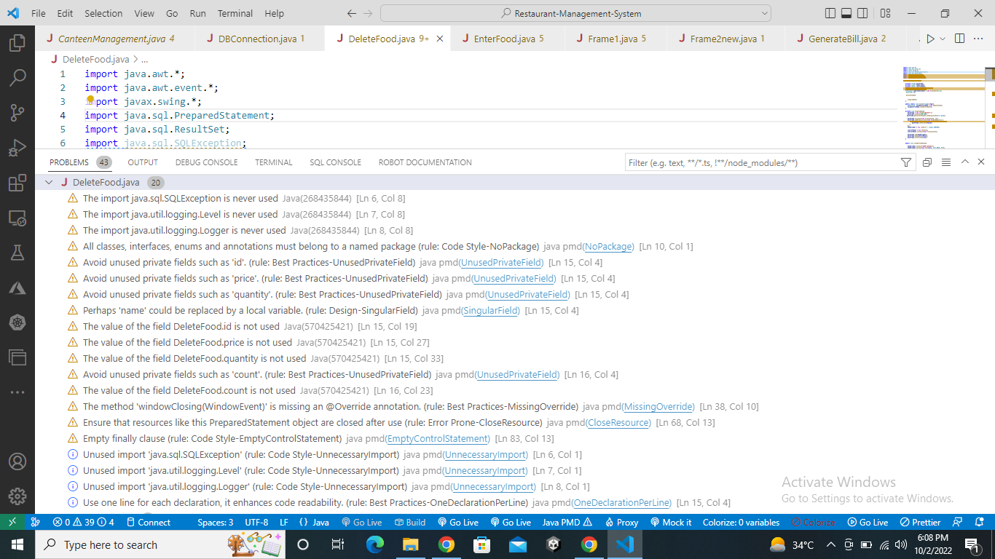

**UpdateFood.java**

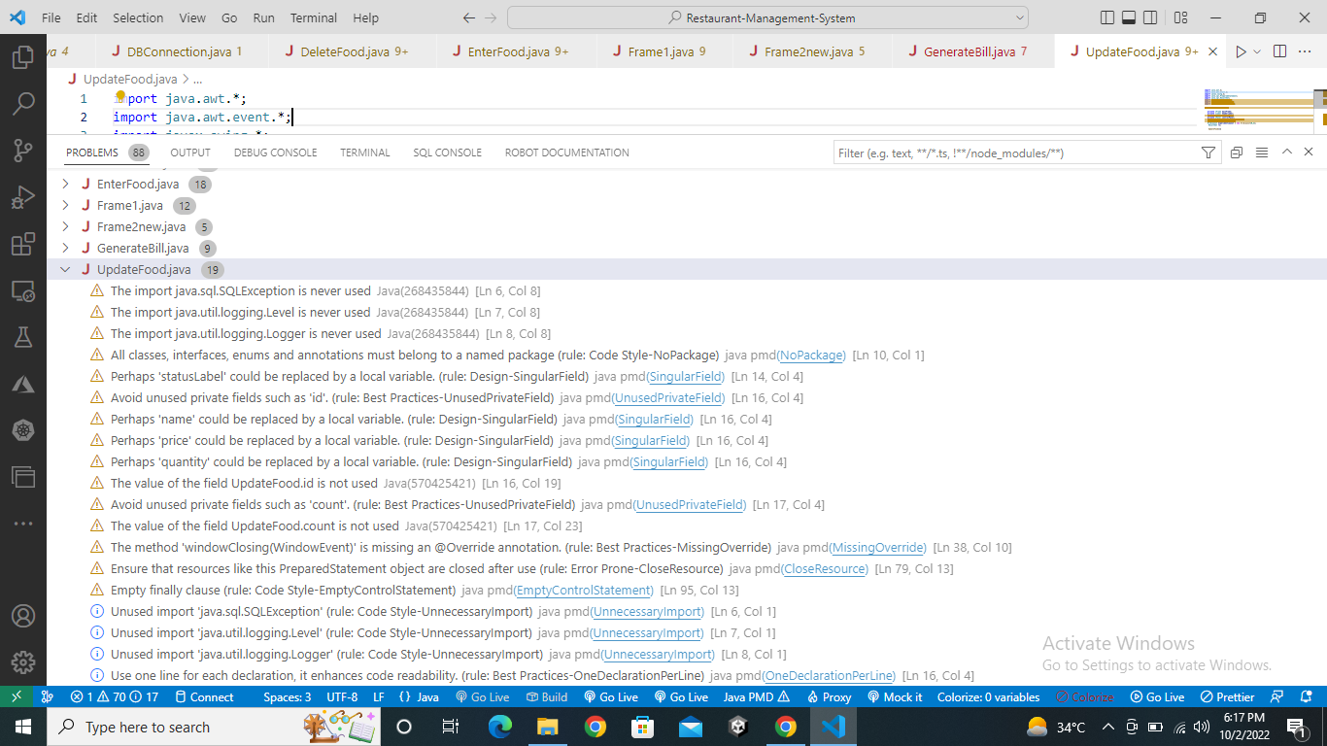

**Iteminfo.java**

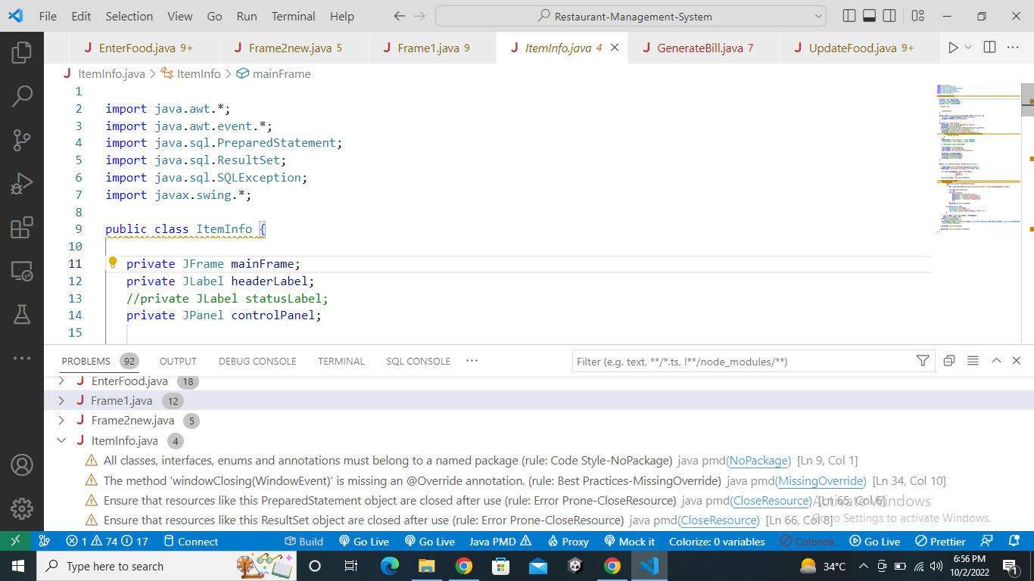

**Frame1.java**

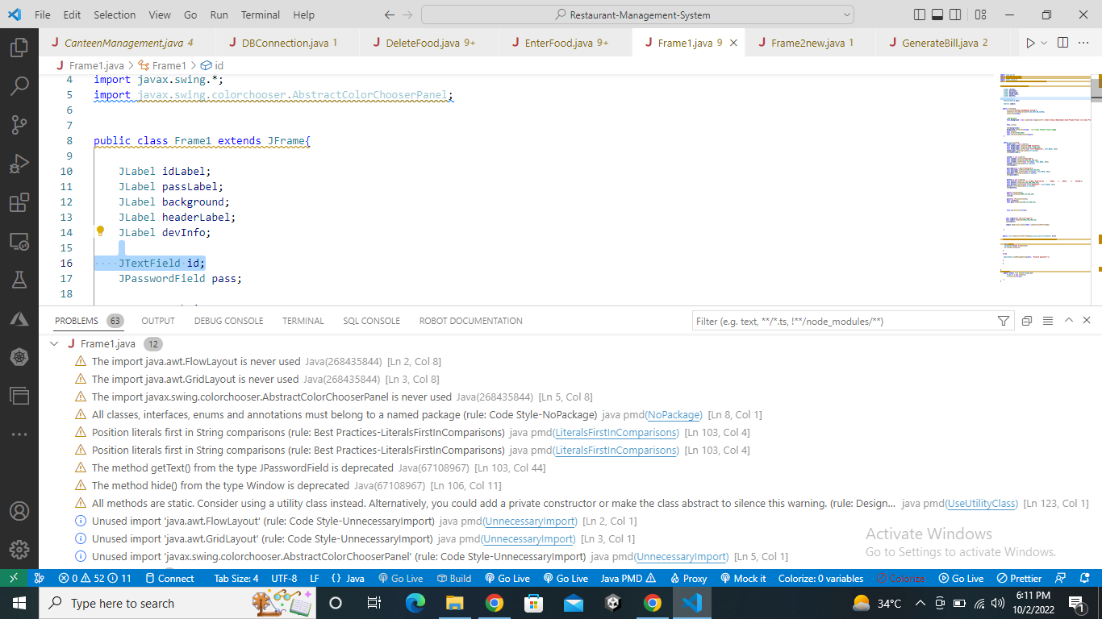

**Frame2.java**

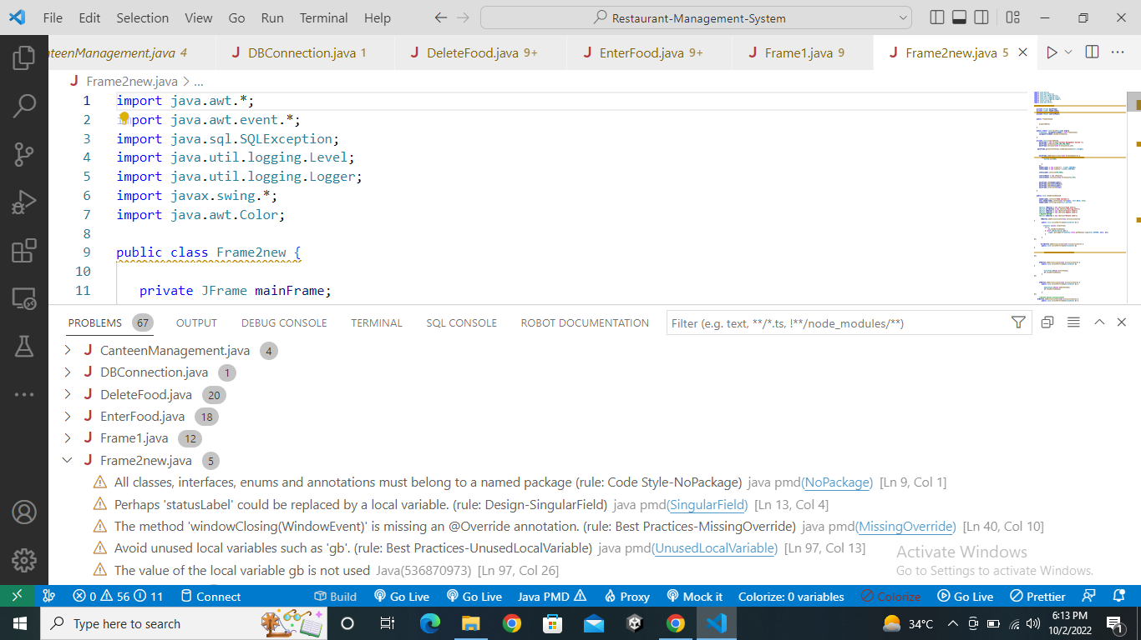

**GenerateBill.java**

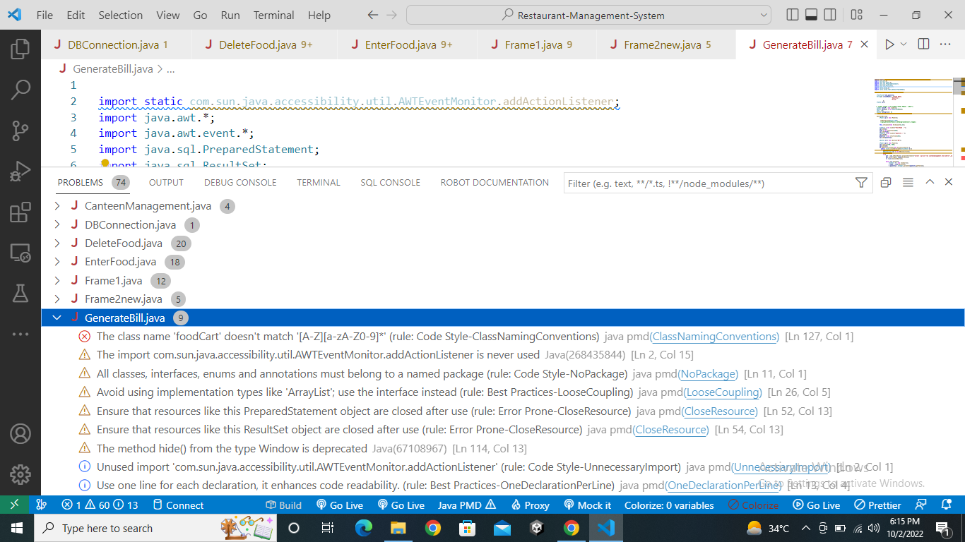

* 1. **Apply at least 3 PMD rules with the help of tool.**

**PMD Rules**

* Unnecessary import

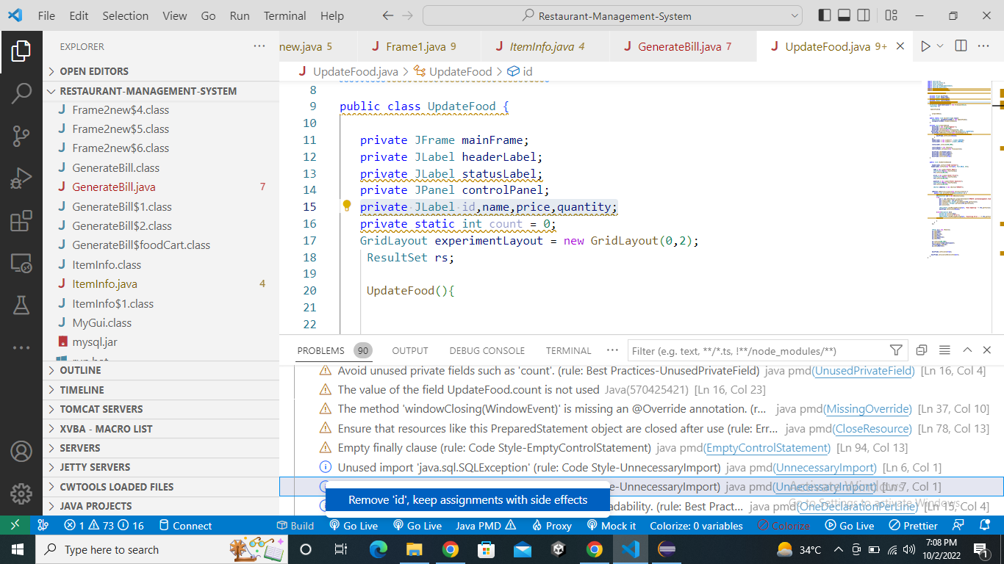

* Unused import

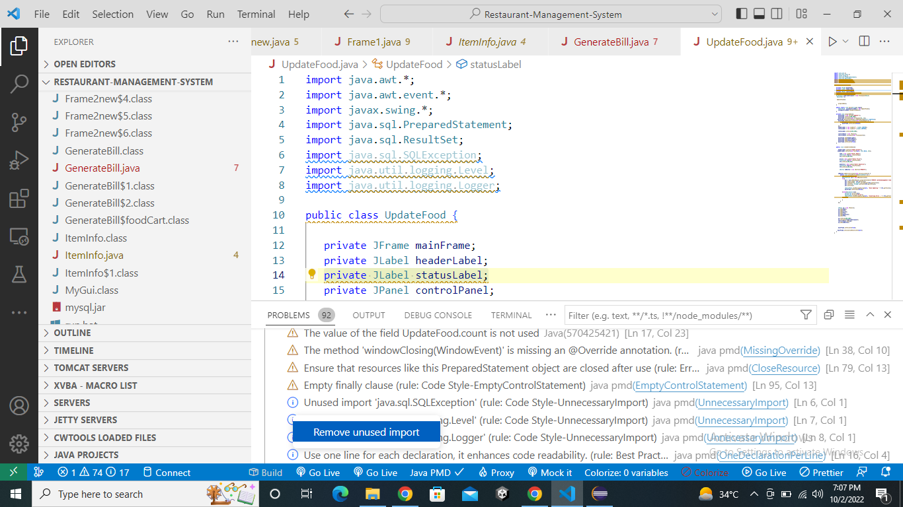

* Unused private fields

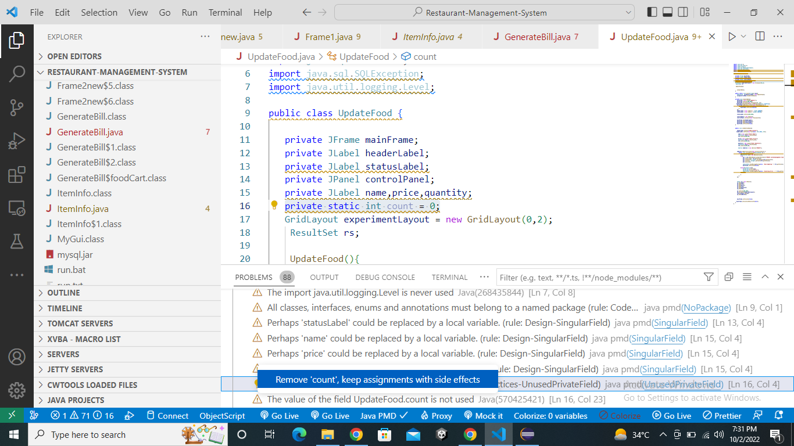

* 1. **Generate the Abstract Syntax Tree of your source code using PMD.**

**CanteenManagement.java**

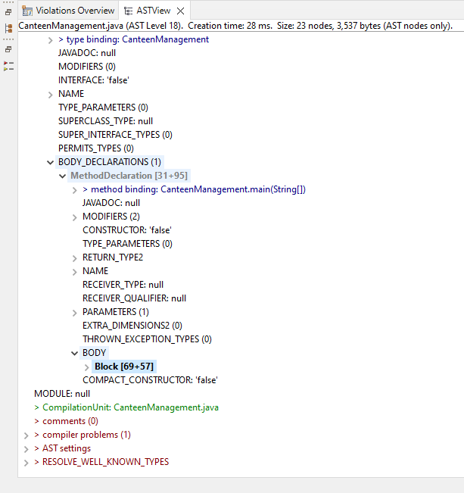

**DBConnection.java**

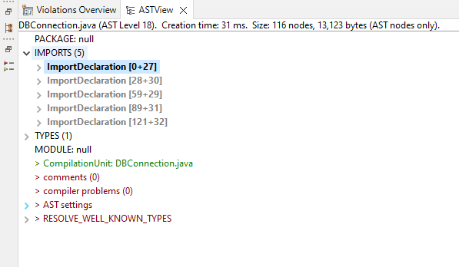

**DeleteFood.java**

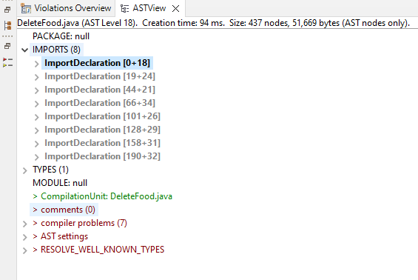

**EnterFood.java**

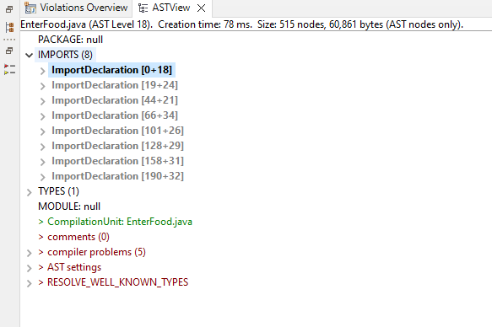

**UpdateFood.java**

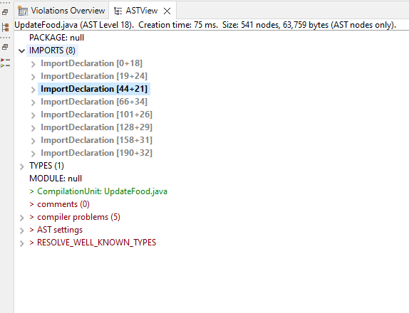

**Frame1.java**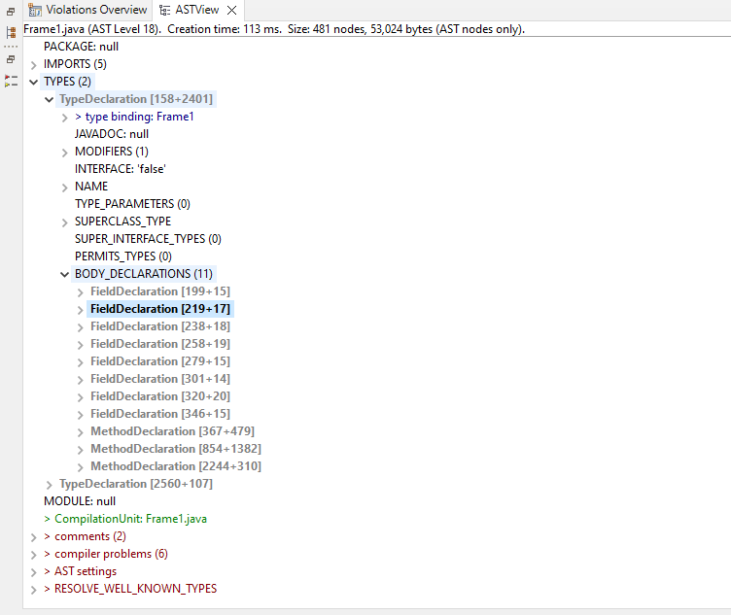

**Frame2.java**

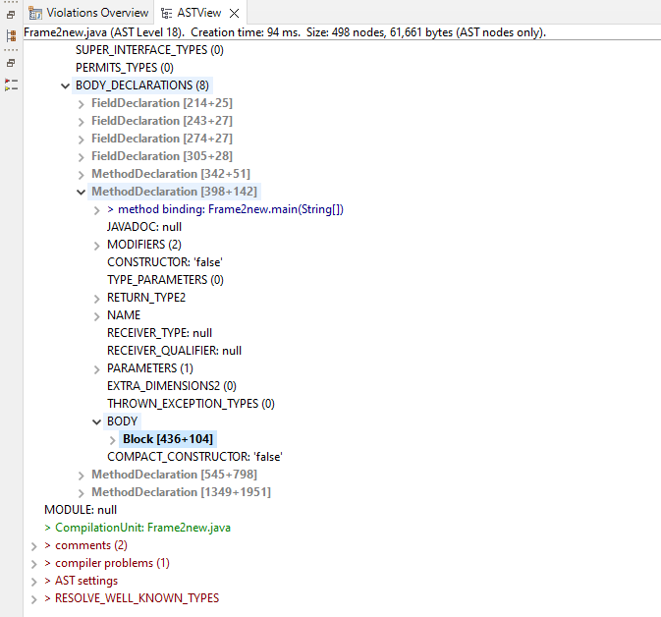

**ItemInfo.java**

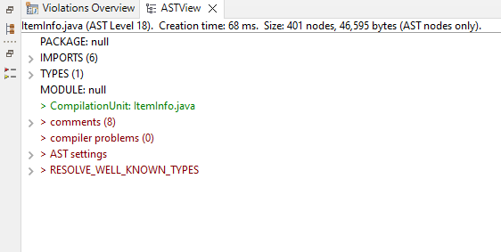

**GenerateBill.java**

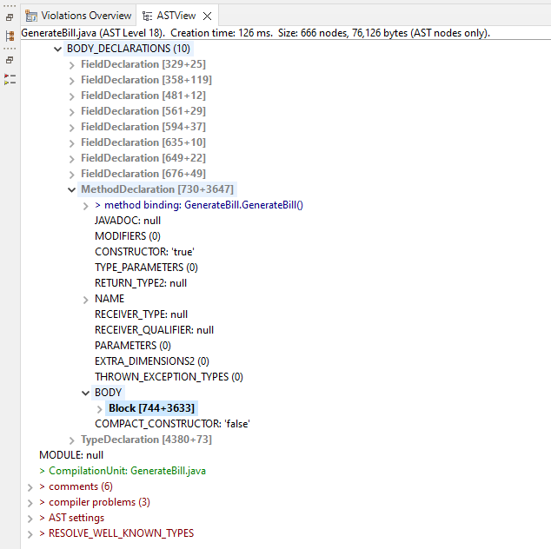

**c) Use the Check Style tool to review your code. At least apply 2 rules on your code using CHeckStyle.**

The Checkstyle plugin performs quality checks on your project's Java source files using Checkstyle and generates reports from these checks. After installing Check Styles in our project, we have reviewed our code using the Check Styles tool. Here are the screenshots representing errors and problems in code using Check Style plugin.

**CanteenManagement.java**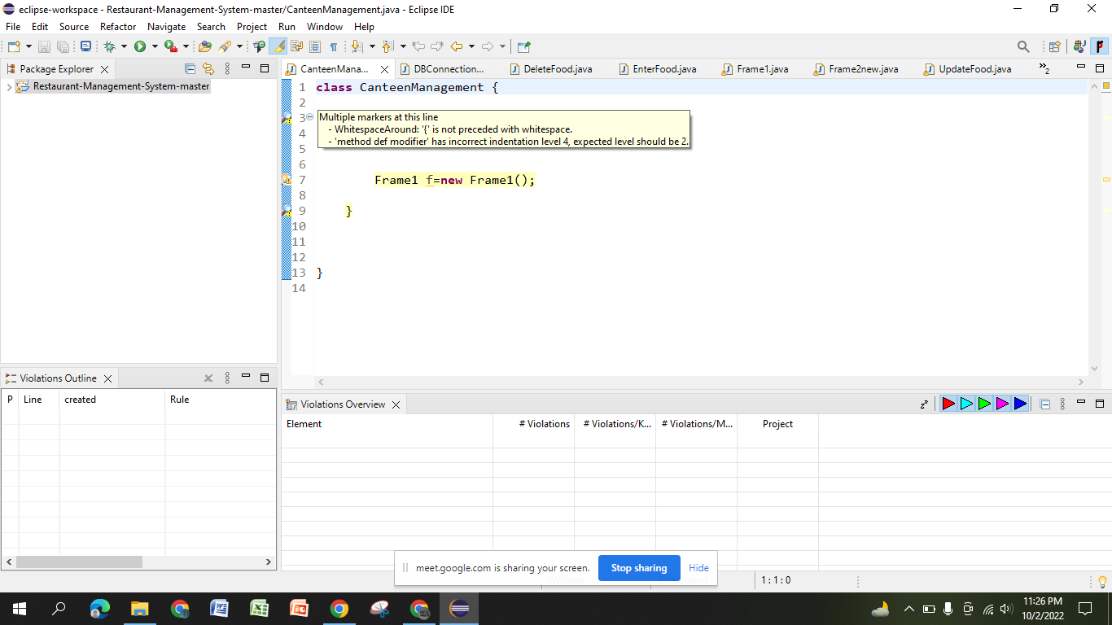

**DBConnection.java**

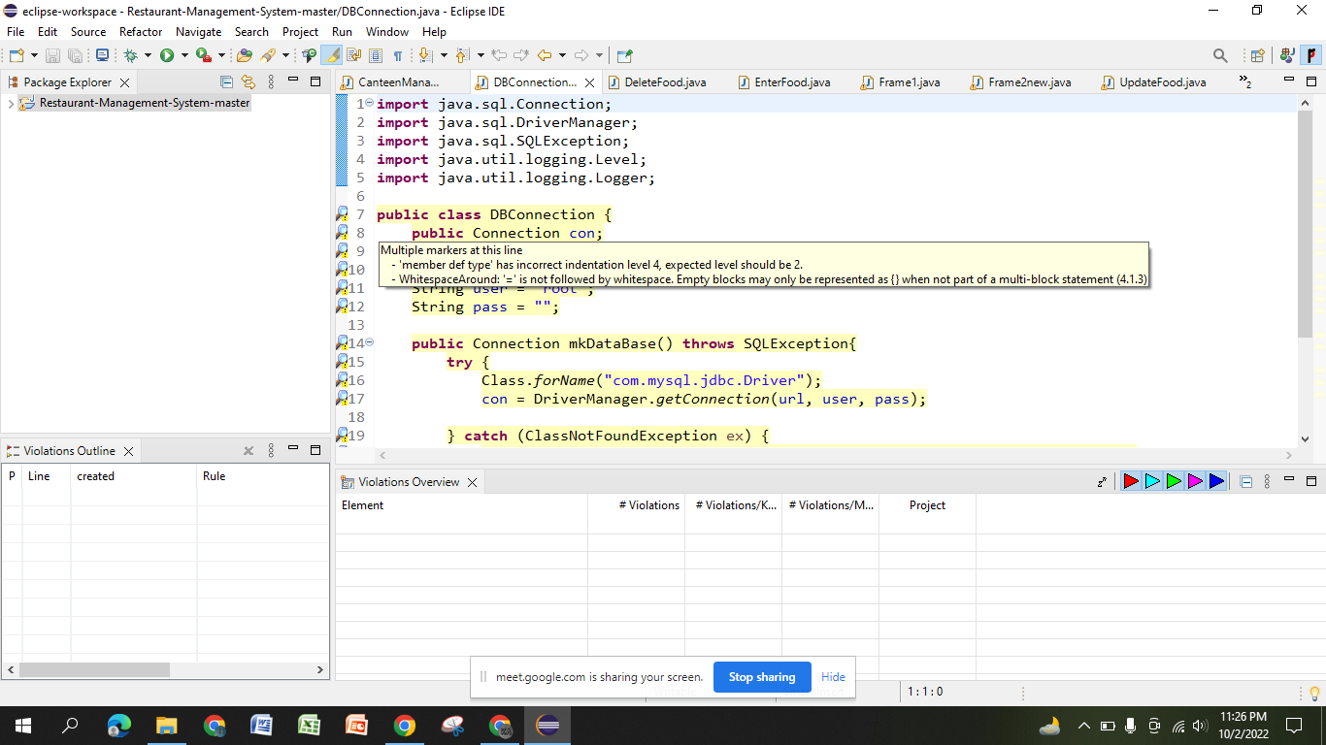

**DeleteFood.java**

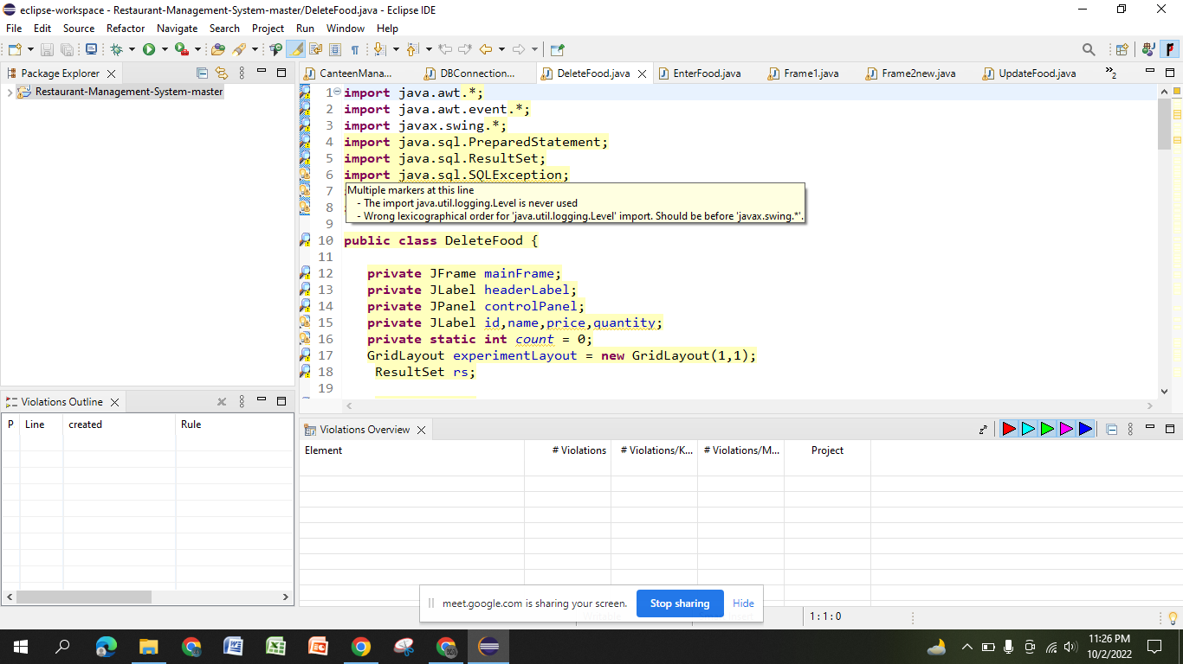

**EnterFood.java**

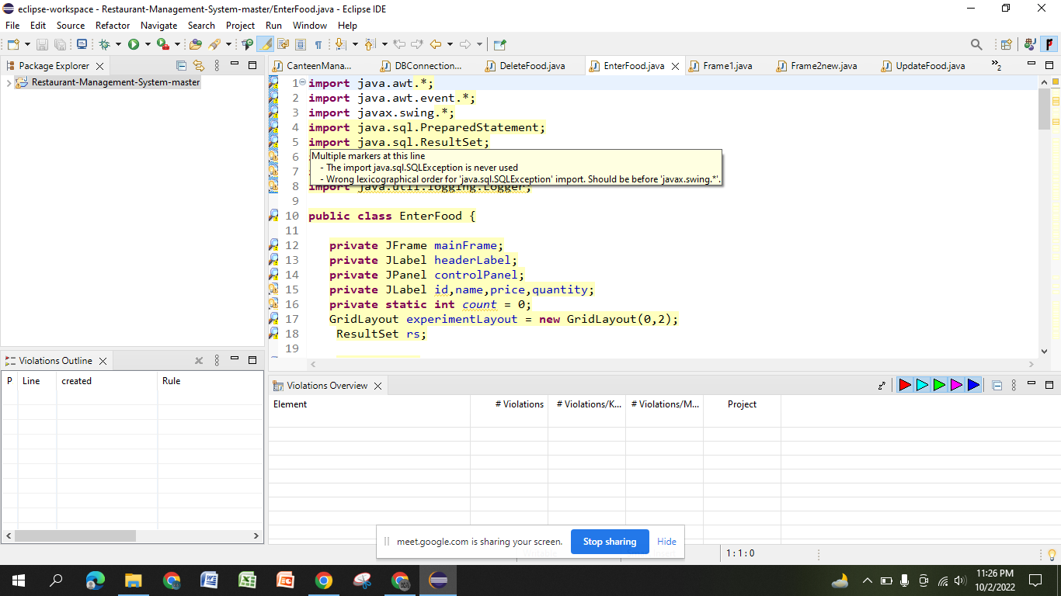

**Frame1.java**

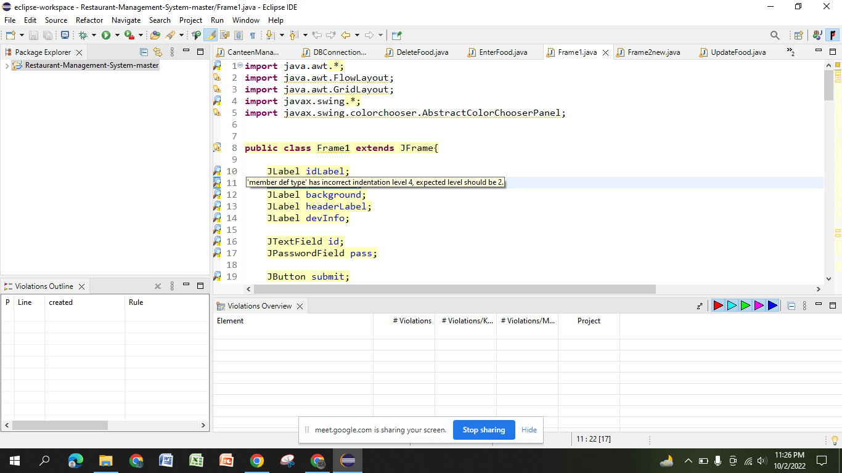

**Frame2.java**

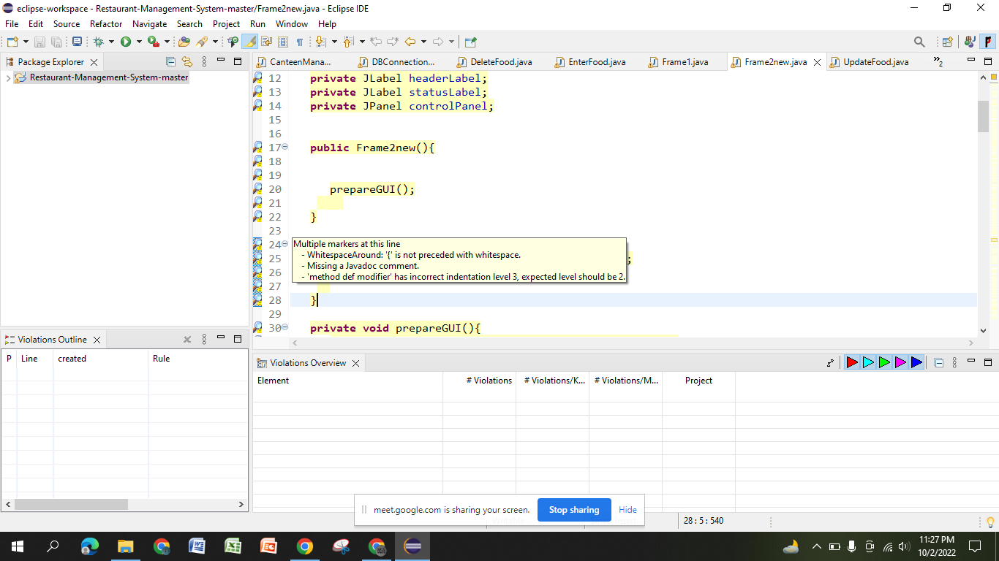

**UpdateFood.java**

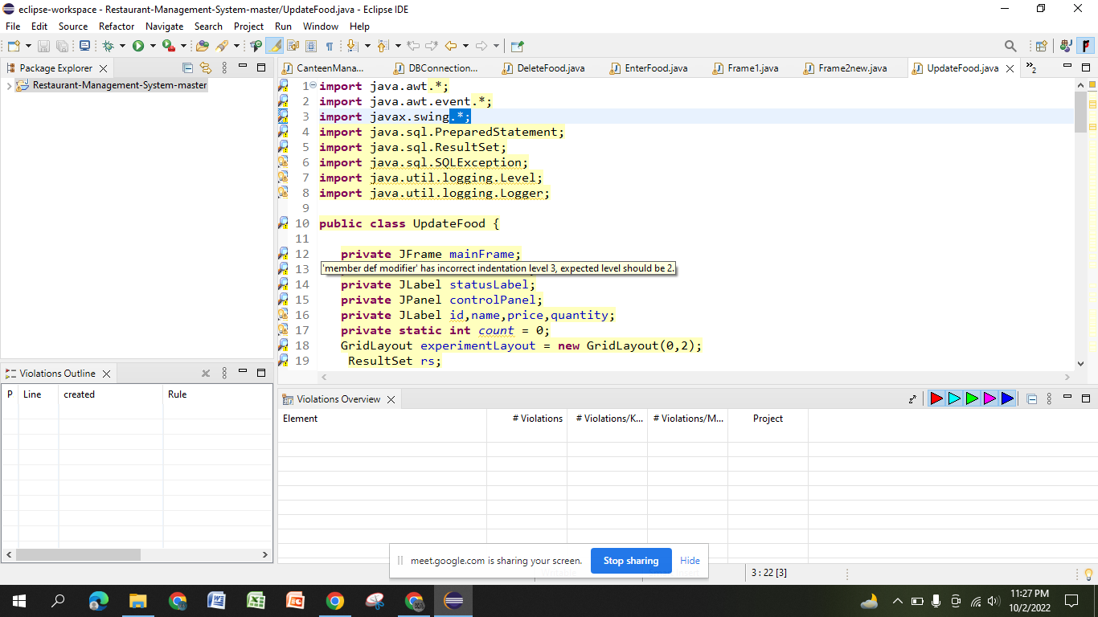

**Iteminfo.java**

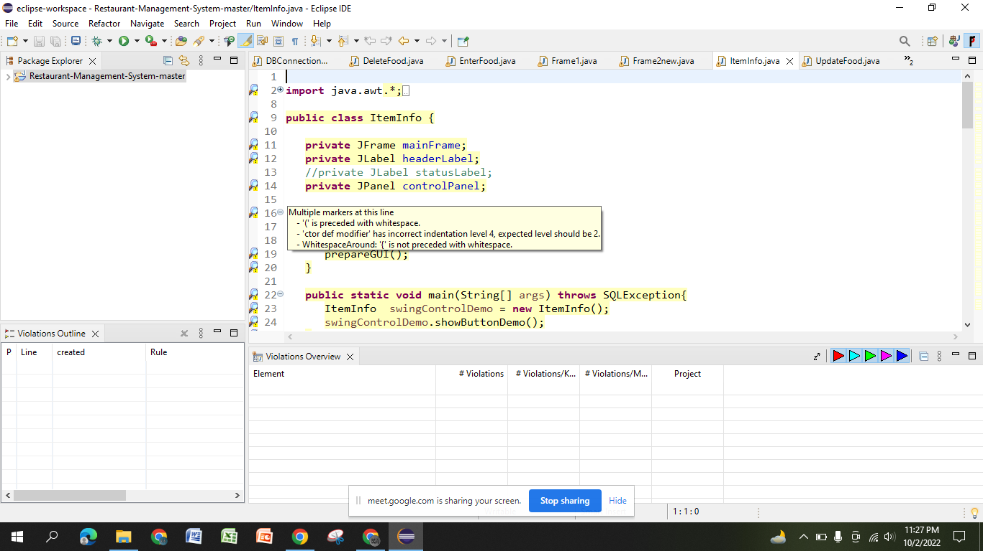

**GenerateBill.java**

