BARANI INSTITUTE OF INFORMATION TECHNOLOGY
Department of Computer Science (AI Program)

CUSTOMER PERSONALITY ANALYSIS &
CUSTOMER SEGMENTATION DASHBOARD
Project Report

Field | Details
Student Name | Kainat Fatima
Degree Program | BS Computer Science (AI)
Duration | 5 Days
Technologies | Python, Pandas, NumPy, Scikit-learn, K-Means, StandardScaler, Streamlit, Plotly, Joblib/Pickle, Git, GitHub

Executive Summary
Customer data contains valuable information about purchasing power, spending behavior, shopping channels, website engagement, campaign response, and purchase recency. However, raw customer records are difficult to translate into clear marketing actions when all customers are treated as one group. This project developed an end-to-end customer segmentation solution that transforms customer records into meaningful behavioral groups and presents the results through an interactive dashboard.
The project used the Customer Personality Analysis dataset containing 2,240 customer records. A selected set of 15 features was prepared for clustering, including income, age, spending, recency, household information, purchase channels, web activity, deal purchases, and campaign responses. Numerical inputs were standardized using StandardScaler and a final K-Means clustering approach with K=4 was integrated into the application.
The resulting segments were interpreted as Premium Buyers, High-Value Customers, Discount Seekers, and At-Risk Customers. These segments were connected with targeted business recommendations. A six-page Streamlit application with Plotly visualizations provides customer exploration, segment analysis, prediction/segmentation, recommendations, and model information. Day 4 quality assurance covered model loading, filtering, visualization, search, export, and prediction functionality, with test and defect reports prepared as project deliverables.
Table of Contents
- Introduction
- Business Problem
- Project Objectives
- Dataset Description and Selected Features
- Data Preprocessing and Feature Engineering
- Machine Learning Methodology
- Customer Segment Profiles
- Dashboard Architecture and Features
- Model Integration and Prediction Workflow
- Day-Wise Project Execution
- Strategic Business Recommendations
- Quality Assurance and Defect Analysis
- Challenges and Solutions
- Skills Learned and Tools Used
- Project Outcomes
- Future Enhancements
- Conclusion
- Appendix

1. Introduction
Customer Personality Analysis focuses on understanding groups of customers according to their characteristics and behavior. Instead of applying identical marketing strategies to every customer, organizations can use segmentation to identify groups with similar purchasing patterns, engagement levels, spending behavior, and campaign responses.
This internship project applies unsupervised machine learning to the Customer Personality Analysis dataset and connects the analytical results with an interactive web dashboard. The project therefore covers both machine learning and software application development, moving from prepared customer data to clustering, interpretation, business recommendations, and QA.

2. Business Problem
- Generic marketing campaigns can treat customers with very different behaviors in the same way.
- High-value customers may not be identified efficiently for retention and loyalty strategies.
- Customers showing long purchase recency may require re-engagement but are difficult to monitor manually.
- Different purchasing channels and deal sensitivity are difficult to understand from raw tabular data alone.
- Non-technical stakeholders need an intuitive interface to consume machine learning insights.

3. Project Objectives
- Prepare and validate customer data for machine learning.
- Engineer and select meaningful demographic and behavioral features.
- Standardize clustering features using StandardScaler.
- Build and evaluate an unsupervised customer segmentation workflow.
- Use K-Means clustering with four final customer groups.
- Profile clusters and assign business-oriented segment names.
- Develop an interactive Streamlit dashboard with Plotly visualizations.
- Integrate saved model artifacts into a customer segmentation/prediction workflow.
- Translate segment profiles into actionable marketing recommendations.
- Perform systematic quality assurance and document test and defect results.
- Prepare final technical documentation, GitHub repository, and presentation.

4. Dataset Description and Selected Features
The Customer Personality Analysis dataset used in this project contains 2,240 customer records. The final clustering workflow uses 15 selected/engineered variables covering demographic, spending, purchasing-channel, digital-engagement, and campaign-response information.
Feature | Description | Category
Income | Annual household income | Demographic
Age | Calculated customer age | Demographic
Total_Spend | Combined expenditure across product categories | Behavioral
Recency | Days since the customer's last purchase | Behavioral
Children | Number of children/dependents | Demographic
NumWebPurchases | Purchases through the web portal | Channel Usage
NumStorePurchases | Purchases through physical stores | Channel Usage
NumCatalogPurchases | Purchases through catalogs | Channel Usage
NumWebVisitsMonth | Website visits during the last month | Channel Usage
NumDealsPurchases | Purchases made using promotional deals | Behavioral
AcceptedCmp1 | Acceptance indicator for campaign 1 | Marketing Response
AcceptedCmp2 | Acceptance indicator for campaign 2 | Marketing Response
AcceptedCmp3 | Acceptance indicator for campaign 3 | Marketing Response
AcceptedCmp4 | Acceptance indicator for campaign 4 | Marketing Response
AcceptedCmp5 | Acceptance indicator for campaign 5 | Marketing Response

5. Data Preprocessing and Feature Engineering
Data preprocessing was necessary because K-Means is distance-based and is sensitive to differences in feature scales. The project workflow included data validation, feature construction, feature selection, and standardization before clustering.
- Missing-value handling was applied during data preparation, including median-based handling for relevant numerical values.
- Total_Spend was derived from monetary spending variables to provide an overall spending indicator.
- Age was derived from birth-year information.
- Behavioral and household variables were reviewed for consistency and relevance to segmentation.
- The final clustering feature set was documented and kept consistent with the saved model pipeline.
- StandardScaler was applied so that features contributed on a comparable standardized scale.
Standardization formula:
z = (x − μ) / σ
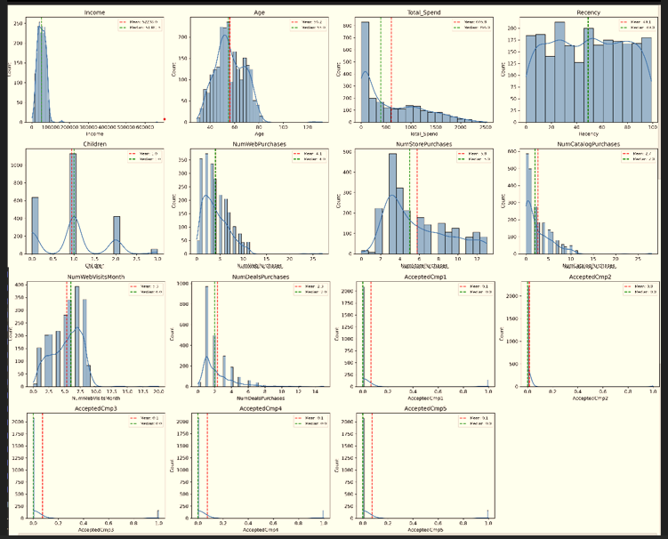
Figure : Feature Distributions after Data Preprocessing and Feature Engineering

6. Machine Learning Methodology
The project uses unsupervised learning because the original customer dataset does not provide a target class representing the desired segment. K-Means discovers groups by measuring similarity between standardized feature vectors.

6.1 K-Means Workflow
- Prepare the selected customer features.
- Standardize the feature matrix using StandardScaler.
- Determine a suitable cluster count using the project's clustering evaluation workflow.
- Train the K-Means model using the selected number of clusters, K=4.
- Assign each customer to the nearest centroid.
- Profile the resulting clusters using demographic, spending, channel, recency, and campaign characteristics.
- Translate numerical cluster profiles into business-oriented customer personas.

6.2 Why StandardScaler?
Income and spending variables have substantially larger numerical ranges than binary campaign indicators or household counts. Without scaling, high-magnitude variables could dominate Euclidean distance calculations. StandardScaler transforms each feature to a standardized scale, allowing the clustering process to consider the selected variables more fairly.

6.3 Evaluation Approach
Because K-Means is an unsupervised clustering algorithm, conventional classification measures such as accuracy, precision, recall, and F1-score are not appropriate for this task. The broader internship workflow used cluster-quality analysis, including WCSS/Elbow, Silhouette analysis, Davies–Bouldin analysis, algorithm comparison, stability analysis, and business interpretability. The final application uses K=4 for the customer segmentation workflow. 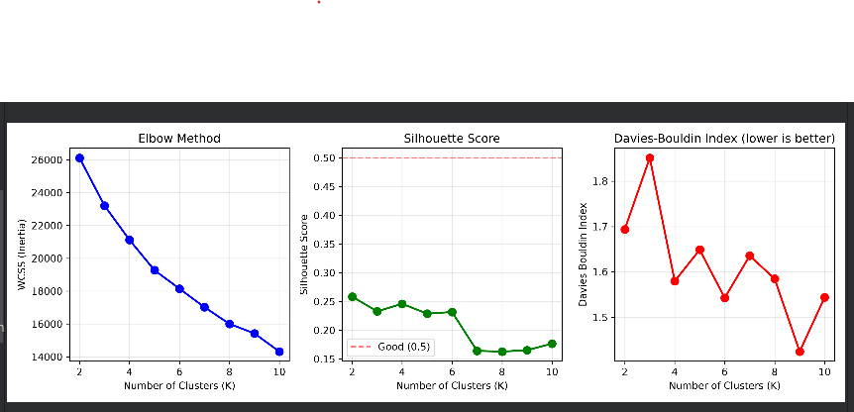
Figure : Cluster Evaluation using Elbow Method, Silhouette Score, and Davies-Bouldin Index

7. Customer Segment Profiles
Cluster | Segment | Core Characteristics | Primary Channels
Cluster 0 | Premium Buyers | High household income; high total spending; lower dependence on deals/discounts. | Catalog and Store
Cluster 1 | High-Value Customers | Solid income; consistent spending; strong campaign responsiveness. | Web and Store
Cluster 2 | Discount Seekers | More price-sensitive behavior; frequent deal purchases and web activity. | Web and Deals
Cluster 3 | At-Risk Customers | High recency; lower engagement and declining purchase activity. | Minimal/Dormant

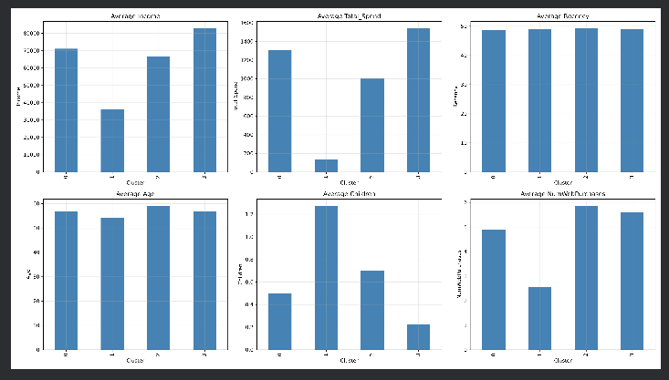
Figure : Comparative Cluster Profiles across Key Customer Features

8. Dashboard Architecture and Features
The final application was implemented using Streamlit and enhanced with Plotly visualizations. The dashboard is designed to make customer segmentation results accessible to users who may not interact directly with the underlying Python model.
Page | Purpose
Home | Project overview, KPI summary, total customer information, and navigation.
Customer Segments | Distribution and comparison of the four customer segments.
Segment Analysis | Detailed comparisons across income, spending, channels, recency, and other behavior.
Customer Prediction | Interactive interface for entering customer features and obtaining a segment assignment.
Business Recommendations | Segment-specific marketing and retention strategies.
About Model | Model, feature, scaling, and artifact information.

8.1 Interactive Capabilities
- Sidebar navigation across the six application areas.
- Dynamic Age, Income, and Segment filters.
- Interactive Plotly charts and customer segment comparisons.
- Customer table and search functionality.
- CSV export for filtered customer records.
- Model-backed customer segmentation/prediction interface.

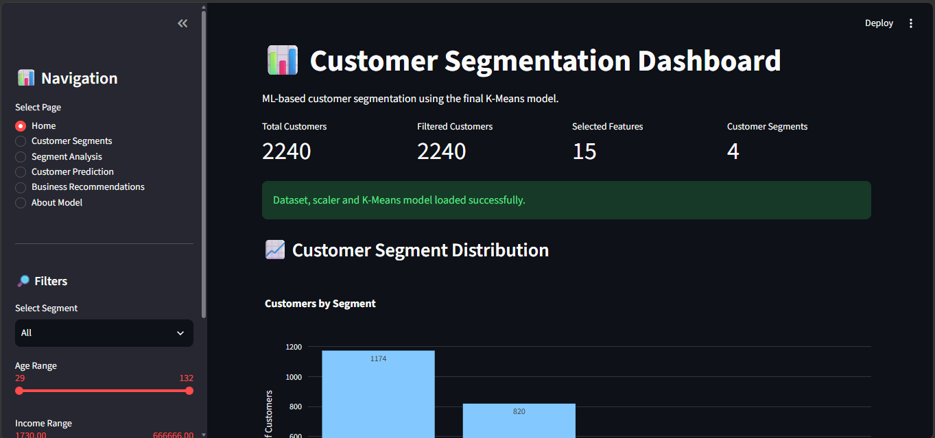
Figure : Customer Segmentation Dashboard Home Page

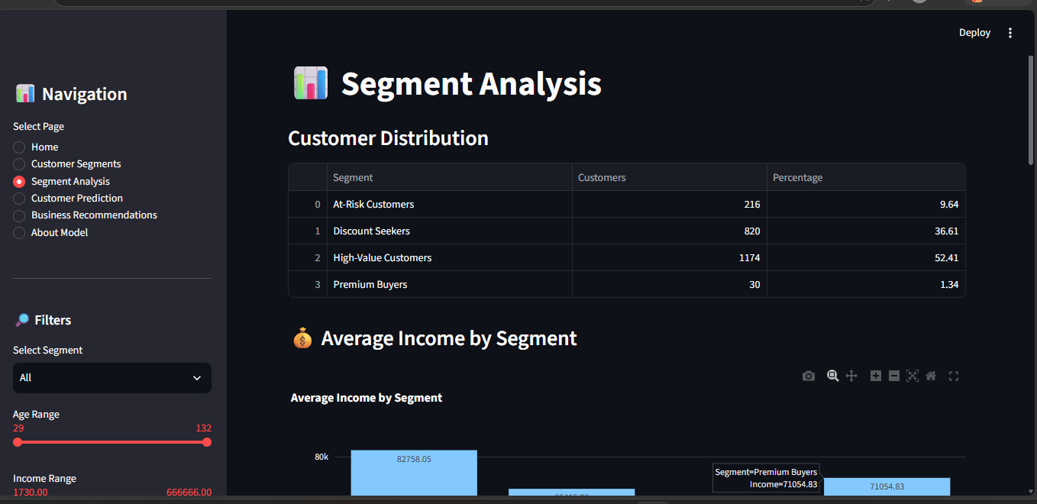
Figure : Segment Analysis Dashboard Showing Customer Distribution and Segment Insights

9. Model Integration and Prediction Workflow
The dashboard connects the trained machine learning components with the application through serialized artifacts. The saved files maintain the same feature preparation and model structure used during training.
Artifact | Purpose
models/scaler_standard.pkl | Saved StandardScaler fitted on the clustering features.
models/kmeans_model_fixed.pkl | Saved K-Means model containing the four cluster centroids.
models/selected_features.txt | Defines the expected feature names and order.
data/cleaned_final.csv | Preprocessed customer dataset used for dashboard analytics.

Customer Input → Feature Ordering → StandardScaler → K-Means → Cluster ID → Segment Name → Recommendation
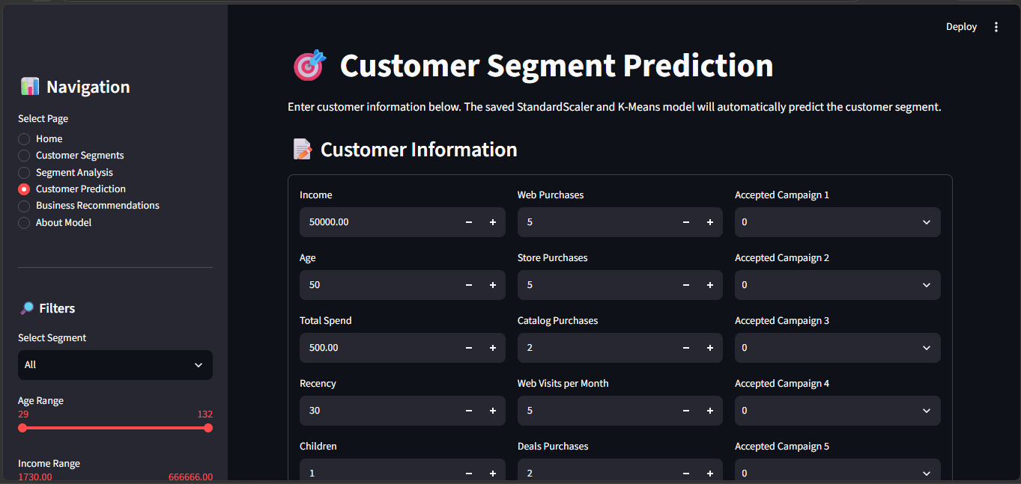
Figure : Customer Prediction Interface for Individual Customer Segmentation

10. Day-Wise Project Execution
Day | Module | Main Focus | Major Output
Day 1 | Module 9 | Dashboard Planning & Data Integration | Dashboard architecture + working application
Day 2 | Module 9 | Dashboard Development | Interactive dashboard
Day 3 | Module 9 + 10 | Prediction/Segmentation Integration & Testing | Integrated application + initial test cases
Day 4 | Module 10 | Quality Assurance | Test report + defect report
Day 5 | Module 11 | Documentation & Presentation | Final report + presentation + demo

10.1 Day 1 — Dashboard Planning & Data Integration
- Reviewed previous machine learning outputs and the final dataset.
- Identified engineered features, saved segmentation model, customer segment labels, and business recommendations.
- Planned the final dashboard architecture and application structure.
- Consolidated inputs from previous modules for dashboard development.

10.2 Day 2 — Dashboard Development
- Developed the Streamlit multi-page application structure.
- Integrated Plotly visualizations and KPI-style summaries.
- Added dashboard navigation and interactive filtering components.
- Connected customer analysis outputs with the dashboard interface.

10.3 Day 3 — Prediction/Segmentation Integration & Testing
- Loaded saved scaler and K-Means model artifacts.
- Connected the inference workflow to the Streamlit application.
- Maintained the expected feature order during model input preparation.
- Performed initial functional testing of the integrated application.

10.4 Day 4 — Quality Assurance
- Executed functional, interface, filtering, visualization, and model-inference tests.
- Prepared the formal DAY_4_TEST_REPORT.txt.
- Prepared the formal DAY_4_DEFECT_REPORT.txt.
- Resolved identified issues and verified the final application state.
- Committed and pushed the QA reports to the GitHub repository.

10.5 Day 5 — Documentation & Presentation
- Compiled the final internship project report.
- Prepared the presentation and live demonstration flow.
- Organized project documentation and repository deliverables.
- Prepared the final dashboard demonstration.

11. Strategic Business Recommendations
Segment | Business Focus | Recommended Actions
Premium Buyers | VIP Retention & Value Maximization | Exclusive loyalty programs; early product access; premium catalog/store service.
High-Value Customers | Cross-Selling & Loyalty Growth | Personalized campaigns; tiered rewards; complementary product recommendations.
Discount Seekers | Volume Incentivization | Targeted discount codes; value bundles; promotional web campaigns.
At-Risk Customers | Churn Mitigation & Win-Back | Re-engagement emails; one-time win-back incentives; feedback surveys.

12. Quality Assurance and Defect Analysis
Day 4 focused on quality assurance. Testing was performed across the main dashboard and model integration components. The formal QA deliverables were stored in the project repository as DAY_4_TEST_REPORT.txt and DAY_4_DEFECT_REPORT.txt.
Test Area | Verification | Status
Model Initialization | Deserialize scaler and K-Means artifacts at application startup. | PASS
Dynamic Filtering | Verify Age, Income, and Segment filters update the displayed analysis. | PASS
Plotly Rendering | Verify charts render correctly across dashboard views. | PASS
Customer Search | Verify search/filter functionality for customer records. | PASS
CSV Export | Verify filtered customer data can be exported as CSV. | PASS
Prediction Function | Verify manual feature input produces a cluster/segment result and recommendation. | PASS

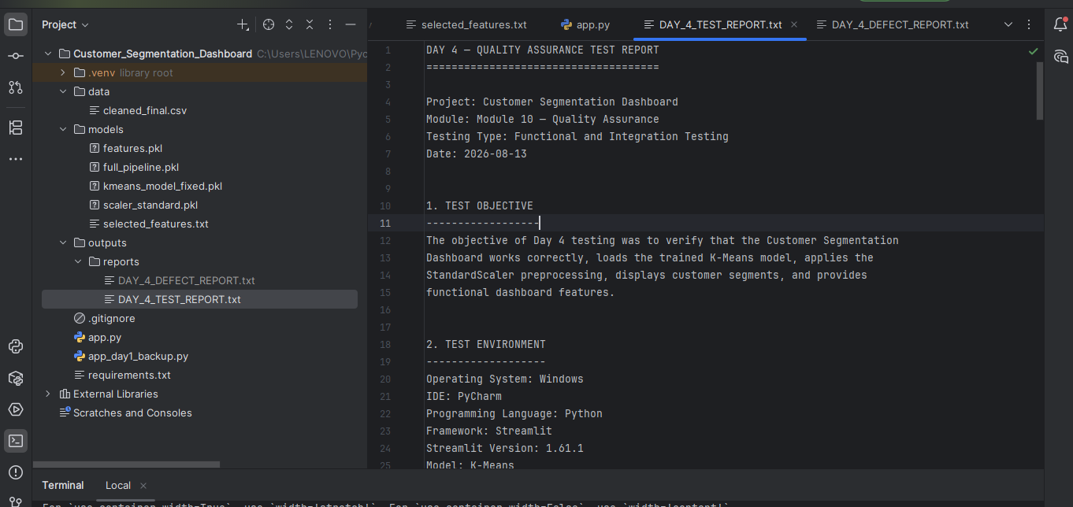
Figure: Day 4 Quality Assurance Test Report

12.1 Defects Identified and Resolved
Defect | Issue | Resolution
Feature Ordering Mismatch | Prediction inputs did not initially follow the exact feature order expected by the scaler. | Enforced the feature order using selected_features.txt.
Chart Redraw Latency | Interactive sliders caused unnecessary recalculation of static dataset operations. | Used Streamlit caching for suitable data operations.

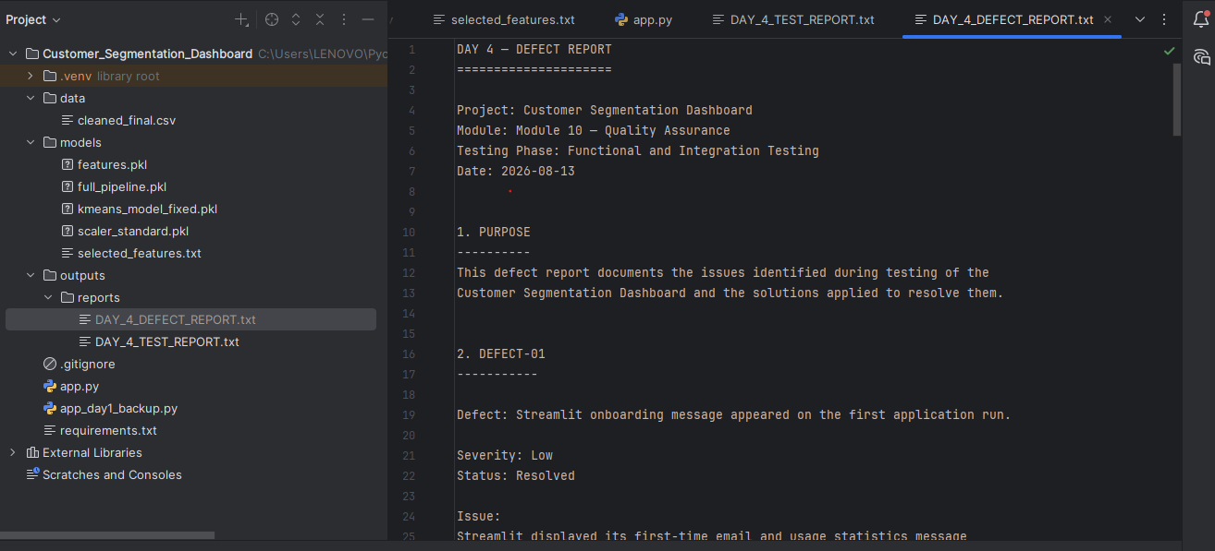
Figure: Day 4 Defect Report

13. Challenges and Solutions
Challenge | Problem | Solution
Scaling sensitivity | Large-value features could dominate distance calculations. | Applied StandardScaler to the selected clustering features.
Feature consistency | Inference inputs must match the training feature order. | Maintained an explicit selected_features.txt schema.
Model/application integration | Saved ML artifacts had to be loaded consistently by Streamlit. | Used serialized scaler/model files and a defined inference sequence.
Dashboard responsiveness | Interactive filtering can trigger repeated data operations. | Used appropriate caching and modular application logic.
Business interpretation | Numerical clusters need meaningful descriptions for decision makers. | Used cluster-wise profiles and comparative analysis to assign evidence-based segment names.

14. Skills Learned and Tools Used

14.1 Machine Learning and Data Skills
- Data cleaning and validation
- Exploratory data analysis
- Feature engineering and feature selection
- Feature scaling
- Unsupervised learning and K-Means clustering
- Cluster evaluation and profiling
- Business interpretation of ML outputs

14.2 Application and Software Skills
- Streamlit dashboard development
- Plotly interactive visualization
- Model serialization using Joblib/Pickle
- Git and GitHub version control
- Quality assurance and defect reporting
- Technical documentation and presentation
Tool/Technology | Use in Project
Python | Core programming and ML workflow
Pandas / NumPy | Data processing and analysis
Scikit-learn | Scaling and clustering
K-Means | Customer segmentation
Streamlit | Interactive dashboard
Plotly | Interactive visualizations
Joblib / Pickle | Model artifact persistence
PyCharm | Development environment
Git / GitHub | Version control and repository management

15. Project Outcomes
Deliverable | Outcome
Dataset | 2,240 customer records analyzed through the project workflow.
Features | 15 selected/engineered clustering features used in the final dashboard/model workflow.
Segments | 4 business-oriented customer segments identified and interpreted.
Dashboard | Six-page Streamlit application with interactive analysis.
Integration | Saved scaler and K-Means artifacts connected to the application.
Business Value | Segment-specific marketing, retention, and re-engagement recommendations.
QA | Formal Day 4 test and defect reports completed.
Repository | Project code and reports maintained in GitHub.

16. Future Enhancements
- Deploy the Streamlit application to a cloud environment for broader access.
- Connect the dashboard to a live database instead of a static CSV data source.
- Introduce automated periodic re-clustering as new customer data becomes available.
- Compare additional clustering approaches as part of future model experimentation.
- Add authentication and role-based access for business users.
- Integrate segmentation outputs with CRM or marketing automation systems.
- Extend the dashboard with RFM-based customer analysis.

17. Conclusion
The Customer Personality Analysis & Customer Segmentation Dashboard demonstrates an end-to-end application of machine learning to customer behavior analysis. The project transformed customer records into four interpretable behavioral segments using a standardized K-Means clustering workflow and connected those segments with business recommendations.
The project also demonstrates the transition from machine learning experimentation to application development. The Streamlit dashboard provides an accessible interface for exploring customer segments, applying filters, viewing interactive analytics, and using the integrated segmentation workflow. Quality assurance on Day 4 added structured testing and defect documentation before the final documentation and presentation stage.
Overall, the internship strengthened practical skills in Python-based data science, unsupervised learning, dashboard development, model integration, Git/GitHub, quality assurance, business interpretation, and technical communication.

19. Appendix

A. GitHub Repository
https://github.com/kainatfatima0683-hub/Customer_Segmentation_Dashboard

B. Suggested Screenshot Evidence
- Dashboard Home page
- Customer Segments page
- Segment Analysis page
- Customer Prediction page
- Business Recommendations page
- About Model page
- Day 4 Test Report
- Day 4 Defect Report
- GitHub repository structure

C. Suggested Application Structure
Customer_Segmentation_Dashboard/
├── data/
│ └── cleaned_final.csv
├── models/
│ ├── scaler_standard.pkl
│ ├── kmeans_model_fixed.pkl
│ └── selected_features.txt
├── pages/
│ ├── 1_Home.py
│ ├── 2_Customer_Segments.py
│ ├── 3_Segment_Analysis.py
│ ├── 4_Customer_Prediction.py
│ ├── 5_Business_Recommendations.py
│ └── 6_About_Model.py
├── app.py
├── requirements.txt
└── README.md

