Prompting Fundamentals on Real Tasks
Kainat Ijaz
FL-02 — Prompt Iteration Log
Anthorpy best practices:
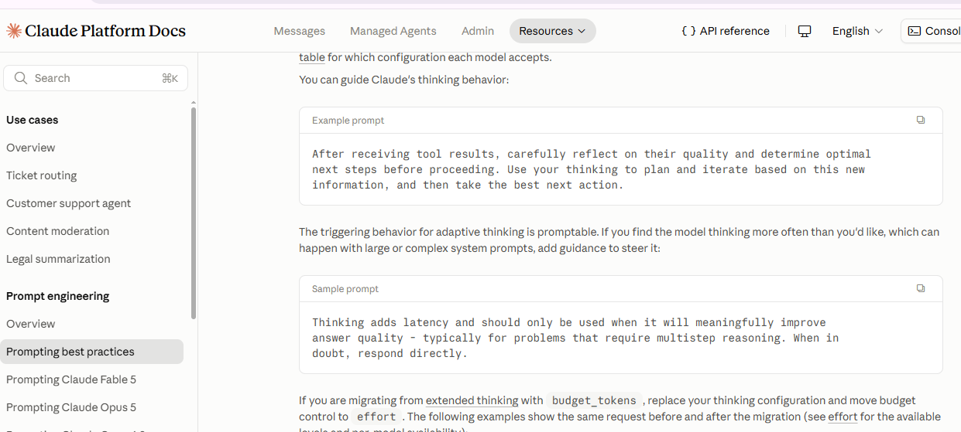
1:claude ss
Run 1 – Naive Prompt
Prompt:
Create a React settings form with validation.
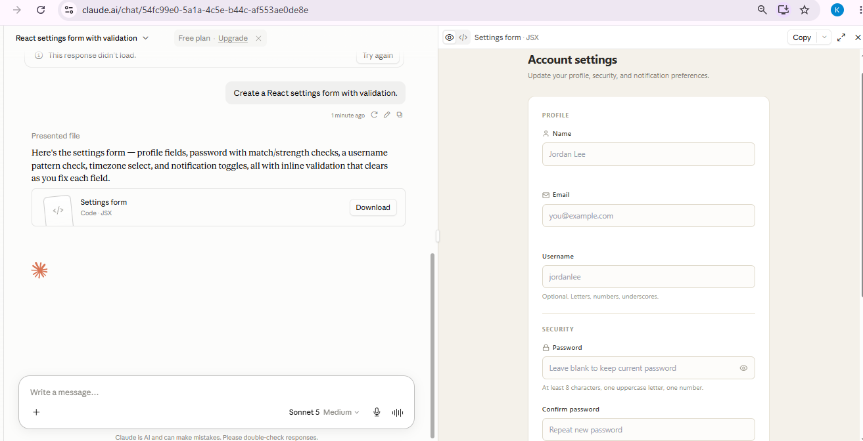
Observation: This established the baseline output.
Run 2 – Role Assignment
2:Prompt:
Act as an experienced React frontend developer. Create a React settings form with validation.
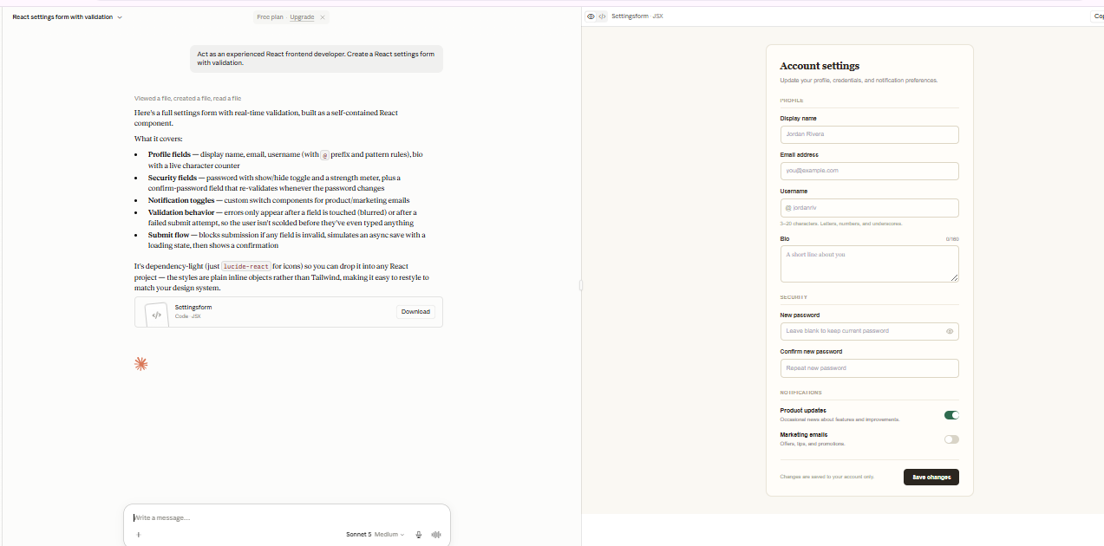
Observation: The output became more focused on frontend implementation.
3:Run 3 – Context and Motivation
Prompt:
Added internship context and project goals.

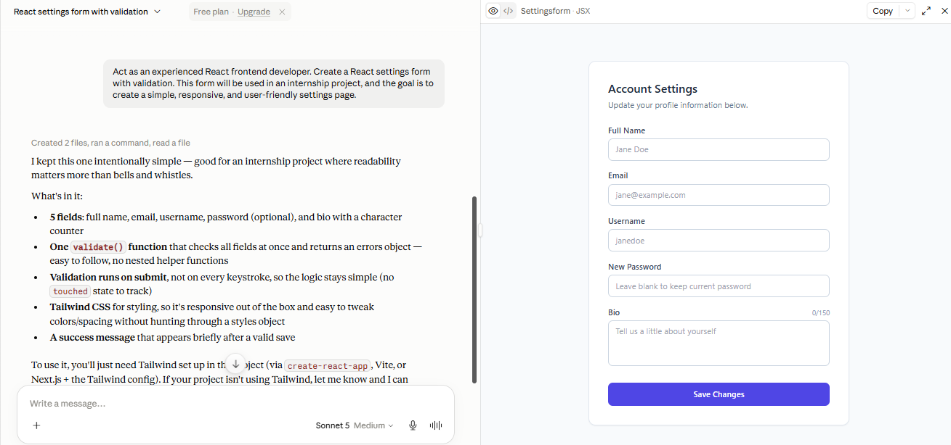
Observation: The response aligned better with usability requirements.
4:Run 4 – Few-shot Examples
Prompt:
Added examples of required fields and validation.

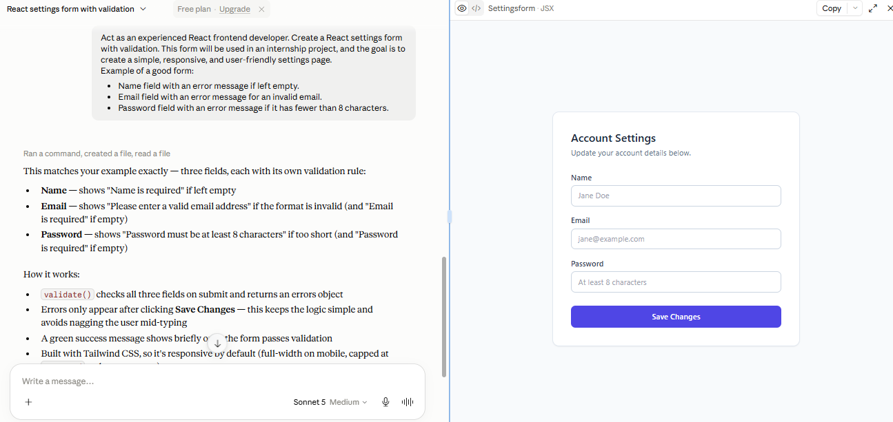
Observation: The output followed the examples more closely.
5:Run 5 – Output Structure
Prompt:
Added a required response structure.

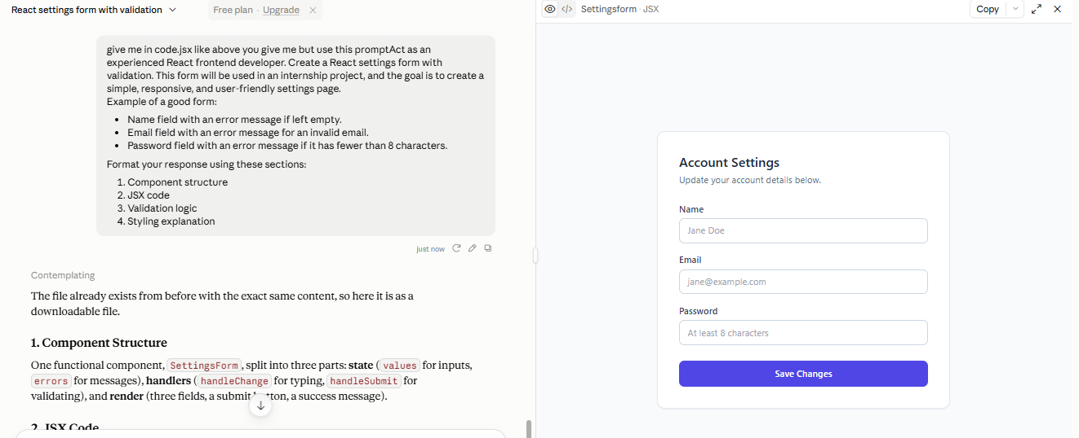
Observation: The response became easier to read and compare.
6:Run 6 – Step Decomposition
Prompt:
Asked the model to solve the task step by step.

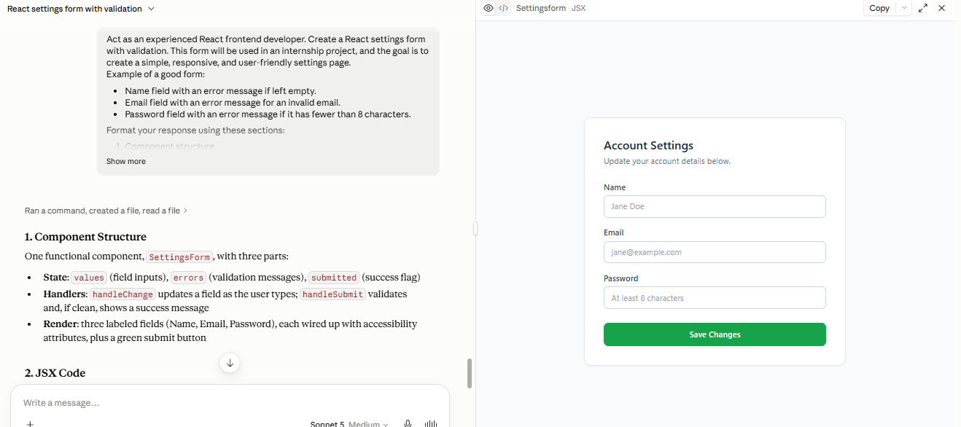
Observation: The response became more complete and systematic.

Gpt Screenshot
1:
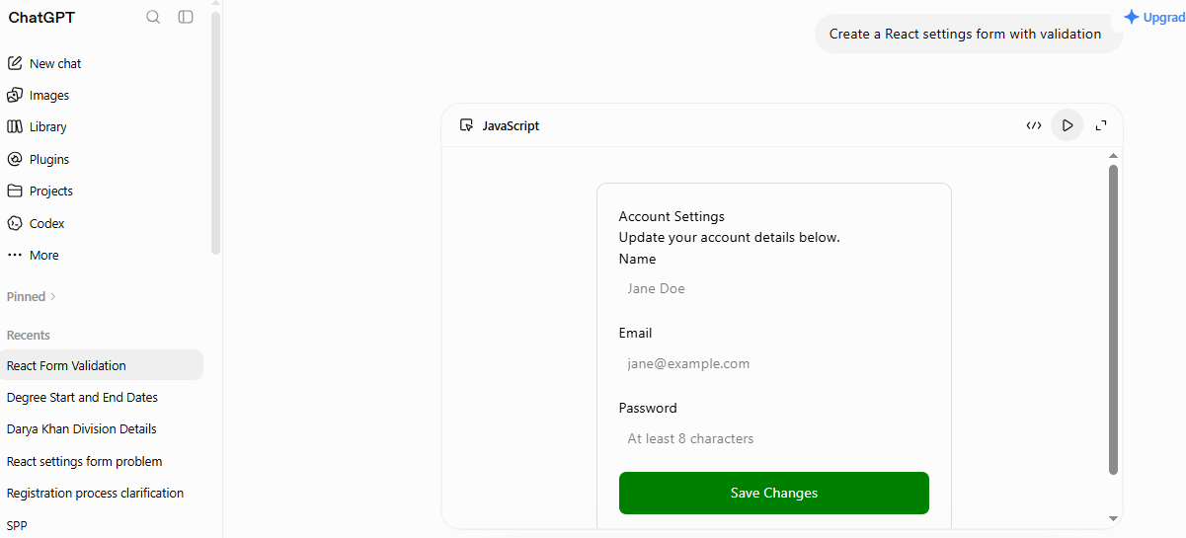
2:
Act as an experienced React frontend developer. Create a React settings form with validation.
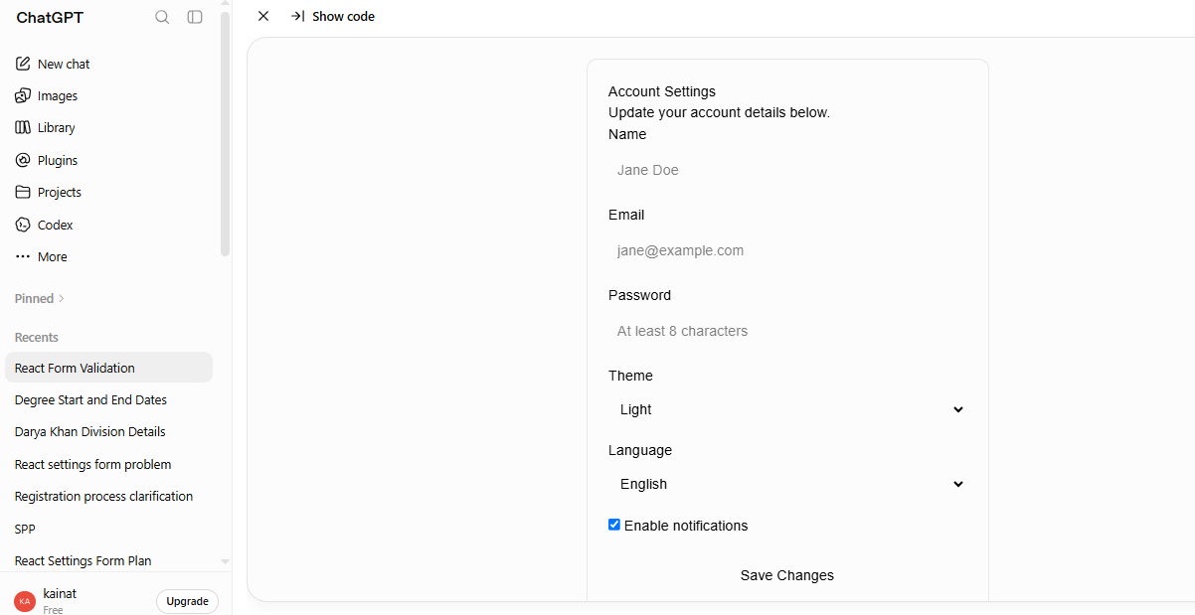
3:
Act as an experienced React frontend developer. Create a React settings form with validation. This form will be used in an internship project, and the goal is to create a simple, responsive, and user-friendly settings page.
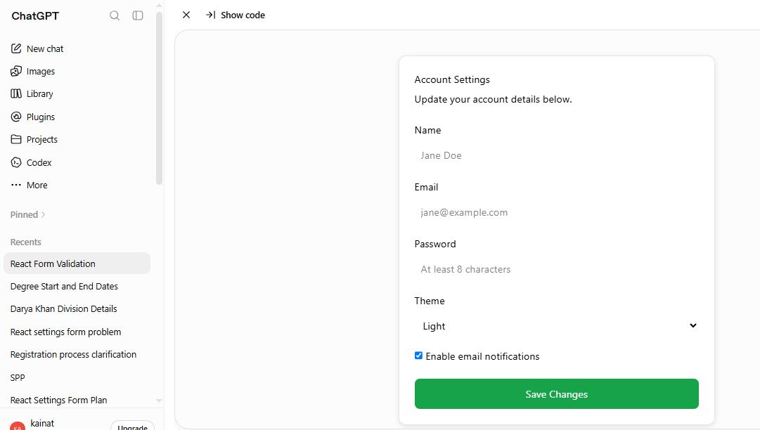
4:
Act as an experienced React frontend developer. Create a React settings form with validation. This form will be used in an internship project, and the goal is to create a simple, responsive, and user-friendly settings page.
Example of a good form:
- Name field with an error message if left empty.
- Email field with an error message for an invalid email.
- Password field with an error message if it has fewer than 8 characters.
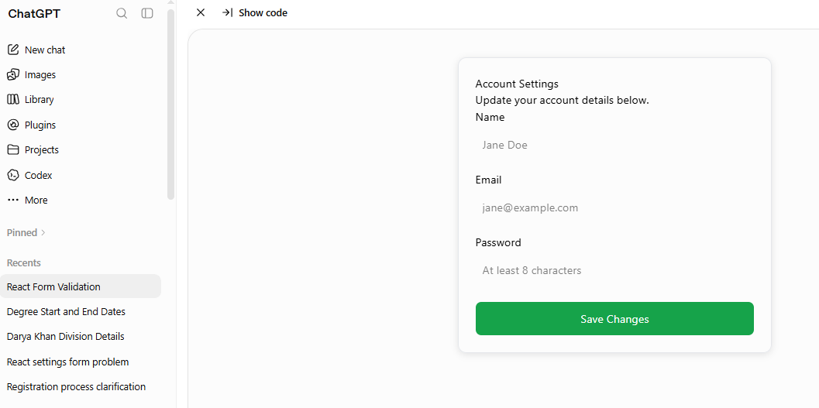
5:
Act as an experienced React frontend developer. Create a React settings form with validation. This form will be used in an internship project, and the goal is to create a simple, responsive, and user-friendly settings page.
Example of a good form:
- Name field with an error message if left empty.
- Email field with an error message for an invalid email.
- Password field with an error message if it has fewer than 8 characters.
Format your response using these sections:
- Component structure
- JSX code
- Validation logic
- Styling explanation
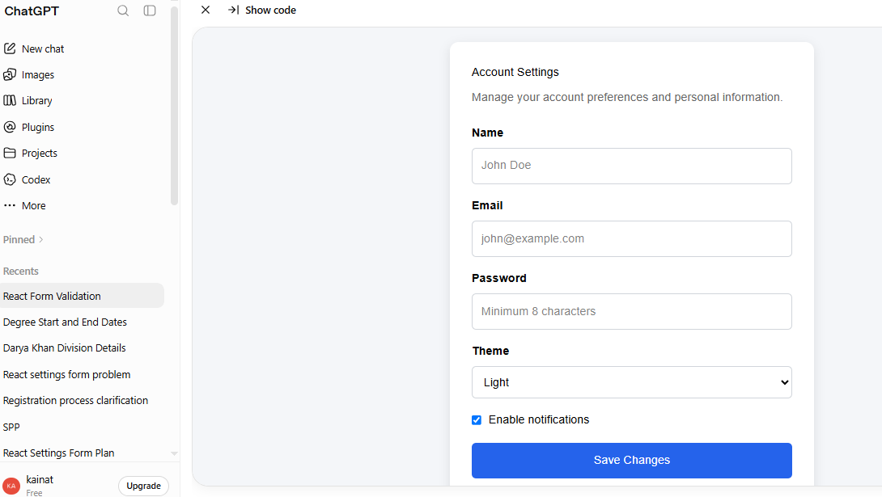
6:
Act as an experienced React frontend developer. Create a React settings form with validation. This form will be used in an internship project, and the goal is to create a simple, responsive, and user-friendly settings page.
Example of a good form:
- Name field with an error message if left empty.
- Email field with an error message for an invalid email.
- Password field with an error message if it has fewer than 8 characters.
Format your response using these sections:
- Component structure
- JSX code
- Validation logic
- Styling explanation
Solve the task step by step:
- Identify the required fields.
- Create the component structure.
- Add validation.
- Add accessibility improvements.
- Explain how to test the form.
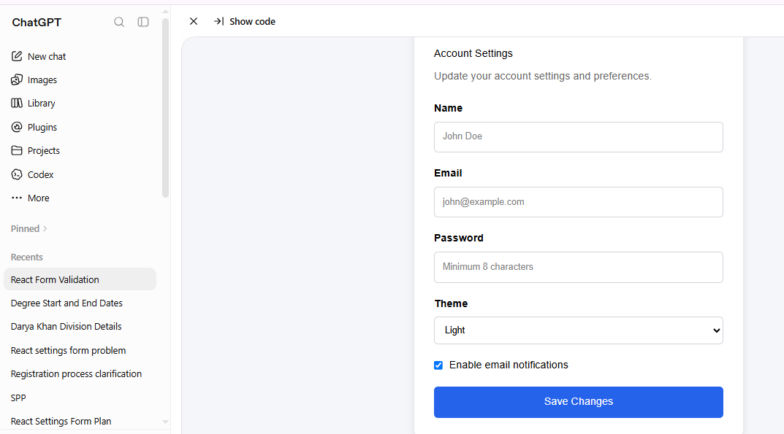
Cross-Model Comparison
Claude provided more explanation, while ChatGPT was more concise. Both generated usable code, but they differed in tone and structure.

