FRAME IT AS CASES
Kainat Ijaz
Work That Speaks for Itself
General AI Fluency · Week 2

1. Voice Card
Direct, clear, practical, honest, simple, learner-focused.

Claude Project Standing Instruction
Write in a direct, clear, practical, honest, simple, learner-focused voice. Avoid buzzwords, exaggerated claims, generic portfolio language, and claims that I cannot personally prove. Use my actual words, decisions, and experience when writing my case studies. Keep the writing concise and specific to my real projects.

Evidence Screenshot
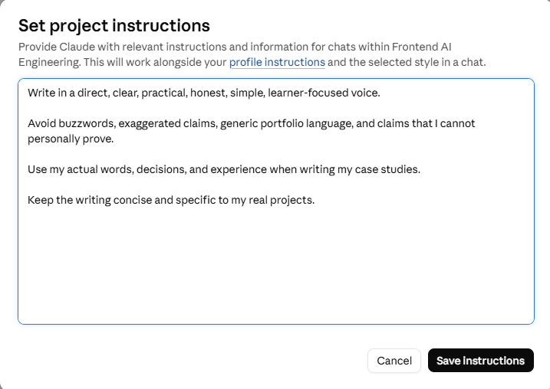
Evidence: Claude Project standing instruction.

2. AI Interview Evidence
I used an AI interview to explain the real problem, what I decided to build, what I personally did, and what changed. The interview was conducted one question at a time.
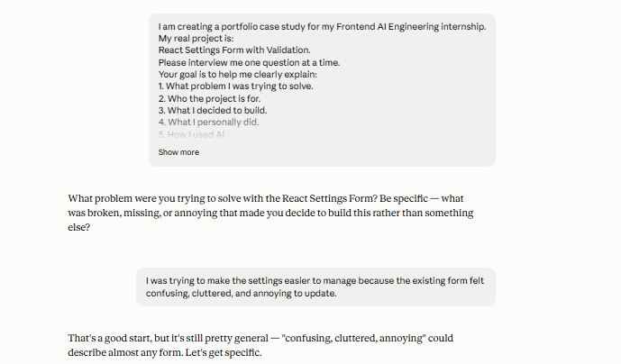
Interview evidence — identifying the problem.
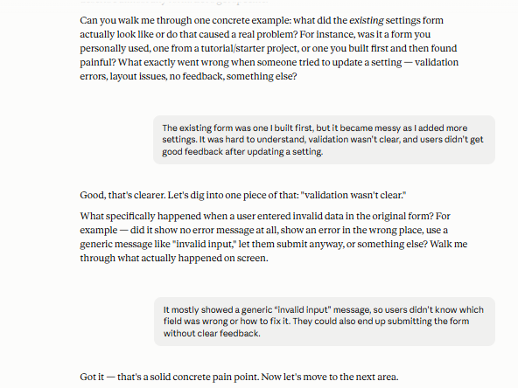
Interview evidence — making the problem specific.

3. Case Study — React Settings Form with Validation

The Problem
I had already built a settings form for a personal practice project, but as I added more fields, it became messy and hard to manage. The bigger issue was validation: when a user entered invalid data, the form showed a generic “invalid input” message. It did not say which field was wrong or how to fix it, and users could end up submitting the form without clear feedback. This was a practice project rather than a real-user product, but the problem felt real enough to be worth fixing properly.

What I Did
I rebuilt the form from scratch rather than patching the older version. I made a simple React settings form with fields for name (required), email (valid format), password (minimum 8 characters), theme, and notification preferences. I designed the structure myself instead of starting from a template, and I wrote the validation logic using basic React state and manual checks rather than adding a library like Formik or Yup.
I kept form state as a single object rather than using separate state for every field. Validation runs on submit, with errors displayed next to the relevant field instead of as one generic message.
I used AI mainly as a reviewer and debugging partner, not to write the form for me. One concrete mistake I caught was the first version's generic “invalid input” message. I described the problem to AI, asked for field-specific error strings (for example, “Enter a valid email address”), and implemented the change myself. AI also helped explain a few React concepts and pointed out accessibility and structure issues; the final decisions were mine.

What Came of It
The result is a working settings form where validation errors are specific and appear next to the field that caused them, instead of one generic message. This directly solves the original problem: a user can see exactly what is wrong and fix it without guessing.
Because this was a practice project, there are no real-user metrics to report. What I can stand behind is the improved field-level error experience and the deliberate, explainable decisions I made about state management and validation timing.

Evidence Screenshot
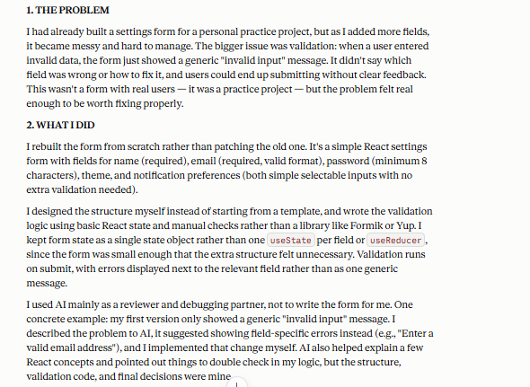
Evidence: case-study details captured from the interview.
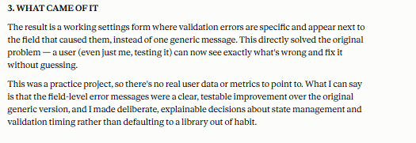
Evidence: outcome and limitations.

4. Audience, Bio & Contact / CTA

Audience
Hiring managers and recruiters looking at a beginner Frontend AI Engineering portfolio.

One Action
Contact me to discuss a frontend project or opportunity.

Bio
I am a beginner Frontend AI Engineering student learning to build usable React interfaces with AI-assisted development. I learn by building, testing, reviewing, and improving real frontend projects.

Contact / CTA
Interested in my work or want to discuss a frontend project? Get in touch with me.
Email: kainatijaz206@gmail.com
LinkedIn: https://www.linkedin.com/in/kainat-ijaz
5. Before / After

Before — Generic AI Copy
I am a passionate and results-driven frontend developer dedicated to creating innovative and user-friendly digital experiences using cutting-edge technologies.

After — My Edited Version
I am learning frontend development by building React projects and using AI to help me design, implement, test, and improve usable interfaces.

Why I Changed It
The original version uses generic phrases such as “passionate,” “results-driven,” and “cutting-edge technologies.” The edited version is more specific to what I am actually doing and avoids claims I cannot prove.

Final Review Notes
- The case is based on my actual React settings-form project.
- The three required beats are clearly separated: problem, what I did, and what came of it.
- The case includes a specific AI mistake I caught and corrected.
- The writing avoids unsupported performance claims because this was a practice project.
- The audience and single CTA are stated explicitly.

