FL-01 Workflow Audit
Name: Kainat
Track: Frontend AI Engineering
Task | Classification | Reason
Attend online classes | Just Me | Requires my own attention and learning.
Complete frontend assignments | Collaborate with AI | AI assists, I verify.
Debug JavaScript code | Delegate to AI with Review | AI suggests fixes; I test.
Write README files | Delegate to AI with Review | AI drafts; I review.
Search documentation | Collaborate with AI | AI explains; I verify.
Plan weekly study schedule | Collaborate with AI | AI organizes; I choose.
Reply to internship emails | Just Me | Personal communication.
Generate CSS ideas | Delegate to AI with Review | AI provides ideas.
Write Git commit messages | Fully Automate | Standard format.
Summarize articles | Fully Automate | AI summarizes quickly.

Three Target Tasks

Debug JavaScript Code
Done well: Bugs fixed, tested, no new issues.

Write README
Done well: Clear overview, setup, tech stack, professional formatting.

Plan Weekly Study Schedule
Done well: Realistic plan, all tasks covered, completed on time.

Screenshots
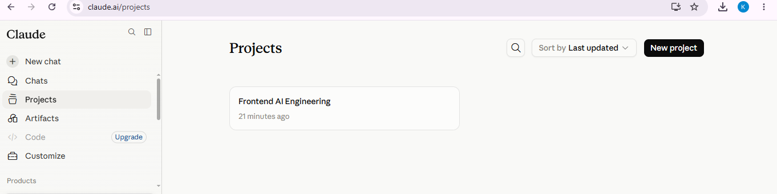

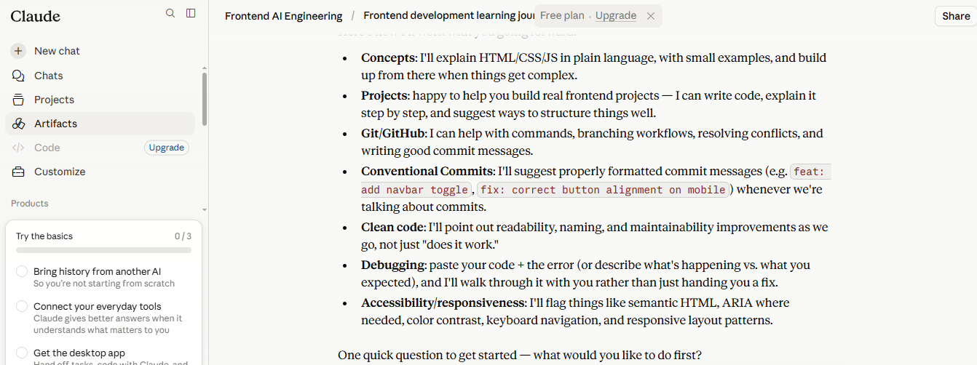
- Screenshot of Anthropic Academy enrollment/completion of first module
