Week 1 – What Are You Proving?
Kainat Ijaz

Proof Statement
I can build clean, responsive frontend web applications using HTML, CSS, JavaScript, React, Git, and AI-assisted development. My portfolio is designed for frontend internship recruiters who are looking for motivated junior frontend developers with practical skills. Through my projects, I want recruiters to see my abilities and contact me for frontend internship opportunities.

Why This Needs to Exist
My portfolio demonstrates my practical frontend development skills and real projects in a way that my CV or LinkedIn profile alone cannot.

AI Collaboration
AI Tool Used: ChatGPT
How AI Helped:
- Asked questions to refine my main skill.
- Helped identify my target audience.
- Assisted in improving my proof statement while keeping it personal.

Screenshot
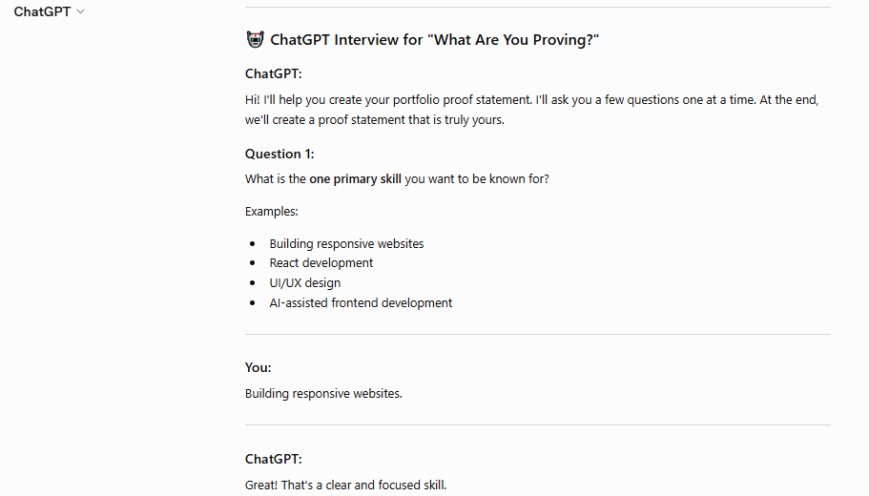
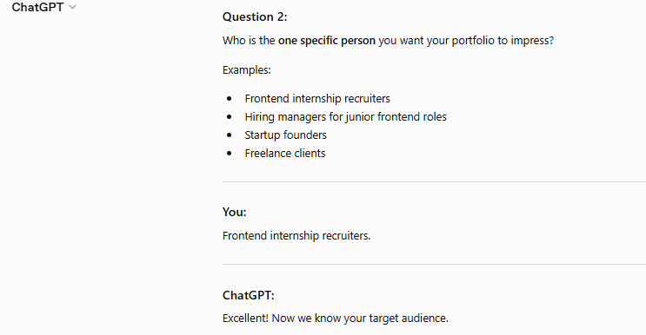
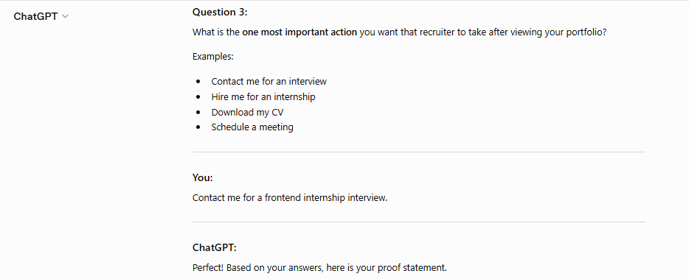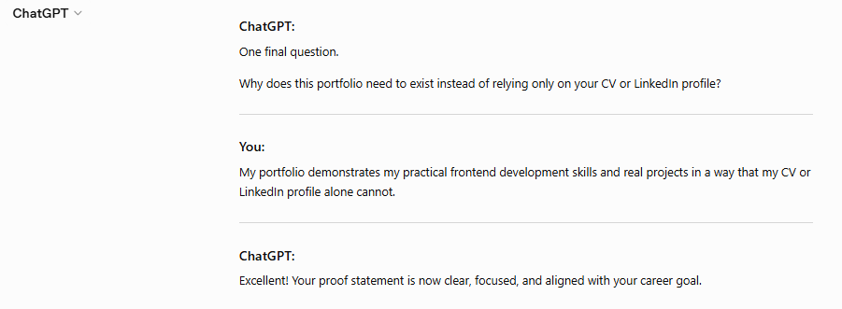

Deliverables Checklist
- One-paragraph proof statement
- One-line why
- AI interview completed
- Screenshot attached

