Week 3 Assignment 3 Kainat Ijaz

Portfolio Sitemap
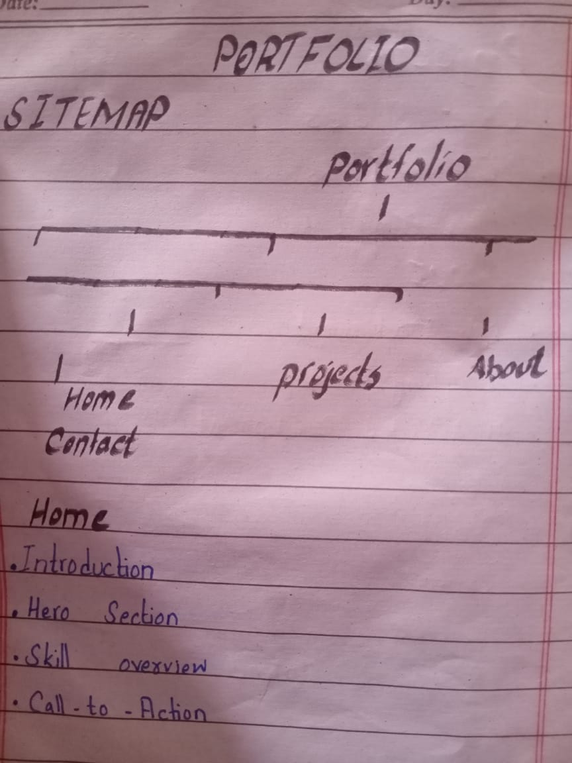
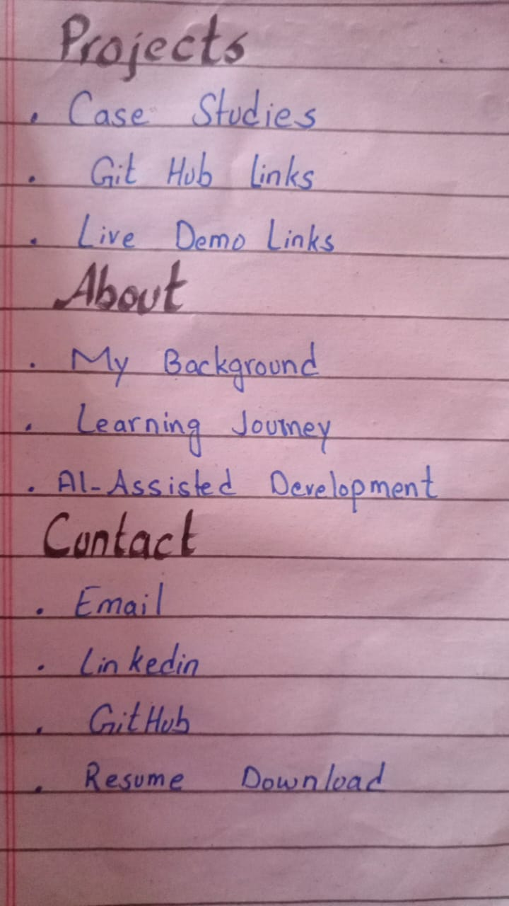

2. Claude Project
Project Name: Frontend Portfolio Build
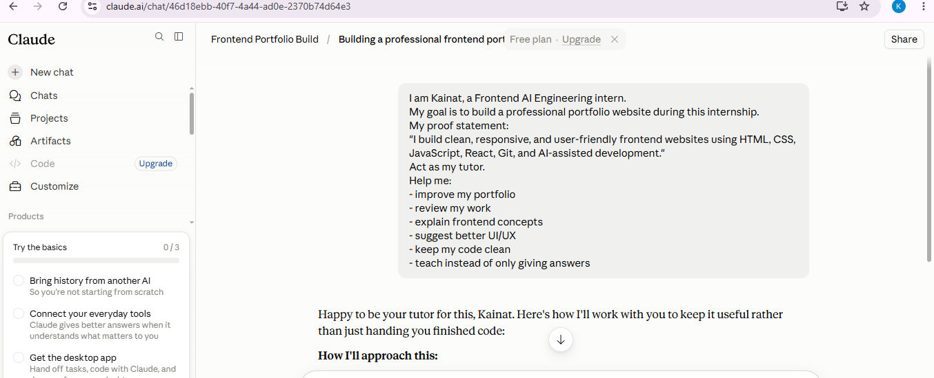

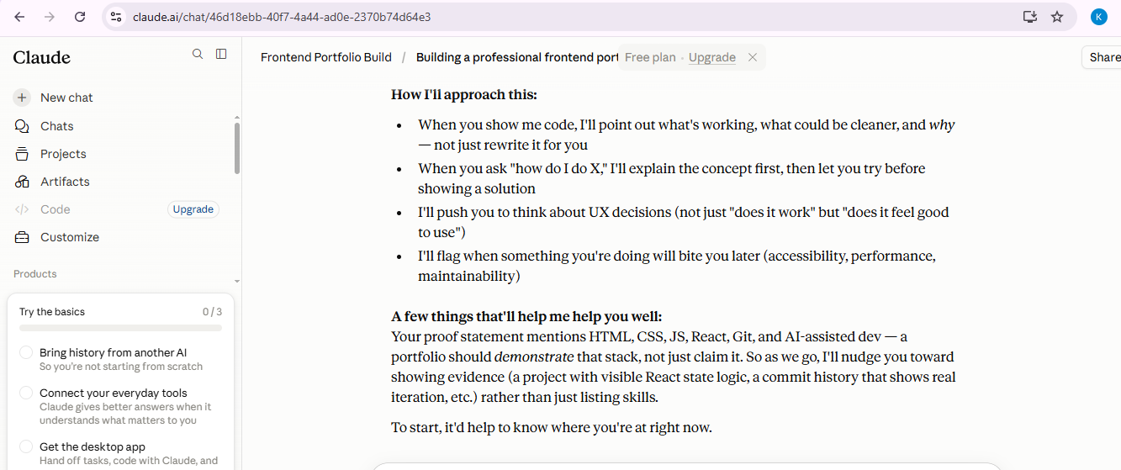

3. Pressure-Test Prompt & Output
Prompt:
I am creating a frontend developer portfolio. My sitemap is Home, Projects, About, Contact. Please pressure-test this sitemap and suggest improvements.
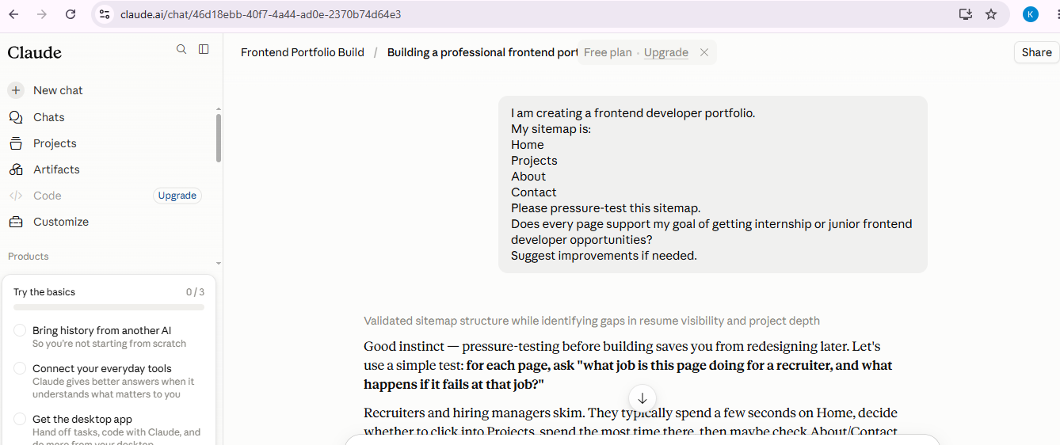

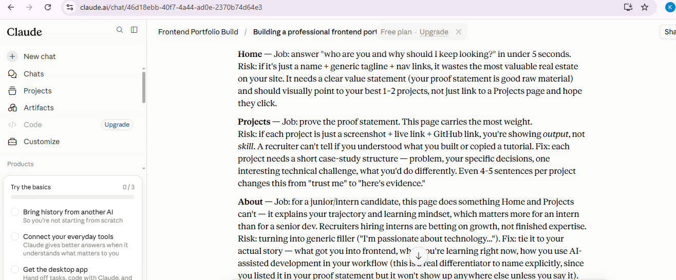

4. One Improvement
Write one improvement based on Claude's feedback:
Based on Claude's feedback, I will improve my Projects section by presenting each project as a short case study instead of only showing screenshots and links. This will better demonstrate my skills and problem-solving process.

